**Report of Graffiti Removal from Boulders in the Dirt Parking Lot on FR-333 on Tuesday, July 9, and the CCC Stone Cabin in Juan Tabo Arroya**

**on Thursday, July 11**

Sam Beard

**Tuesday, July 9** – In the afternoon Tuesday, Sam attempted to remove four graffiti tags from five boulders in the dirt parking lot near the two large stone pillars on the road (FR-333) that leads to La Luz Trailhead. He does not have “before” photos of all these boulders.

**Thursday, July 11** – Sam went to the CCC stone cabin, because he had seen the red tag above the front window. When he went into the cabin, he found a total of two small tags and three larger tags.

See photos below

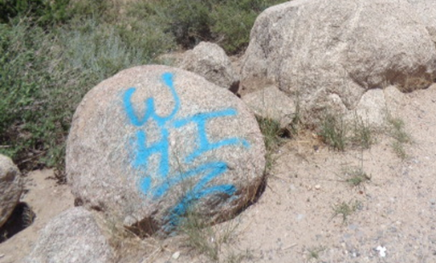

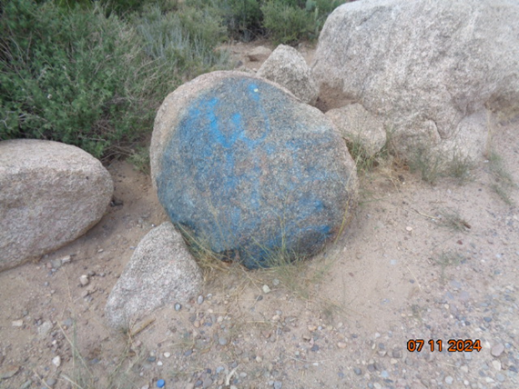

The top photo shows the original color of the blue paint that was on five boulders

in the dirt parking lot near the large stone pillars on FR-333. The lower photo shows

that not all the blue paint was removed after three applications of the graffiti

removal chemical. All photos by Sam Beard

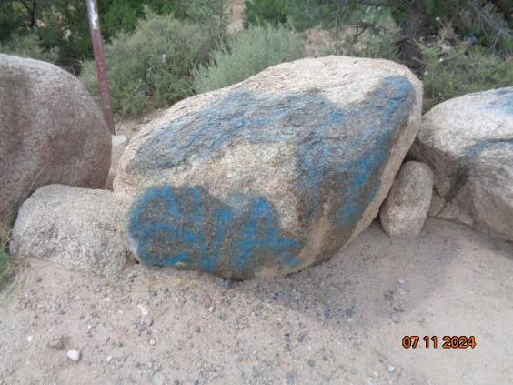

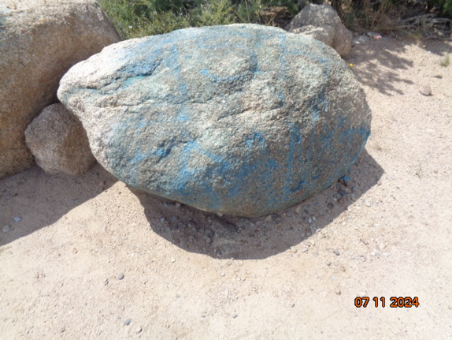

Only about half of the paint was removed from these boulders

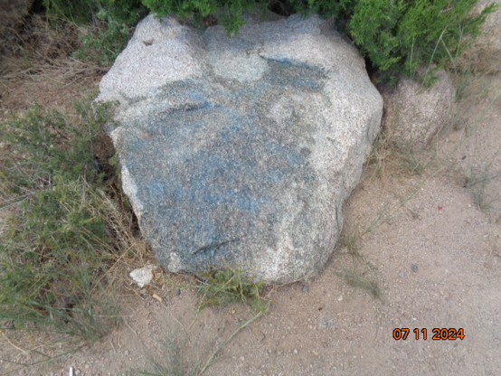

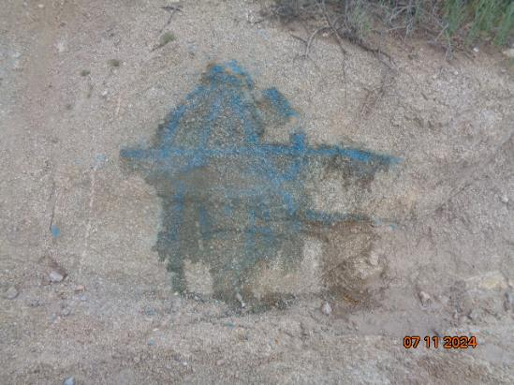

Not all the graffiti was removed from the boulder in the top photo.

The tag in the bottom photo was on a natural stone wall adjacent to the road.

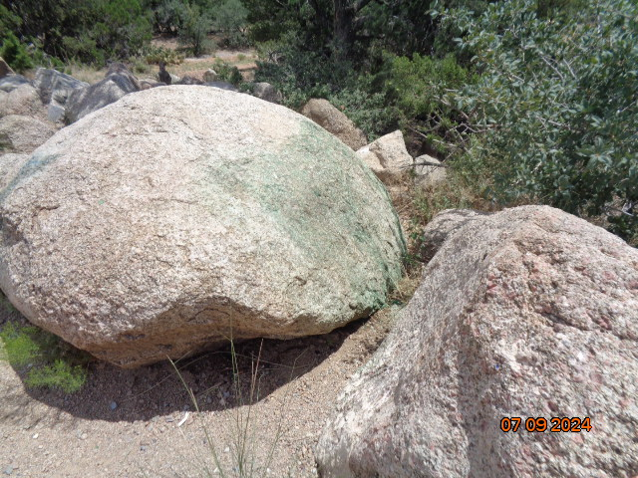

Most of the bright green paint was removed from the right side of this boulder.

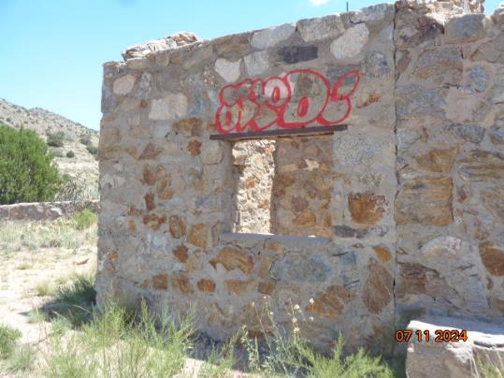

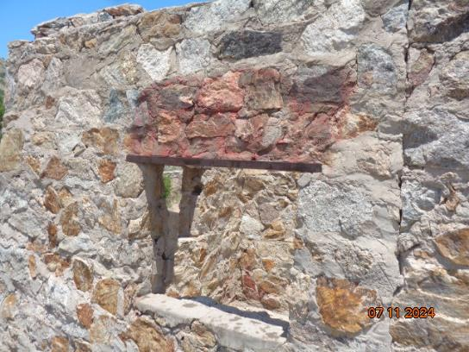

Before and after photos of the red paint on the front of the CCC Juan Tabo

Cabin south of Forest Road 333. Unfortunately, some of the red color

is visible from the road.

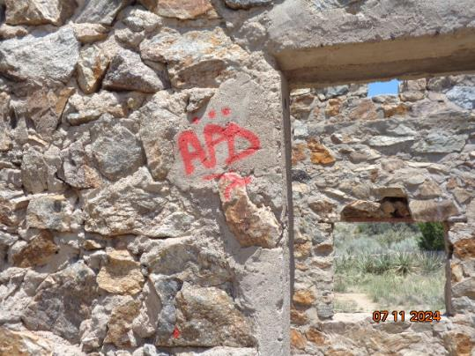

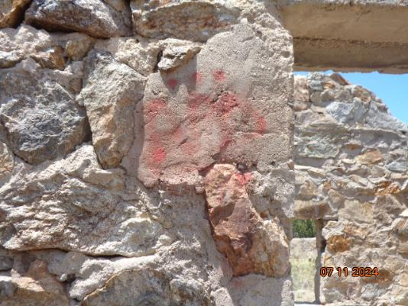

Before and after photos of a small red tag on an interior wall

of Juan Tabo Cabin.

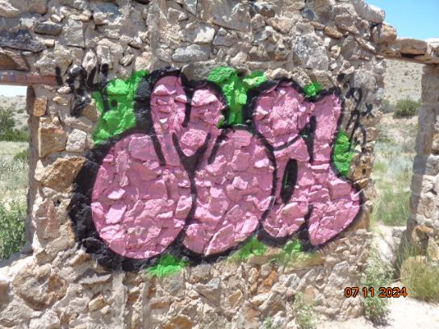

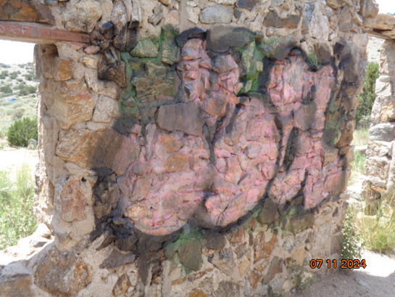

Before and after photos of this very large tag on the east side of the front wall.

Paint is very difficult to remove from this stone and mortar wall, because it is very rough.

Paint soaks into the mortar more than the stone.

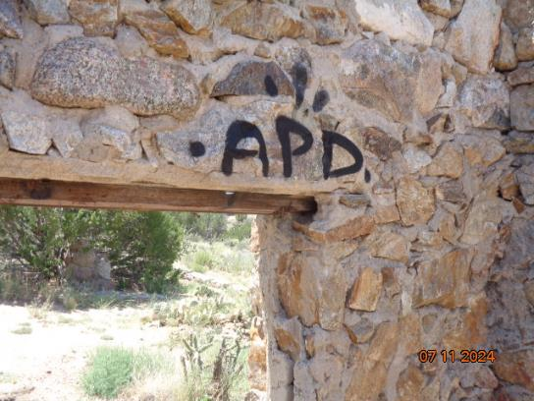

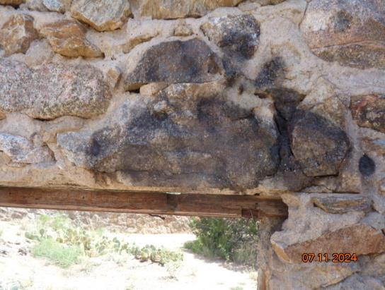

Only about half of this black paint was removed after three

applications of the chemical.

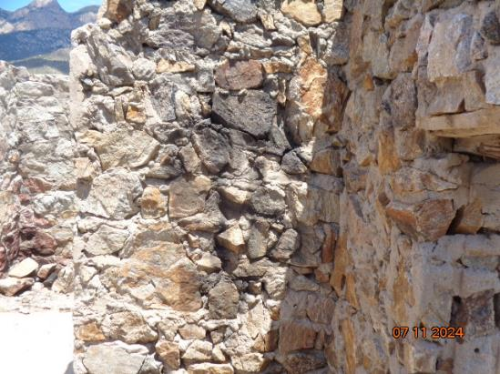

A large black dollar sign was removed from this wall.

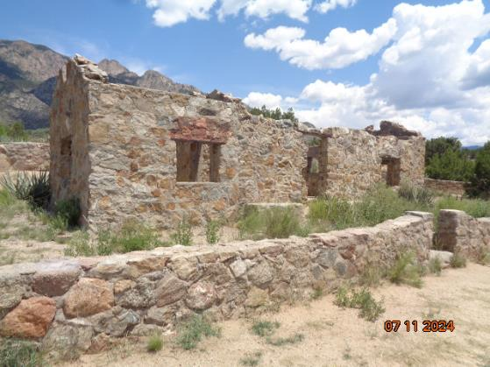

A red stain is still visible above the window after treatment with the chemical

and rinsing with water.

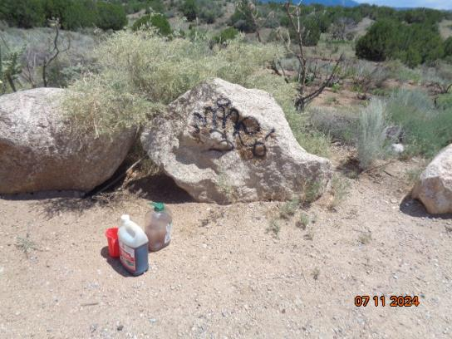

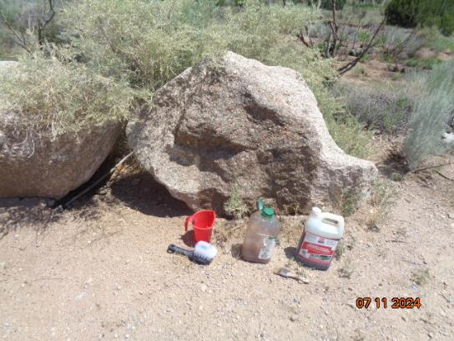

This black tag was on a boulder at the cabin parking lot. Fortunately, the tag

was completely removed with the chemical and water.