July 11, 2024: Thirteen Thursday FOSM volunteers joined SRD’s Jen, Chris, Zay and Dorothy to finish the Acequia Trail which now forms a loop with the Cienega road running down the middle and a picnic area on either end. It was another great day, warm but not uncomfortable. The crew finished benching the trail at the end of the road and at the other end where it crosses the road at the restrooms. Signs were added at these places also. Lots of hands made for quick work and the crew was done around lunchtime.

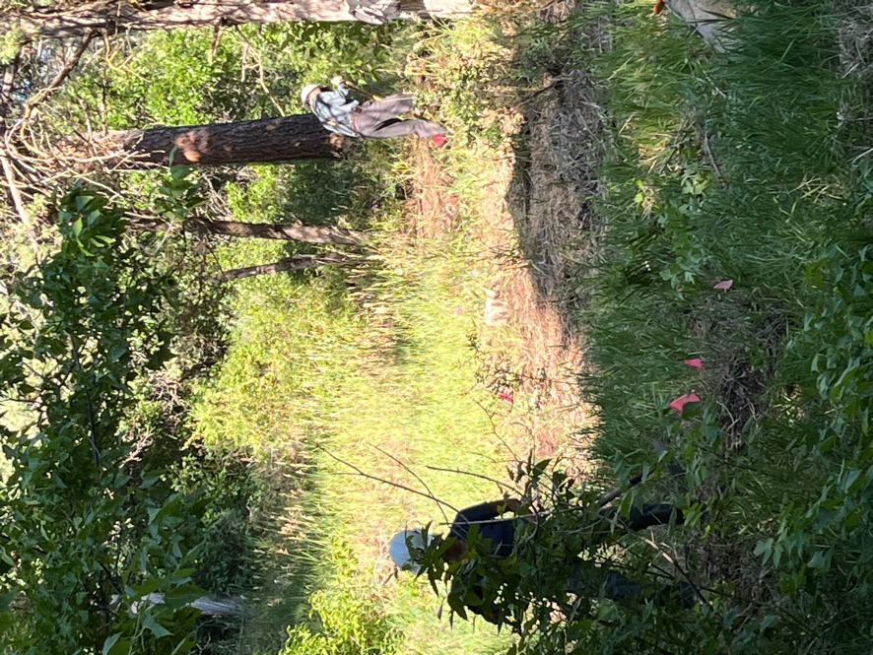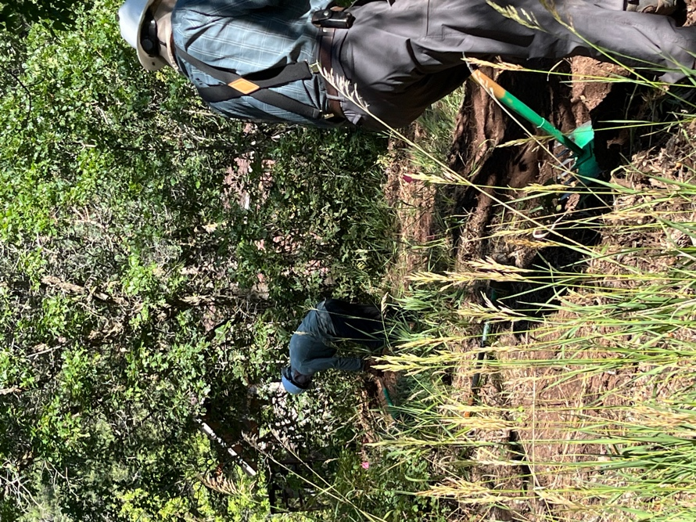

Claudia, Bruce and Scott work towards the road.

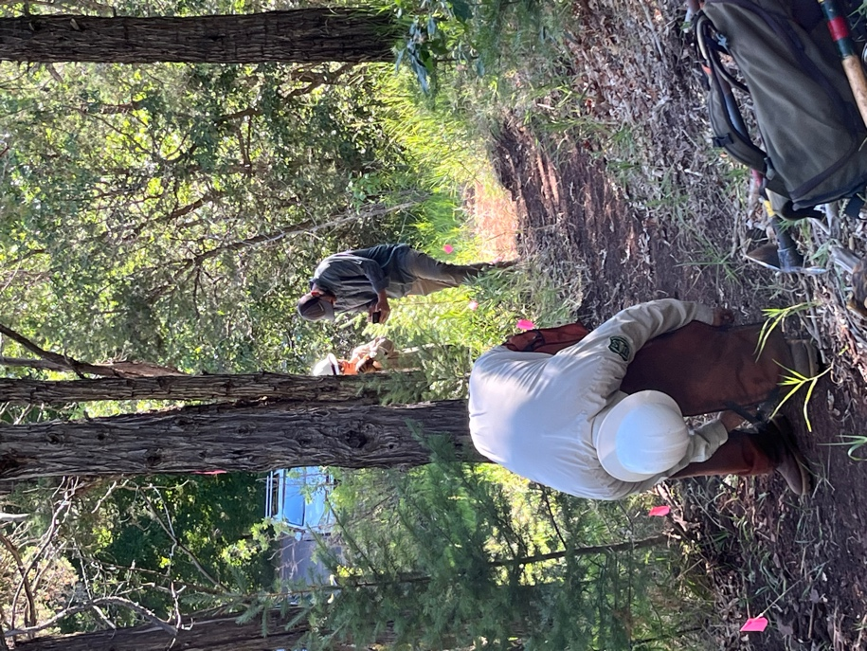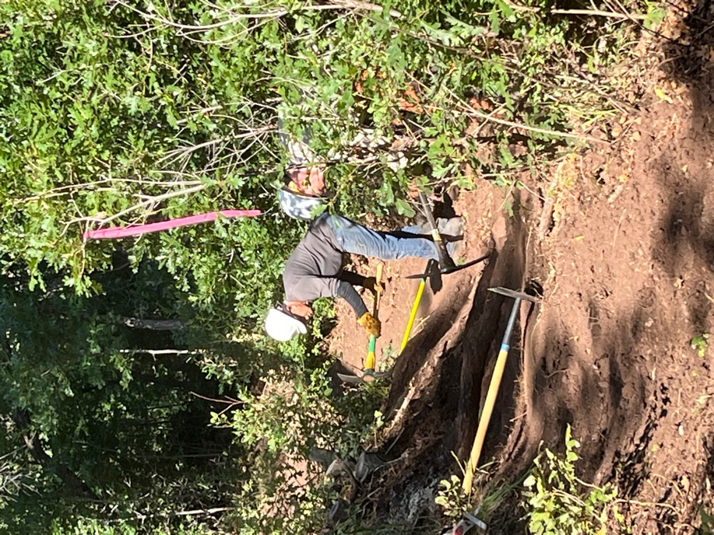

Chris gets his chaps on while Steve and Chris work to access large
Canyon and Dorothy talk strategy. tree roots to be cut out.

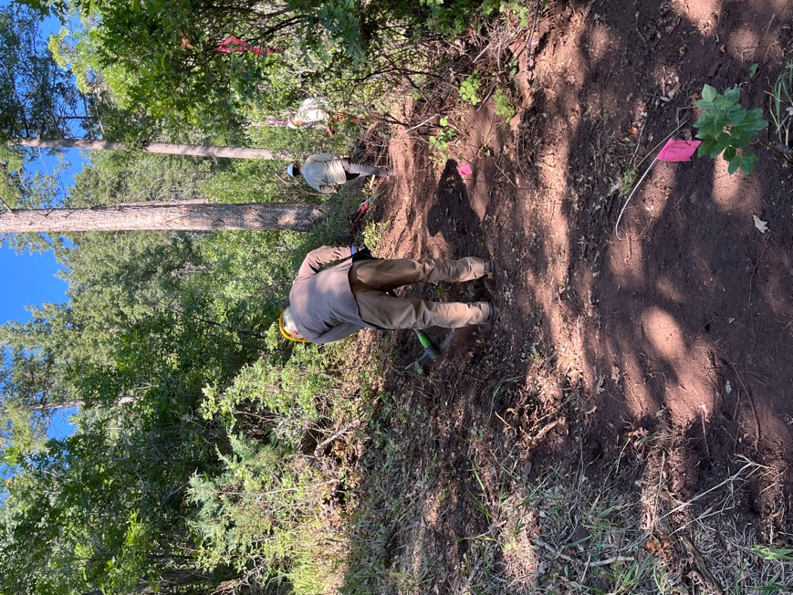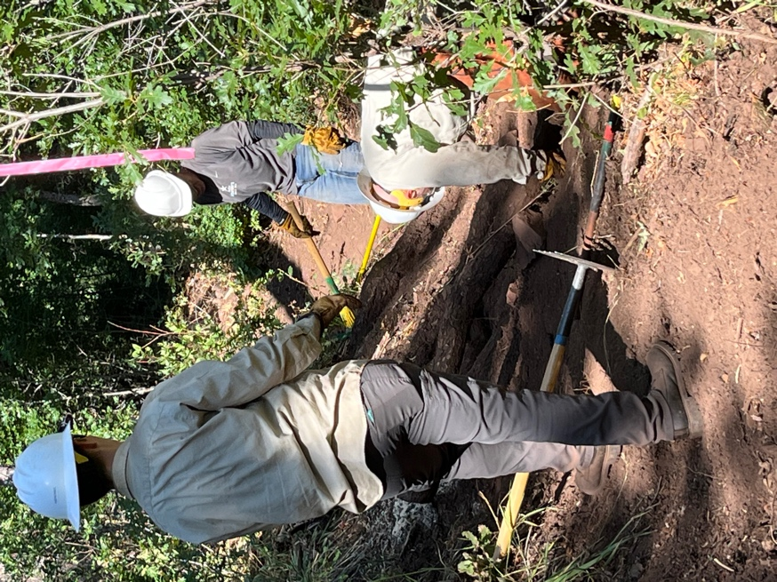

Mike works an upslope. Dorothy Steve and Chris work on the roots.

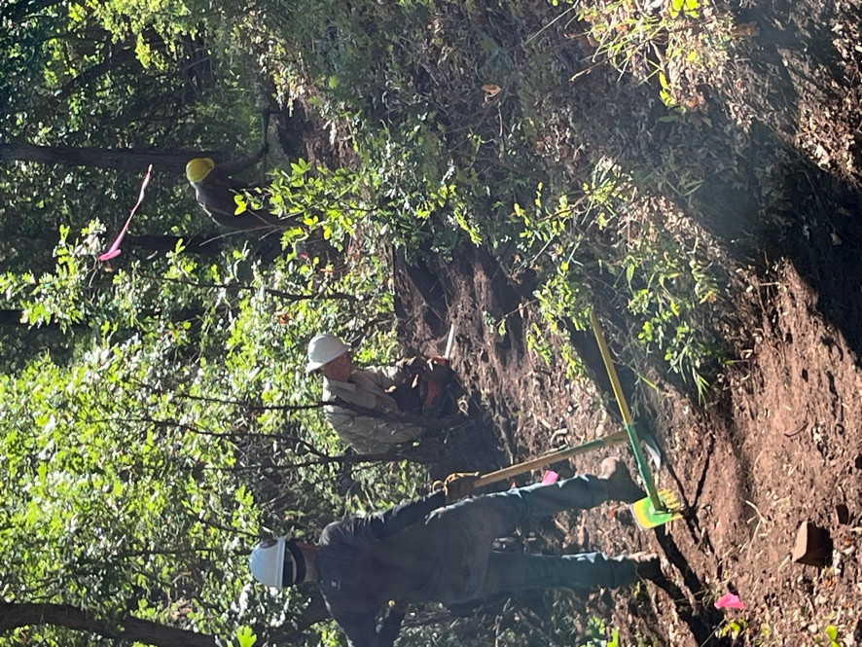 Chris cuts the large roots with the electric
saw.
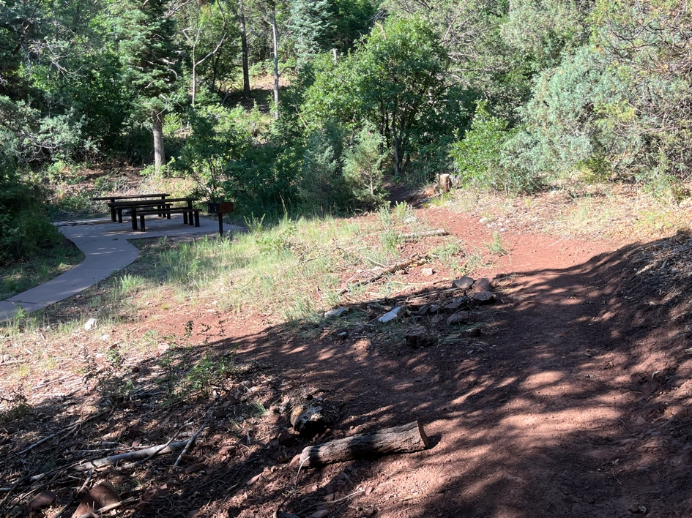

The trail loops around the picnic/bathroom area.

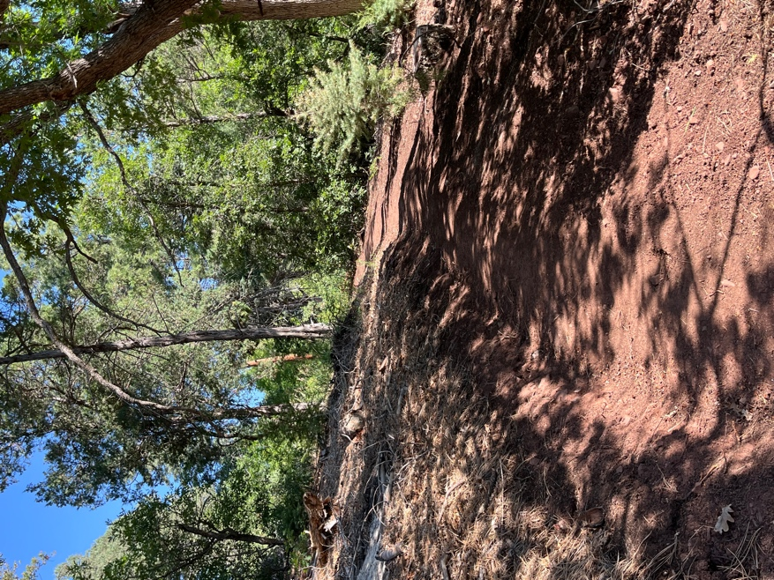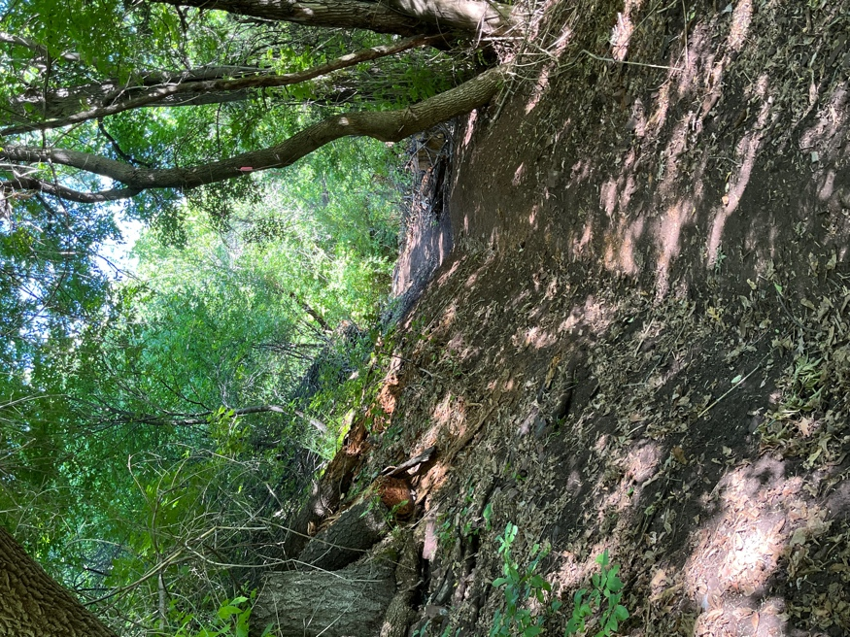

The trail moves through the woods heading towards the picnic area at the end of the road.

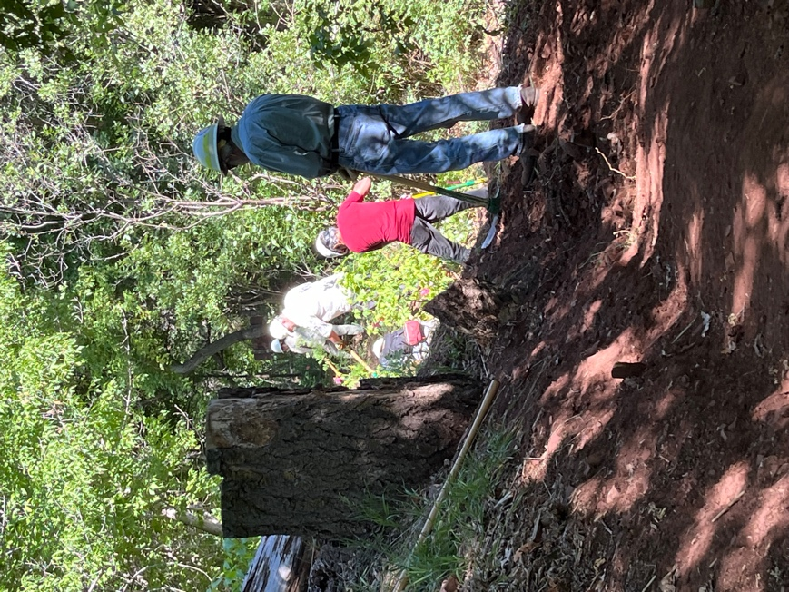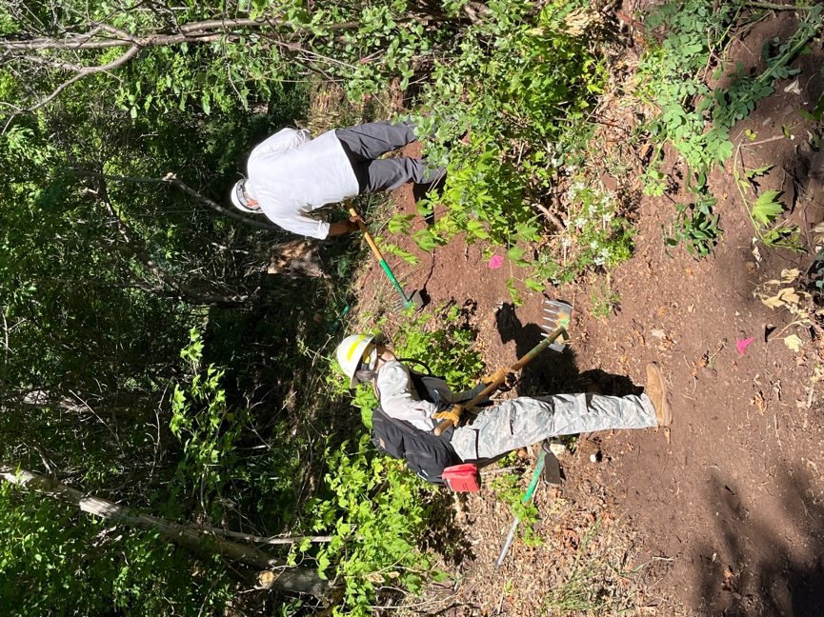

Byron and Luis work on upslope. Rav and Rich take a dip out of the trail.

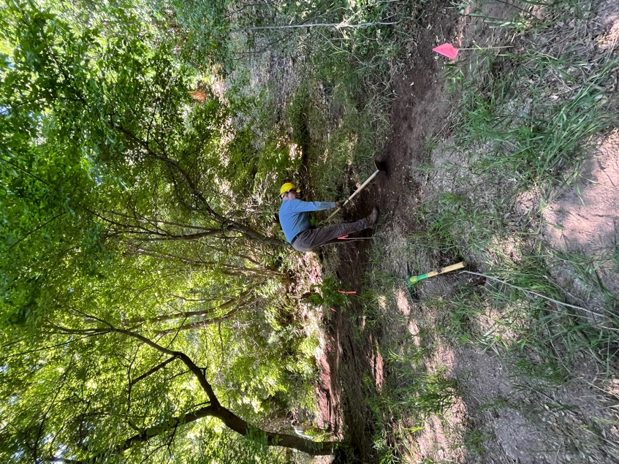 Eric cuts trail in the shade of some trees.

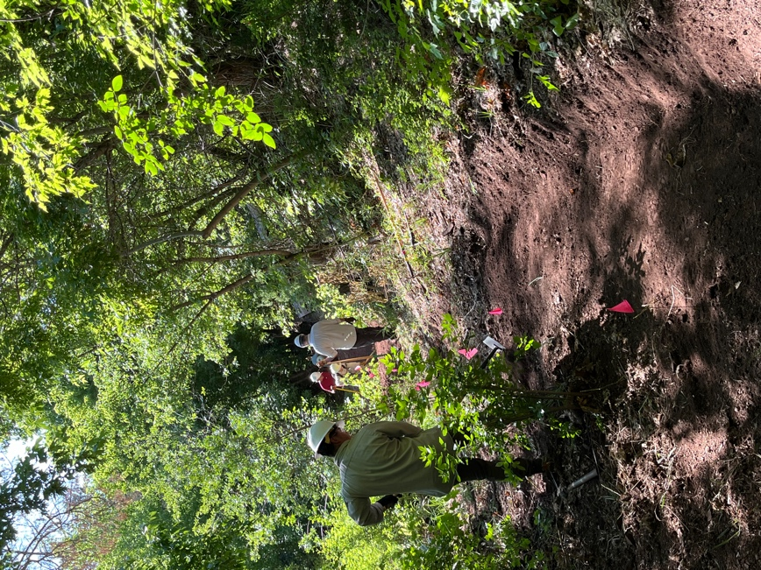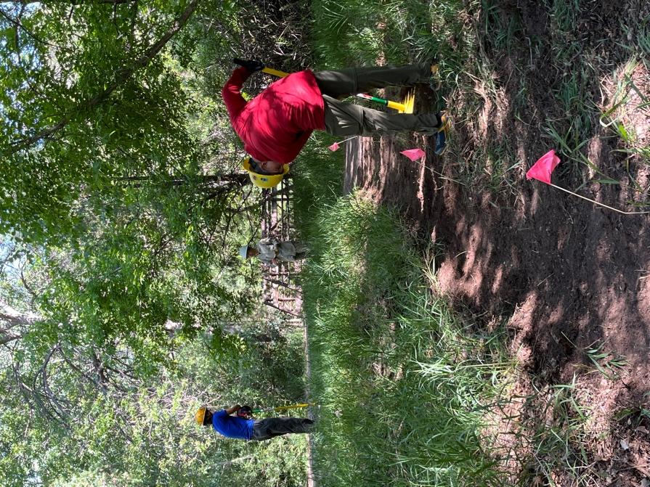

Zay works on benching. Roland, John and Jen work the very end of the
trail near the end of the road.
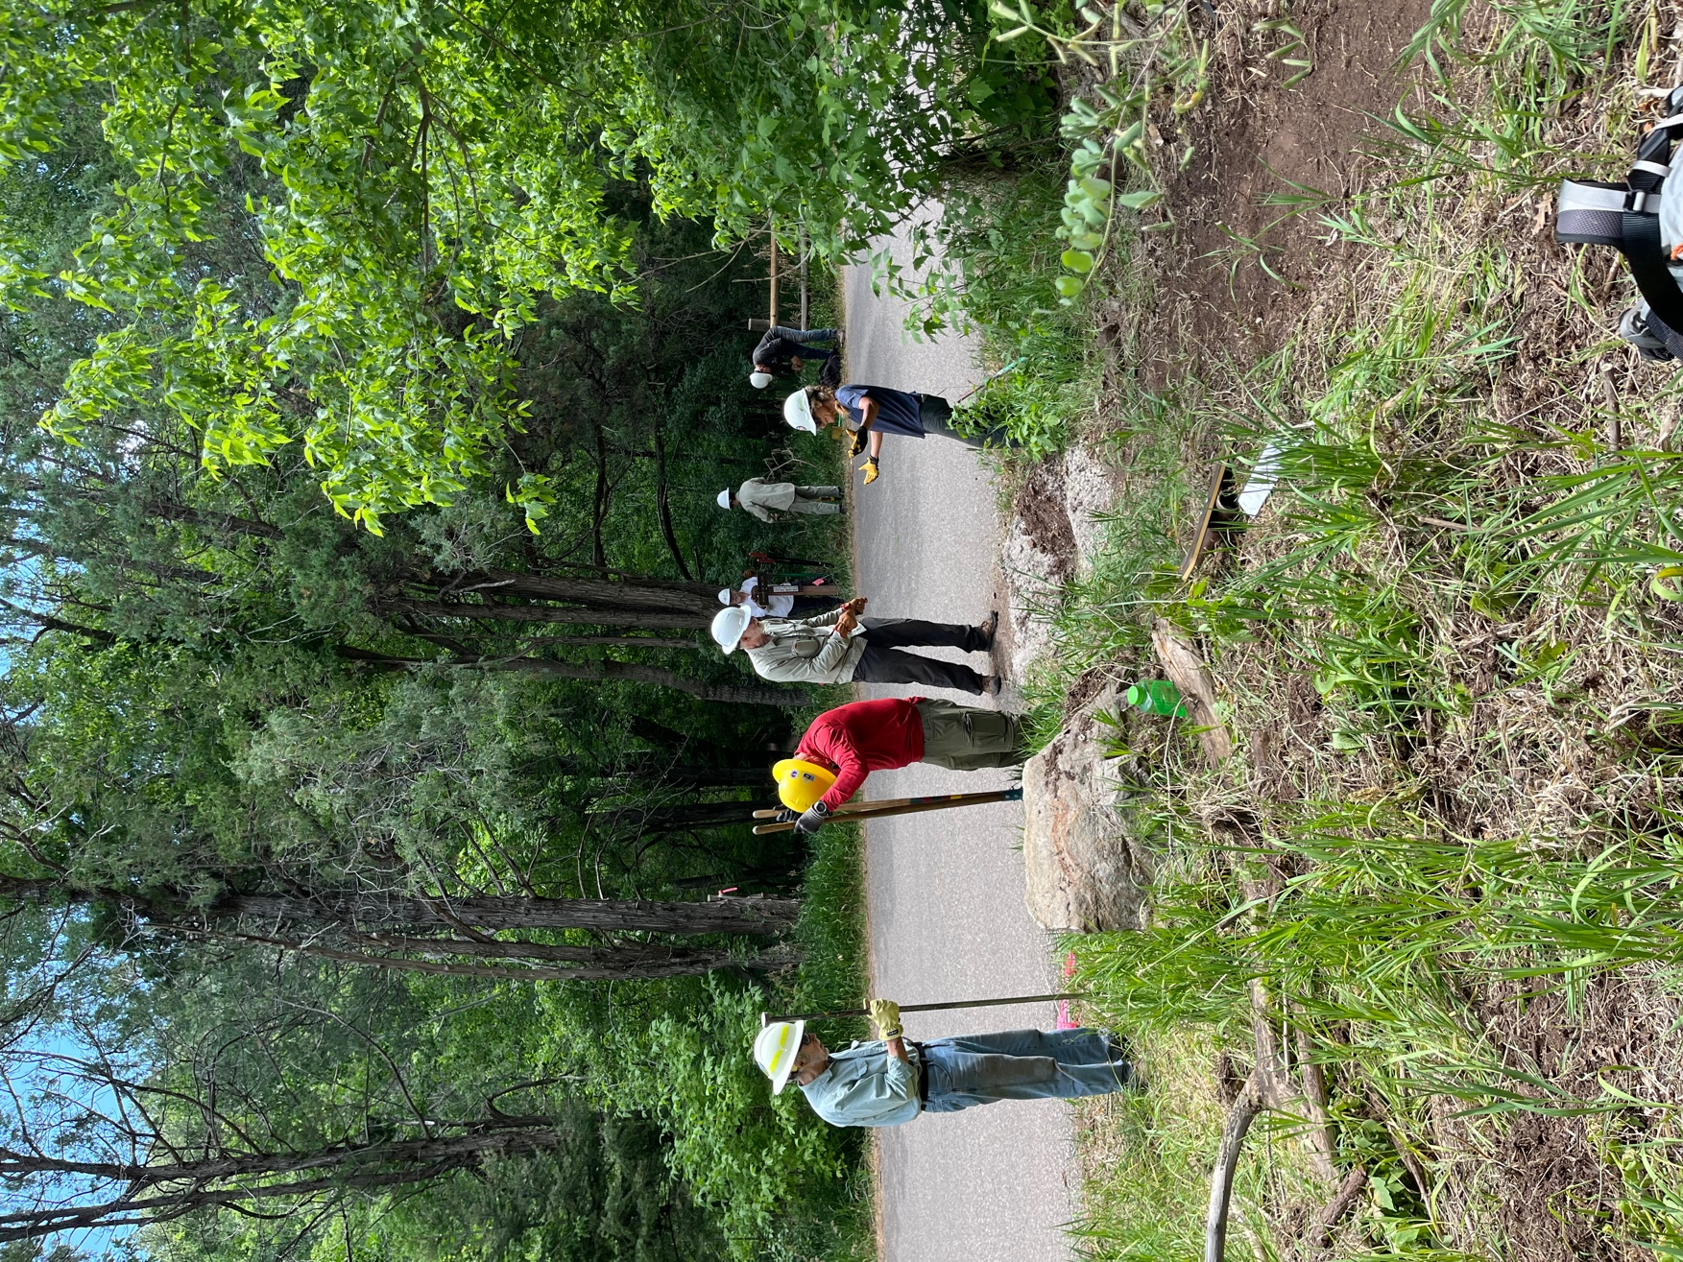

Byron and John dig a hole for the sign while Claudia and Scott work on placing rocks and gravel over a dip in the trail at the edge of the road. Jen, Rich and Steve place a sign on the other side of the road.
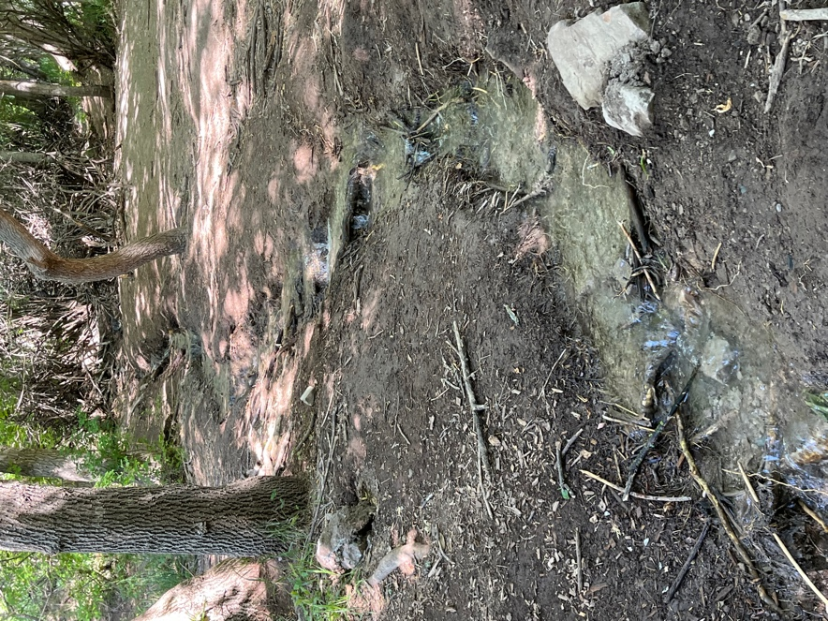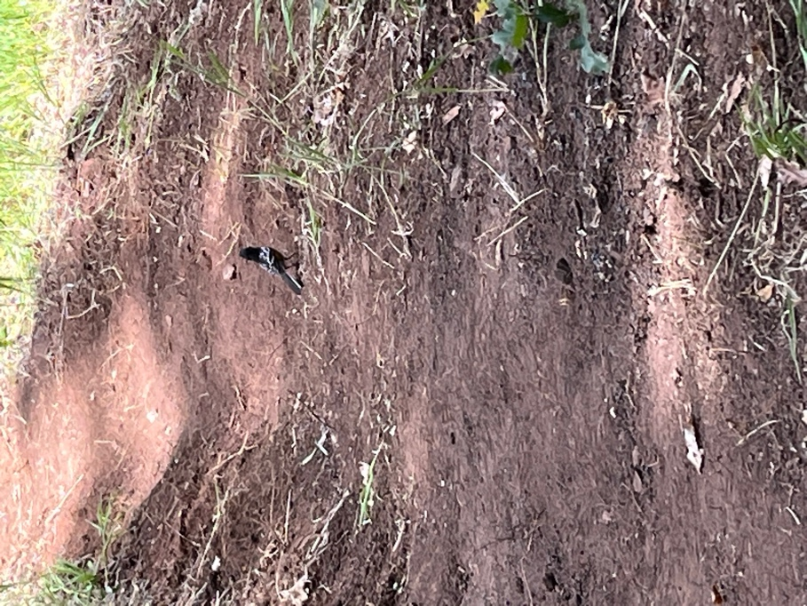

A nice clear stream runs through the area and Towhees love the newly turned soil.

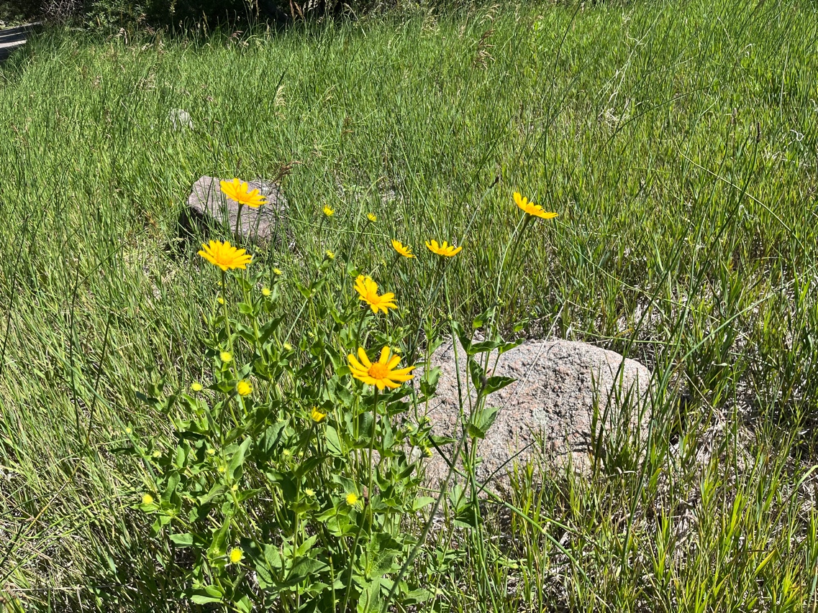 Time for lunch!!

