Thursday, 07/18/24: It was a beautiful day in the neighborhood! After a delayed start due to the repaving and truck traffic on the Crest Road, a crew of 11 volunteers and 5 SRD staff hiked from the Ellis parking area. We crossed the road and hiked through flowering meadows for about a mile down the trail to work a reroute section. Four of the SRD staff- Canyon, Dorothy, Chris and Zay worked with chainsaws clearing the new trail corridor. Jen and the volunteers started clearing debris and benching new trail. The weather held and the day remained comfortable and sunny despite the forecast calling for rain. The soil was moist at the top layers but very dry below- a sure sign we are still in drought. This section of reroute heads into the forest area and we encountered lots of roots and rocks. We will head back to this area next week. The hike out seemed ALL uphill but the wild flowers were spectacular- every color and every variety imaginable!

Volunteers: John Braly, Luis Cuadros, Rich Fagioli, Byron Garner, Mackenzie Gibbs, Bruce Hansche, Laura Leon, Mike Madden, Bill Perkins, Eric Russell, and Scott Sunde.

Pictures: Laura Leon

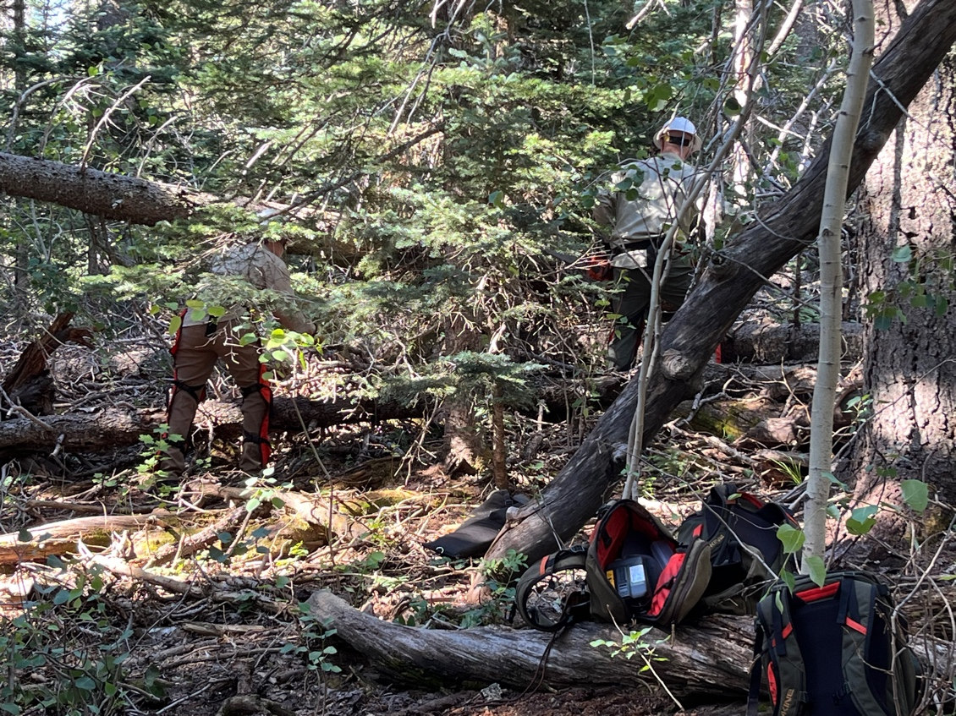

Dorothy and Chris clear trees.
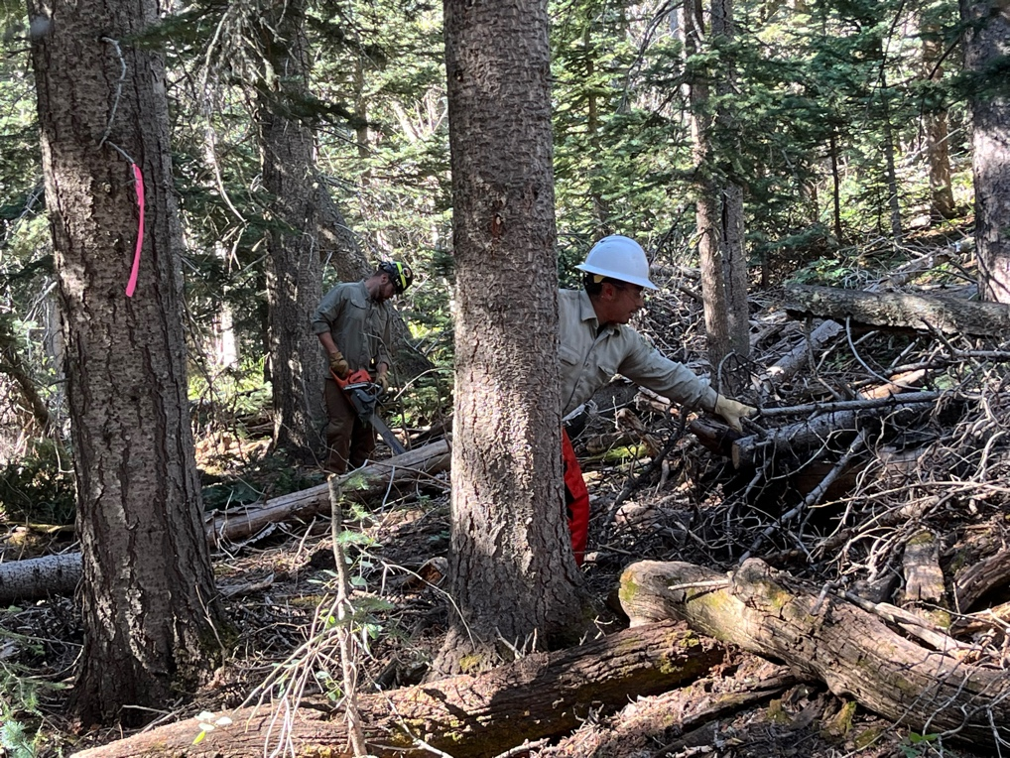

Zay and Canyon work the saws.

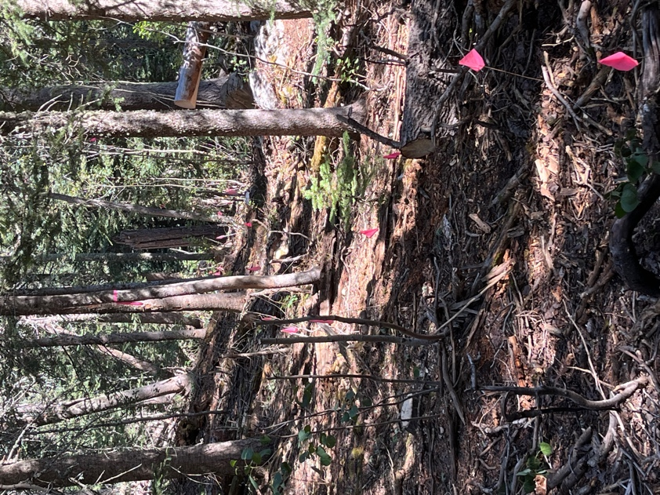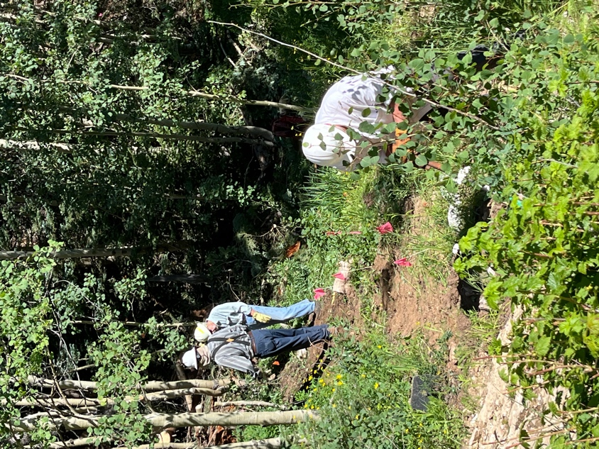

New trail awaits. Byron, Bruce and Rich work at the junction of new
and current trail.

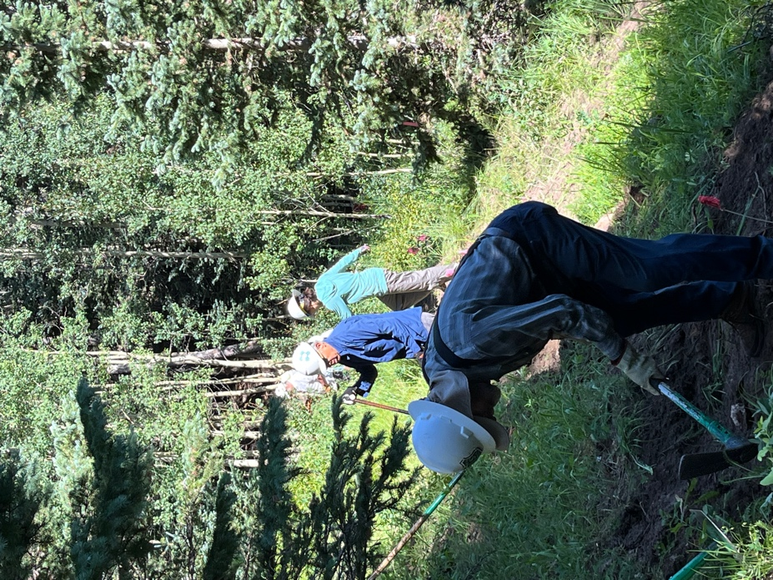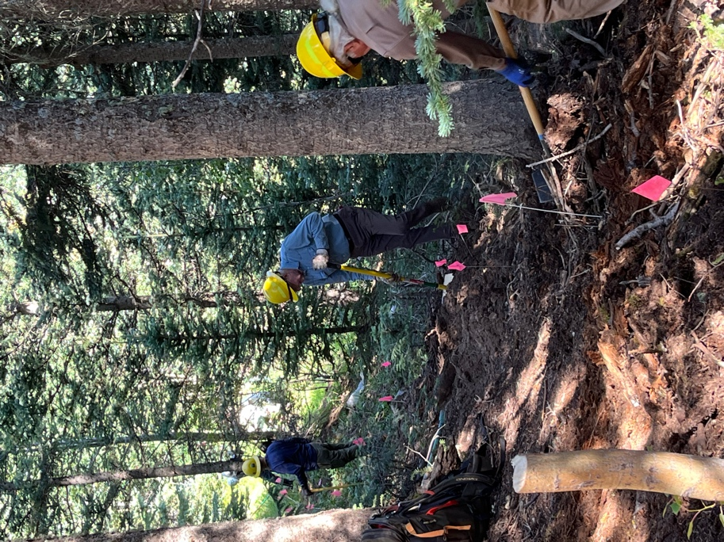
Looks like a chain gang without the A short open section moves into the
stripes! woods.
Bruce, Luis, Mackenzie…. Mike, Eric and John
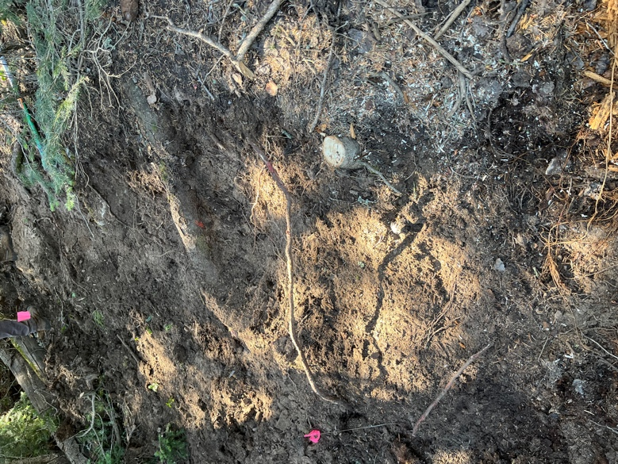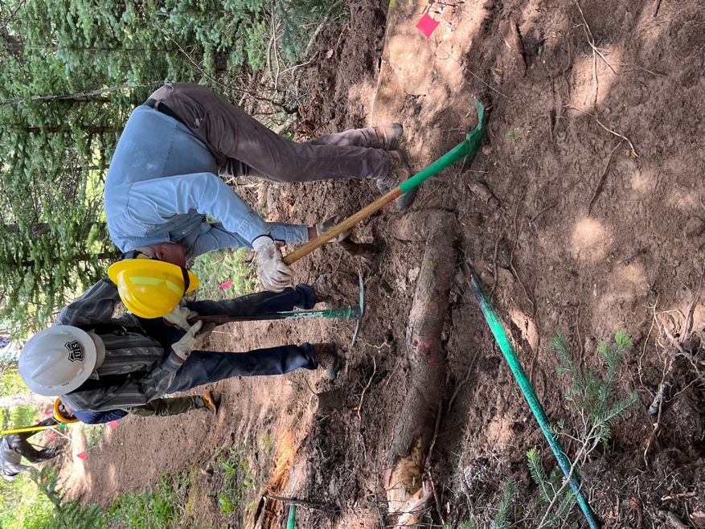

This hunk of root turned into a giant hunk of root! Eric and Bruce took care of it.

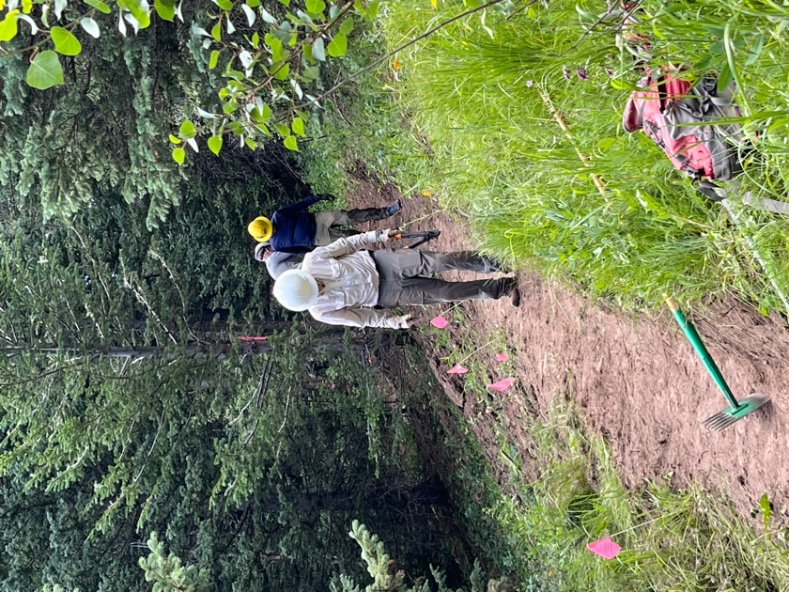 Bill works his section to perfection!

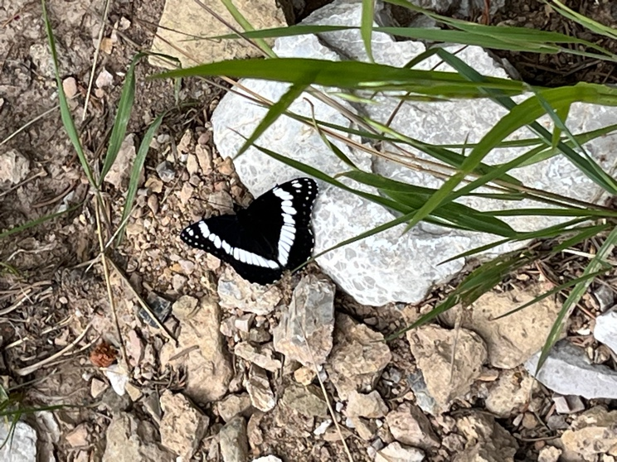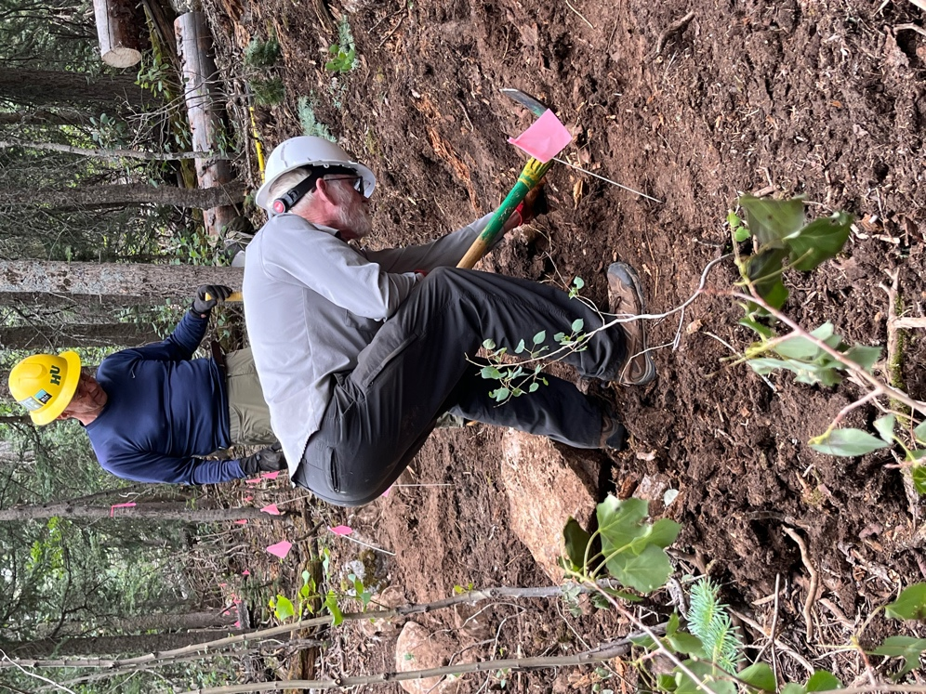

Spectators of all kinds. Scott and John move a giant rock to find…
There were several interested hikers. more rocks and roots.

So many flowers on the hike!! 