**Report of FOSM Project to Increase the Slope of Two Rain Collectors**

**in the Bernalillo County Ojito Open Space**

**near San Antonio on NM-14 on Wednesday, July 17, 2024**

Joelle Hertel, Dan Benton, and Sam Beard

On Wednesday, July 17, five FOSM volunteers completed the project to increase the slope of two rain collectors surfaces in the Bernalillo County Ojito Open Space. Water will now flow to the gutter at the lower edge of the collector and into the pipe leading to the large black plastic tank under the collector surface. From the tank the water flows to a float valve located in a small concrete trough where wildlife can drink water.

The objective of the project was to increase the slope of the metal roofing panels so that water would drain to the lower end. The screws in the upper end of the roofing panels were removed so that wooded shims could be placed between the metal panels and 2x6 wooden cross members of the frame supporting the panels. The upper end of the panels was raised 3 inches by slabbing a 2x6 onto the upper frame member. The thicknesses of the other shims in decreasing thickness were 2-1/2 inches, 2 inches, 1-1/2 inches, and 3/4 inch. The raised panels were reattached by inserting screws through the panels and shims into the frame cross members. Joelle had cut and fabricated the shims at her home before the project started, and this preparation allowed the crew to complete the project by noon.

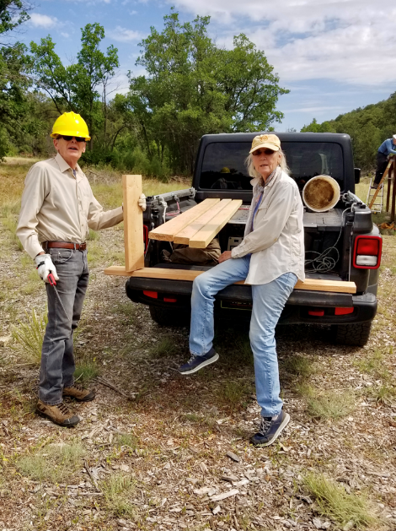

Sim Cook and Joelle Hertel are cutting a 2x6 to fit on the upper end of one of the structures.

The 10-foot length of 2x6 raised the upper end of the metal panels 3 inches.

Photo by Betsy Galloway

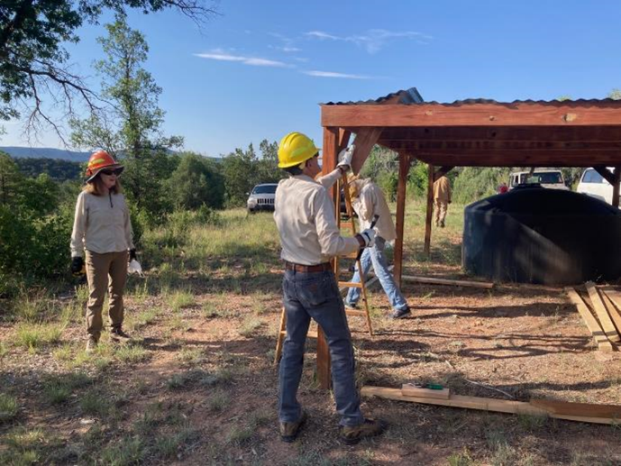

Betsy Galloway observing Sim Cook removing a brace on the upper collector.

L to R: Betsy Galloway, Sim Cook, Joelle Hertel, and Dan Benton. Photo by Cliff Giles

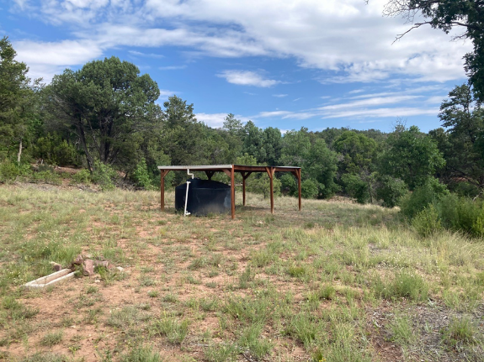

The upper collector with an increased slope on the roofing panels, the gutter on the lower edge,

the water storage tank, and the wildlife water trough. Photo by Cliff Giles

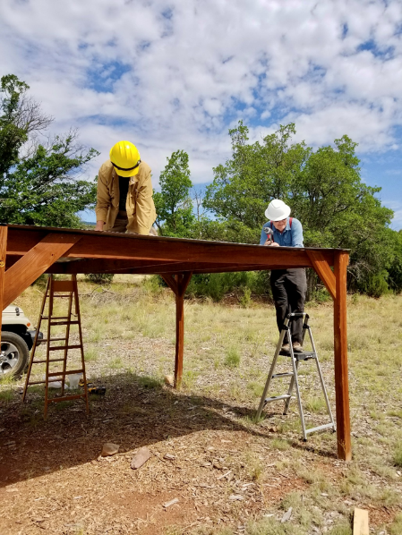

Dan and Cliff removing screws in the panels on the lower collector. Photo by Betsy Galloway

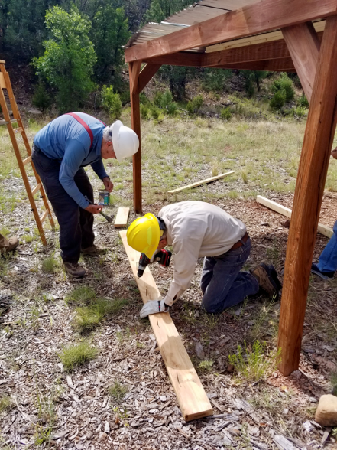

Cliff and Sim putting screws in the 2x6 to be installed on the lower collector.

Photo by Betsy Galloway

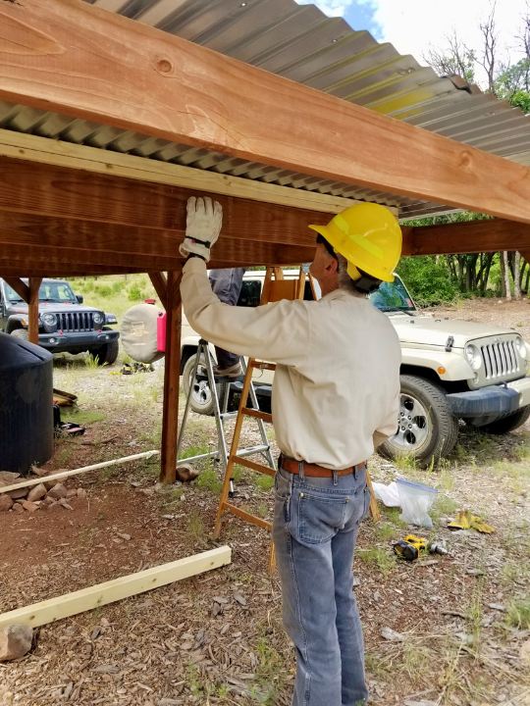

Sim installing a shim between the metal panel and a frame cross member.

Photo by Betsy Galloway

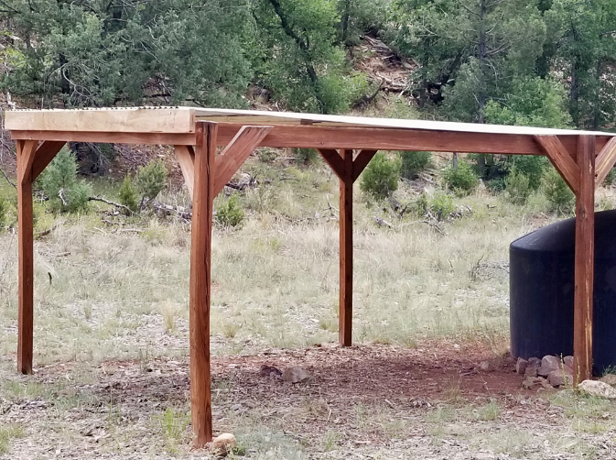

The slope of the panels on this lower collector has been increased. Note the 2x6 on the left end of the collector

that raised the upper end of the panels 3 inches. Photo by Betsy Galloway