Thursday, 07/25/24: Twelve volunteers and 3 SRD staff (Dorothy, Zay and Chris) continued work on one of the reroute sections of Ellis Trail. After a mile hike in everyone benched and moved brush. Lot of r & r- rocks and roots! The weather was beautiful and the smoke from wildfires was not too bad. The flowers were spectacular again and the grasses are making a nice show too.

Volunteers: Scott Sunde, Rich Feddersen, Steve Roholt, Mike Madden, John Braly, Luis Cuadros, Rich Fagioli, Byron Garner, Mackenzie Gibbs, Claudia Bergsohn, Becky Levinson and Laura Leon.

Pictures: Laura Leon

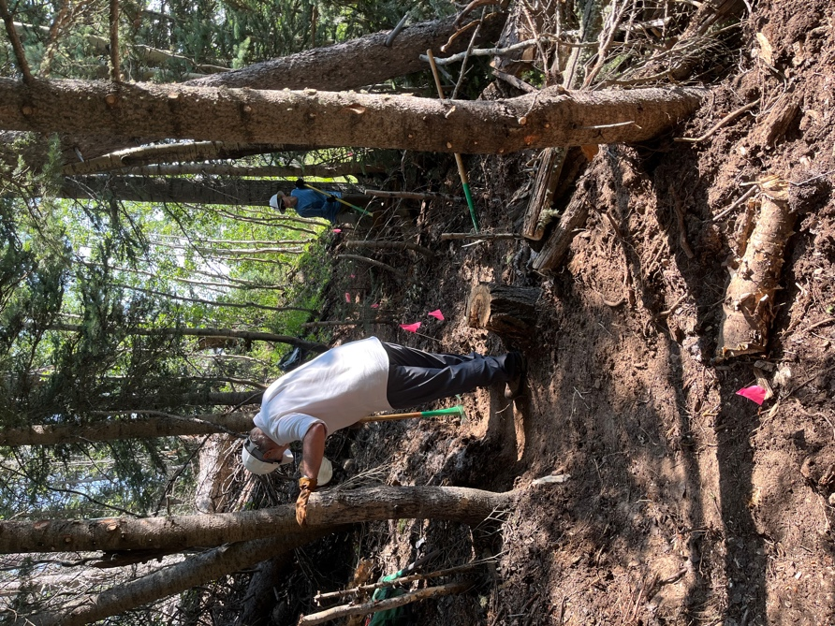 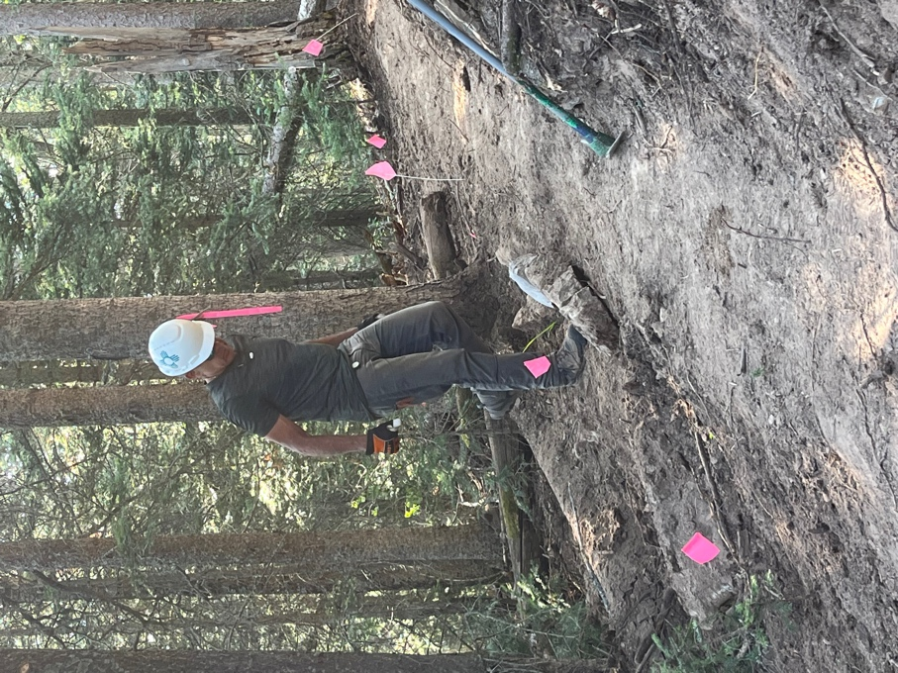

Rich and Becky add the finishing Luis sets a rock along the trail.

touches.

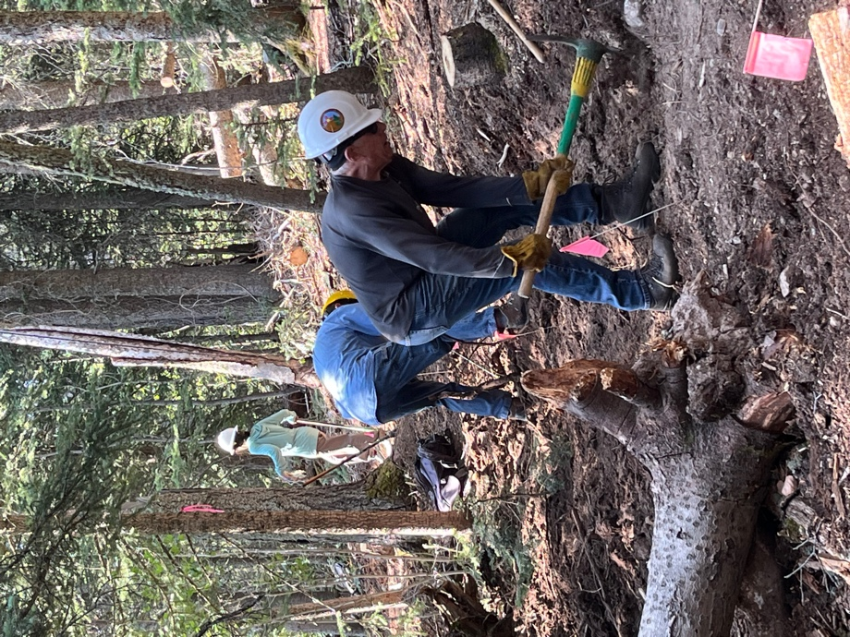 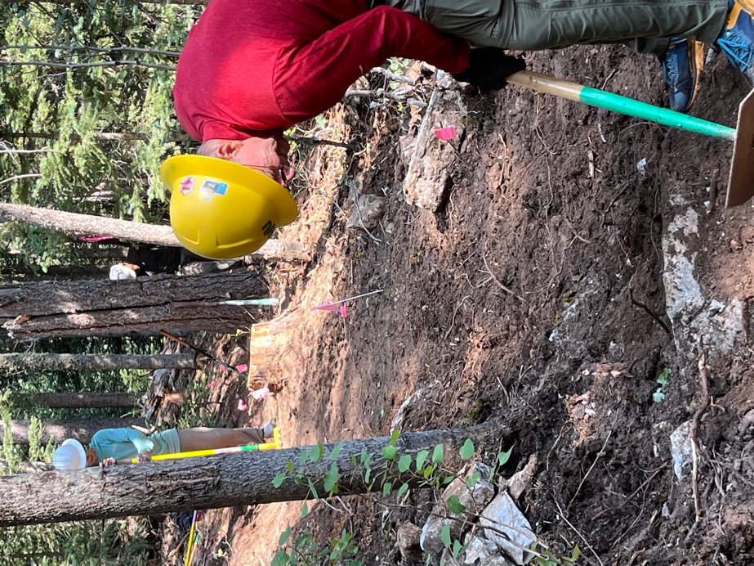

Steve, Rich and Mackenzie…… John and Mackenzie- everybody bench!

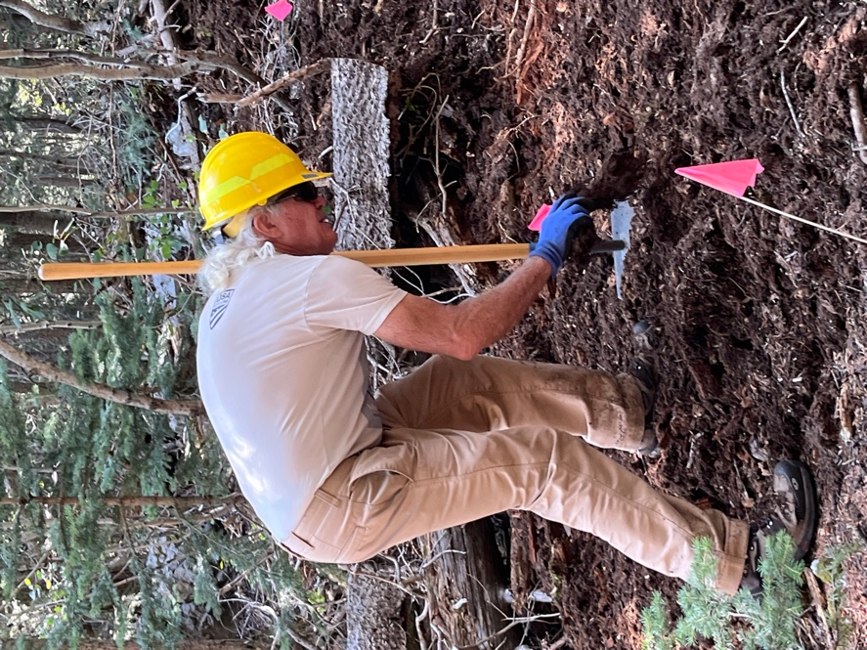 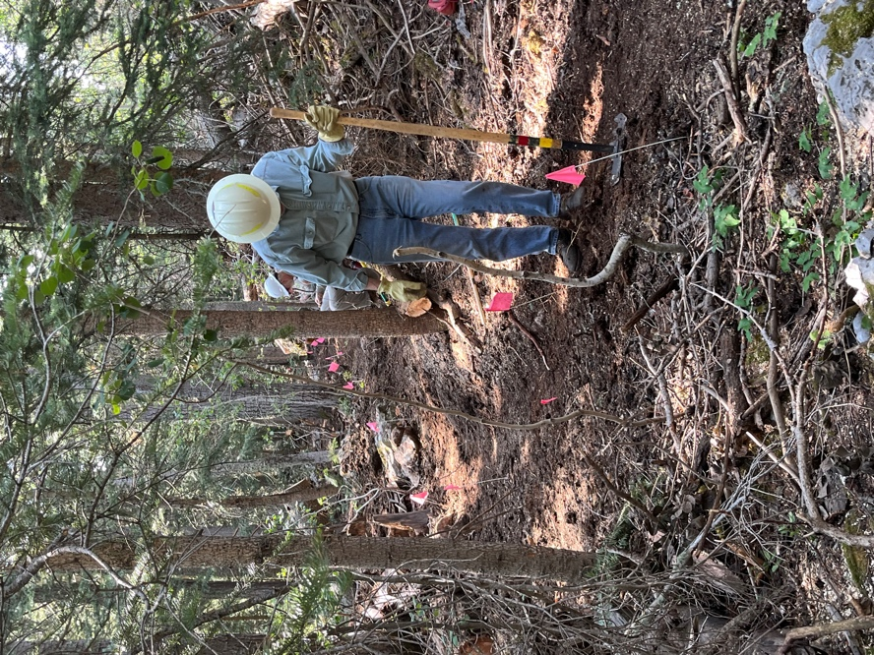

Mike clears and area. Byron making progress.

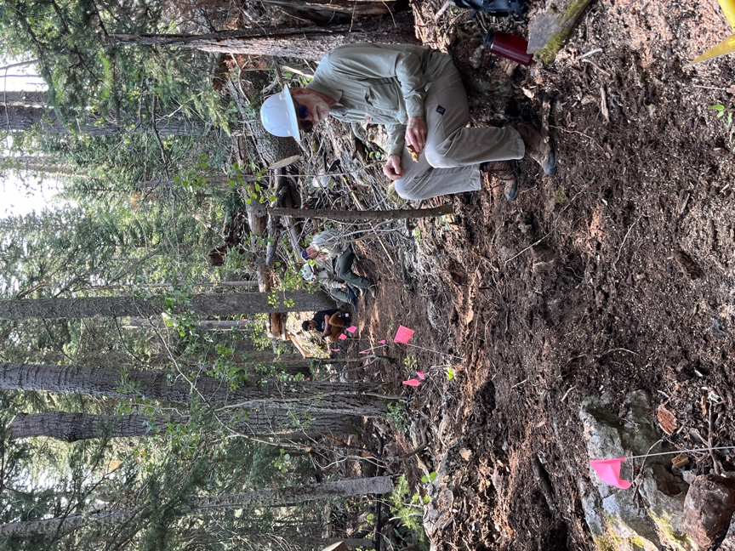 Scott and the SRD crew break for snack time

