**Report of FOSM Project to Fell Hazard Trees along 10KN Trail**

**and in Burned Area, Wednesday, July 24**

Sam Beard

On Wednesday, July 24, eight FOSM volunteers felled 13 hazard trees that were leaning toward 10KN Trail. The largest diameter was 21 inches. Hazard trees were felled in the area between the 10KN parking lot and the burned area. Hazard trees were also felled in the burned area located a short distance north of the parking lot.

Jerry Carroll mentored two A (apprentice) chain sawyers (Francis Algermissen and Jamey Browning) who had recently been certified. He covered chain saw operation, evaluating a tree to be felled, determining the lean direction, and making face cuts (notch) and final back cuts during which the tree falls.

The volunteers working on Wednesday were Jerry Carroll, Eric Russell, Dan Benton, Lou Romero, Sam Beard, Jamey Browning, Cliff Giles, and Francis Algermissen.

Project photos are presented below.

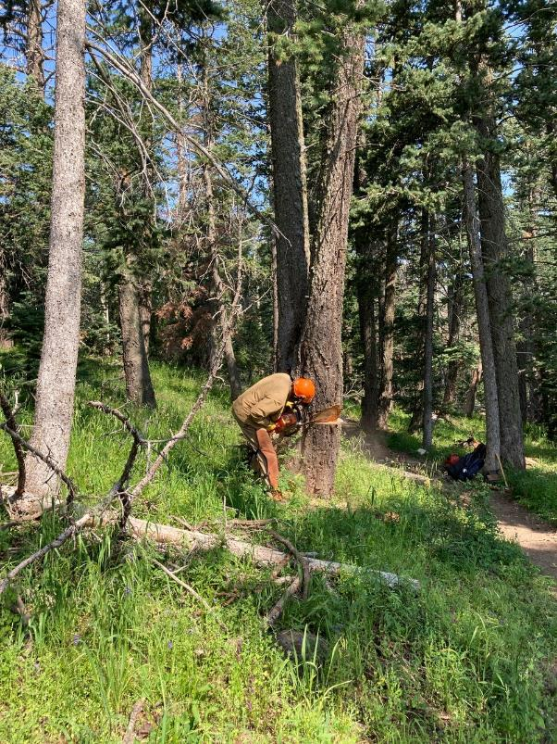

Dan Benton is making the face cut in this fir tree. All photos by Cliff Giles

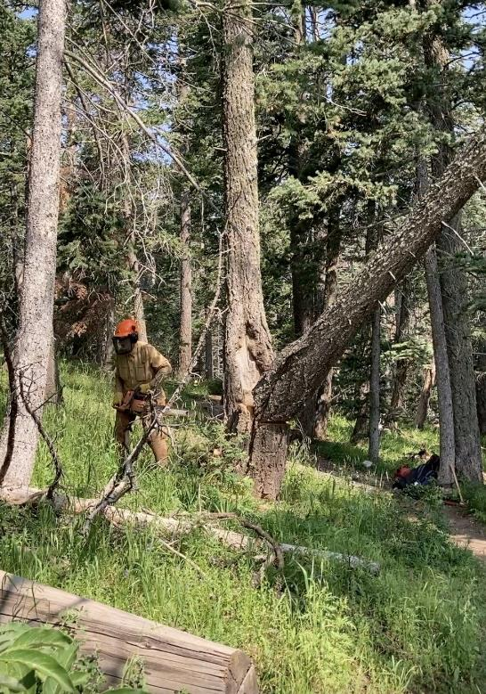

Dan is moving away from the tree as it falls.

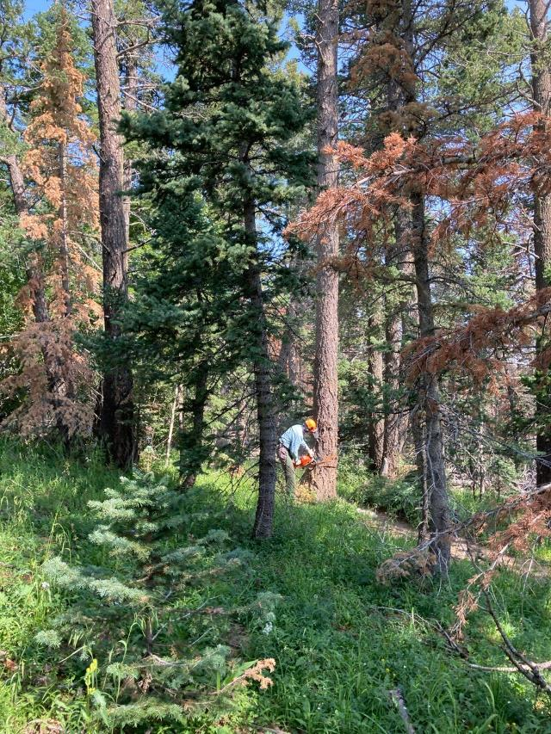

Eric Russell has almost completed the face cut in this fir tree.

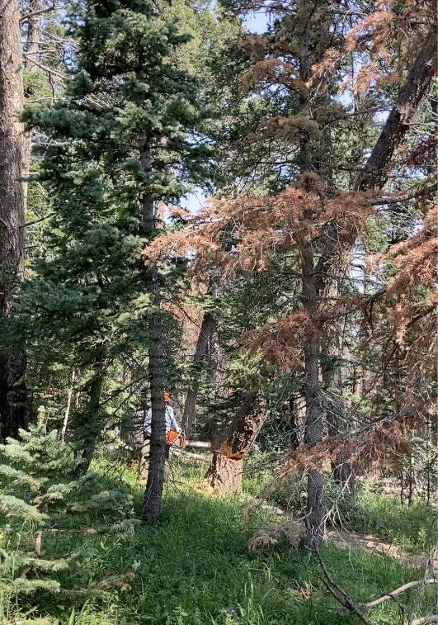

Eric is running away from the tree as it begins to fall.

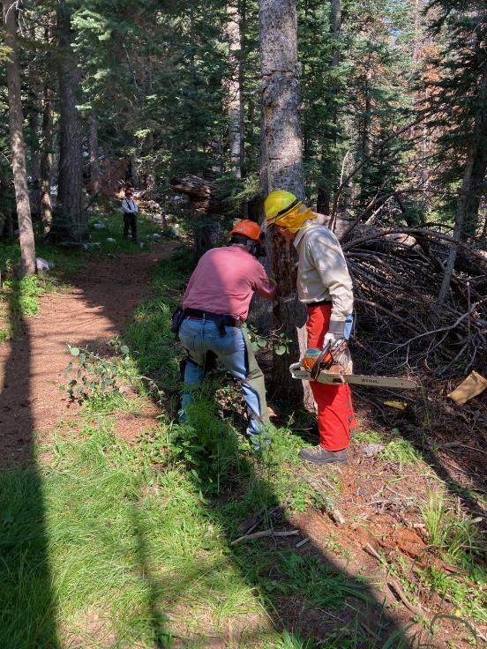

Jerry Carroll is explaining how to fell this tree to Francis Algermissen.

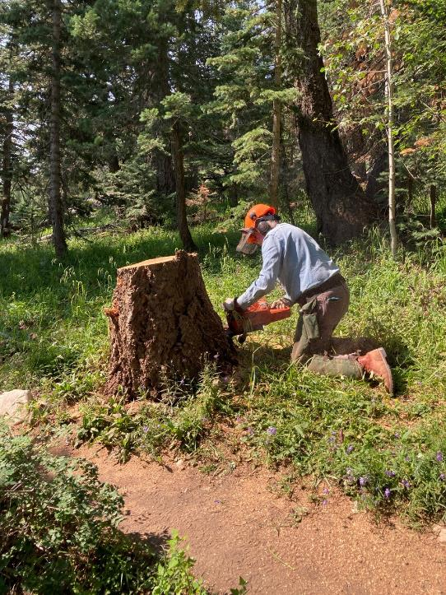

Eric is low cutting this stump.

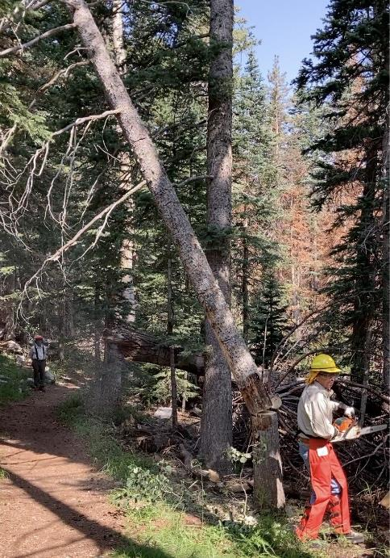

Francis is moving away from the tree that he has just felled.

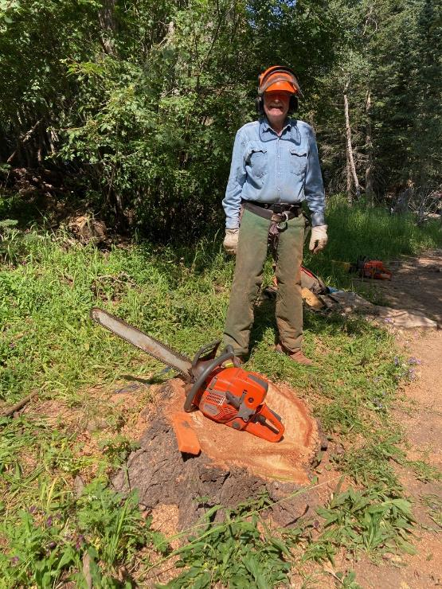

Eric has just completed low cutting this stump.

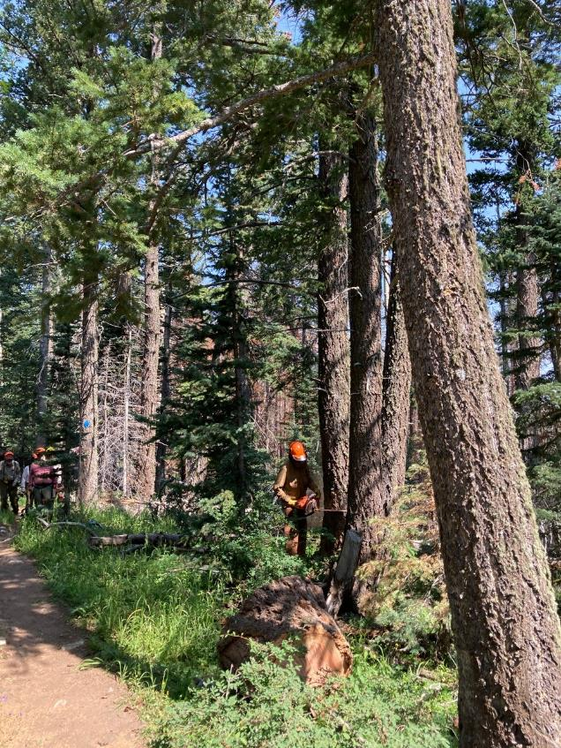

Dan is beginning the face cut of this tree that he is felling.

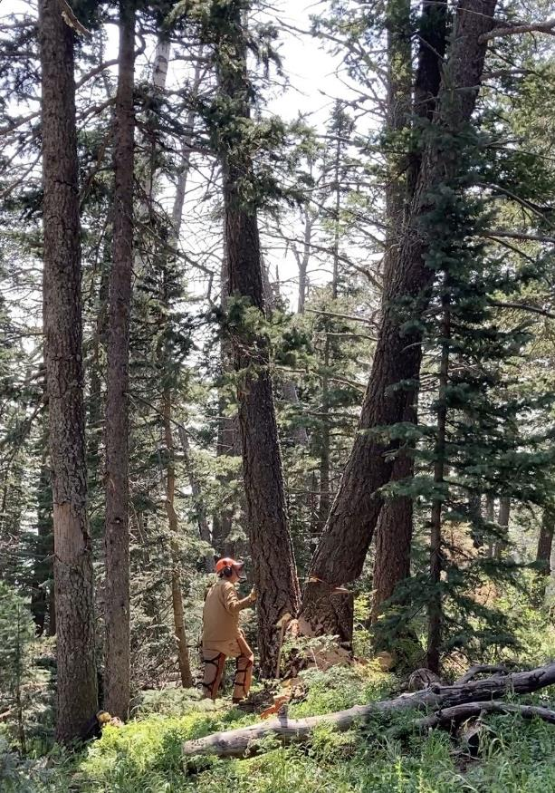

Dan has moved away from this tree that is just beginning to fall. The USFS considers “V” shaped forked

trees with bark between the two trunks to be two trees that grew adjacent to each other.

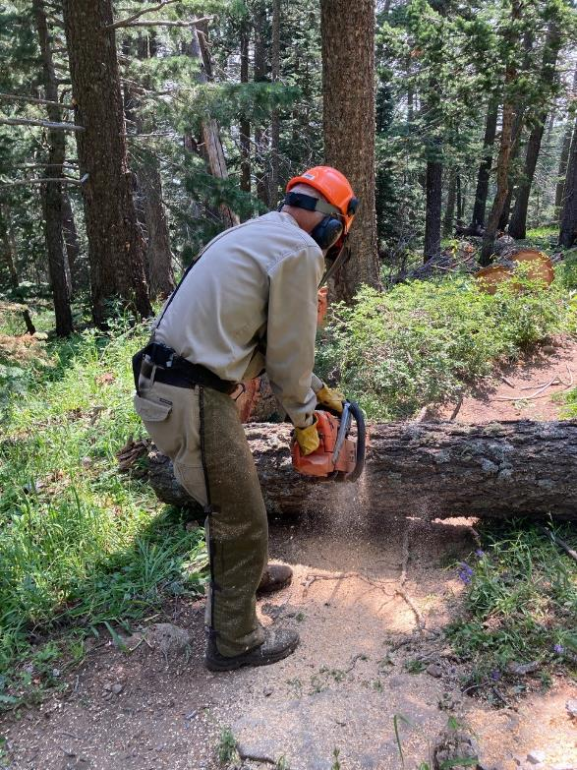

Sam Beard bucking a tree trunk that Dan just felled.

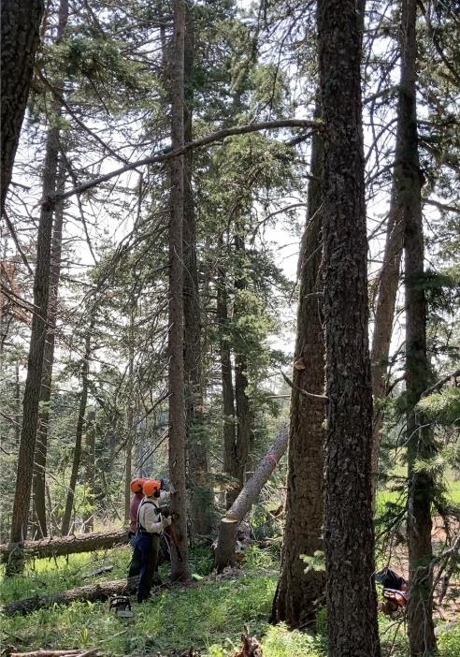

Jerry and Jamey watching a tree fall.

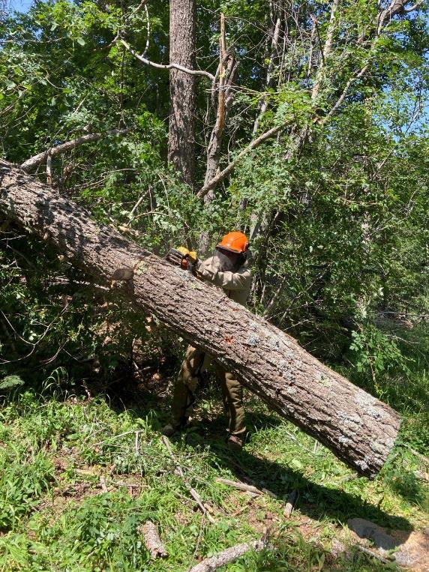

Sam bucking fir tree in order to get both ends of the trunk of the ground.

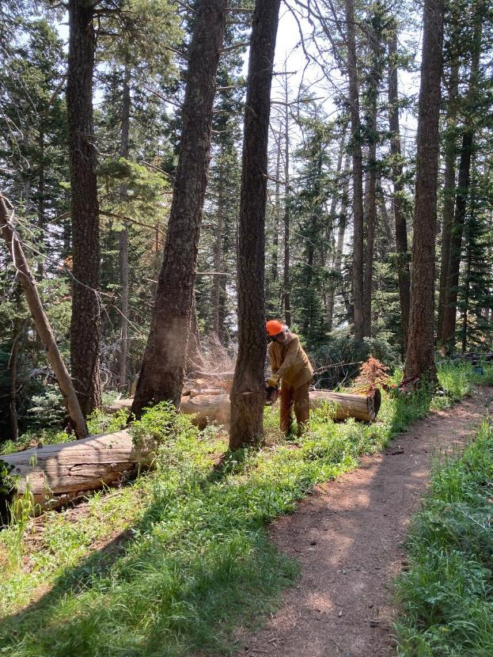

Dan felling another hazard tree leaning toward the trail.

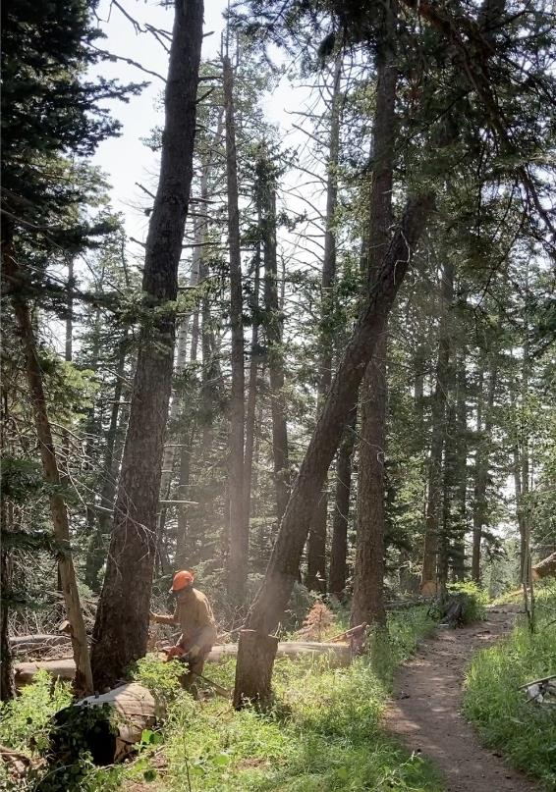

Dan running away from the tree as it falls.

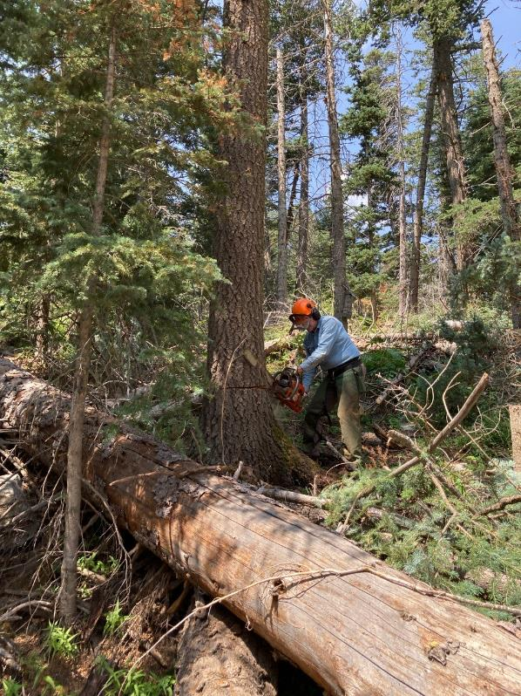

Eric making the face cut in another large tree.

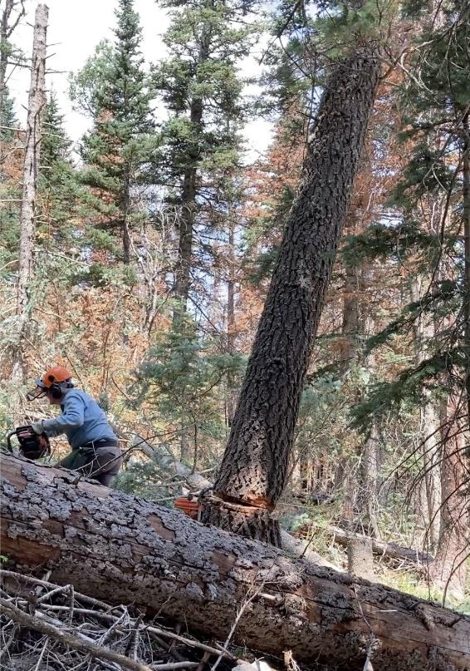

Eric runs away as the tree falls.

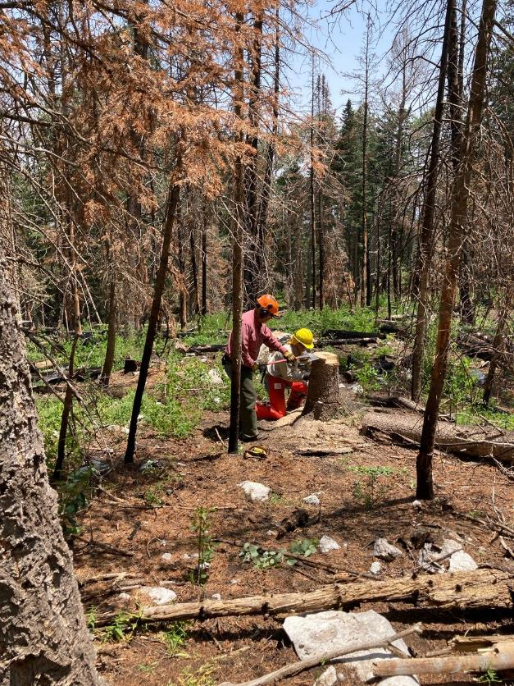

Jerry and Francis discuss the stump of a felled tree. Reading the stump reveals the thickness of the hinge wood,

the stump shot height, the diameter where the tree was cut, and the width of the face cut.

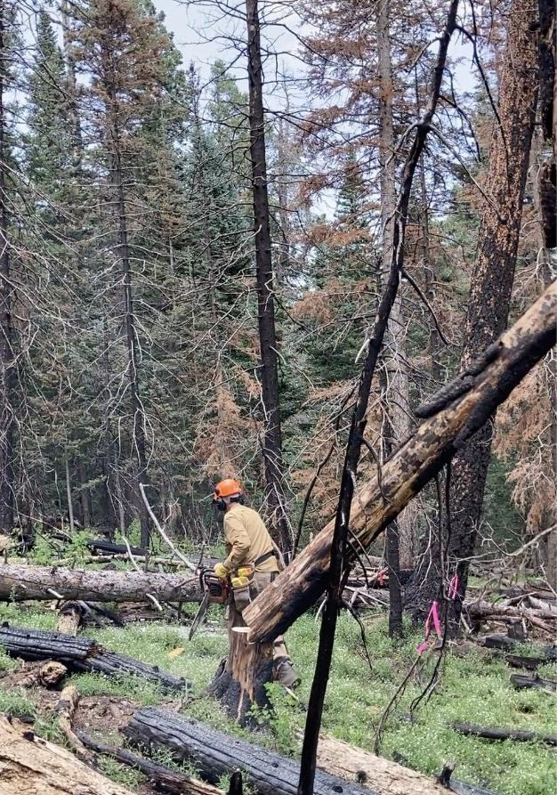

Dan running away from a burned tree that he has just felled.

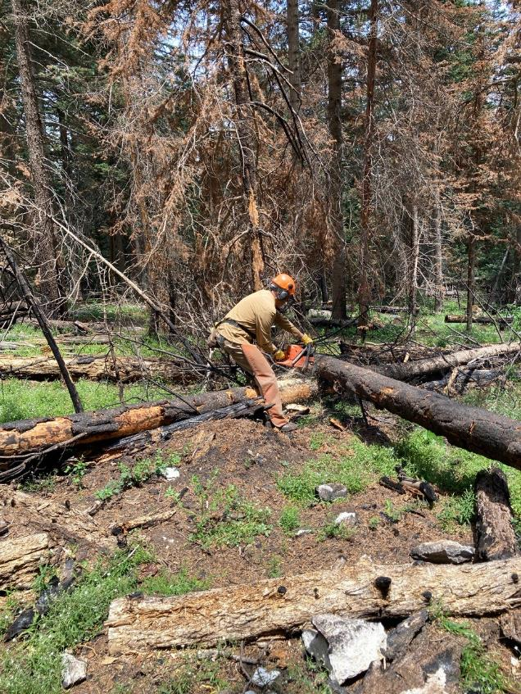

Dan bucking a log in the burned area.

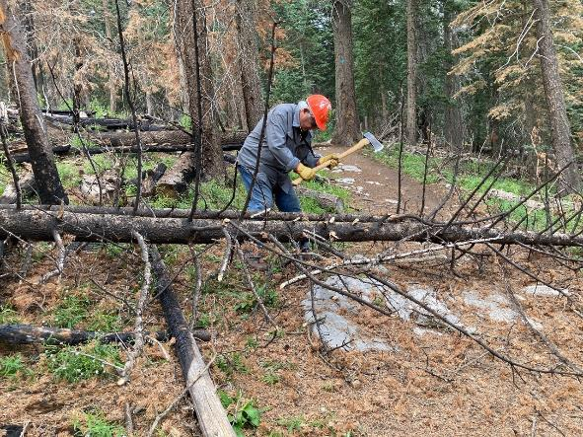

Lou Romero limbing a burned tree that has just been felled.

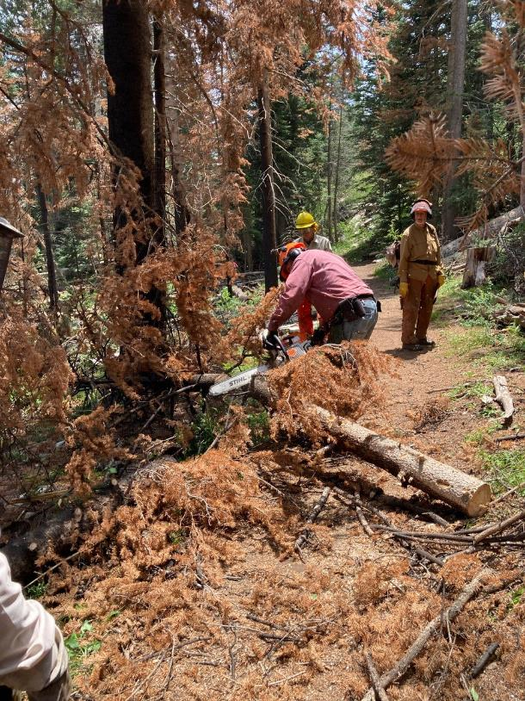

Jerry bucking a log while Francis and Dan observe.