Thursday, 08/01/24: A warm day on the mountain for 10 volunteers and Chris and Zay from the SRD. None the less, the team finished out just over 1100 ft of reroute #6 on the Ellis trail. The team moved from the pine forest into a meadow to link up with the original trail. We’ll be moving on to reroute #5 and #4 next week.

Volunteers: Bill Perkins, Bruce Hansche, Byron Garner, Claudia Bergsohn, Jim Houle, Laura Leon, Luis Cuadros, Mackenzie Gibbs, Rich Fagioli and Scott Sunde.

Photos by Laura Leon and Luis Cuadros.

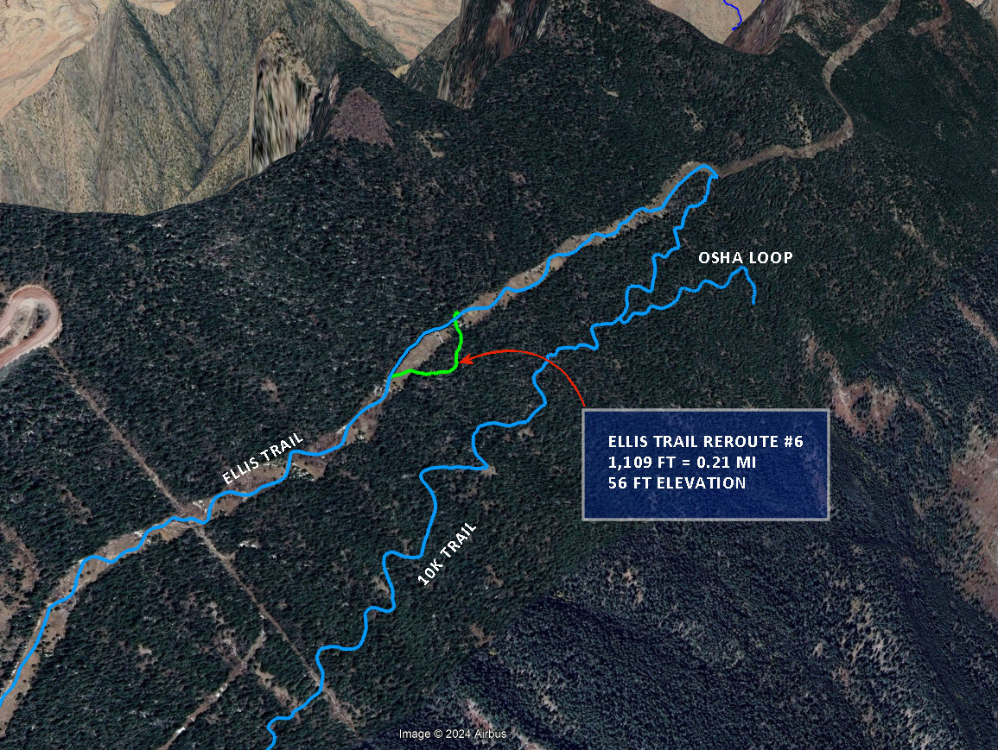

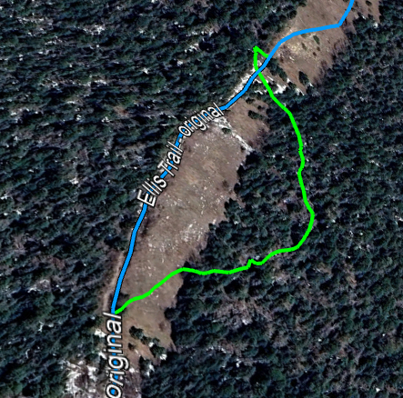
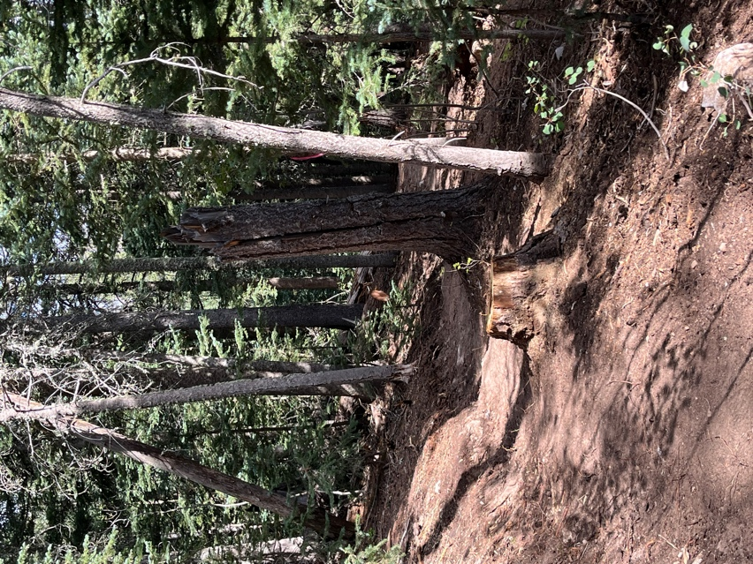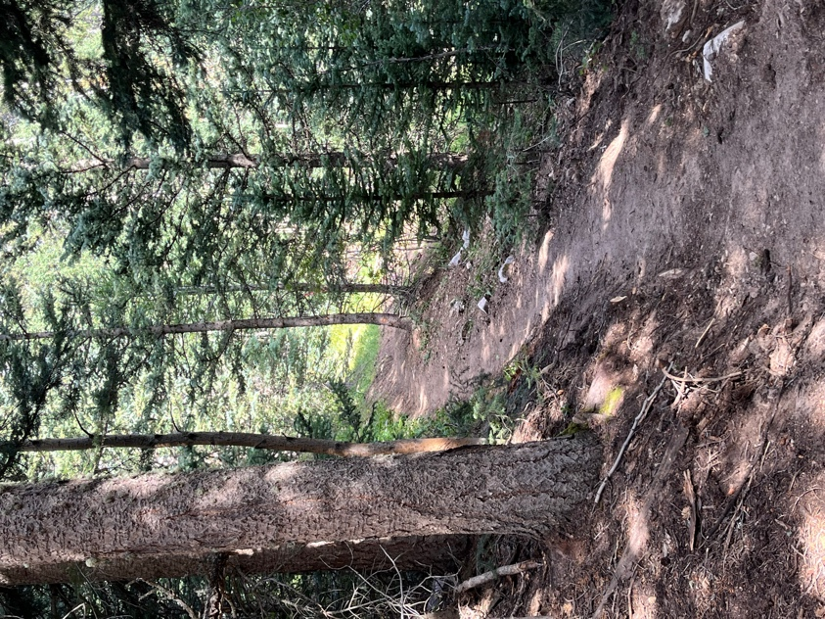

New trail cuts through the woods and off the rocky old road.
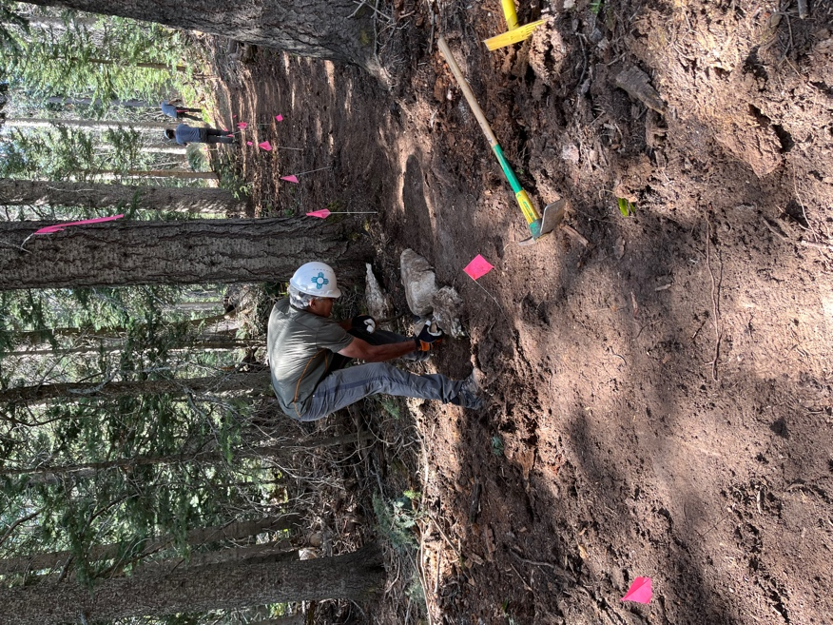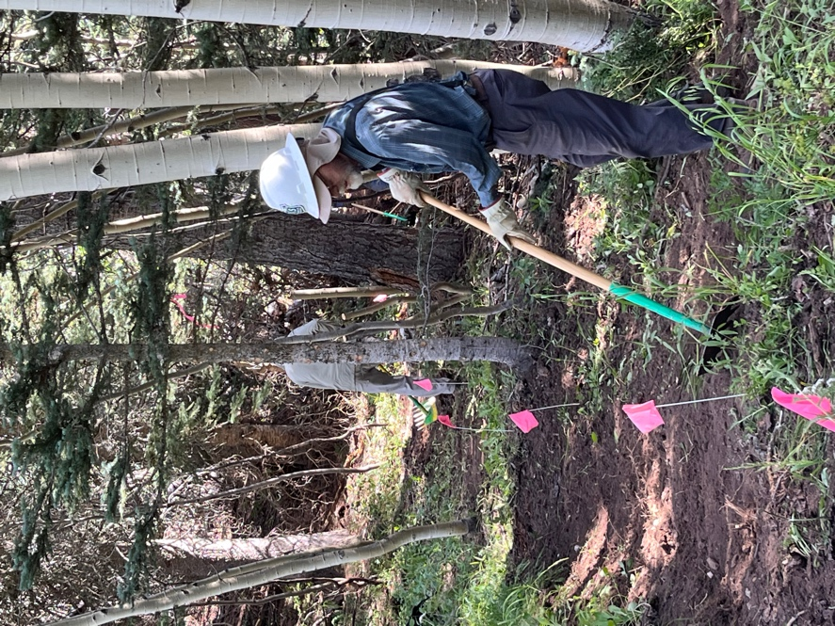

Luis playing with rocks again….. Bruce and Scott work on the edge of the woods.
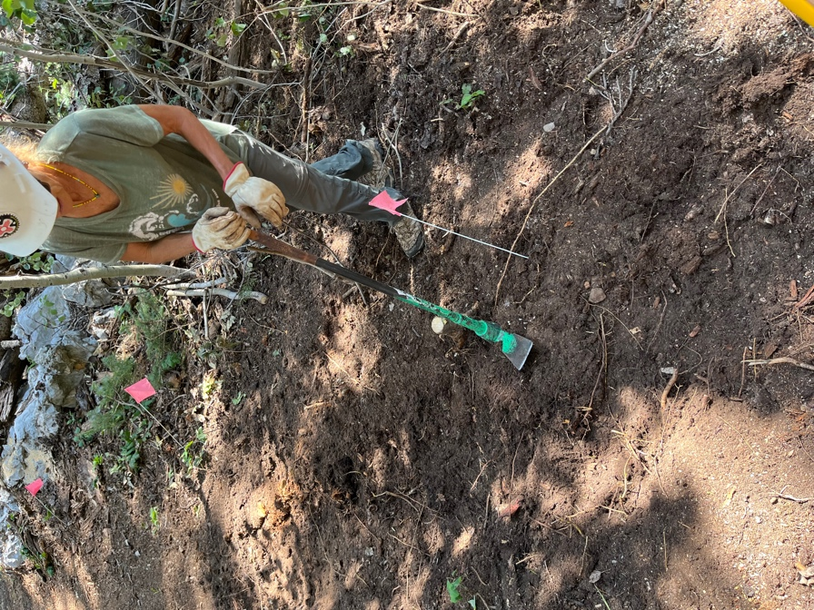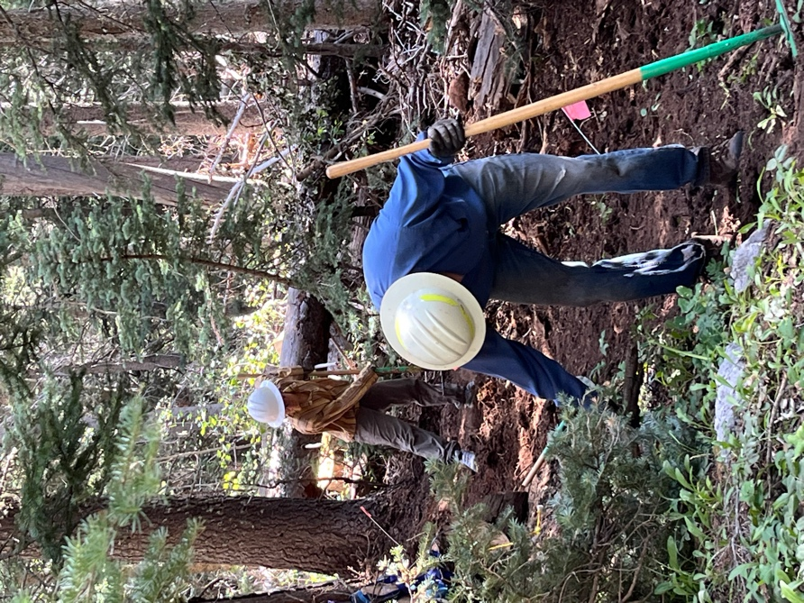

Claudia goes after a stump. Jim and Mackenzie work on slopes.

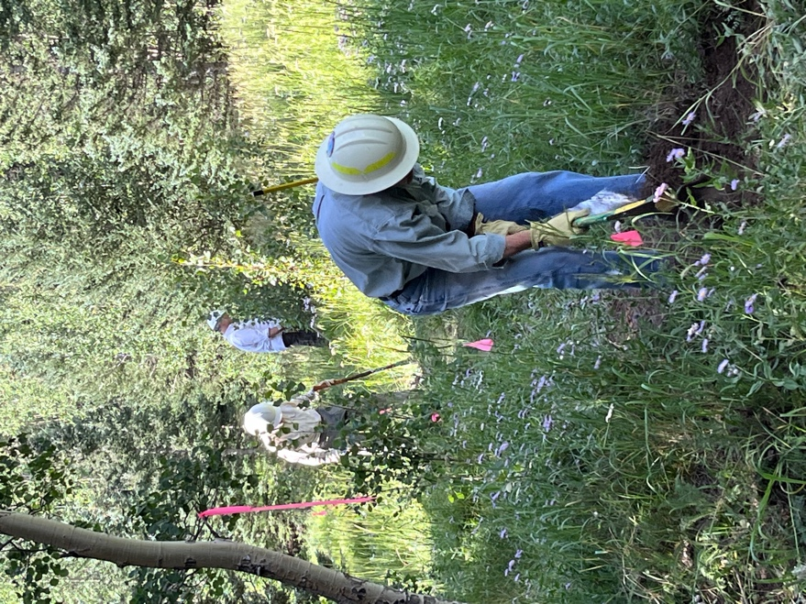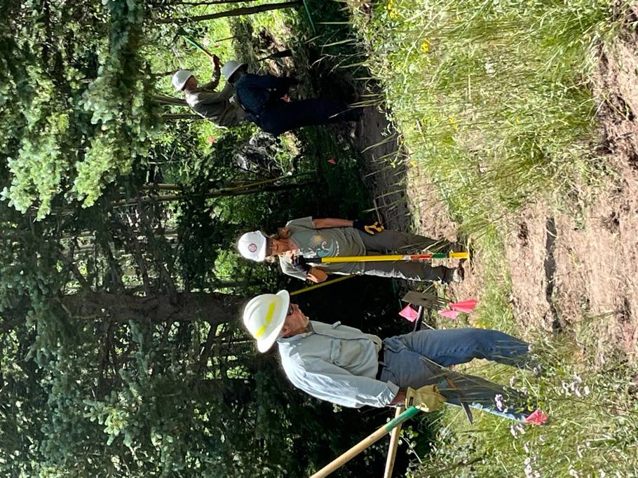

Byron, Bill and Rich head out of the Byron, Claudia, Bruce and Scott work
woods into the sun. near the old trail connection.

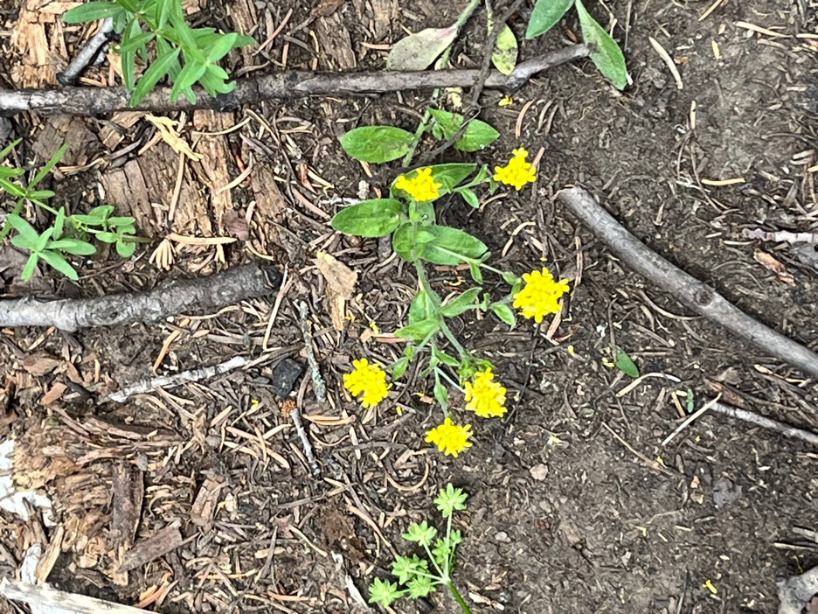 Little bit of sunshine….
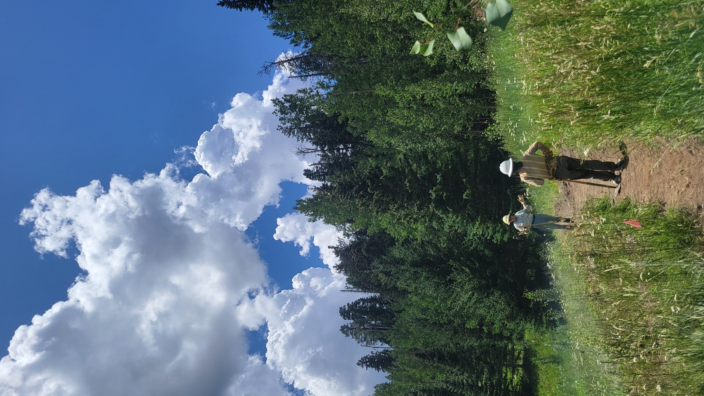

Byron and Mackenzie find common experiences in Tennessee!

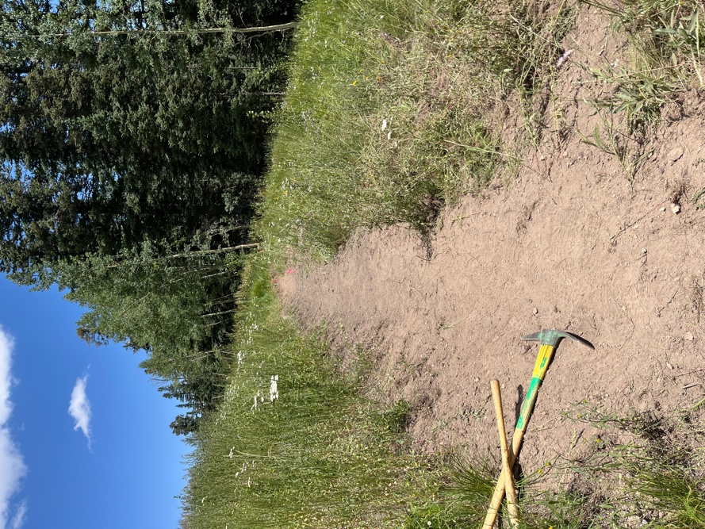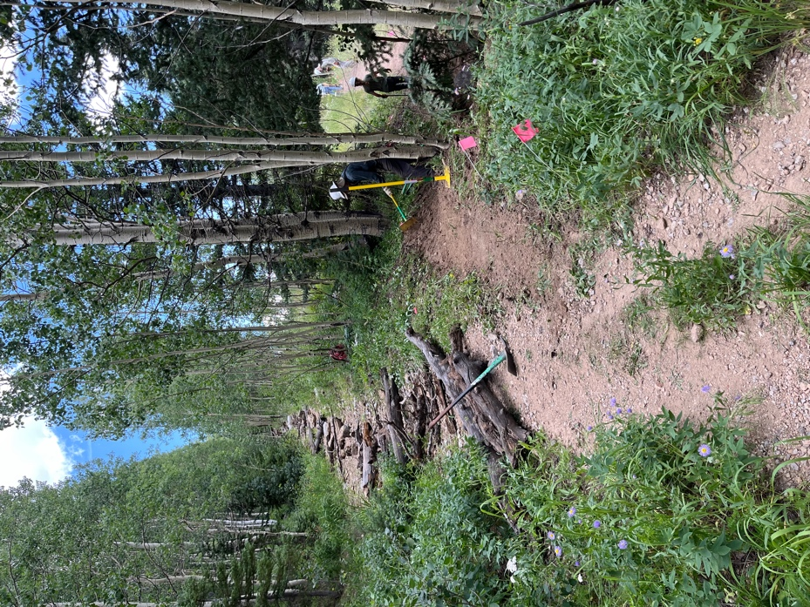

New trail leading into the woods. New trail connects with the old road.
The team obliterated the old trail.

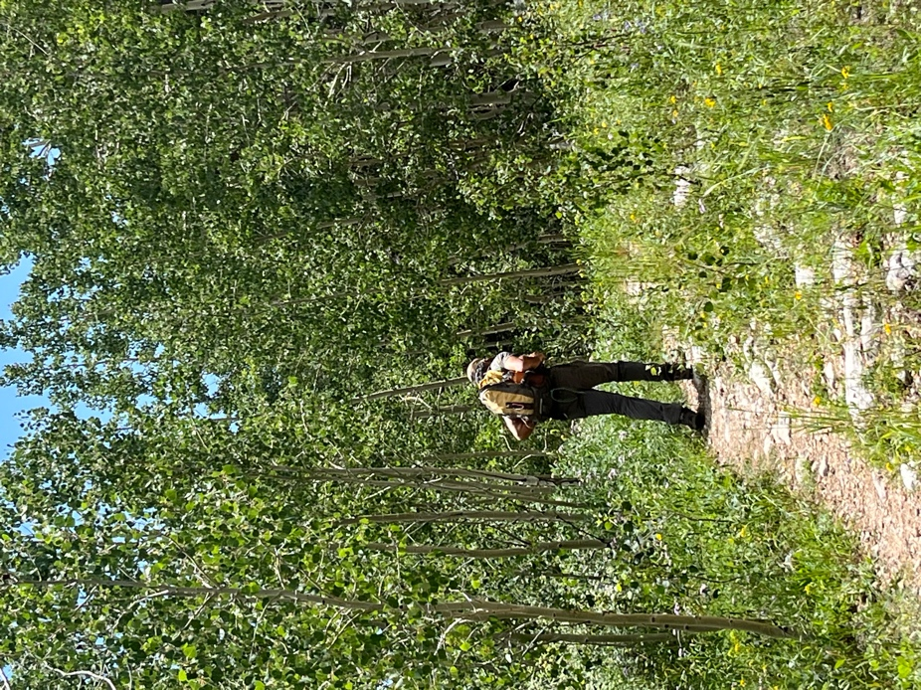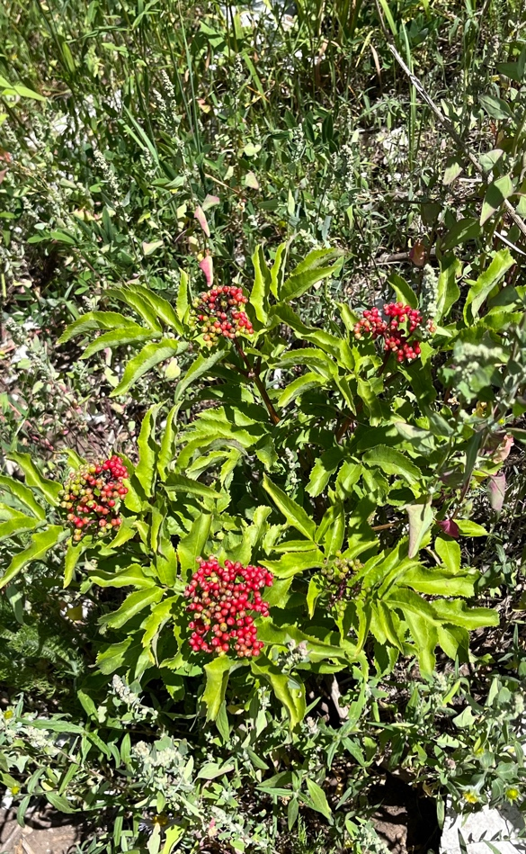

Heading back to the parking area. Always the beautiful flowers!

