**Report of FOSM Project to Remove Hazard Trees from Sandia Nordic Ski Club Trail near Dan’s Loop on Wednesday, July 31**

Sam Beard

On July 31, seven FOSM volunteers removed five hazard trees from a Sandia Nordic Ski Club (SNSC) Trail near Dan’s Loop on the Crest Highway between 10K Trailhead and Ellis Trailhead. From Dan’s Loop, we hiked across the Crest Highway and Challenge Trail to the trail where the five dead trees were located.

One of the objectives was to have Scott Dietrich and Sim Cook do most of the cutting for practice, because they were recently certified for the first time as USFS chain sawyers. Jerry Carroll mentored them in all aspects of tree felling – analyzing the tree for various properties including lean, making a face cut in the direction that the tree would be falling, making a back cut to make the tree fall, running away from the falling tree, reading the stump to learn hinge wood thickness and other properties of the cut, limbing the log, bucking the log into pieces small enough to handle, and cutting the stump lower for better forest appearance.

The five hazard trees were felled safely, and the bucked trunks was moved off of the trail.

The other volunteers at the site were Cliff Giles, Don Carnicom, Lou Romero, and Sam Beard.

Project photos by Cliff Giles are presented below.

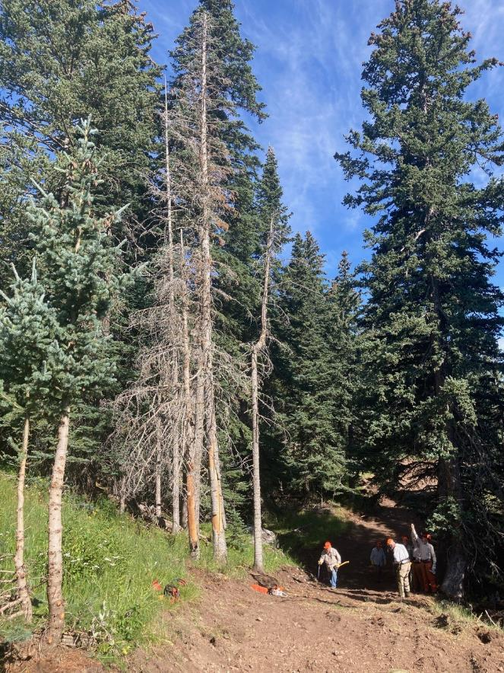

The five dead trees beside a trail recently graded by Sandia Nodic Ski Club volunteers.

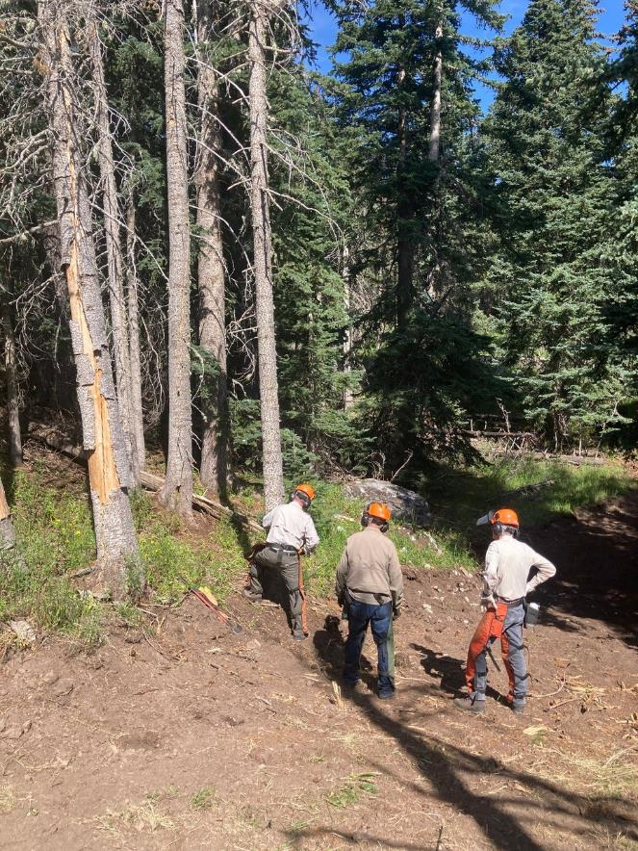

Scott making the face cut in this 8-inch cork bark fir tree.

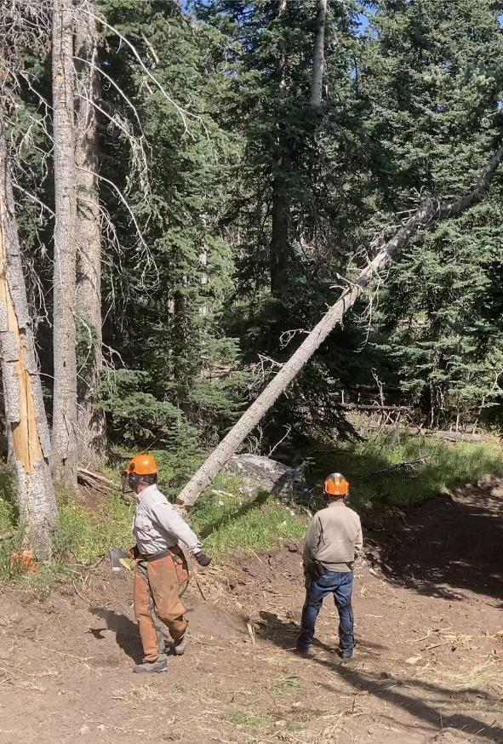

Scott running away from the falling tree.

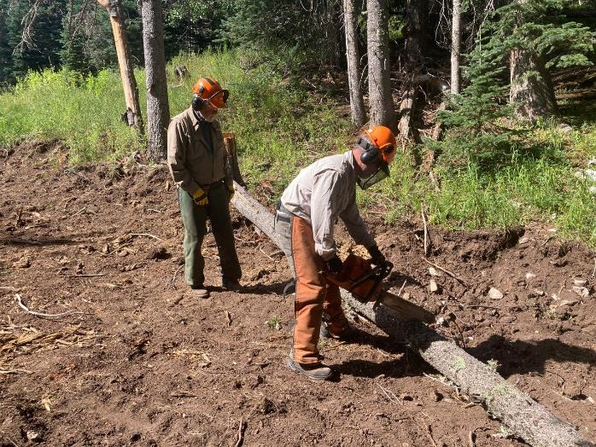

Scott bucking the felled tree with Jerry observing.

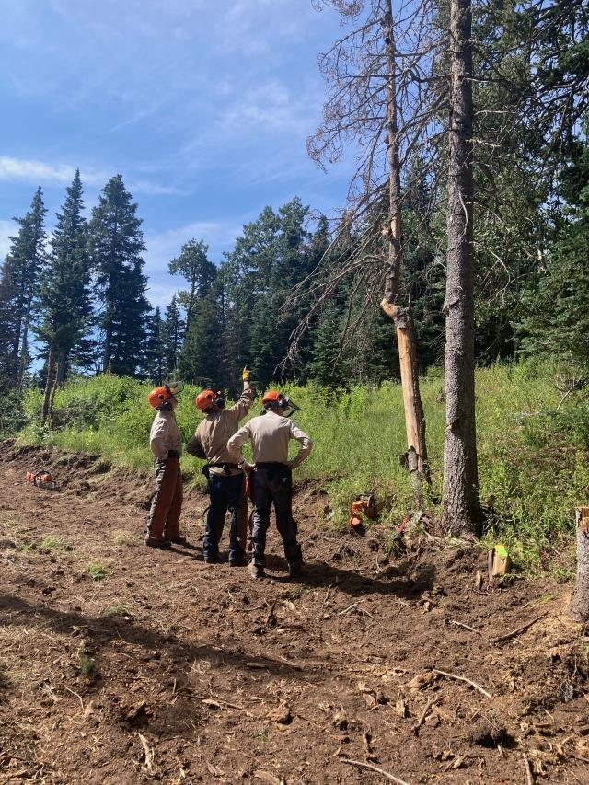

The group analyzing the next tree to be felled. Finding the lean direction

is one of the important properties to define.

si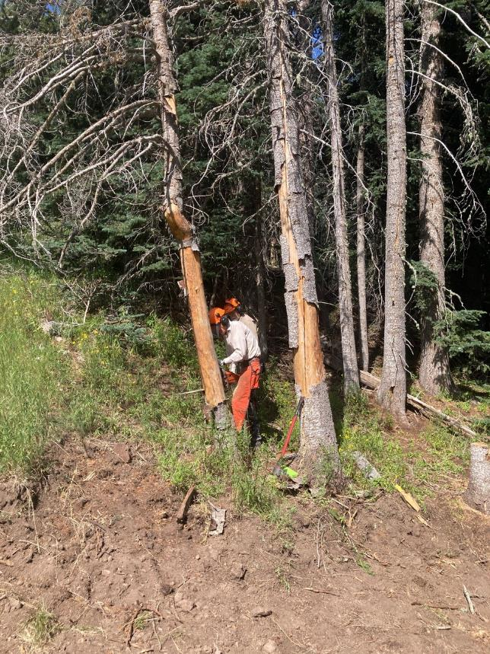

Sim making the face cut in this small cork bark fir tree.

si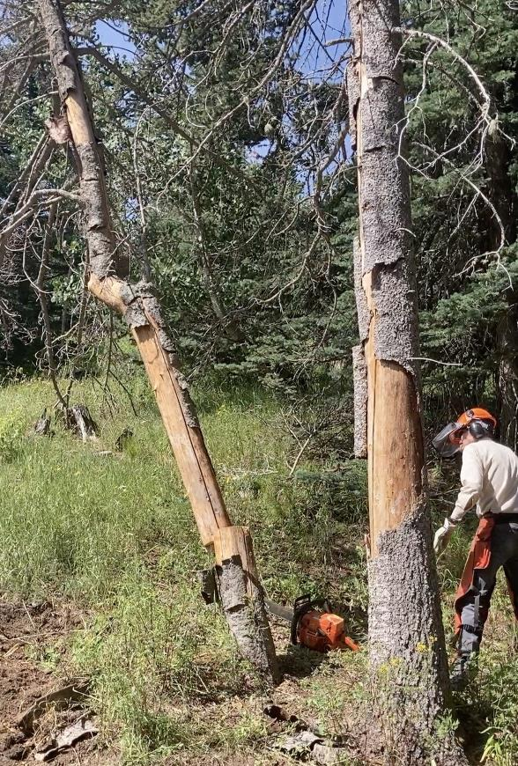

Sim running away from the falling tree.

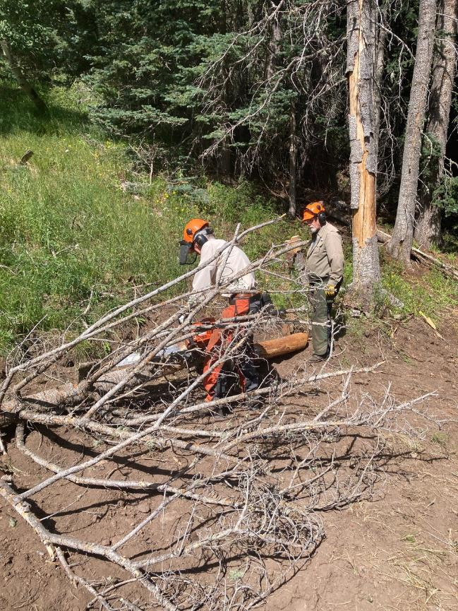

Sim limbing the tree he just felled.

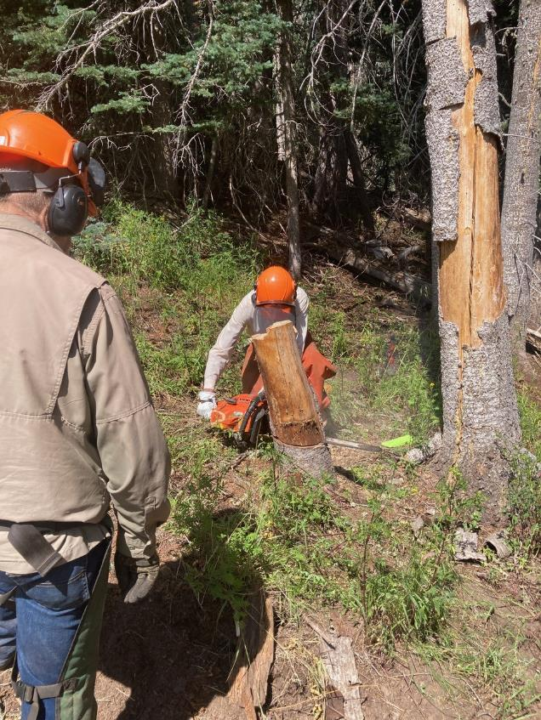

Sim cutting the stump lower.

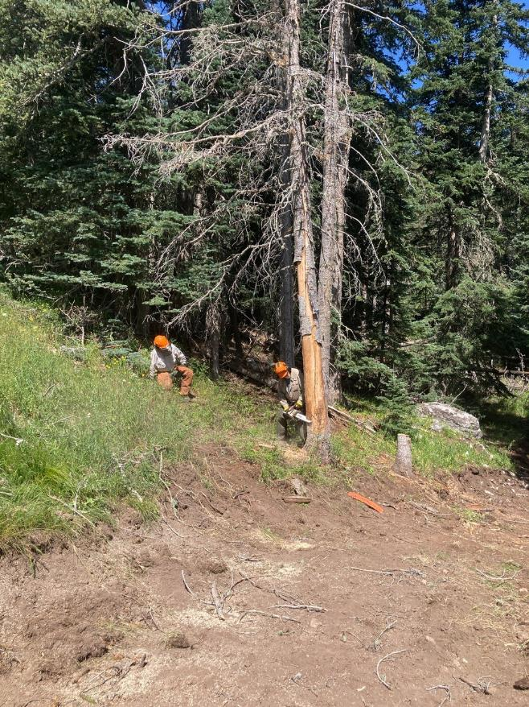

Jerry making an open face cut in this tree.

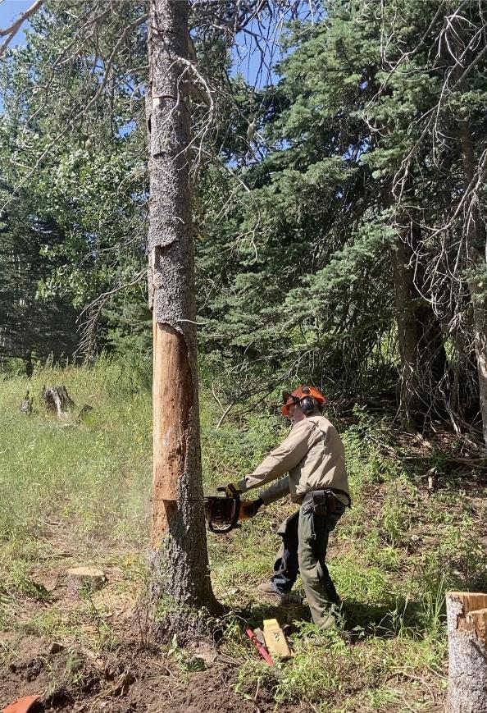

Jerry completing the back cut just before the tree felled.

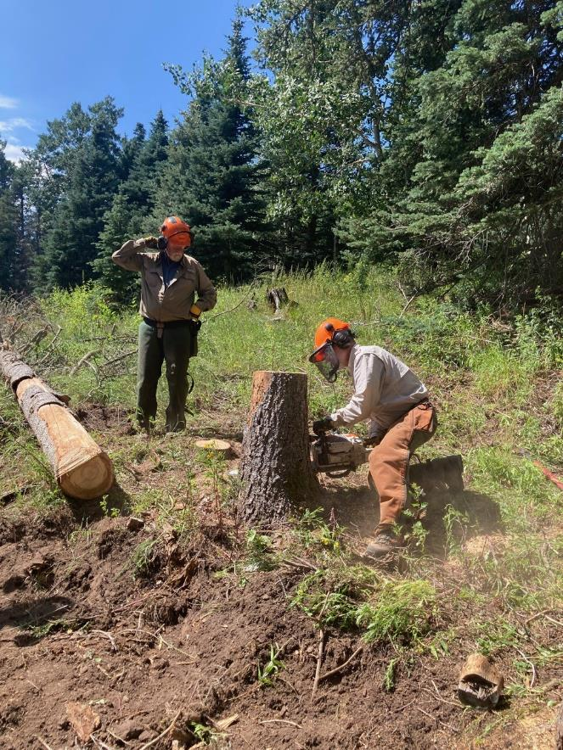

Scott low stumping this tree.

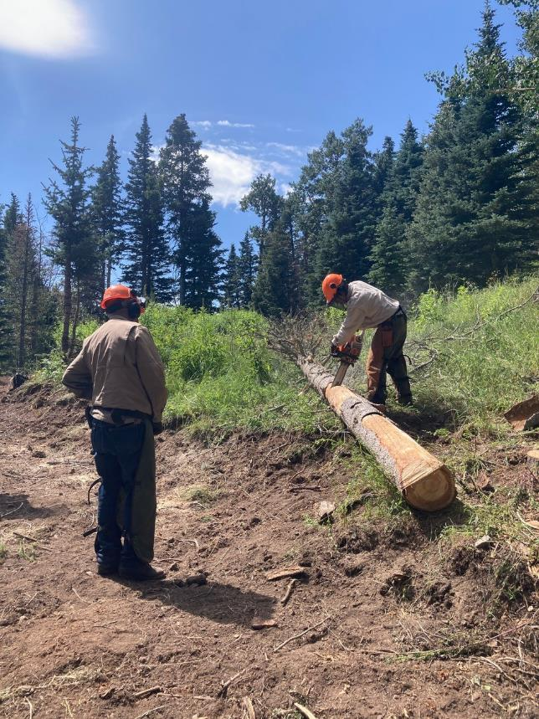

Scott bucking the trunk of the tree that Jerry just felled.

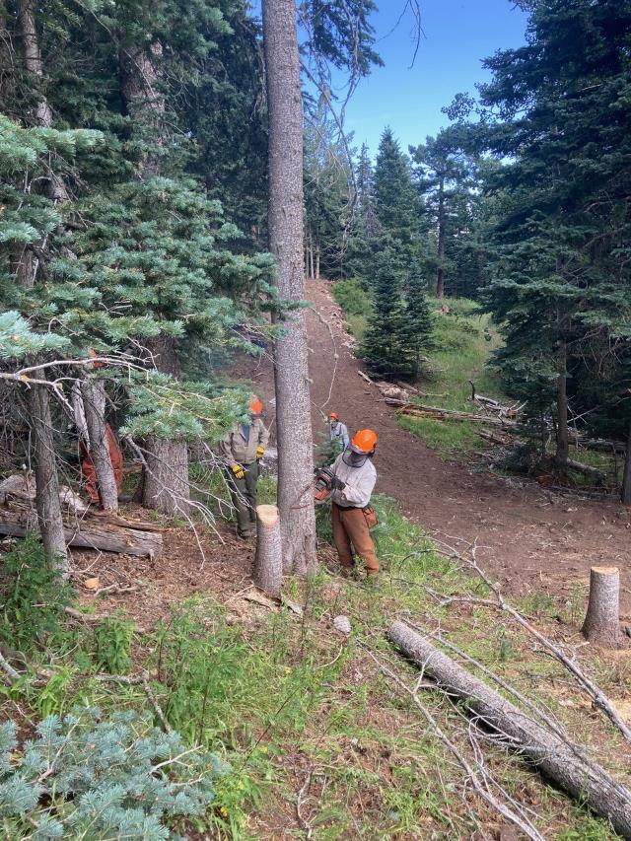

Scott making the face cut in this dead cork bark tree. It is easy to see the horizontal cut and

angle face cut to create a notch in the direction that the tree will fall.

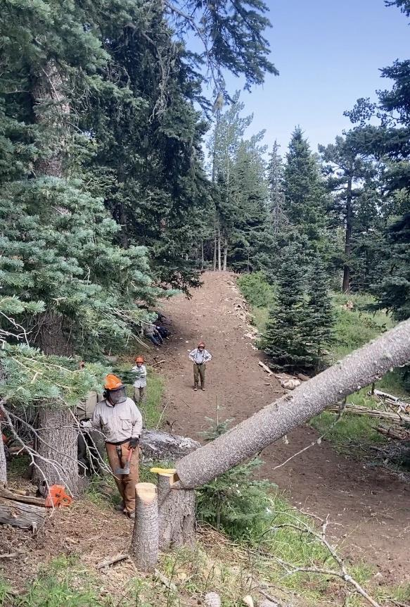

Scott’s tree is falling across the trail after he used a wedge to make it fall.

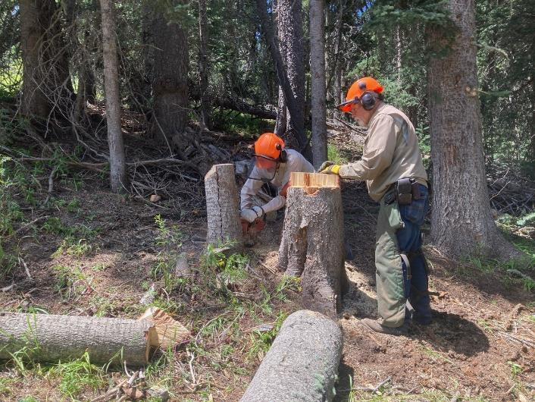

Sim is low stumping this tree.

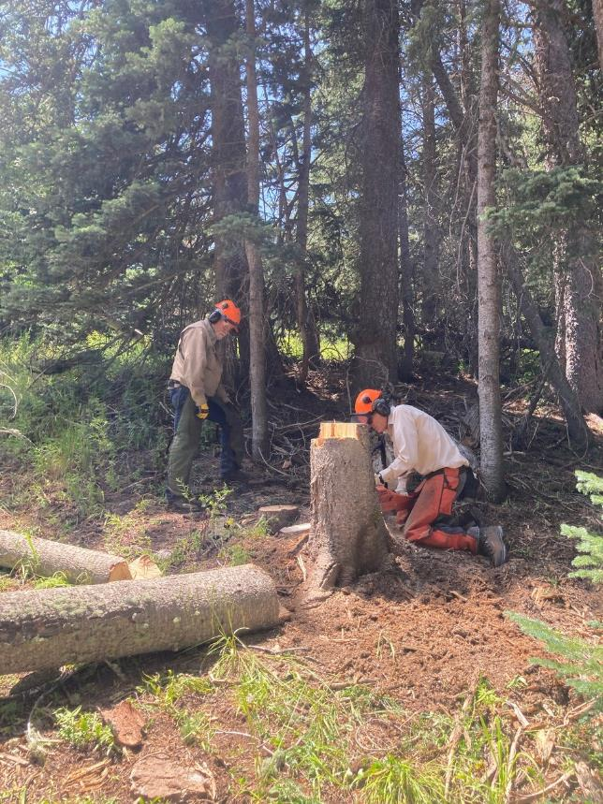

Sim is low stumping the tree that was larger.

si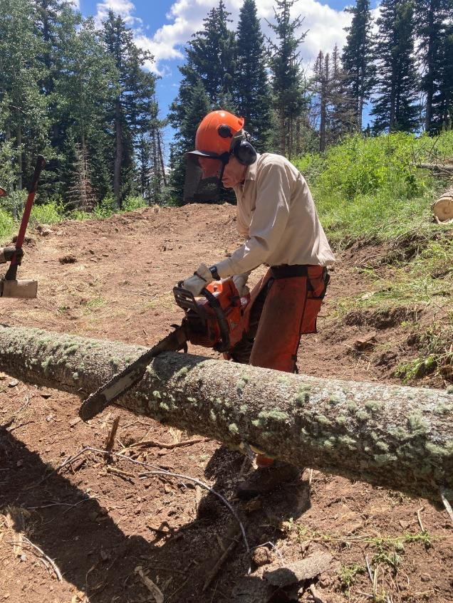

Sim bucking the tree that fell across the trail.