Thursday, 08/08/24: Eleven volunteers and Jen from SRD headed back to the Ellis Trail reroutes. Chris, Zay and Dorothy of SRD fame went back to Ellis reroute #6 to do some finishing work. There were lots of deer along the road on the drive up the mountain and it was a cool and comfortable start to the day. Discussions on the way to the work site included numerous topics including Koi, politics, the start of school, the Olympics (why isn’t cross country running part of the Olympics??) and the new bike ordinance. We started work on the #5 reroute and work was going well but we had to leave an hour early due to thunder and gathering clouds. We shall return!

Volunteers: Jim Houle, Laura Leon, Bill Perkins, Byron Garner, Claudia Bergsohn, Eric Russell, John Braly, Luis Cuadros, Roland Stumpf, Scott Sunde and Rich Fagioli.

Pictures by Laura Leon.

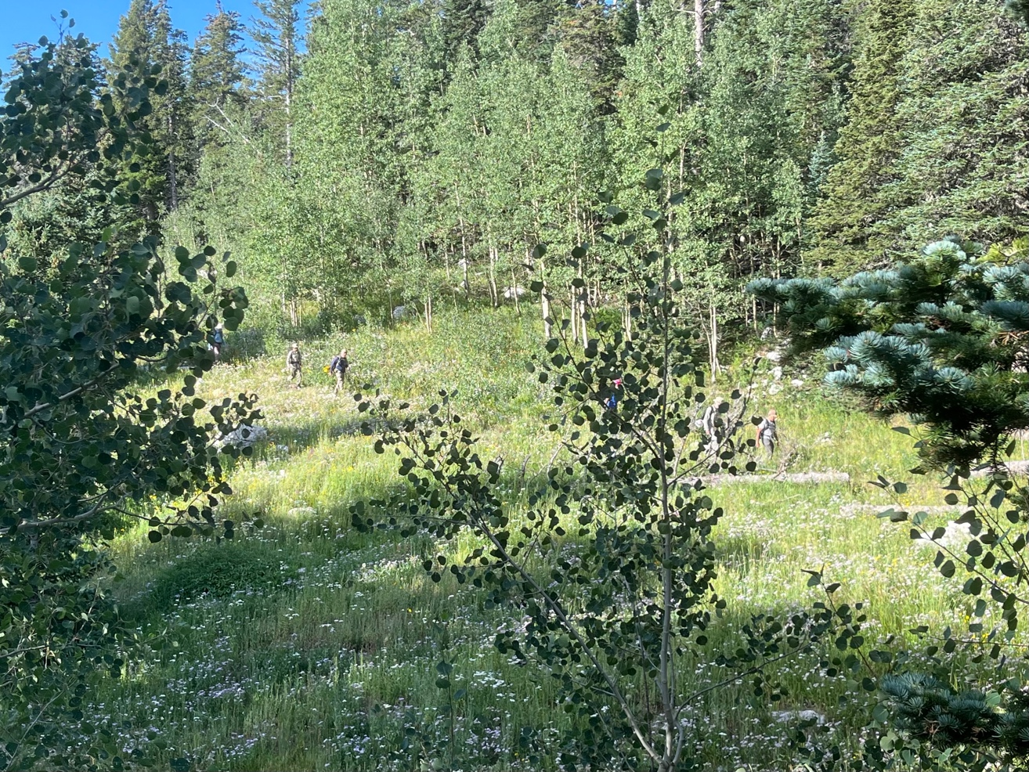

Hiking in.

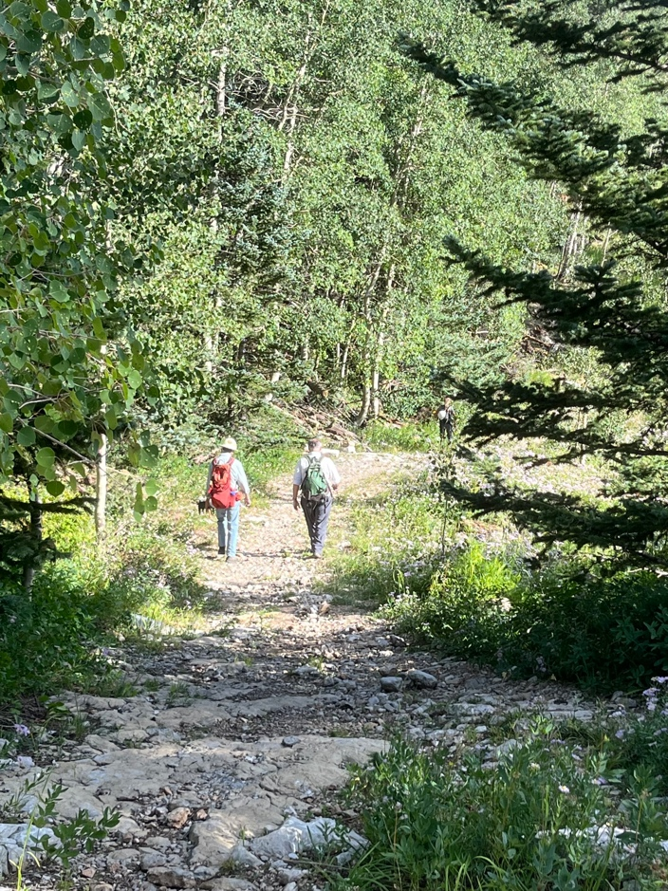 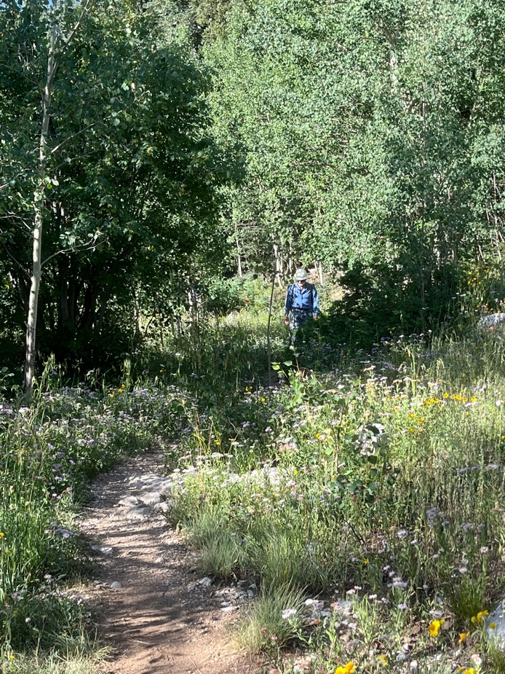

Still lots of flowers although they are starting to move past full bloom.

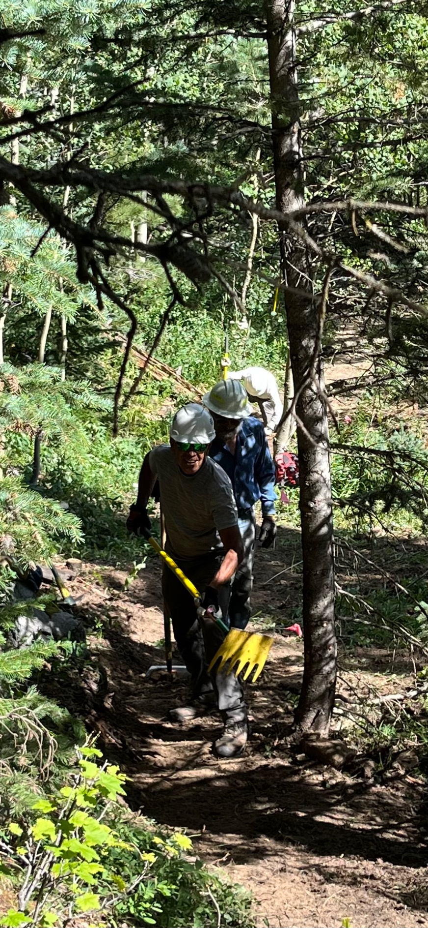 Luis, Jim and Bill work on tread.

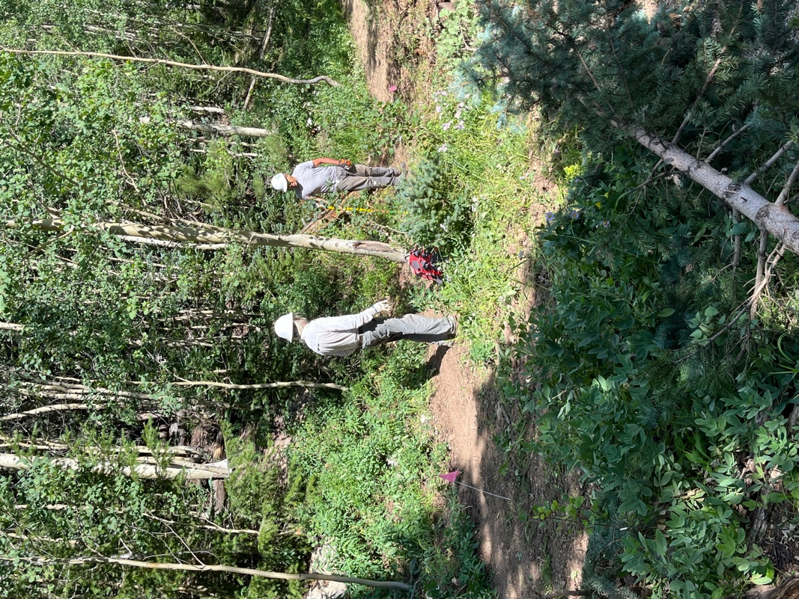 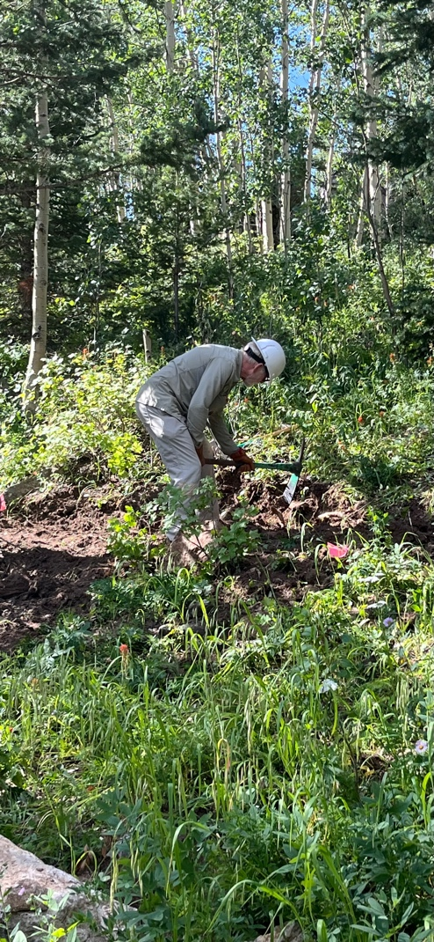

Luis and Bill look over the trail work. Scott digs away.

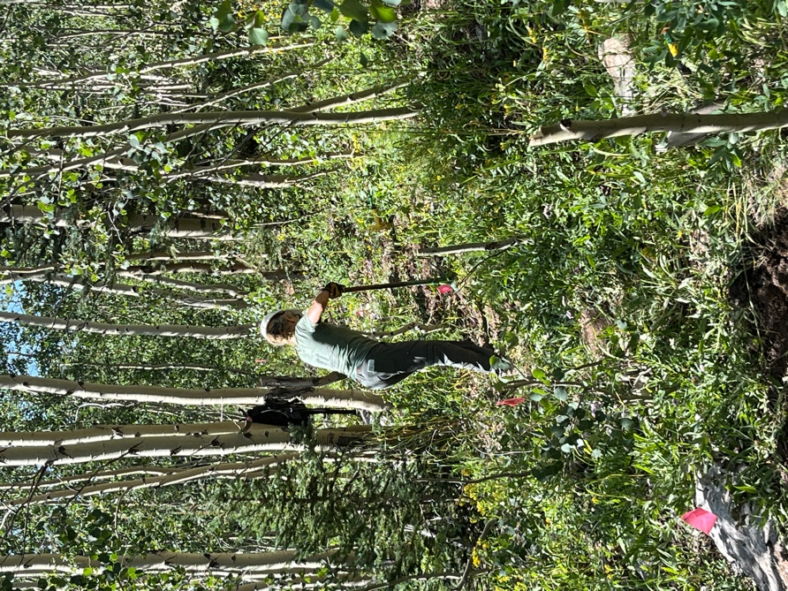 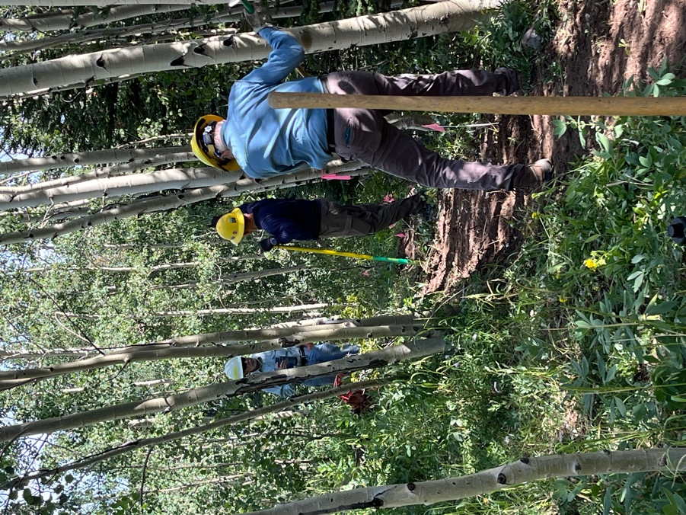

Claudia removes stumps- her specialty! Byron and John chat while Eric takes a

big swing.

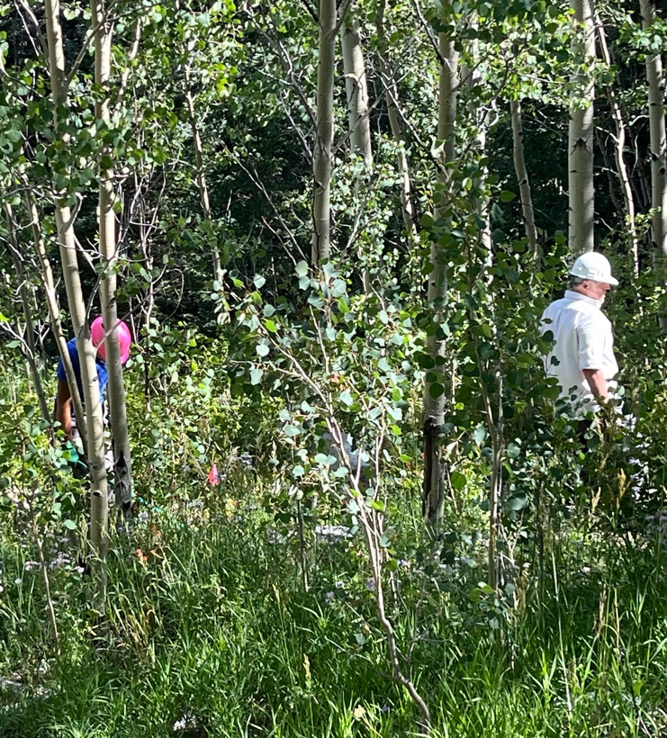 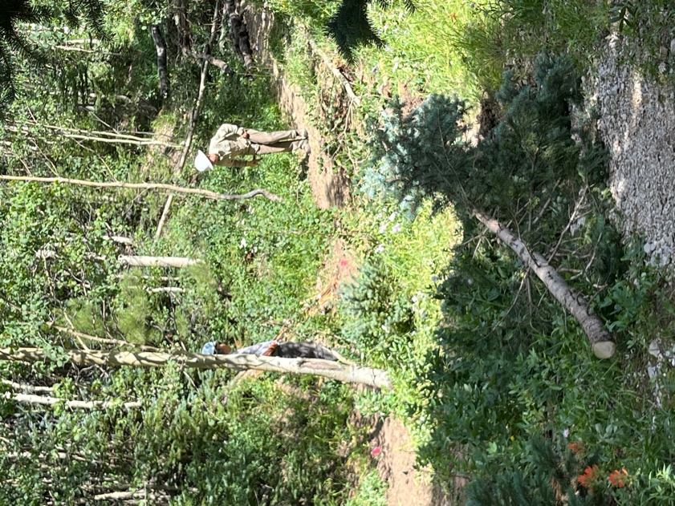

Roland and Rich work in the Aspens Luis and Jen take another look at the

removing rocks. dip in the tread.

And then we heard thunder, stashed the tools and skeedaddled!!