**Report of Felling Hazard Trees on 10K North Trail and in the Burn Area on Wednesday, August 7, 2024**

Sam Beard

On Wednesday, August 7, ten FOSM volunteers felled approximately a dozen hazard trees along 10K North Trail in and adjacent to the burned area.

The volunteers working on Wednesday were Rene Archer, Jamey Browning, Susan Gregory, Lou Romero, Cliff Giles, Dan Benton, Sam Beard, Eric Russell, Jerry Carroll, and Sim Cook.

Project photos are presented below.

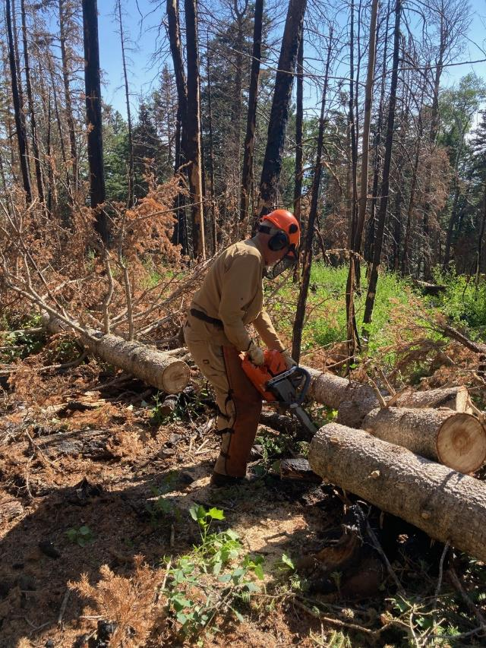

Dan Benton bucking a felled hazard tree in the burned area near 10K North Trailhead.

All photos by Cliff Giles

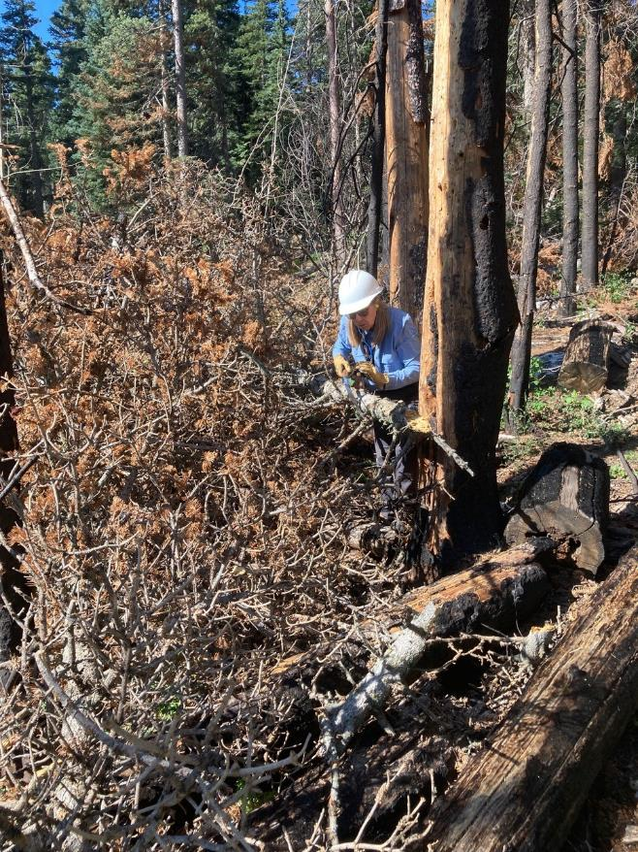

Rene Archer cutting limbs on a felled hazard tree.

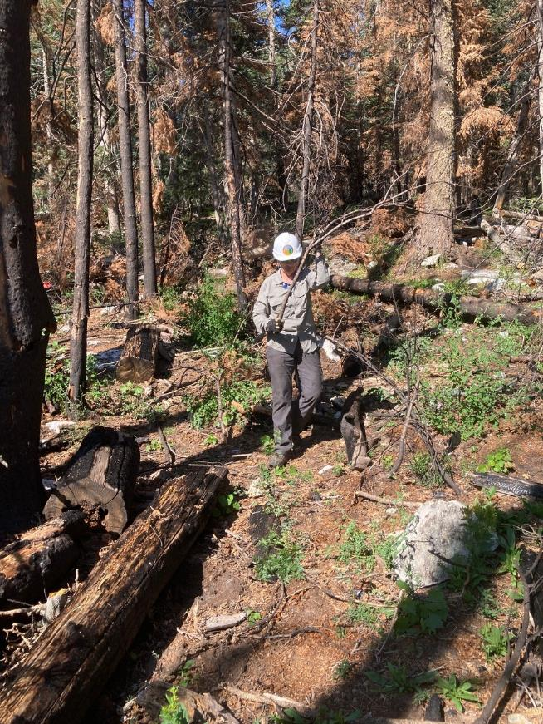

Susan Gregory removing a limb cut by a sawyer in the burned area.

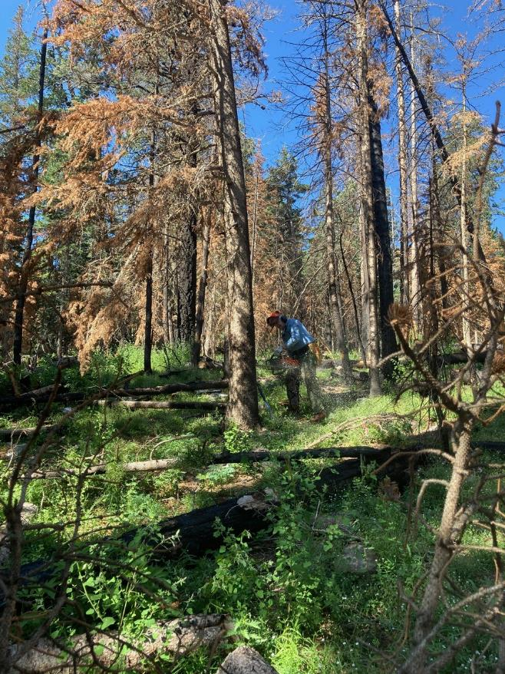

Eric Russell felling a dead tree in the burned area.

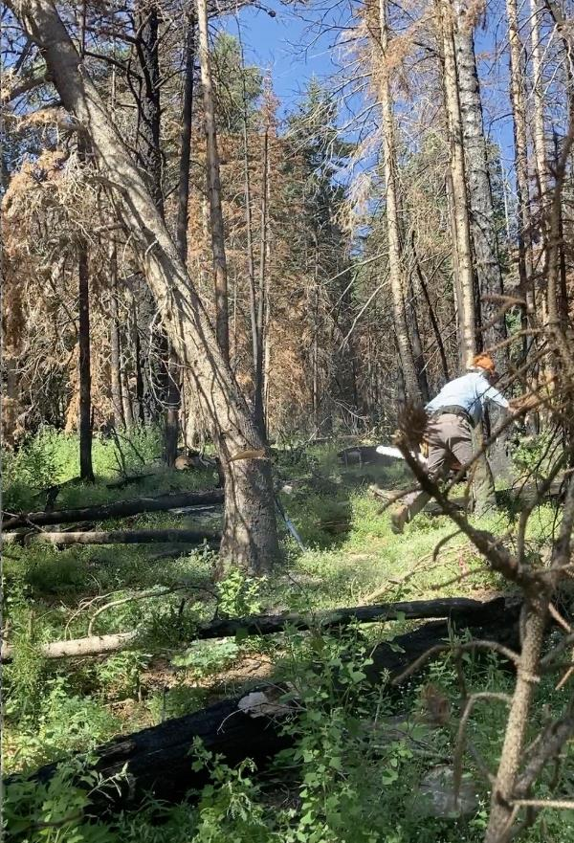

Eric running away from the falling tree.

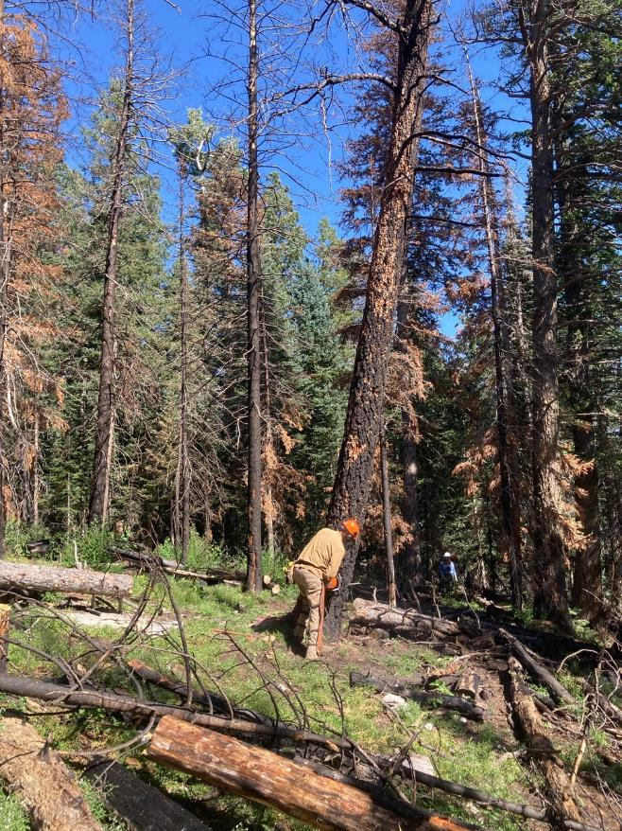

Dan felling a dead tree in the burned area.

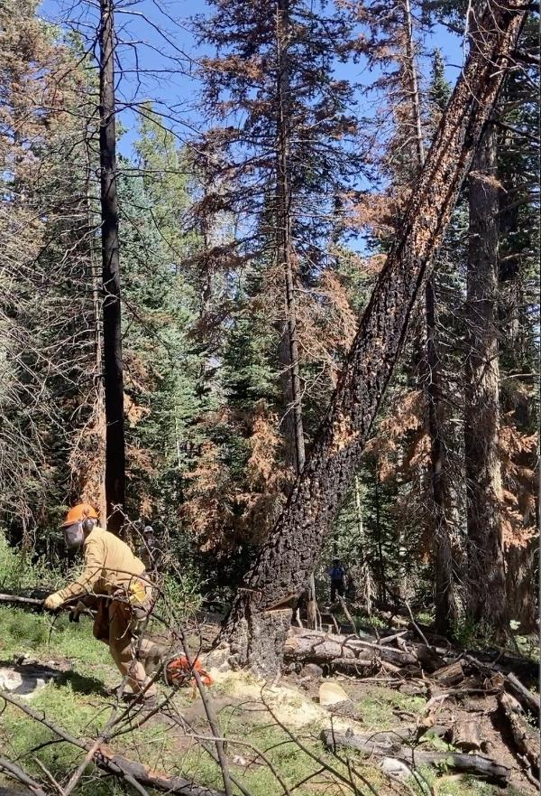

Dan running away from the falling tree. Note how the face cut is closing as the tree falls.

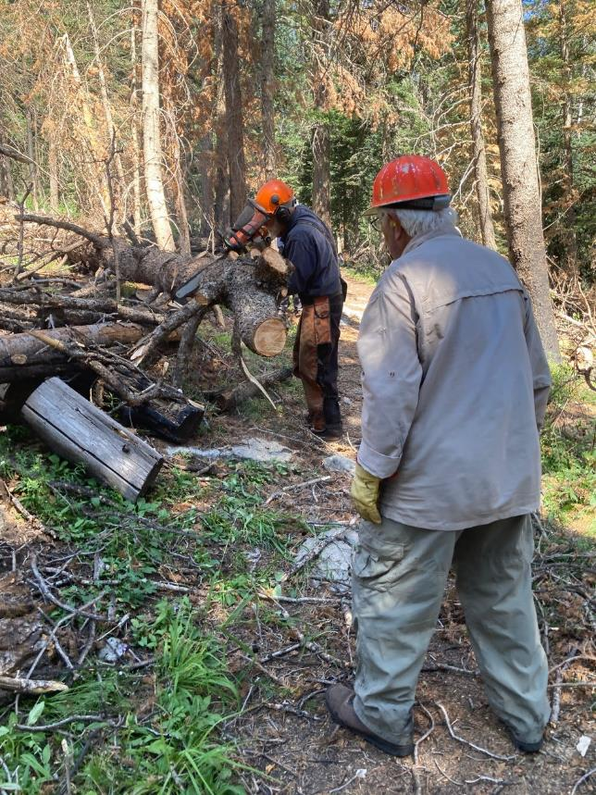

Lou Romero observing Sam Beard bucking a tree that fell across the trail.

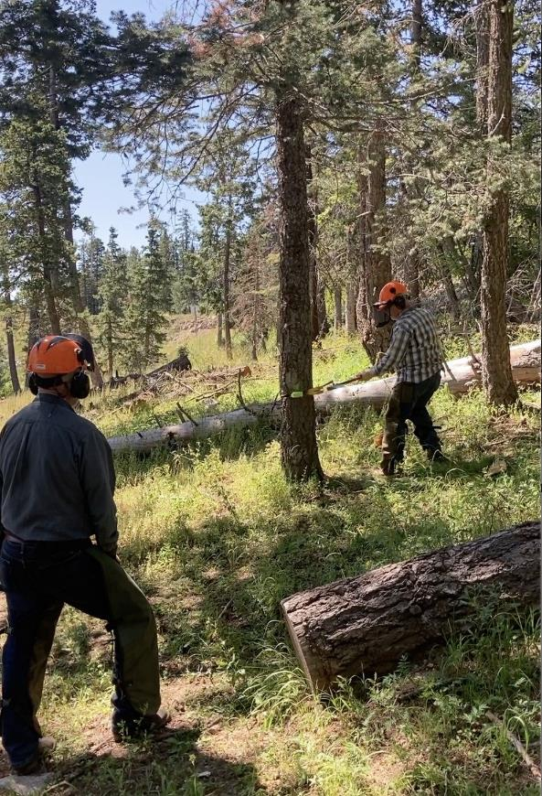

Jerry Carroll observing Jamey Browning driving wedges in the tree he is felling.

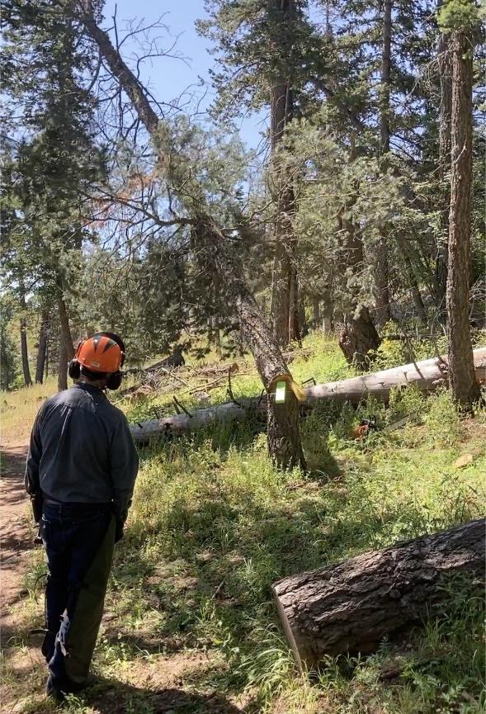

Jamey’s tree is falling.

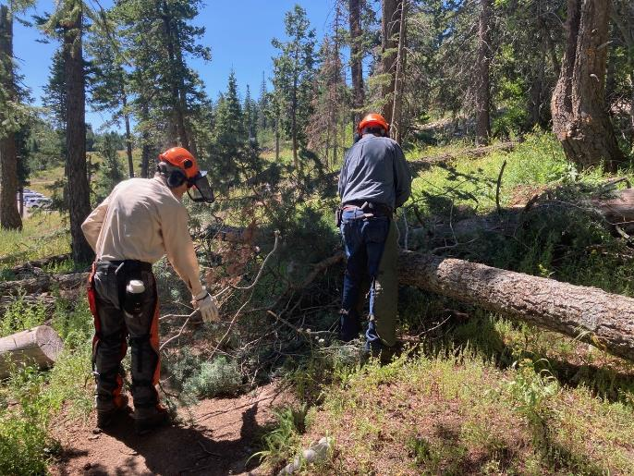

Jerry Carroll and Sim Cook are limbing and bucking a felled tree.

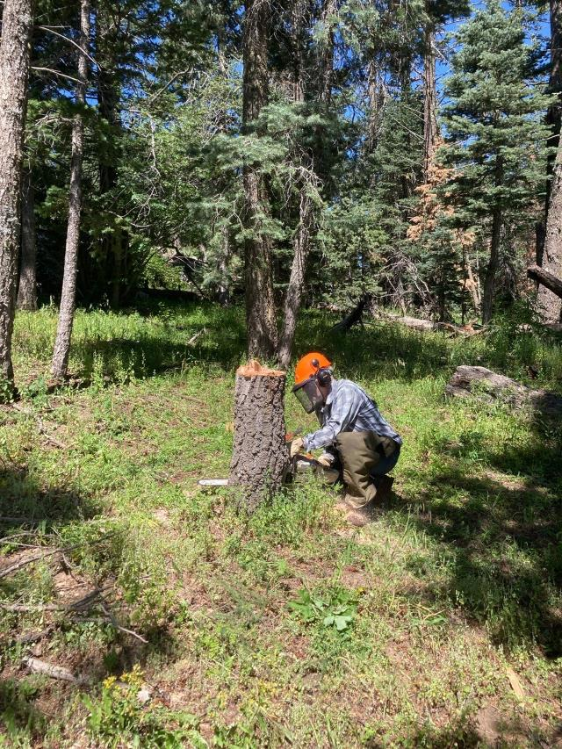

Jamey low stumping the tree he felled.

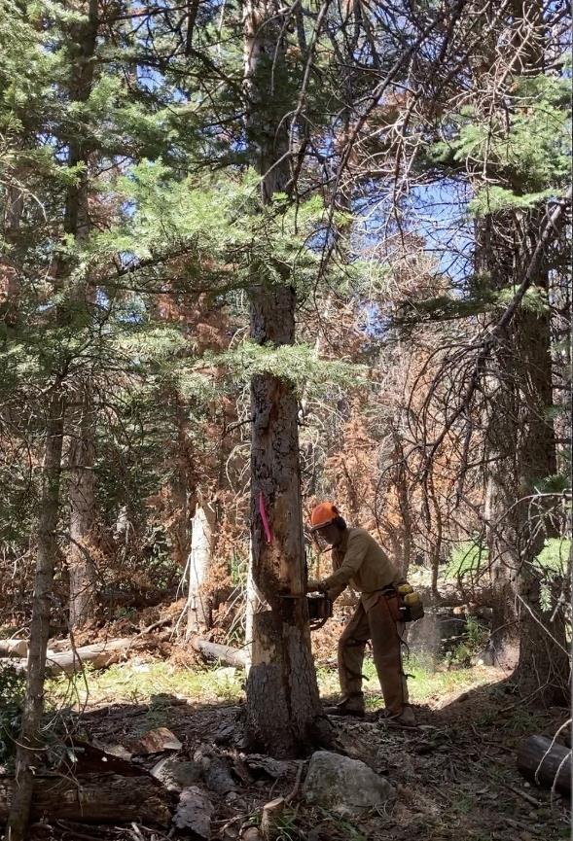

Dan felling a hazard tree.

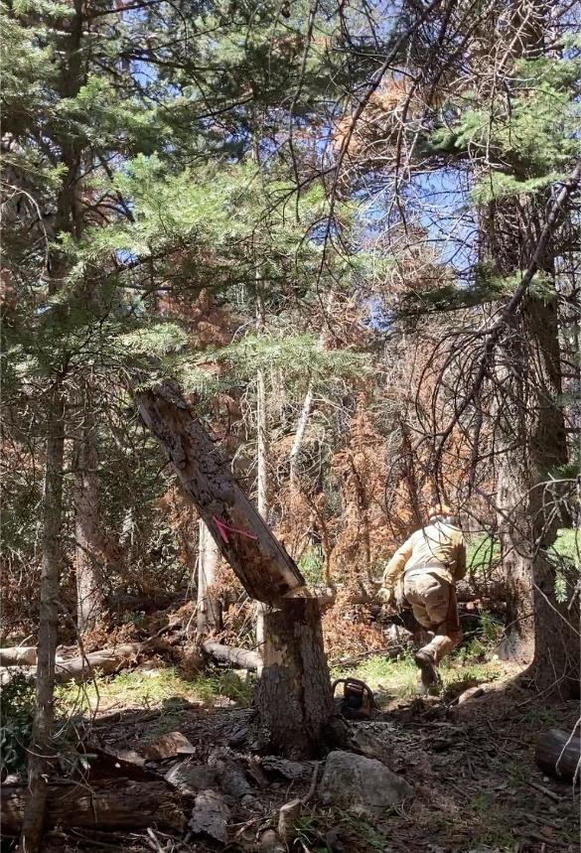

Dan running away from the falling tree.

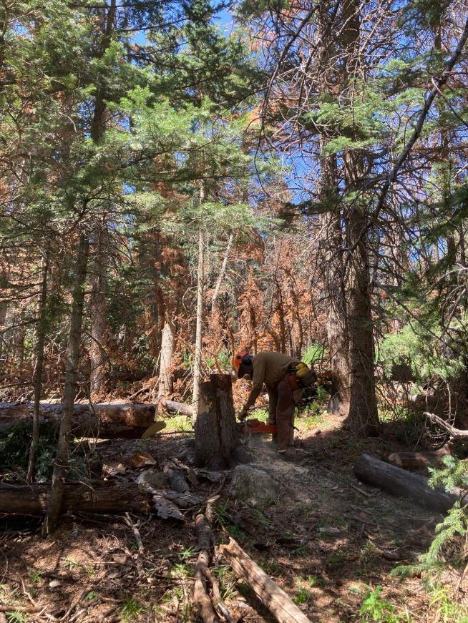

Dan low stumping the tree he felled.