Thursday, 08/15/24: Back to Ellis! Twelve (!) volunteers joined (SRD) Jen, Chris and Dorothy on the Ellis reroute #5. It was a nice cool morning with a light breeze all day so it was perfect for working. We have a little bit left to do on reroute #5- some trees will need to be cleared so we can get the trail finished. We started on reroute #4 after lunch- *lots* of stumps and roots will take some time to work through. Also, one grumpy hiker who doesn’t like her favorite trail turning in another 10K- she *really* like the open views. We make great progress with all these hand and backs!

Volunteers: Mike Madden, Luis Cuadros, John Cooper, John Braly, Jim Houle, Claudia Bergsohn, Byron Garner, Bill Perkins, Laura Leon, Rich Fagioli, Roland Stumpf, Steve Roholt.

Pictures taken by Claudia Bergsohn.

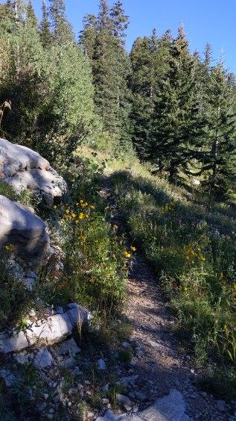 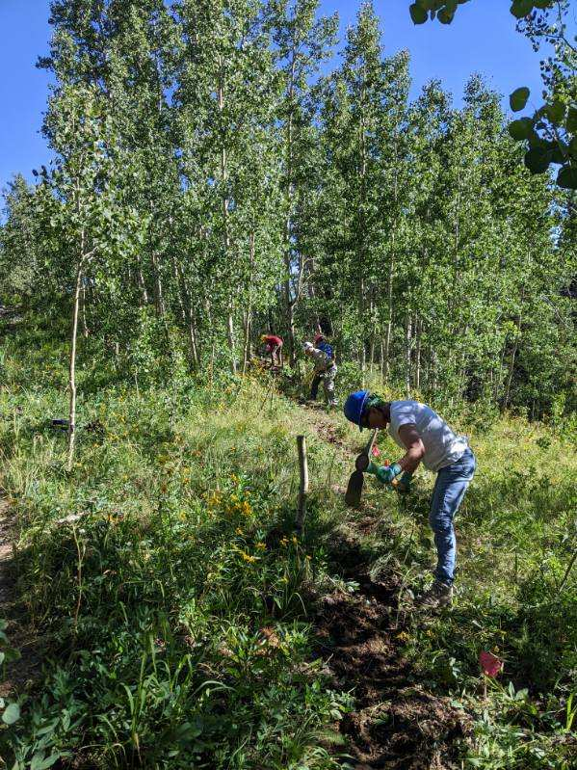

Another nice walk in. The chain gang gets to work- Laura, John,

John, and Roland.

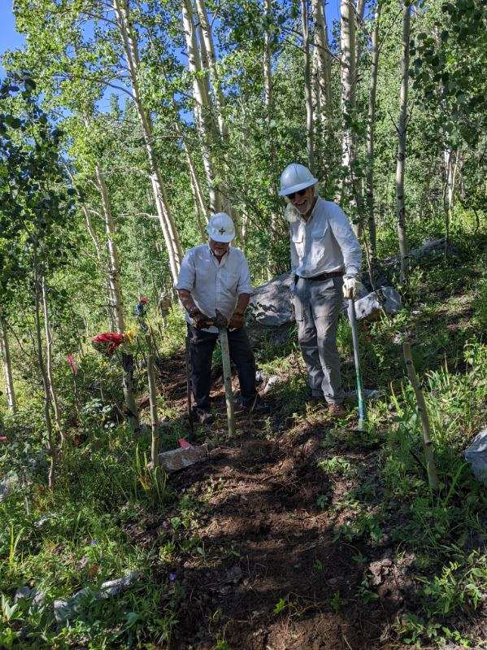 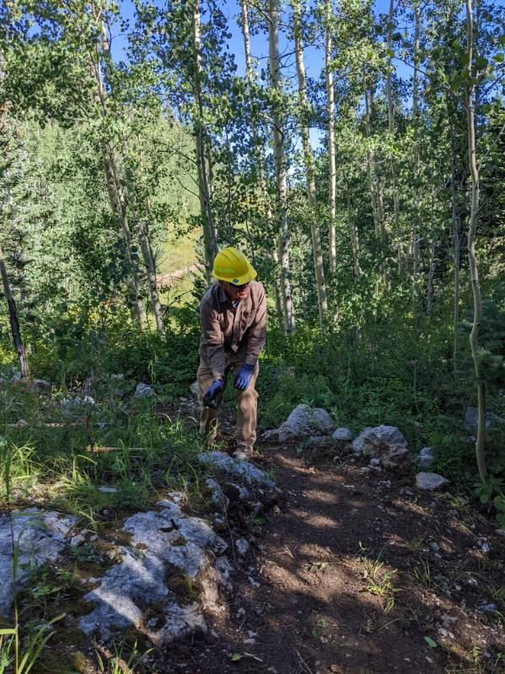

Rich and Bill having fun. Mike busy at work.

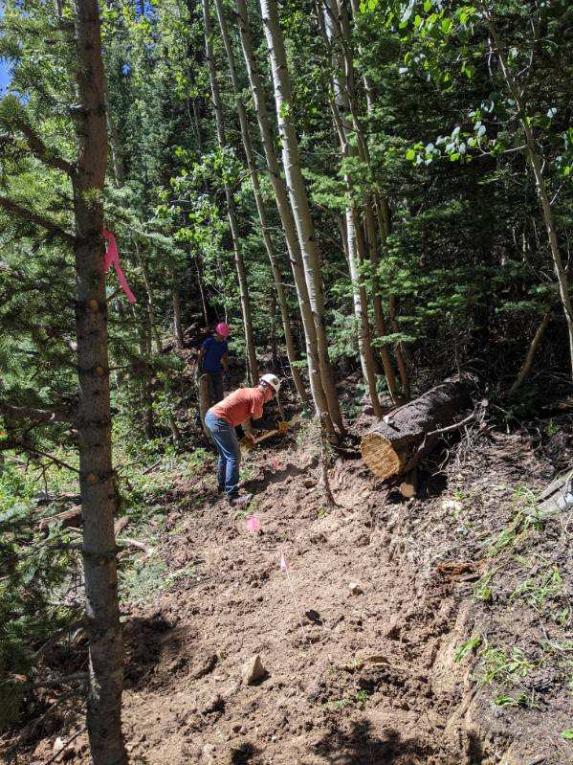 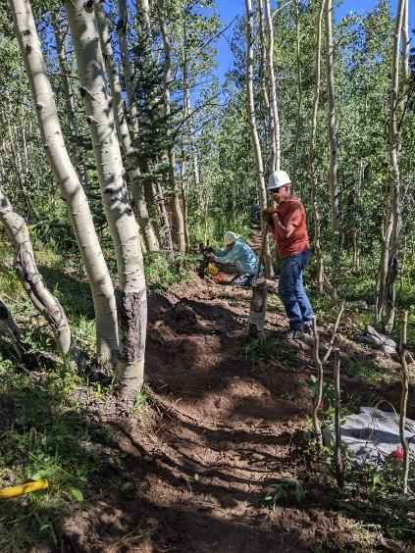

Steve and Roland dig. Steve and Jim working.

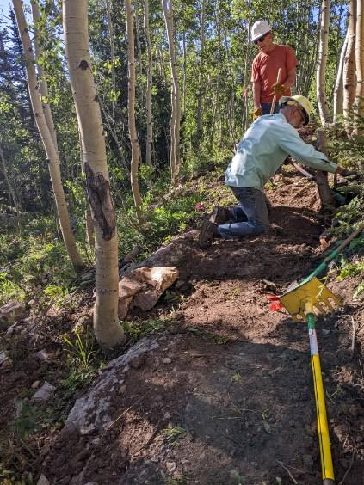 A bit of back sloping and cribbing.