**Report of Felling Hazard Trees on 10K North Trail near the 10K Burn**

**on Wednesday, August 14, 2024**

Sam Beard

On Wednesday, August 14, eight FOSM volunteers felled three hazard trees on 10K North Trail near the area that burned a couple of years ago. The felled trees were limbed, bucked, and moved off the trail. On the hike back to the trailhead, the sawyers stopped and scored about a dozen very large rounds from a hazard tree that was felled a few months ago. These rounds will be manually split so that the pieces are light enough to be placed on a power splitter.

The volunteers working on this project were Lou Romero, Sim Cook, Susan Gregory, Jamey Browning, Dan Benton, Jerry Carroll, Byron Garner, and Sam Beard,

Project photos are presented below.

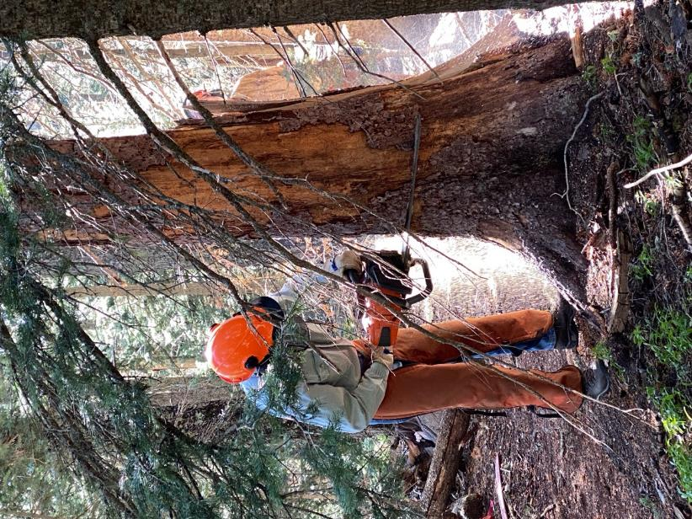

Byron Garner felling a short dead tree so that a nearby hazard tree can be safely felled.

All photos by Susan Gregory

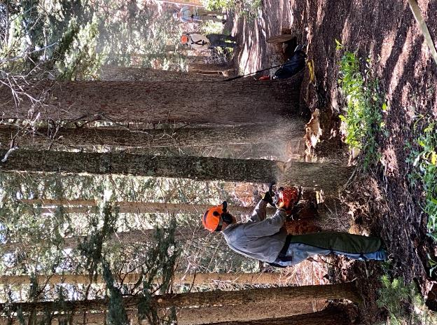

Jerry Carroll felling a small hazard tree.

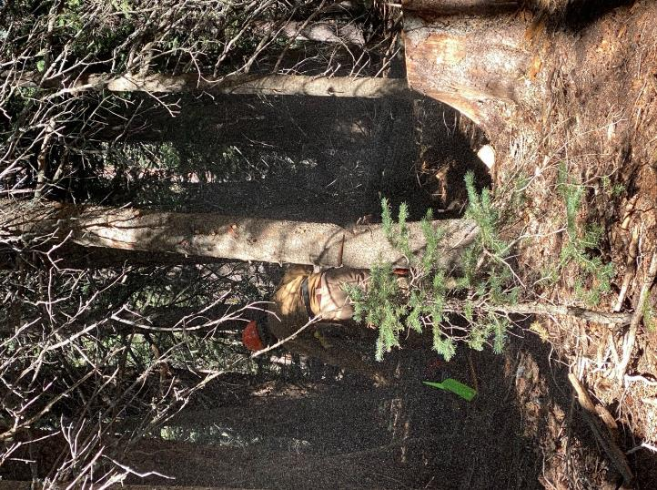

Dan Benton running away from a tree that is just beginning to fall.

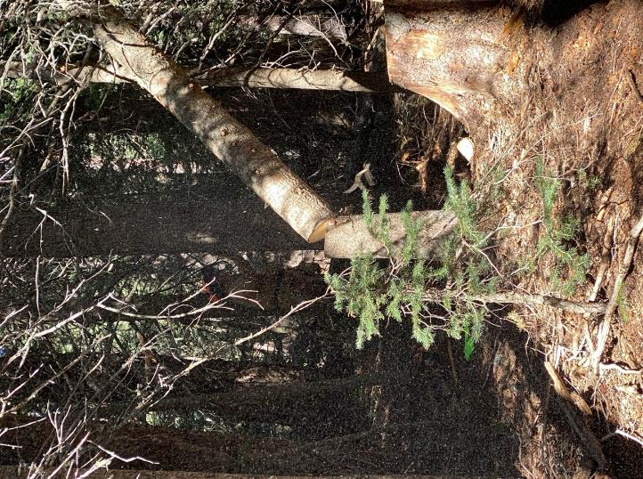

The tree fell into another tree, and the lower end is resting on the stump.

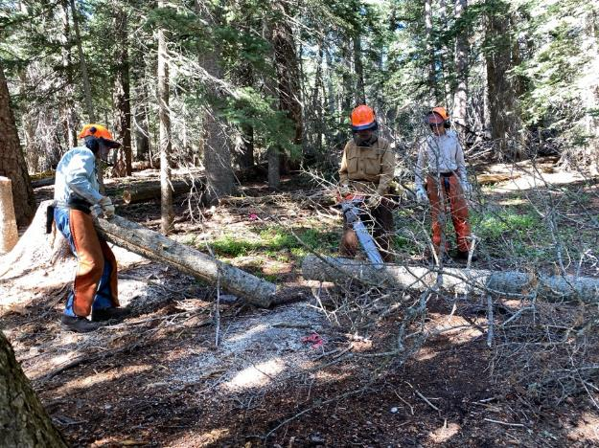

Byron Garner and Sim Cook are observing Dan Benton limbing a felled tree.

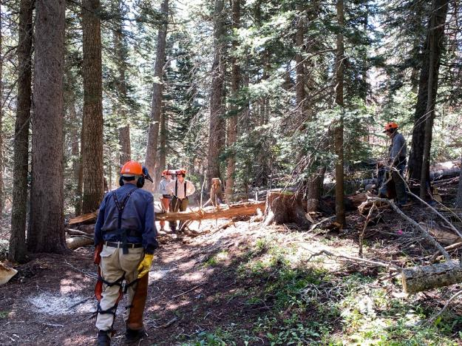

Sam Beard is walking toward a tree that just fell across the trail.

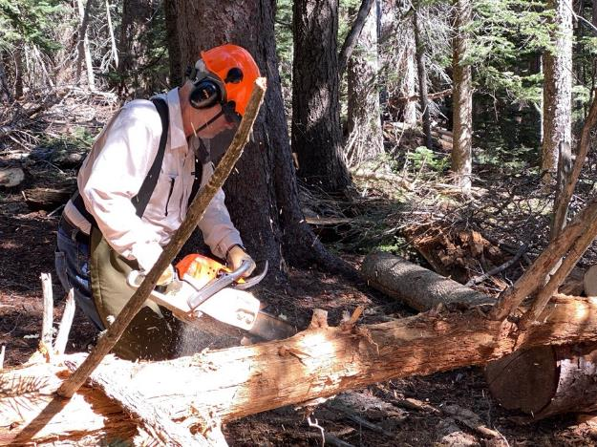

Jamey Browning is limbing the felled tree.

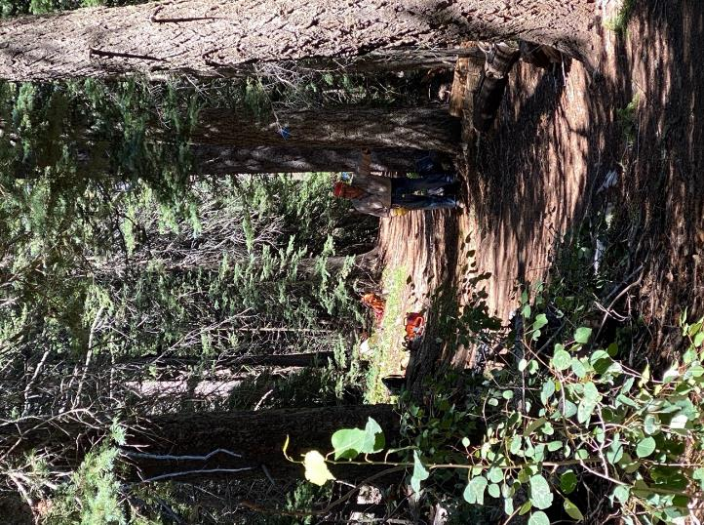

Lou Romero is a lookout for hikers when trees are being felled.

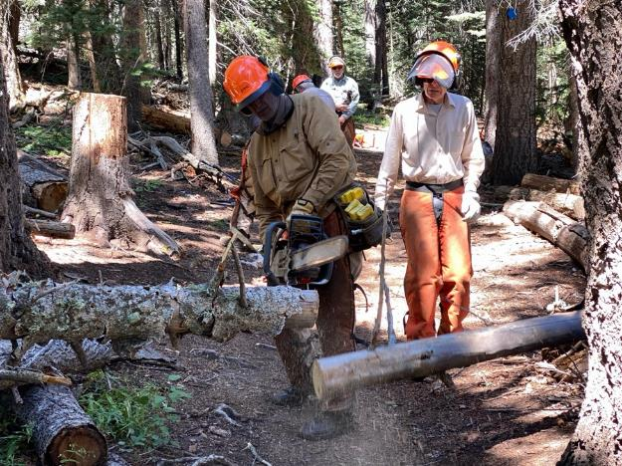

Sim Cook is observing Dan Benton bucking a felled tree.

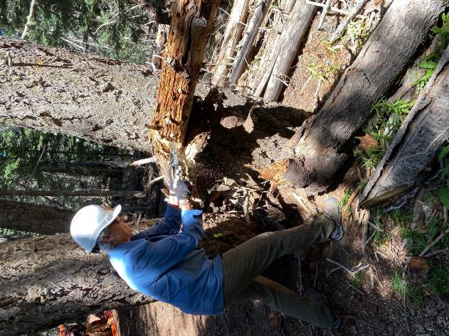

Susan Gregory is bucking a tree with a small hand saw.

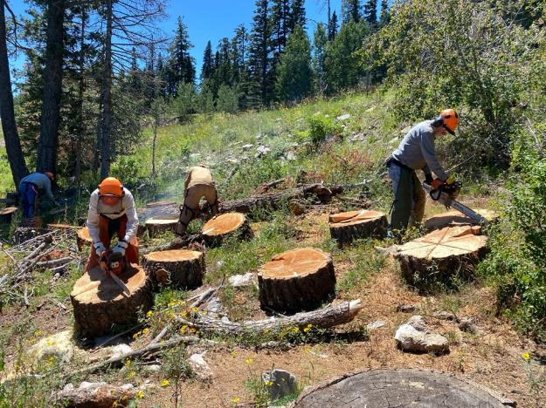

Sawyers are scoring large rounds near the 10K North Trailhead parking lot. In a couple of weeks

volunteers will use these 2-inch-deep scores to help split these rounds into four pieces that

can be more easily placed on Lou Romero’s power splitter.