Trail Maintenance Report: Monday, August 19, 2024

Byron Garner

On August 19 the Monday trail crew hiked Faulty and Oso Corredor trails from Bill Spring to remove a previously reported "14" tree located above Doc Long and blocking Faulty. After almost four miles of hiking in humidity and rising temperatures, it became overwhelmingly apparent that a bit more definitive information would be required to successfully locate our objective. With a collective decision to return to the trail head, we tightened the straps and headed back. A few crew members with afternoon commitments had to head home while the remaining crew moved up to Ellis for a cool lunch and rest. The next item of business was to clear a "head banger" 1.16 miles down Survey reported by Tannenbaum. This 9" leaning aspen wedged between several down grade trees and at shoulder height +/- was an interesting study in binds requiring a carefully considered corroborative strategy - an effort rewarded with a no surprise result. We also found a few bonus trees which included 8" and 5" leaning firs and an aspen. Survey remained cool and comfortable aided by an occasional shade cloud as we concluded our days work. The crew included Rav Nickolson, Sim Cook, Jamey Browning, Rene Archer, John Cooper, Ken Wilson, Susan Gregory, Jeff Kokos, Dave McCreery, Chuck Logan and Byron Garner. Photos: Rene Archer and John Cooper

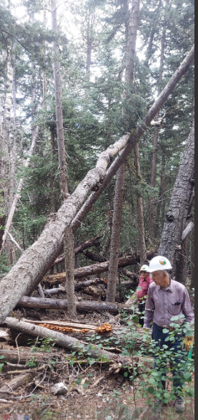Archer

John and Dave doing the math on our "head banger" aspen

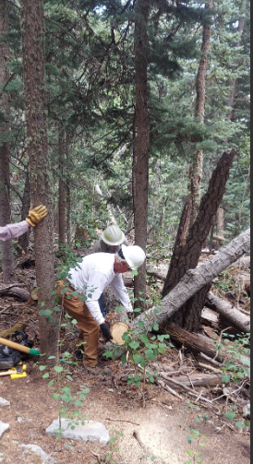Archer

Jeff finishes the job with the trail now clear

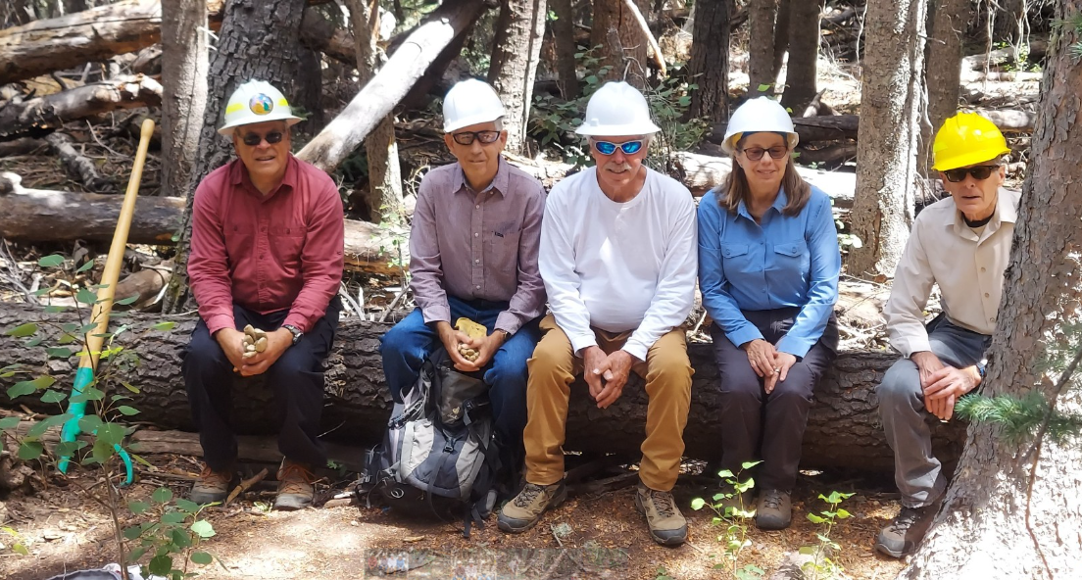

Dave, John, Jeff, Rene and Sim

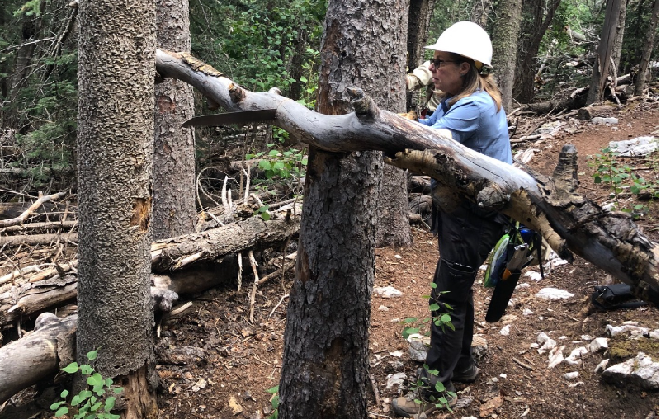Cooper

Rene takes care of our last aspen business for the day