Report of FOSM Project to Paint Kiosk Posts in Restored Nine Mile

Picnic Area, Tuesday, Sept. 3, 2024

Sam Beard

On Tuesday, Sept. 3, eight FOSM volunteers painted five posts supporting new large kiosk panels in the restored Nine Mile Picnic Area which will be opening to the public soon.

The volunteers working on this project were Laura Leon, Steve Roholt, Katie Ziegweid, Cliff Giles,   
Rich Feddersen, Pauline Ho, Rick Buss, and Sam Beard.

Project photos are presented below.

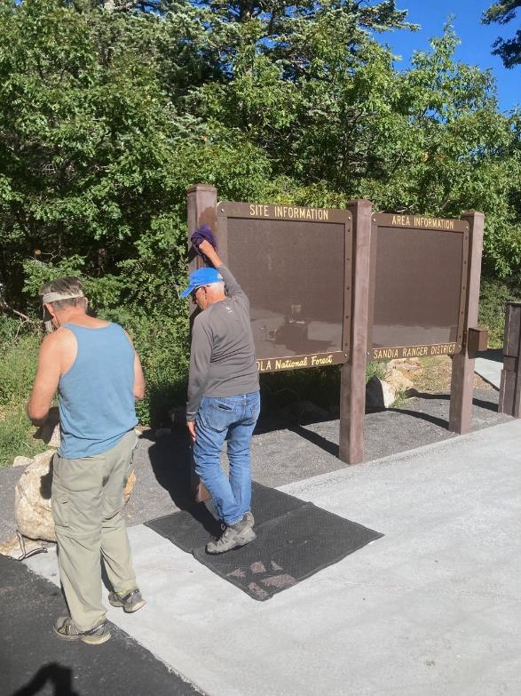

Steve Roholt washing the steel kiosk posts that had been sanded.

All photos by Cliff Giles

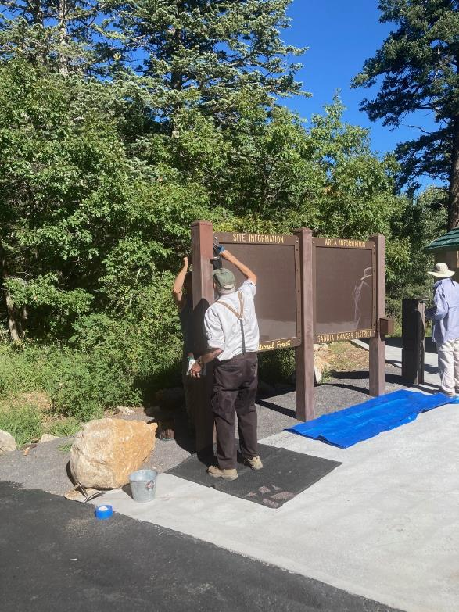

Sam Beard and Rich Feddersen painting the sanded posts with USFS brown paint.

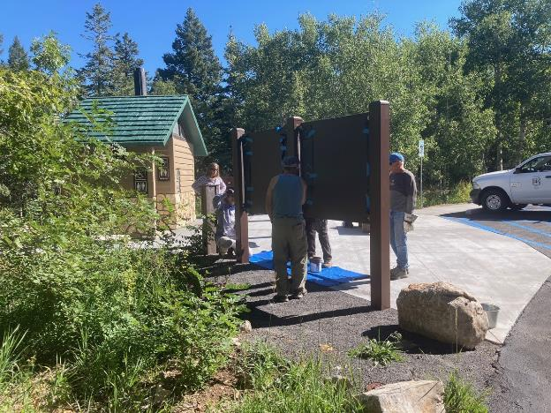

Rich painting the back of one of the steel posts. Note the new restroom with a green roof.

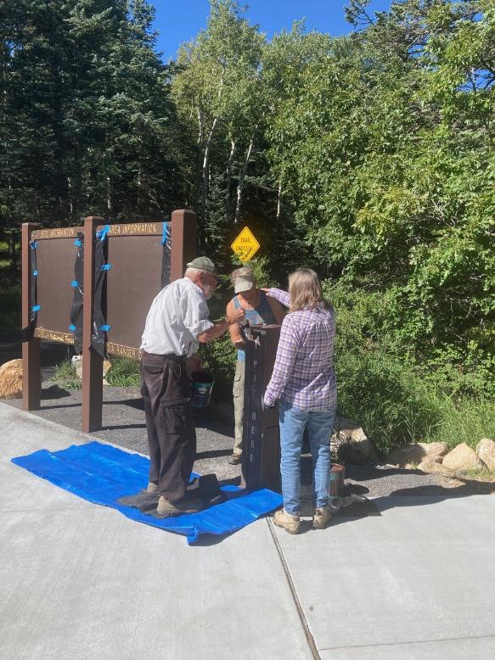

Sam Beard, Rich Feddersen, and Laura Leon painting the pay tube.

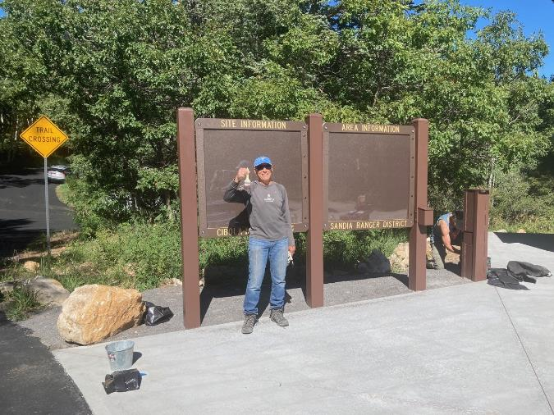

Steve Roholt in front of the new Nine Mile Picnic Area kiosk with three painted posts.

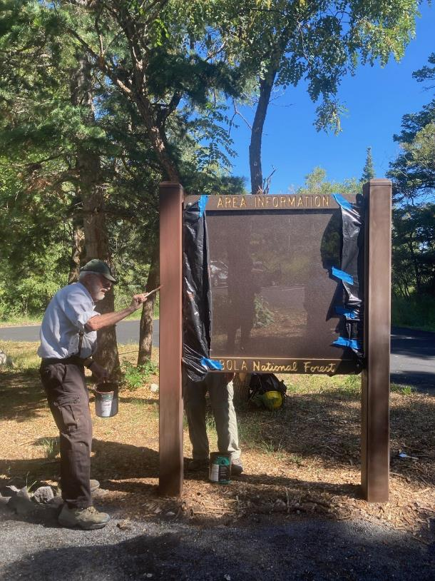

Sam and Rich painting posts in the upper part of the picnic area.

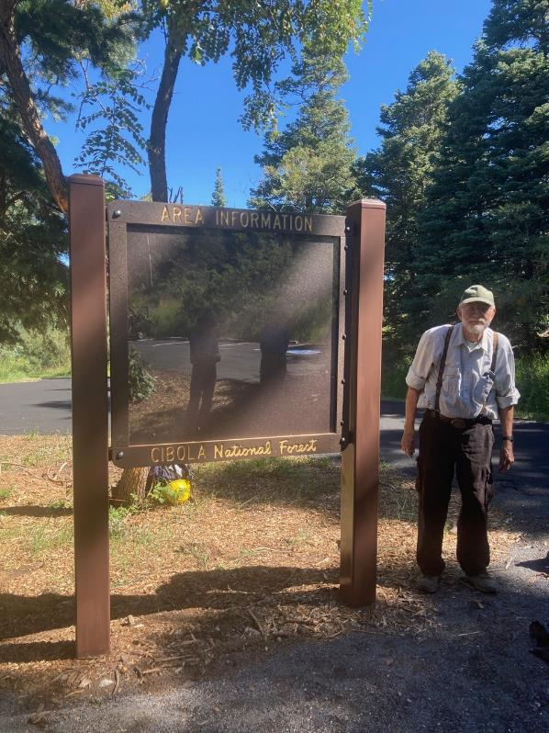

Sam at the upper kiosk with two painted posts.