Thursday, 09/05/24: Back on Ellis today with 13 volunteers (!) and Dorothy, Chris and Zay from SRD. The weather was perfect and we were able to finish our work before the wind and weather blew in. Reroute #2 is mostly done, just a few touchups needed. The SRD crew cut some trees and did some rock work on reroute #3 where it crosses the old trail. Reroute #2 is a beautiful walk through the woods with meadows visible on either side and a stand of aspen at the end.

Volunteers: Steve Roholt, Rich Fagioli, Mike Madden, Rich Feddersen, Luis Cuadros, John Braly, Jim Houle, Eric Russell, Eric Messerschmidt, Claudia Bergsohn, Byron Garner, Bruse Hansche and Laura Leon.

Pictures- Laura Leon

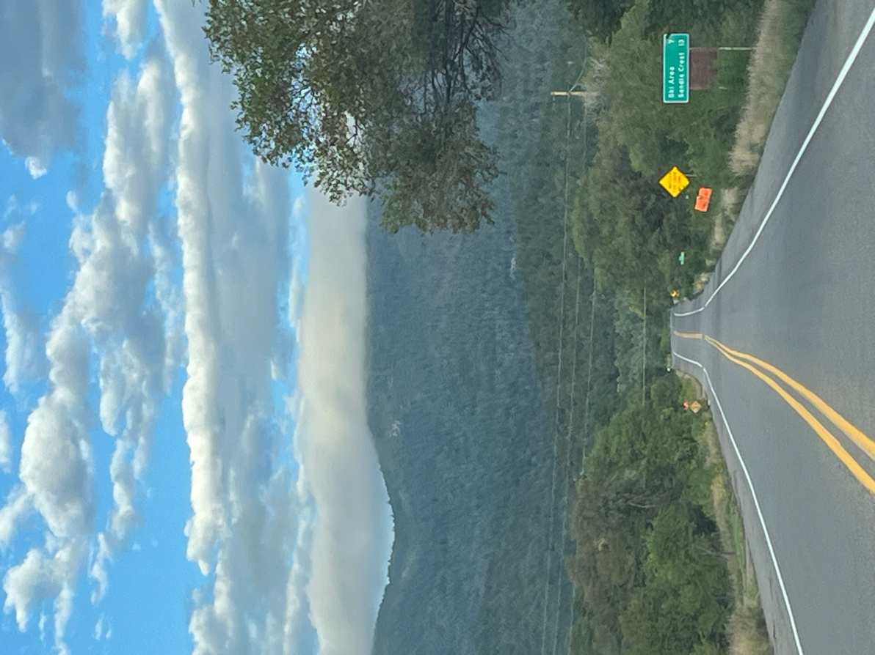

Low clouds on the drive up the Crest Road.

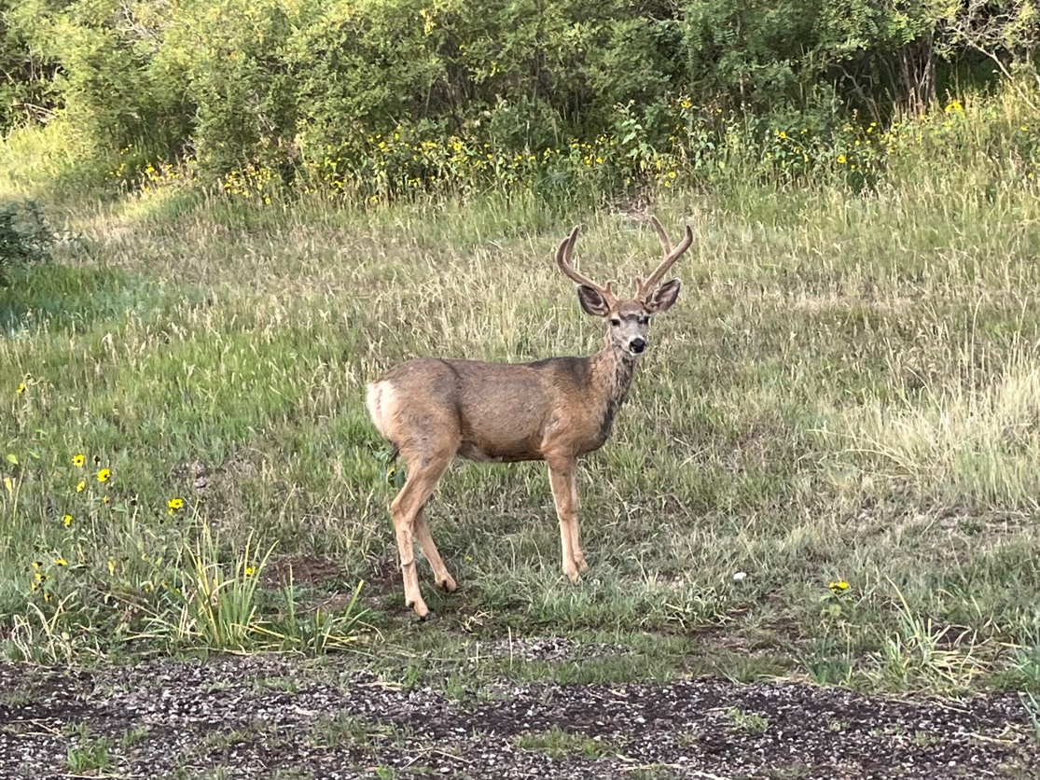

Everyone is out eating in the early mornings!

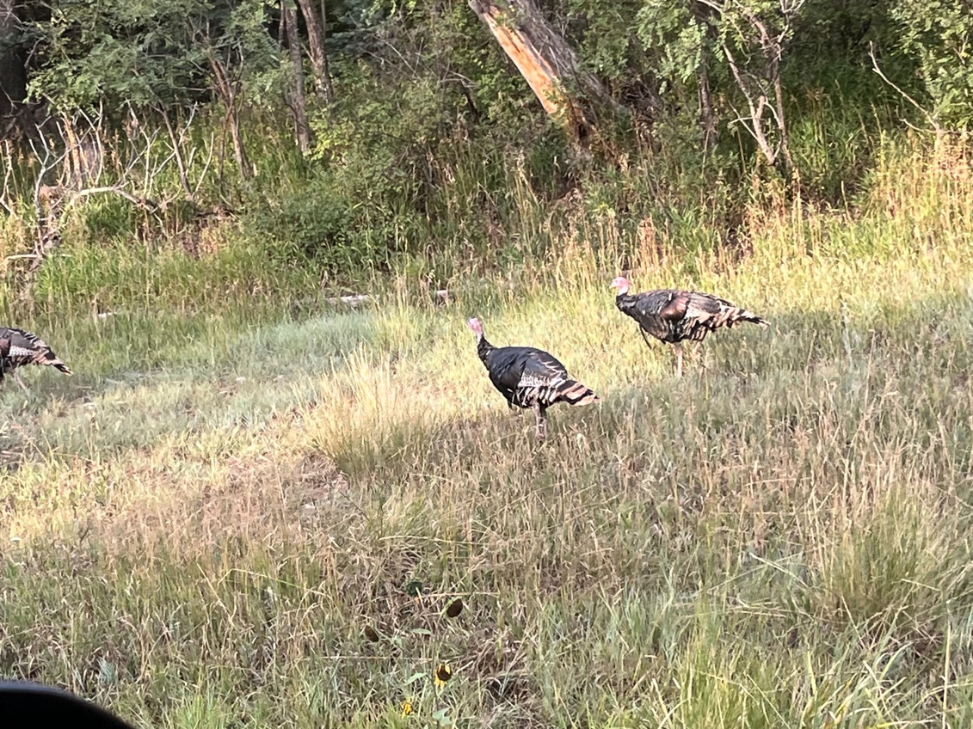

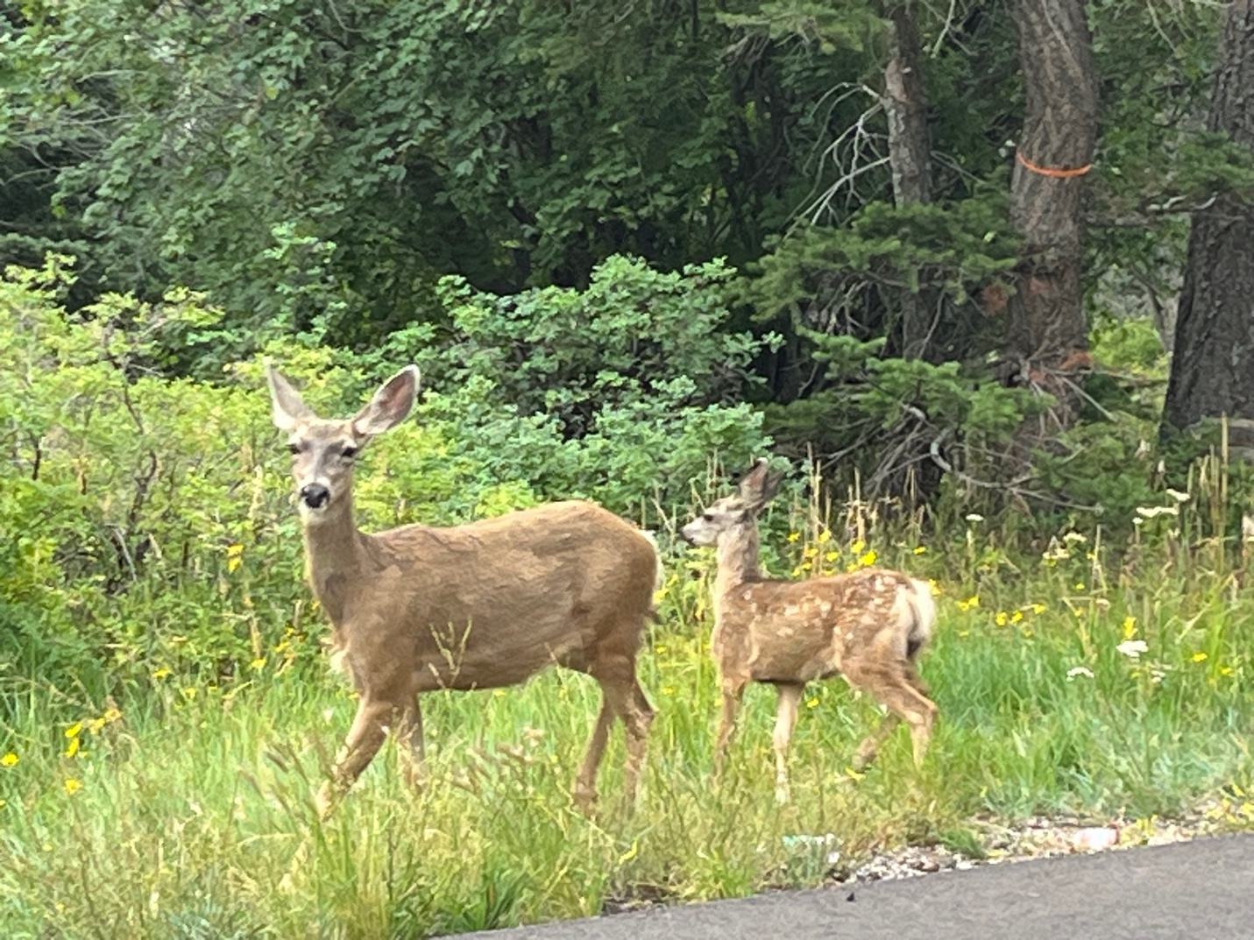

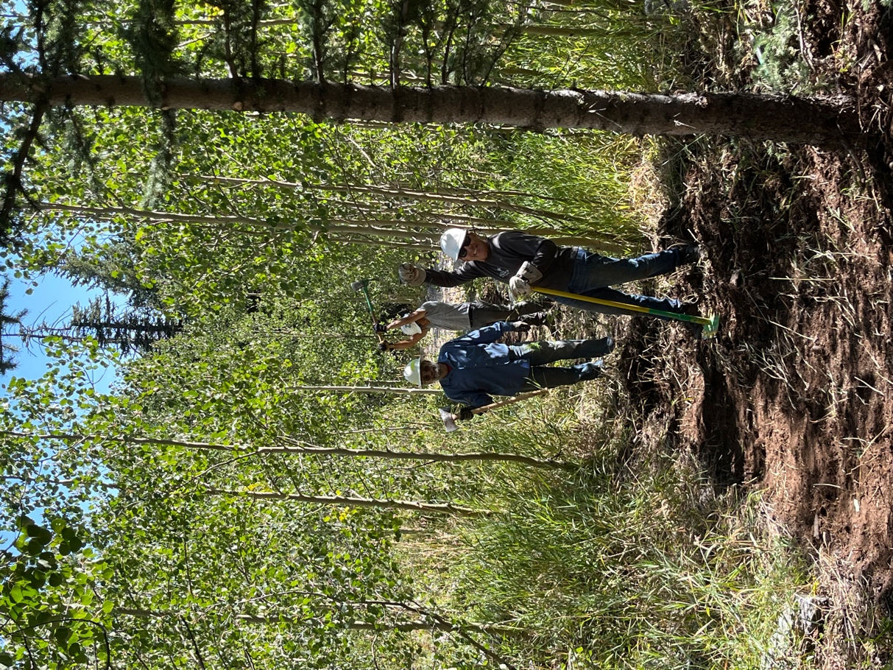 Jim, Luis and Steve work in an aspen stand.

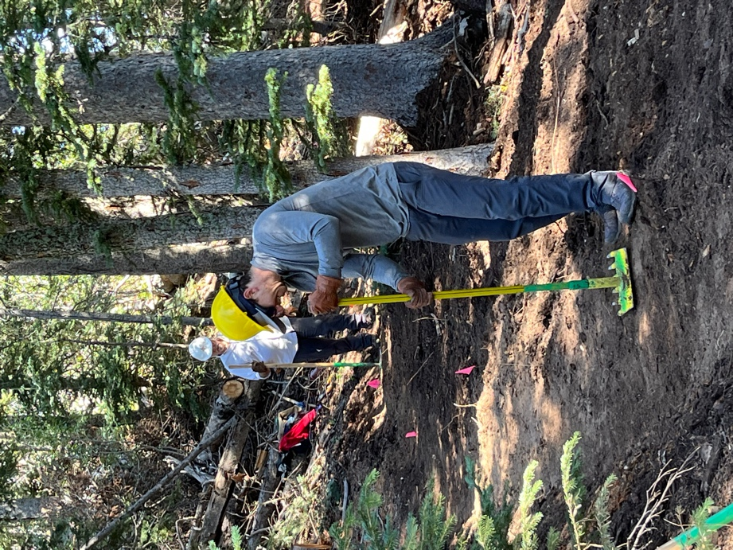 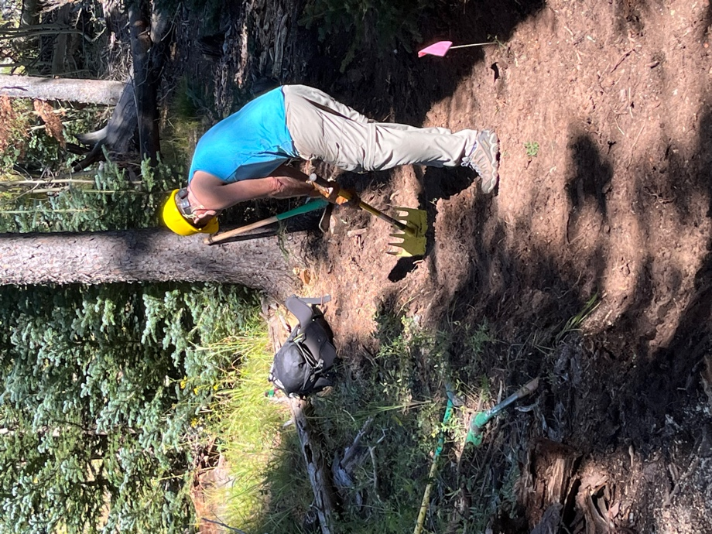

Rich, Eric M. and Rich smooth the trail. Lots of duff!

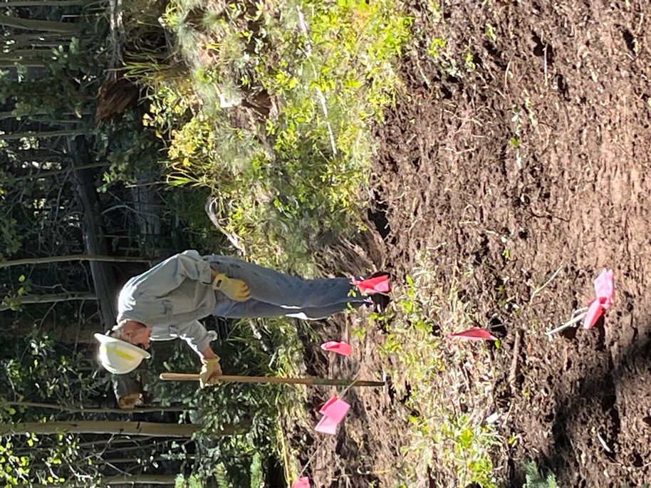 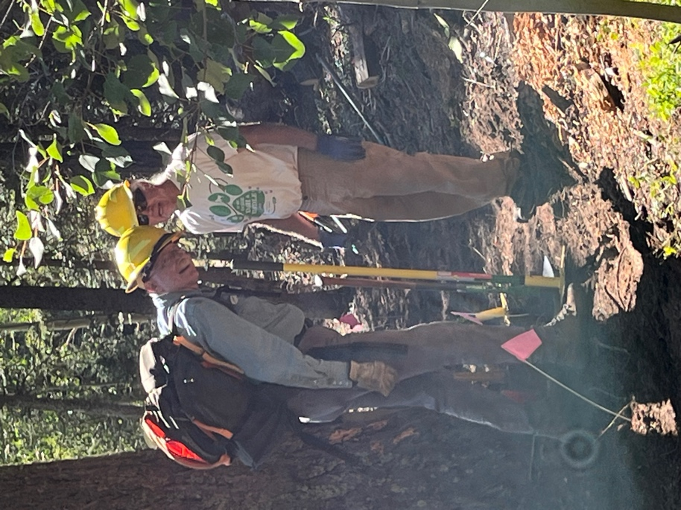

Byron works among lots of flags. Eric R. and Mike talk Pulaski strategy.

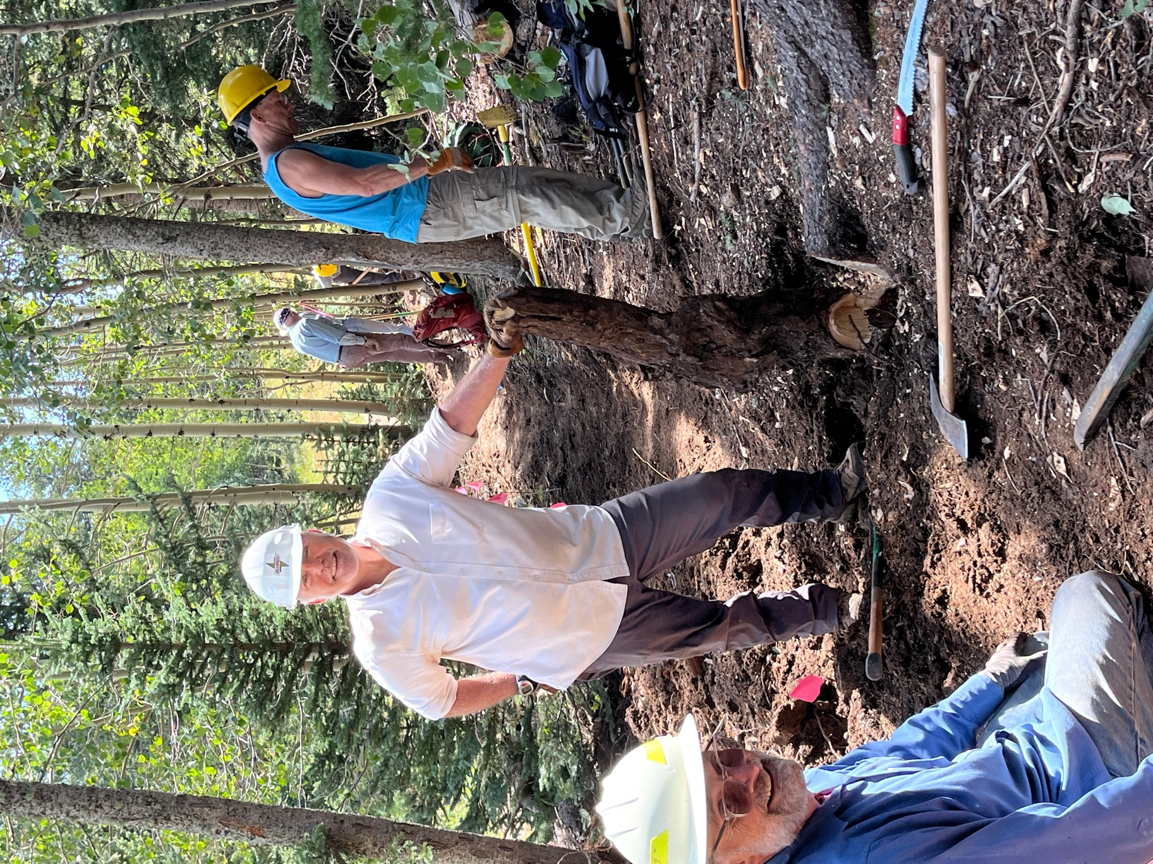

Jim and Rich taking care of root problems!