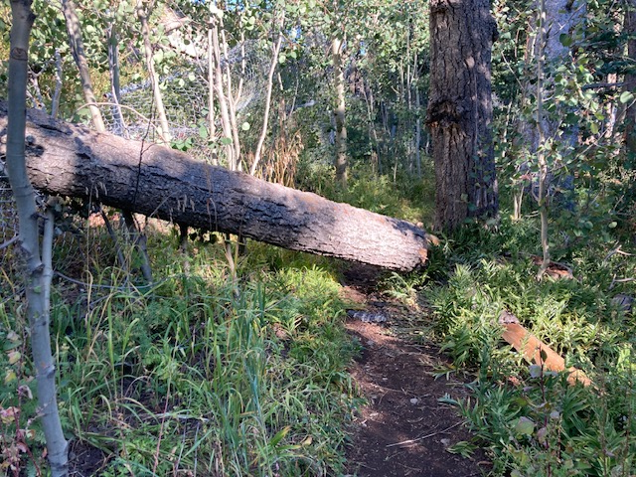
This was the first fallen tree to greet us shortly after we began our hike on Crest Trail 130 North. It is part of the broken top of the large dead fir tree located at the bottom end
of the big log.
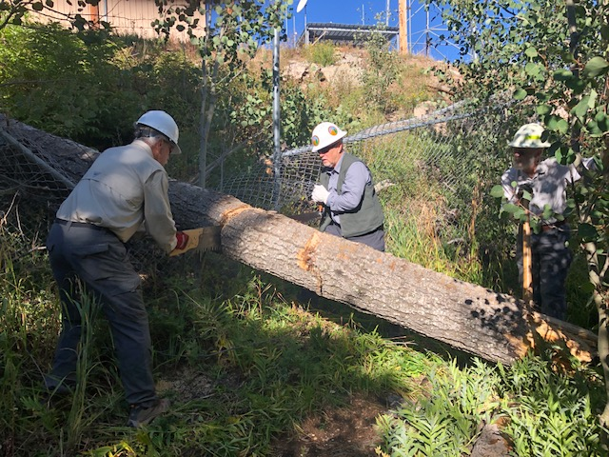
The crew is just about finished with the cut needed to remove the fallen tree. The crew member to the right of the photo is using a cant hook to stabilize the tree while it is being cut.
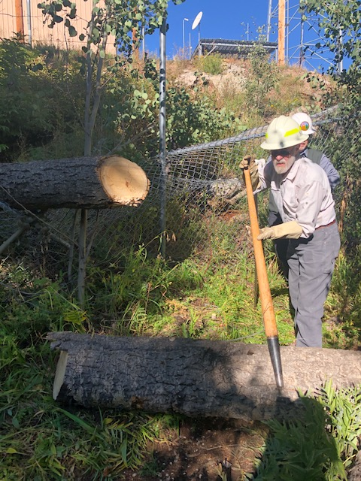
The cut portion of the fallen tree is moved off the
bottom of the trail.

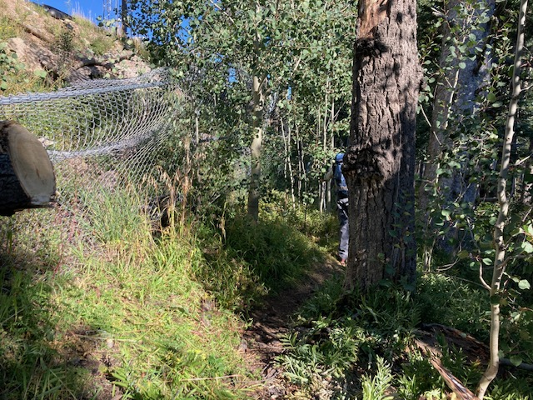
The trail is clear. The remaining cut portion is near the fence and far enough from the trail not to be a hazard to users.
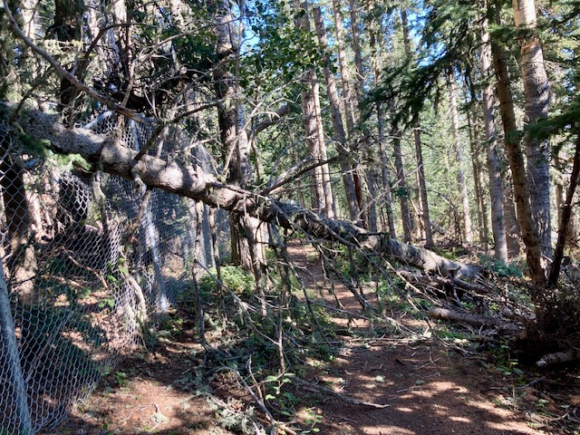
Our next customer, not far north of the first tree. Lots of branches to remove.

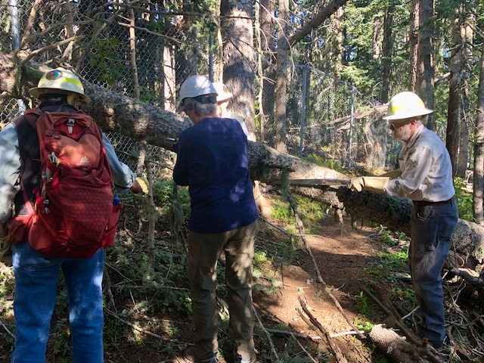
Branch removal begins.
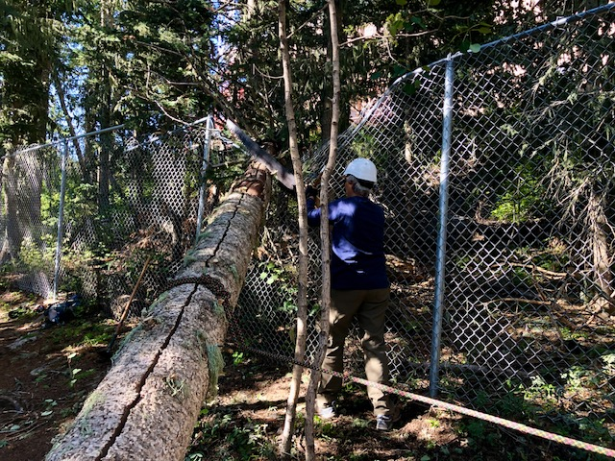
The first cut is started. Susan gets some practice with the crosscut saw. The cut was finished by a B-Certified sawyer. A lot of material had to be removed to provide an escape route for the sawyer. The rope was initially placed to stabilize the tree but was not needed. It did not interfere with the escape route.

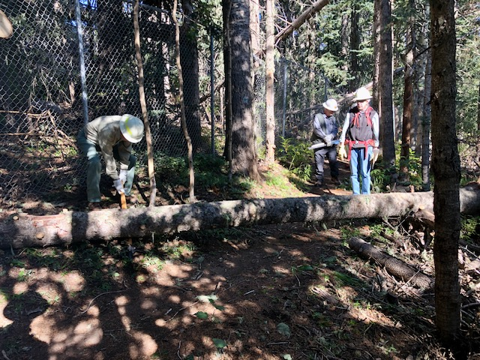
The tree from the previous photo is on the ground and being moved off the lower side of the trail.
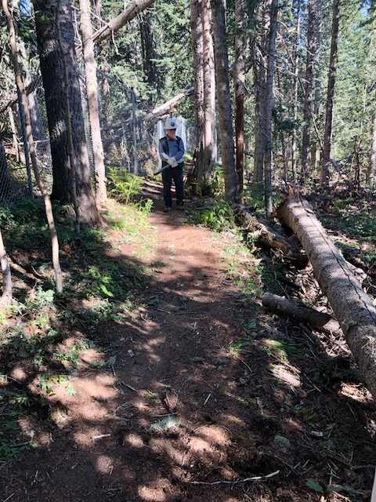
The trail is clear.
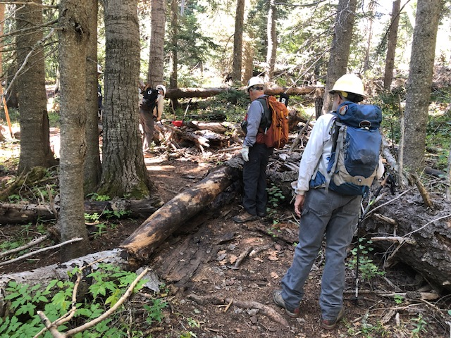
OK, so here’s another one! This old partially petrified fallen tree broke at a convenient spot (lower left in photo) when it fell. The crew is preparing to remove it.

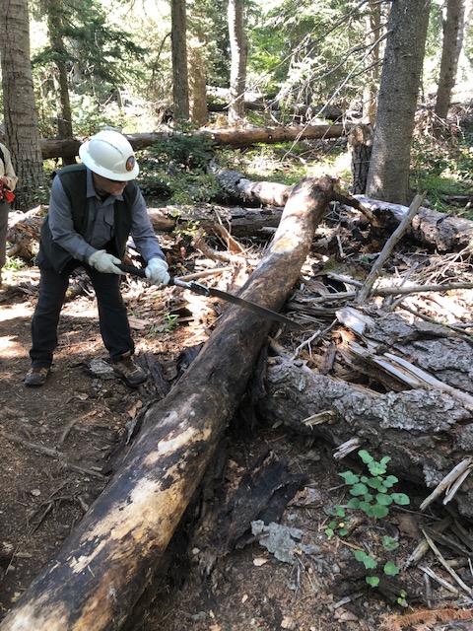
Large Silky KatanaBoy saw does the job.
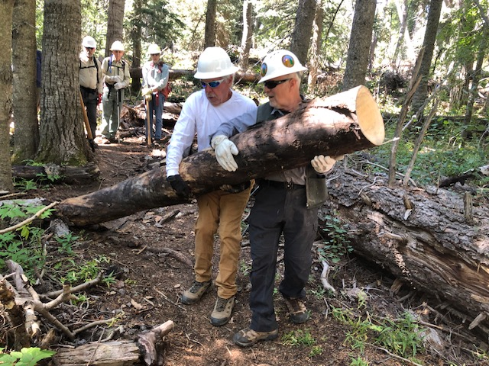
“Many hands make light work”. The cut section of the fallen tree is removed from the trail.
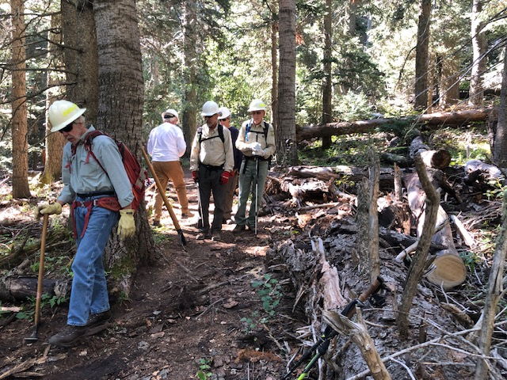
The trail is clear, again…

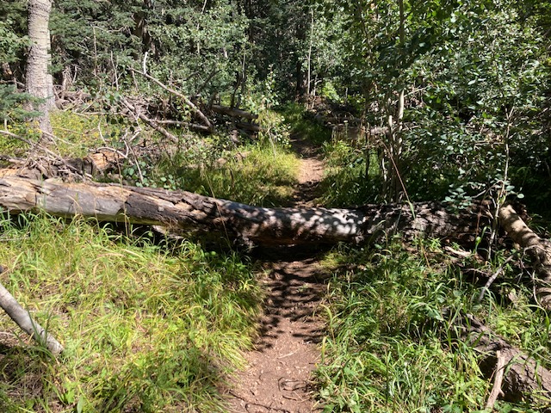
But wait! There’s more!! Another large fallen tree resting peacefully in an inconvenient location.
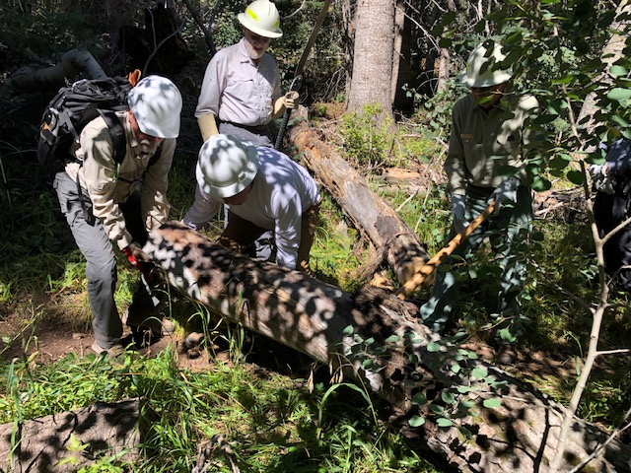
The fallen tree has been cut and is being moved away from the trail.
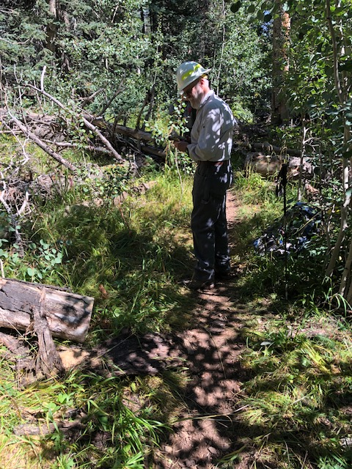
Final check is made to be sure the tree doesn’t try
to sneak back across the trail.

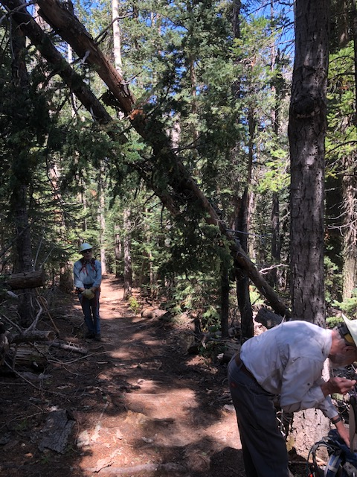
This three-tree hang-up was looming over Survey trail.
The two larger dead trees brought a small live fir tree
along when they fell. Branches of the fir were hanging
down into head space for anyone passing through on
horseback. The small fir was removed.
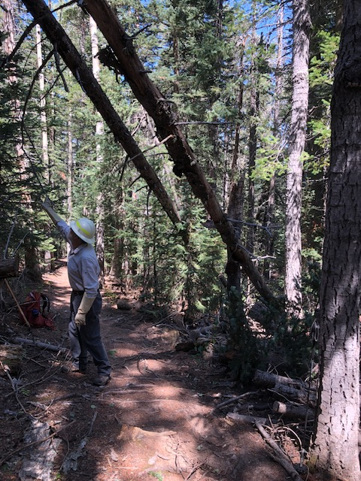
The two remaining trees appeared to be well supported
and there is now sufficient headspace for users. The crew
determined that it was not necessary to remove them now.

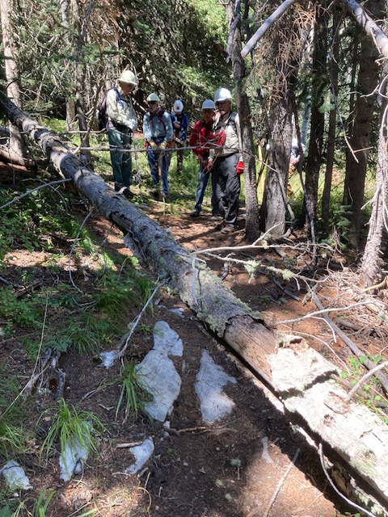
Just when you think you are just about back to the
trailhead and done for the day, something like this
happens. The tree was removed.

