Thursday, 09/12/24: A nice cool start to the day. Lots of wildlife on the way up to Ellis parking area. Groups of bucks standing around together discussing what they are going to do with the day. Ten volunteers worked on the finishing touches of Ellis reroute #2 and the benching of reroute #1. Reroute #1 is mostly finished but needs some final touches and obliteration of the old trail which we will do next week. Reroute #1 cuts across a meadow. The winds picked up in the afternoon as we finished work and a few of the aspen are starting to turn yellow. Special thanks to Eric Russell for being the Pulaski fix-it man!

Volunteers: Steve Roholt, Mike Madden, Luis Cuadros, John Braly, Eric Russell,

Eric Messerschmidt, Rich Fagioli, Scott Sunde, Bill Perkins, and Laura Leon.

Pictures: Laura Leon and John Braly

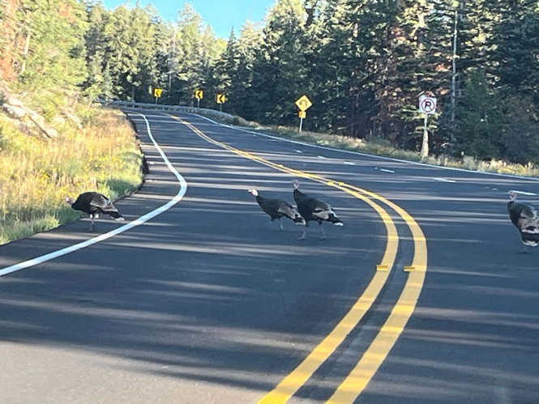 Turkeys out fattening up.

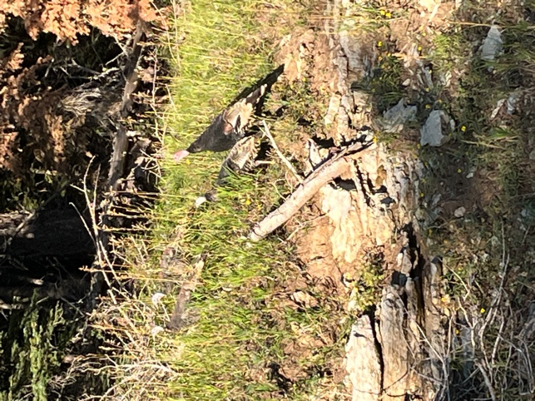

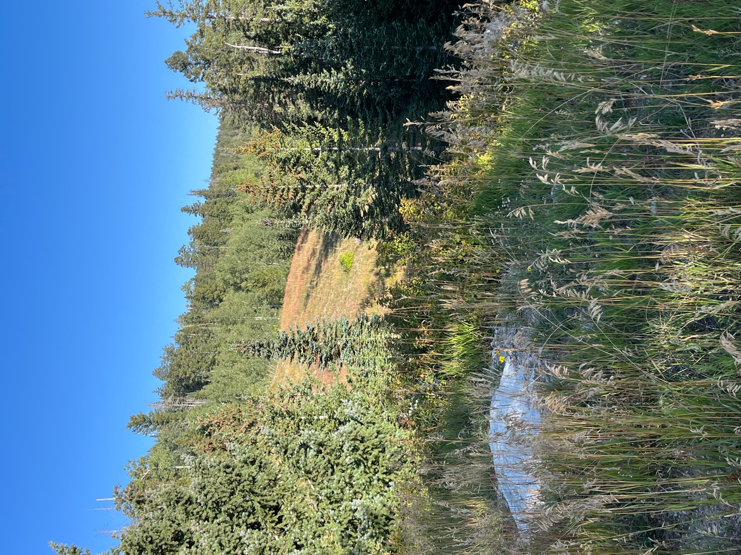 Vistas are starting to make color changes. Grasses now look gold and reddish brown but there are still some wild flowers.

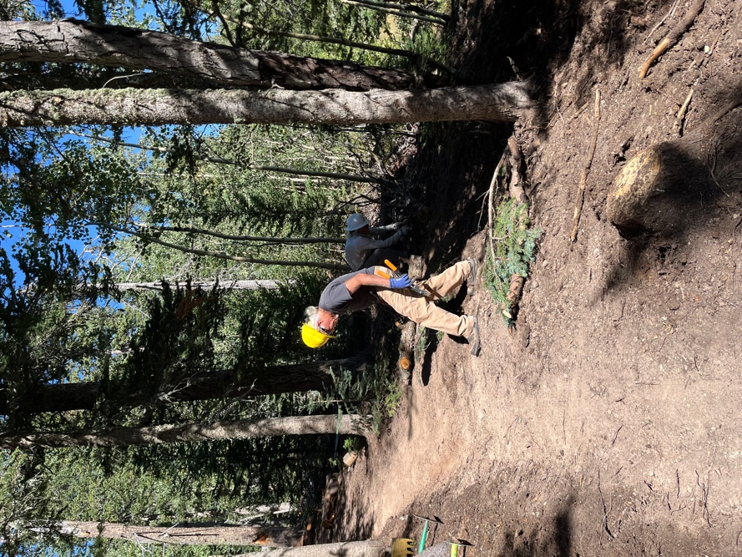 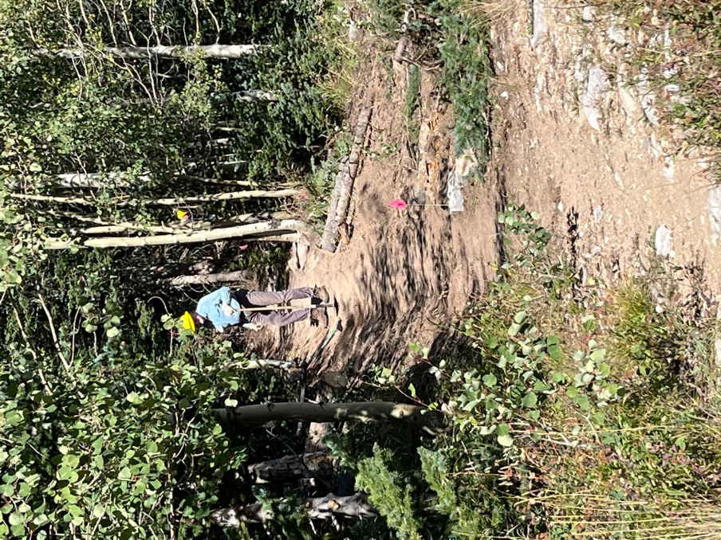

Mike and Bill clean up and Eric R. works on the entrance to reroute #2.

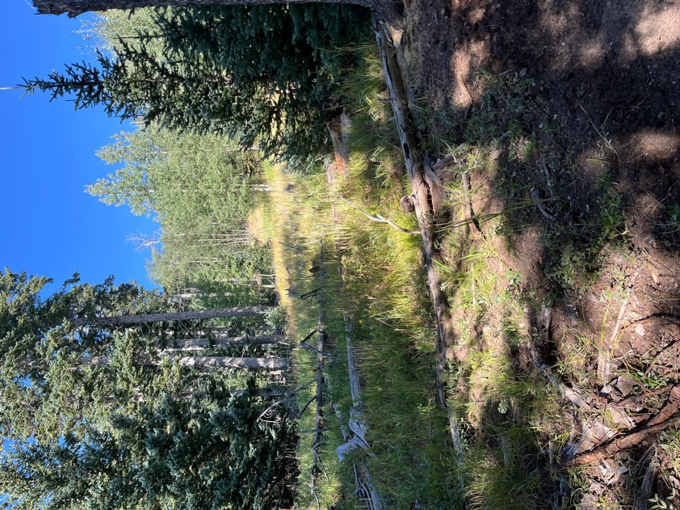 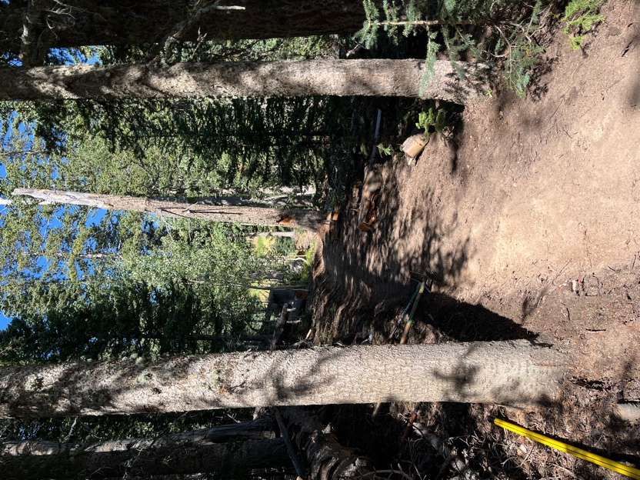

Reroute #2 moves through a wooded section and gives a peak at a meadow uphill.

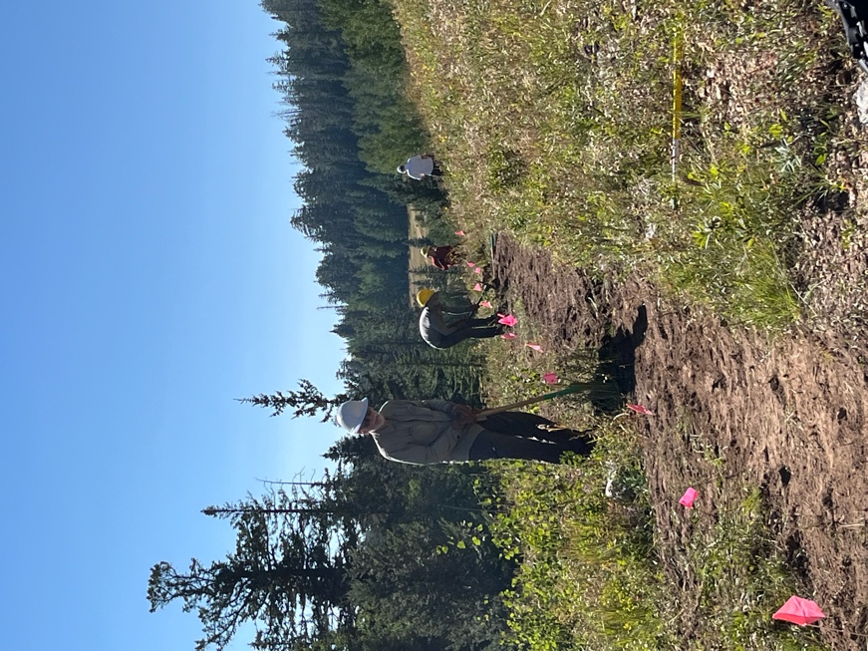 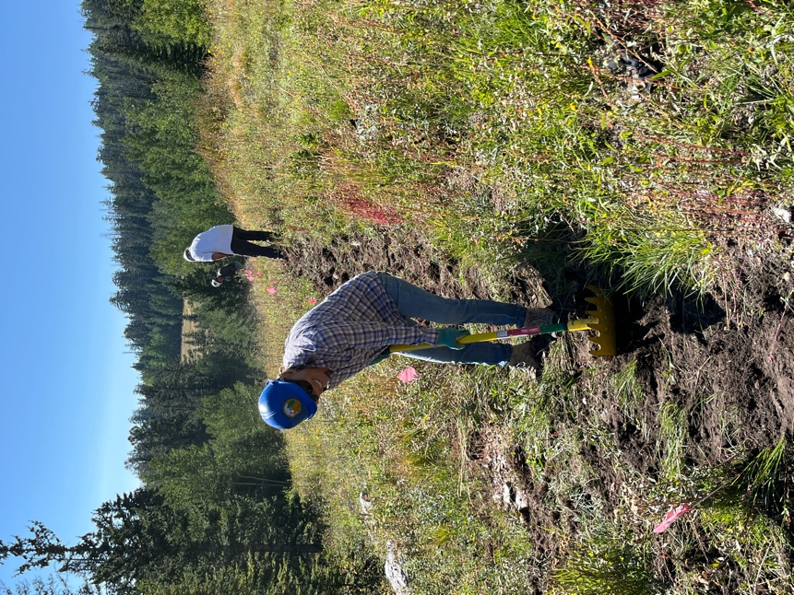

Scott, Eric M. Rich, John and Laura work reroute #1- lots of grass!

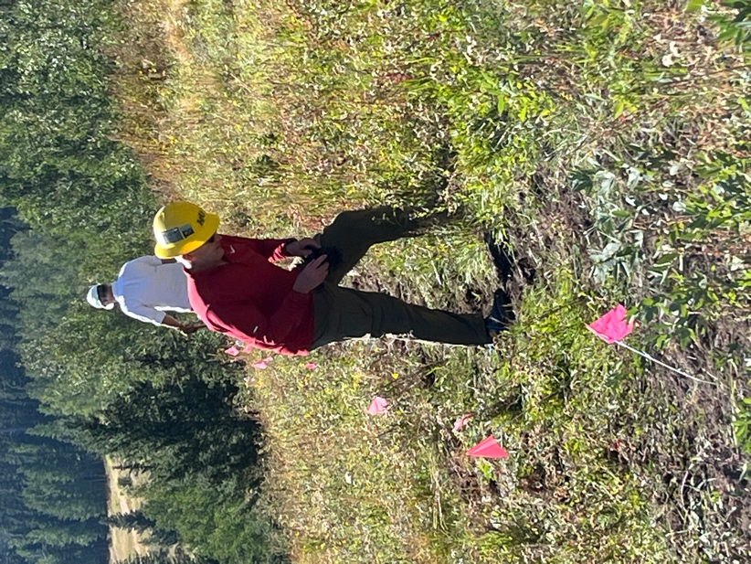 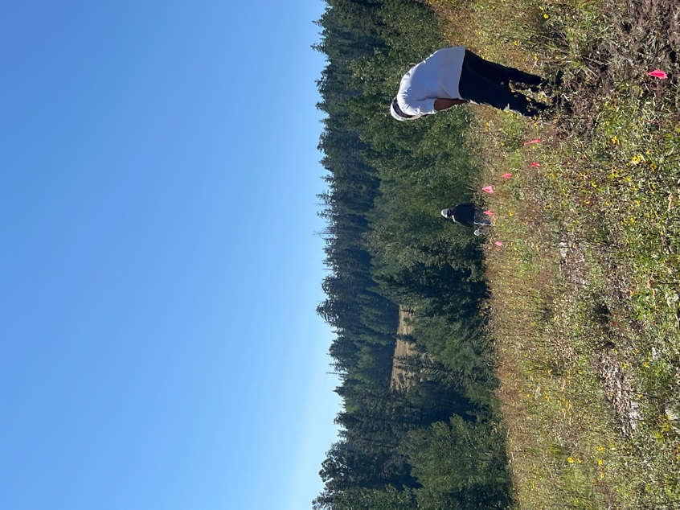

More reroute #1.

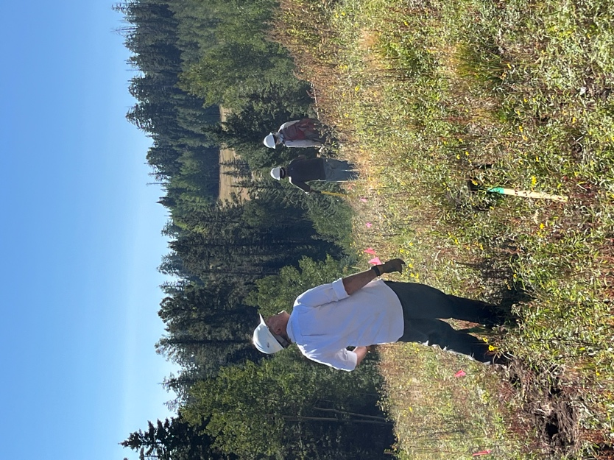 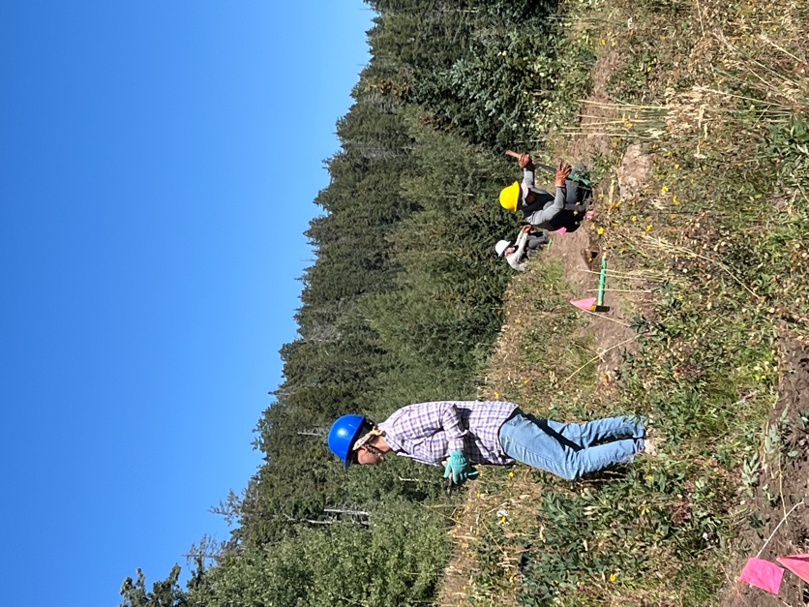

It’s a bird, it’s a plane…. I have no idea. Eric M. is stuck in a hole with a big rock.