**Report of FOSM Project to Buck and Split Two Logs near the Service Road Gate**

**at Ellis Trailhead, Wed., Sept. 11**

Sam Beard

On Wednesday, September 11, ten FOSM volunteers began processing two logs on the ground near the Service Road gate at Ellis Trailhead. These trees had been felled by Canyon Young, Sandia Ranger District Trials and Wilderness Program Manager. Wood from a 26-inch Engelmann spruce and several rounds from a white fir filled Mike Oliver’s trailer, and he hauled the wood to the woodlot at his home. The wood will be distributed to families in the East Mountain area by Wood Ministry members of the Mountain Christian Church on NM-14.

The volunteers working on this project were Mike Oliver, Sam Beard, Cliff Giles, Dennis Crowther, Dan Benton, Lou Romero, Eric Russell, Jerry Carroll, Betsy Galloway, and Don Carnicom.

Project photos are presented below.

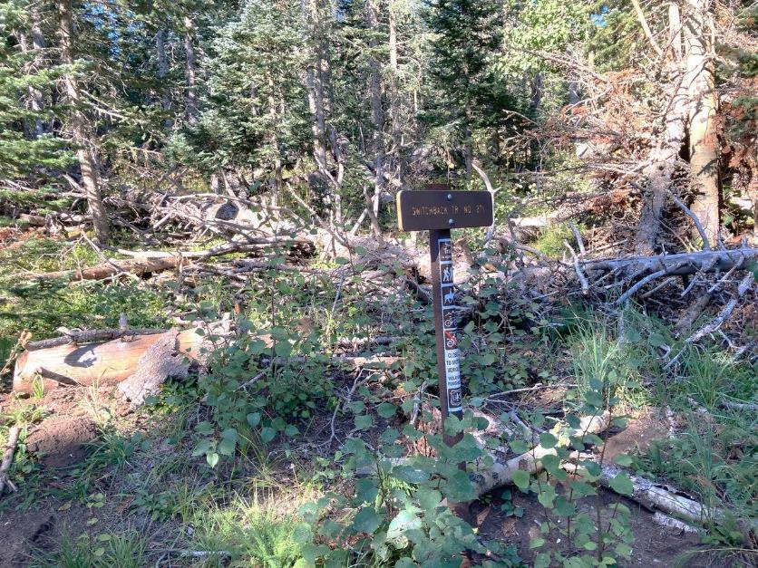

Lou Romero’s crew limbed, bucked, split, and loaded the long Engelmann spruce log lying diagonally across the picture from the

upper left to the center of the photo behind the sign. All photos by Cliff Giles unless noted otherwise.

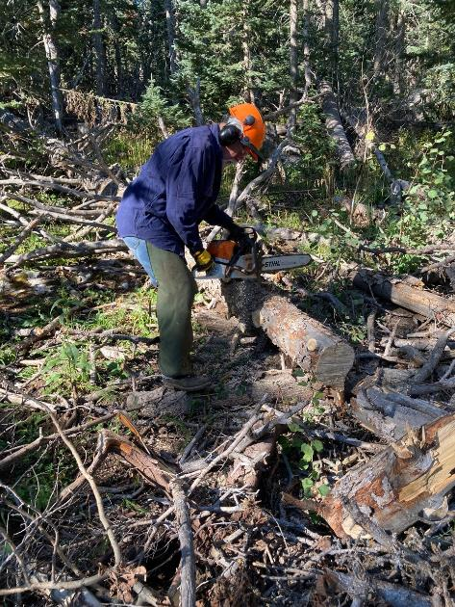

Jerry Carroll bucking the upper end of the long spruce. More than a cord of firewood

was obtained from this one tree.

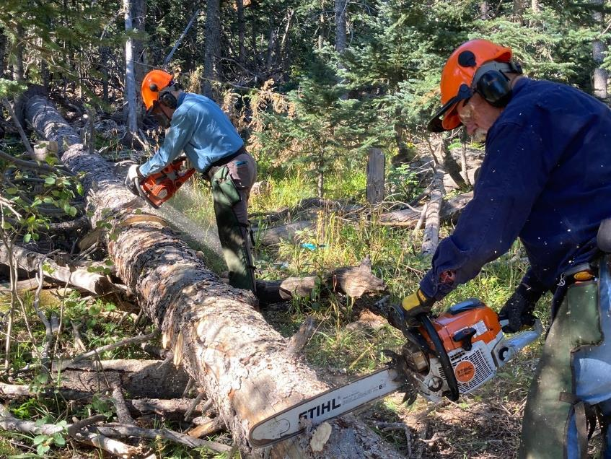

L to R: Eric Russell and Jerry Carroll bucking the spruce log.

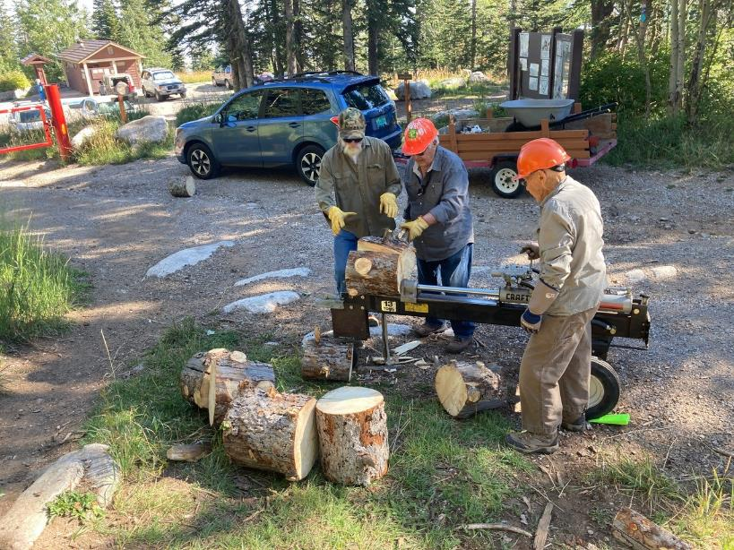

L to R: Mike Oliver, Lou Romero, and Don Carnicom splitting spruce rounds with Ellis Trailhead in the background.

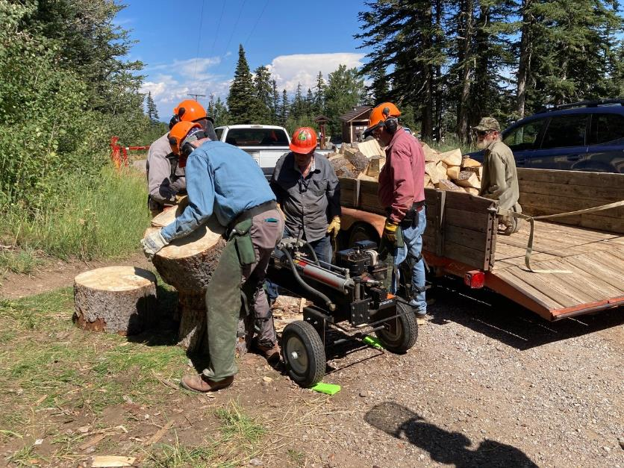

L to R: Eric Russell, Lou Romero, Jerry Carroll, and Mike Oliver splitting spruce rounds and loading them on Mike’s trailer.

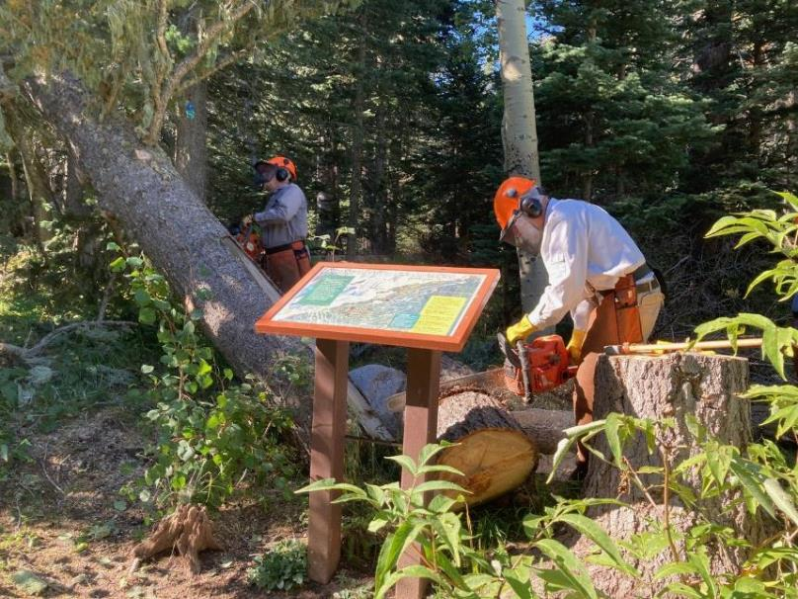

L to R: Dan Benton limbing the large white fir hang-up and Sam Beard bucking a round behind the map display at the first curve in the Service Road.

The map display was very close to this tree, but the sign was not damaged by the falling tree or the processing of the wood.

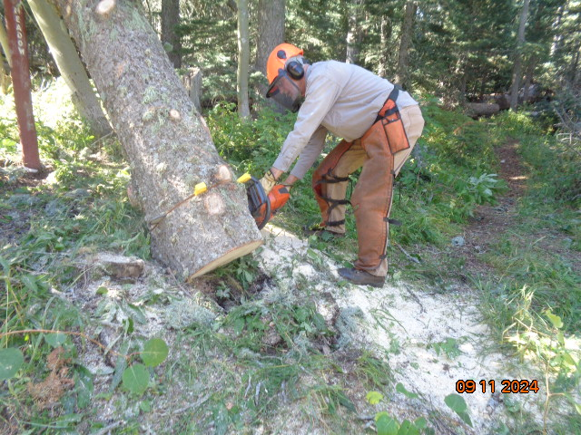

Dan bucking the hang-up to reduce its weight before Dennis Crowther pulled it to the edge of the road. Photo by Sam Beard

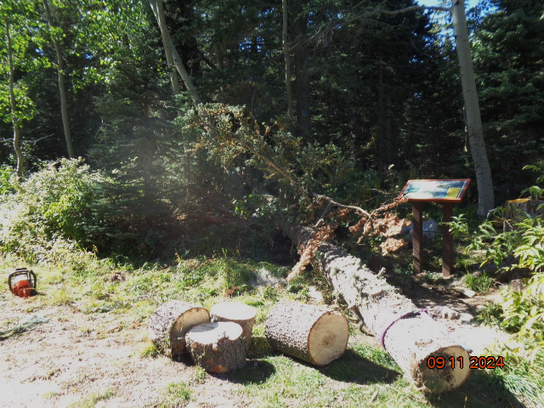

More rounds have been bucked from the fir trunk, and the trunk was pulled to the road by Dennis Crowther with the winch

on the front of his Jeep. Photo by Sam Beard

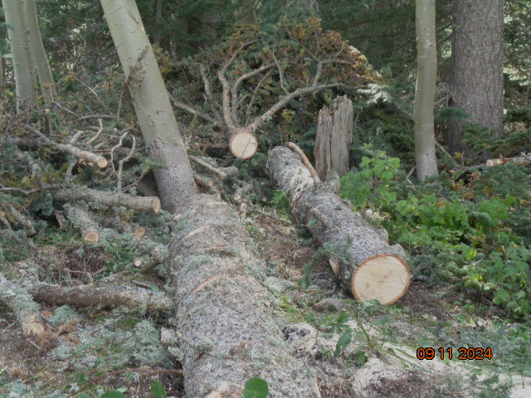

Long rounds bucked from the trunk and the upper part of the fir with many limbs. Photo by Sam Beard

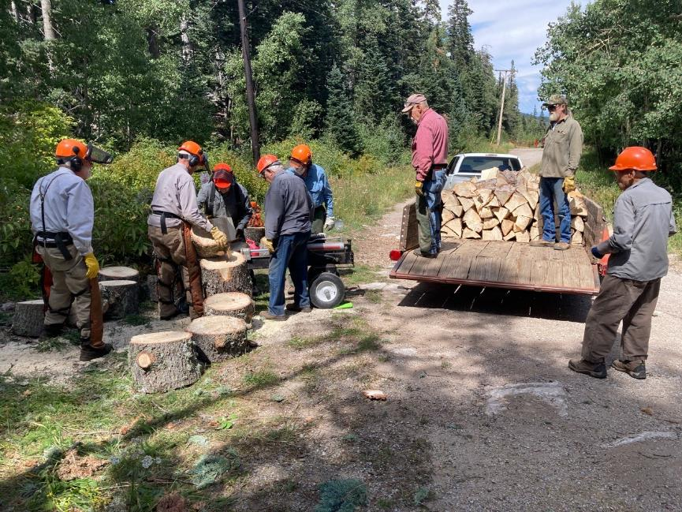  
The crew is splitting the fir rounds and loading them on Mike’s trailer.

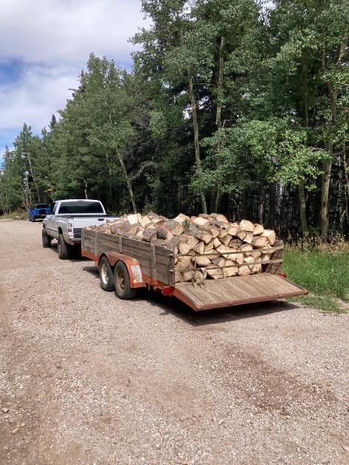

Mike is hauling the full trailer load to the church woodlot at his house.

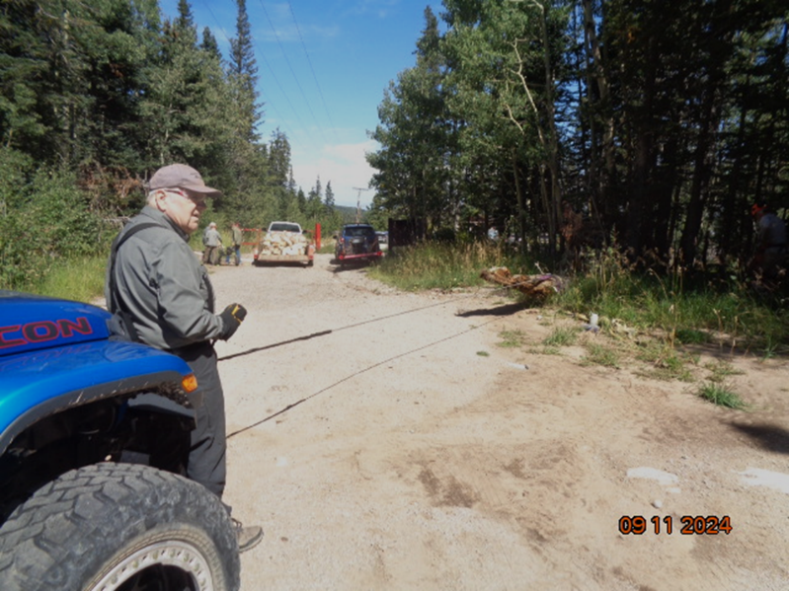

The fir tree that Dennis is pulling with his winch was a hang-up with its top over Rocky Point Trail. Photo by Sam Beard

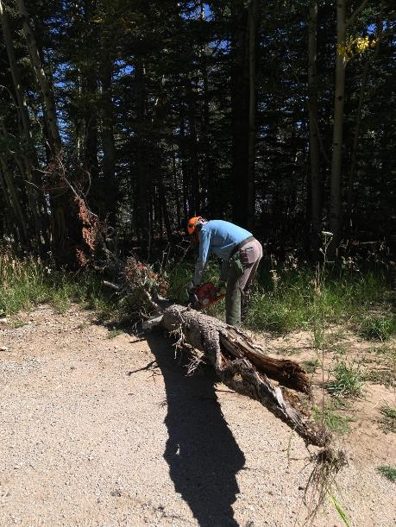

Eric is bucking the fir near Rocky Point Trail so that the top is not in the road.

Photo by Sam Beard