On the drive up we are greeted by pretty yellow flowers, deers and turkeys. A nearly full moon was poised over the Sandia crest.   
  
We performed a variety of tasks on this outing Including trail obliteration, finishing work, trail remediation, and new trail construction.  
  
We split up into several groups. The old section 1 was obliterated by Zay Claudia, Luis, Eric M and Cleave. The new section 1 required additional finishing work by Eric, Jim and Luis in order to meet the fussy FOSM standards. Moving down AS we passed through sections 2 through 6 we were delighted to see what a beautiful trail we had built. When we got to section 4, we were shocked to see that the previously obliterated area had been cleared off by persons unknown. This then required a re-obliteration using brush, logs and felled aspens. We also encountered extensive horse hoof damage, especially on sections 1 and 4, which required additional tread work. Part of the crew, including Bill, Claudia, Eric M and Byron continued onward to work on section 7. This section turned out to be approximately 320 feet long and could not be completed today. It was a long hike back. All in all it was a beautiful day and a lot was accomplished.

The crew consisted of 9 FOSM and 2 SRD: Byron Garner, Bill Perkins, Cleve Sharp, Claudia Bergsohn, Eric Messerschmidt, Eric Russell, Jim Houle, Mike Madden, Luis Cuadros, Jen Medina-Grey, and Zay (on chainsaw).

Pictures and report by Luis Cuadros.

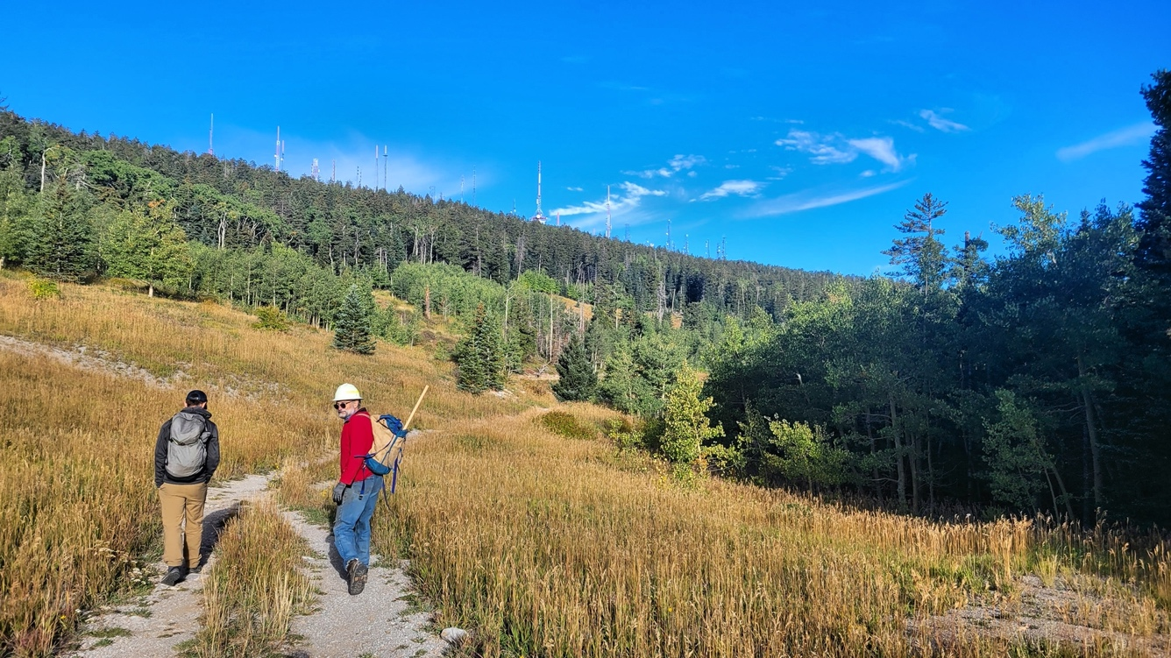

Jim and Eric M heading out on a beautiful fall morning.

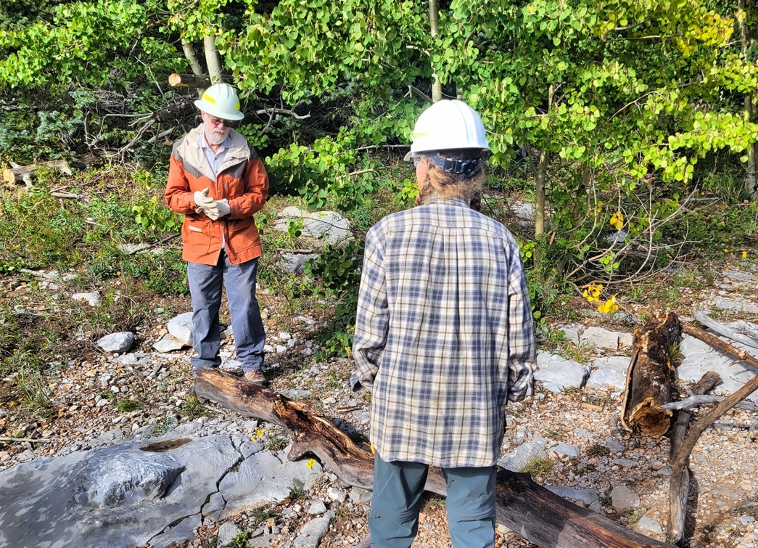  
Claudia and Cleve discuss the best way to obliterate a trail.

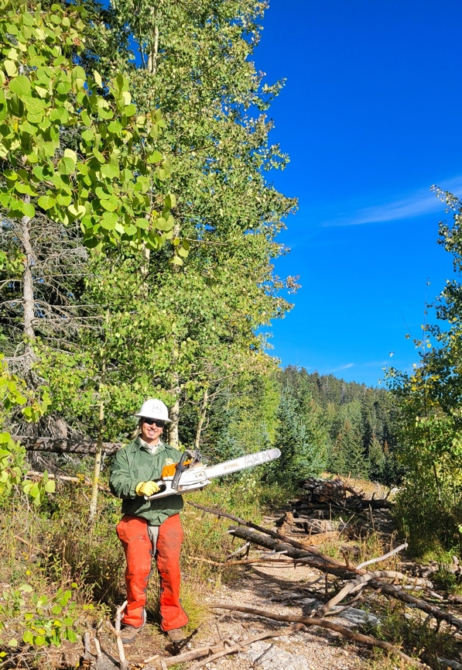 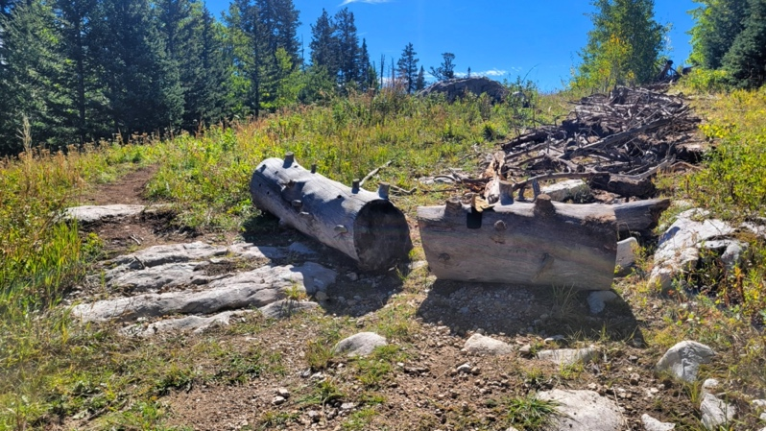

Vroom! Vroom! Zay with his chainsaw. Now this is obliteration!

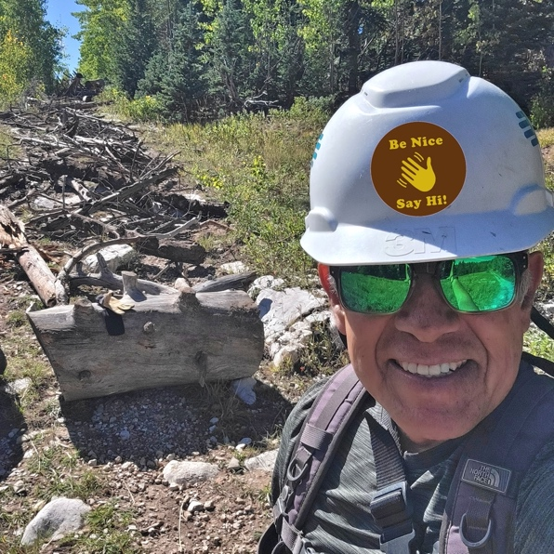 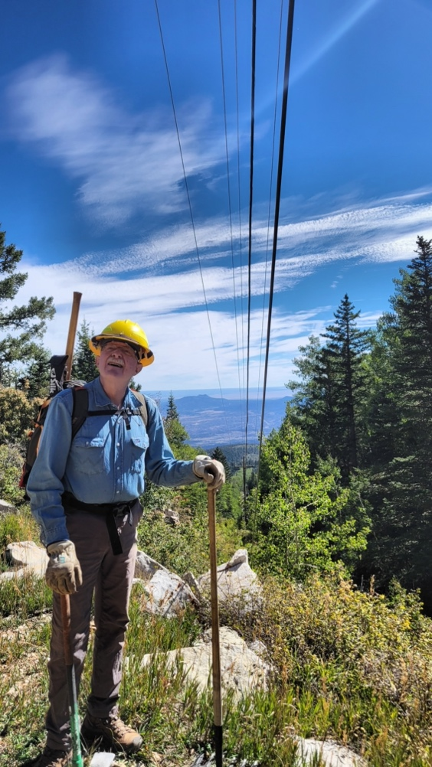  
Be Nice, Say Hi!  
Eric looks up at the power line wondering “isn’t this a little low?”

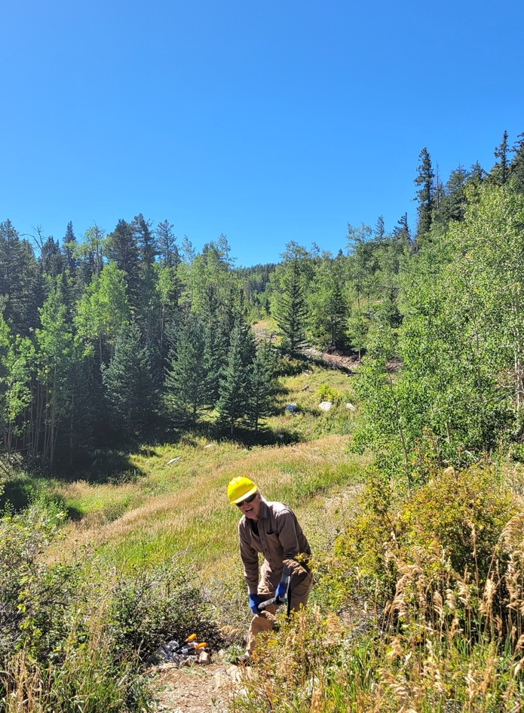 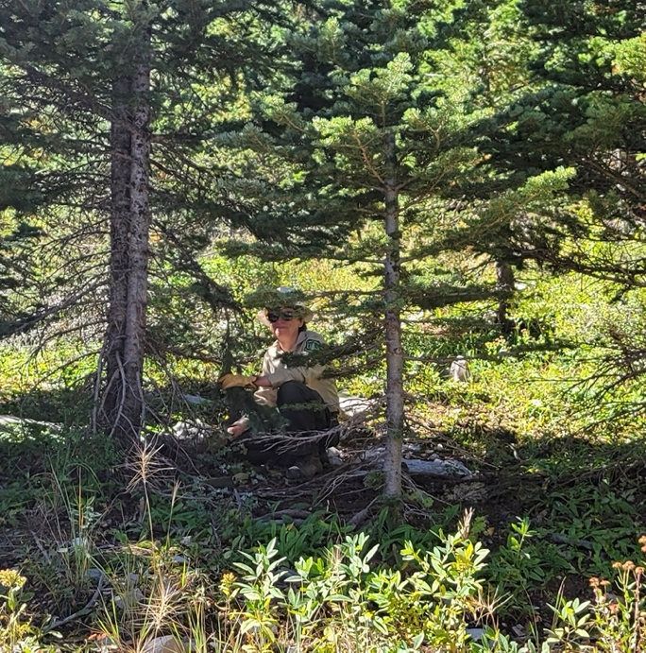

Mike looks up from his enthralling work. Who is that hiding in the forest?

Could it be Jen?

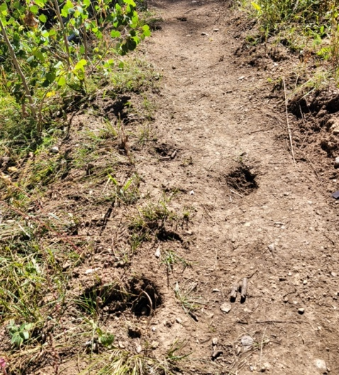 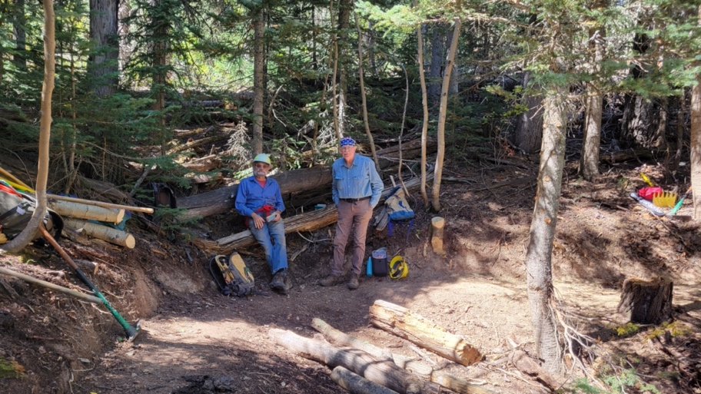

Horse hoof damage done by Did someone say lunch?

equestrians riding after recent rainfall. Jim and Eric R take a break.

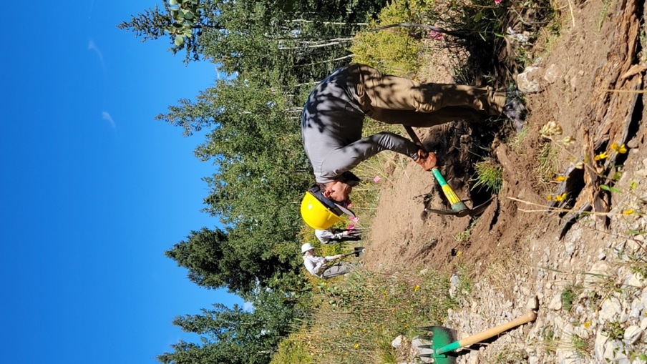 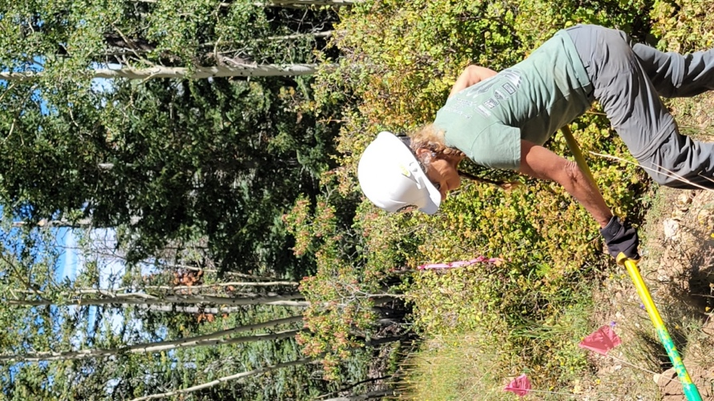

Eric M slicing new trail at the Claudia shows her famous

upper end of segment 7. Crouching Tiger technique.

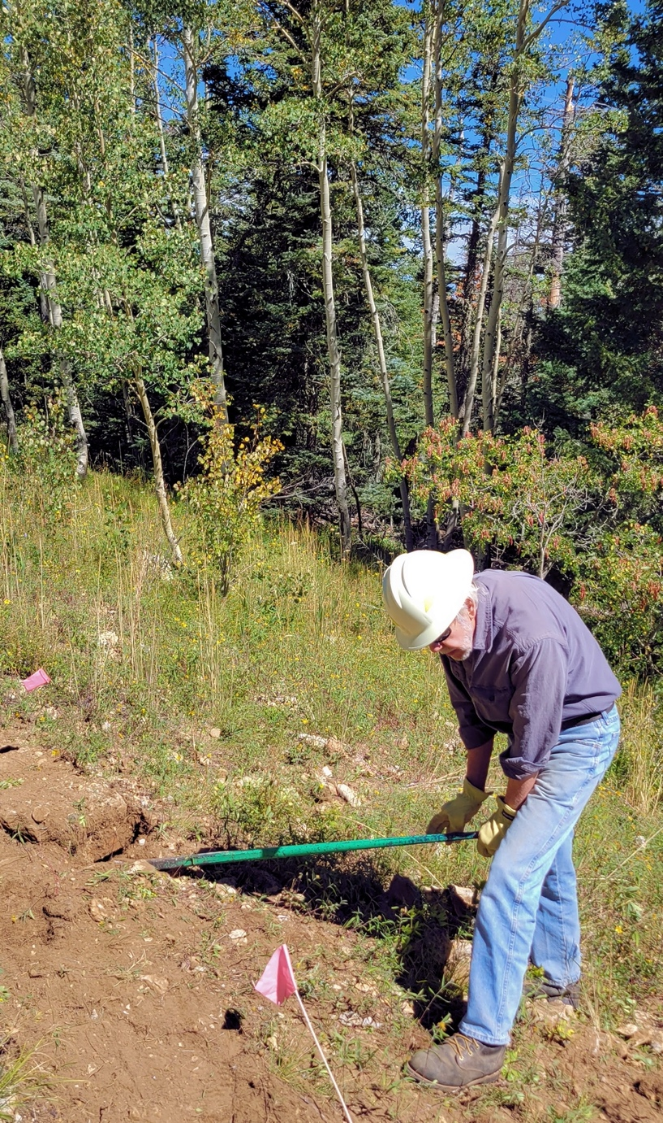  
Byron finds another behemoth rock to do battle with. Or did the rock find Byron?

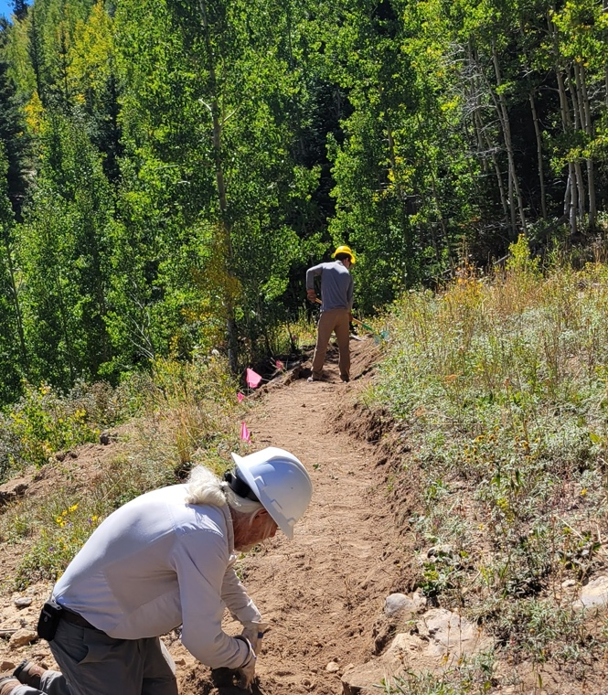 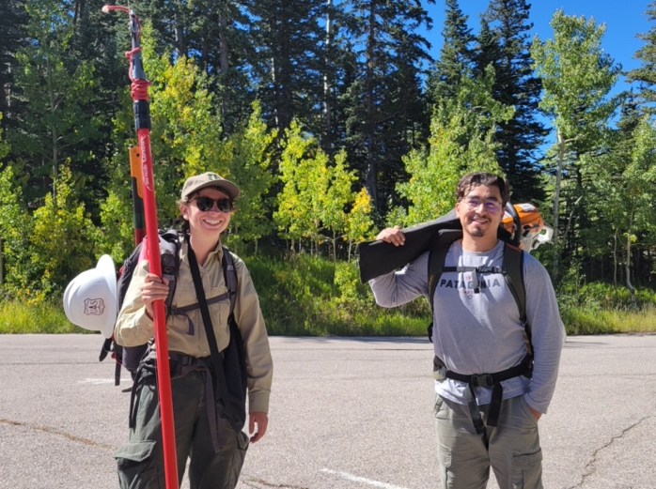

Bill resorts to digging with his hands as Eric M toils away in the distance.

Jen-Medina Gray and Zay at the end of a wonderful day of work.