Trail Maintenance Report: Monday, September 23, 2024

Byron Garner

On September 23, the Monday trail crew hiked 130 S and Faulty Loop from Canyon Estates to remove two reported trees. The first, an eight inch'er, was discovered to have already been removed but not reported. The second tree, a ten inch leaner was well above the trail with plenty of clearance and securely entangled in the crown of a support tree leaving us with no safe way or urgent need to get this one down. We did however find several intrusions and low overhanging branches which were cleared along with a four inch'er suspended across the trail like a tollgate.

The day warmed quickly and continuously reminding us all of this relentlessly hot summer that just won't let go though lunch and a shady respite at the junction was enjoyed by us all. This was also an opportunity to welcome Scott Christenson - a new and first time member to the Monday trail crew. The crew included Phil Cromer, Rene Archer, Scott Christenson, Jamey Browning, Dave McCreery, Ken Wilson, Chuck Logan and Byron Garner. Photos: Archer and Garner

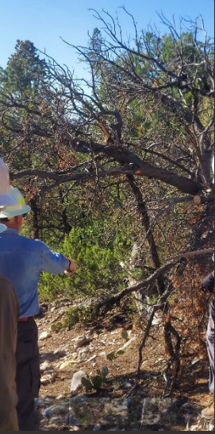Archer

A pesky intrusion about to yield to the pruning saw

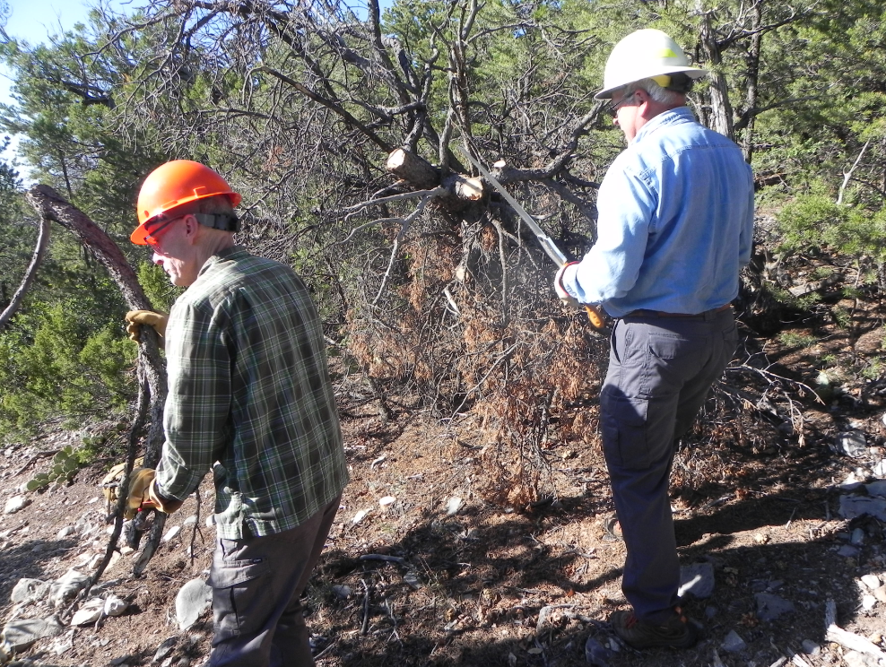

Scott and Dave finish off the intrusion

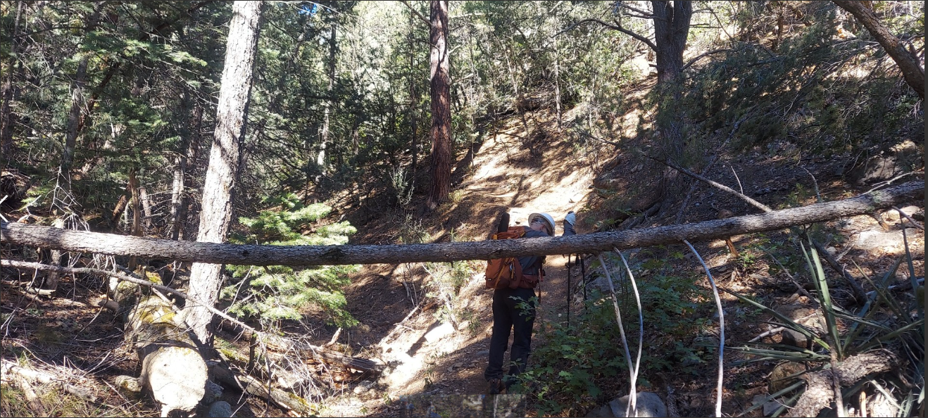The tollgate 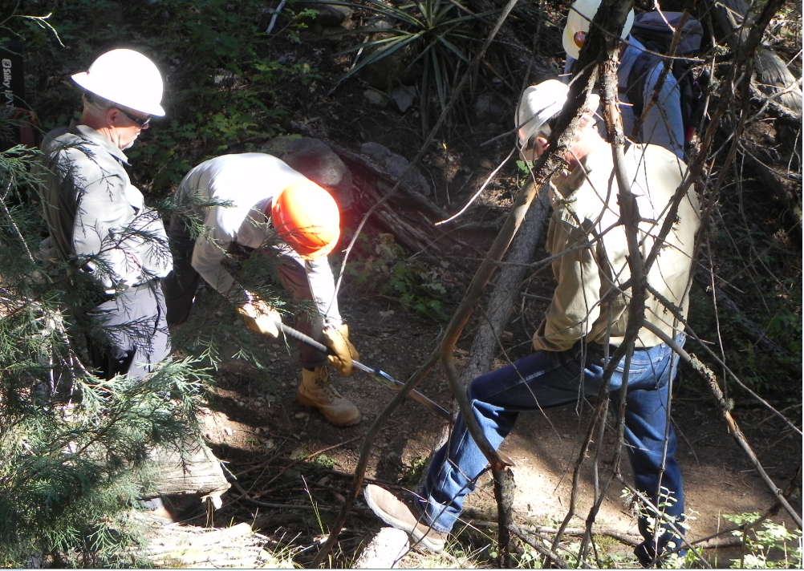

Jamey, Scott, Chuck and Dave make quick work of the tollgate

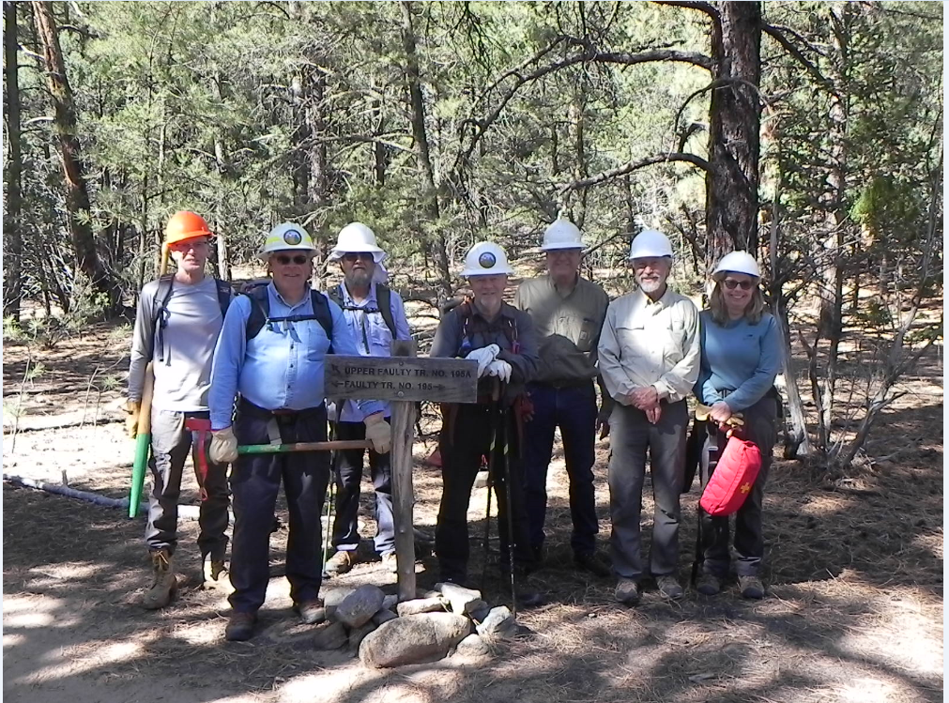

Scoot, Dave, Phil, Jamey, Chuck, Ken, and Rene