Thursday, 09/26/24: What a great day! After meeting at Ellis parking area, 10 volunteers hiked to the 7th reroute, about 1.3 miles out. It was a cool start but not as cold as some of the other mornings have been. The aspens are starting to change colors and the sky was a bold blue. When we got to the end of reroute #6 we found someone had taken all the obliteration materials off. Canyon came by to do some flagging and give us some direction on a curve on reroute #6. Laura worked on re-obliterating and Claudia and Rich fixed the curve on 6 while everyone else went to work on reroute #7. We finished #7 shortly after lunch and took the tools out to #8 for stashing.

Volunteers: Byron Garner, Bill Perkins, Becky Levinson, Claudia Bergsohn, Rich Fagioli, Eric Russell, Jim Houle, Laura Leon, Luis Cuadros, and Mike Madden.

Pictures: Laura Leon

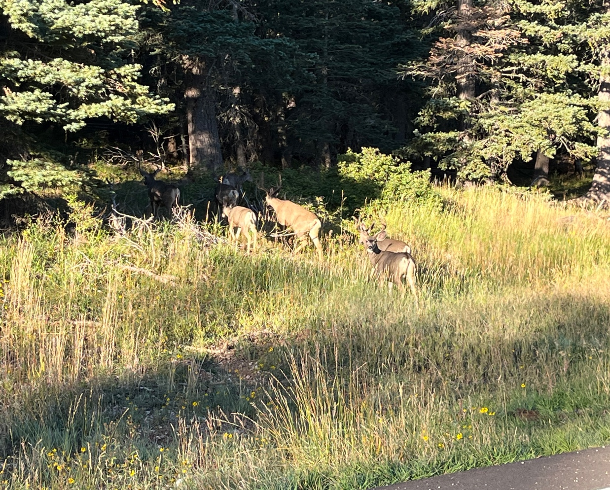

A group of 8 deer crossing the road.

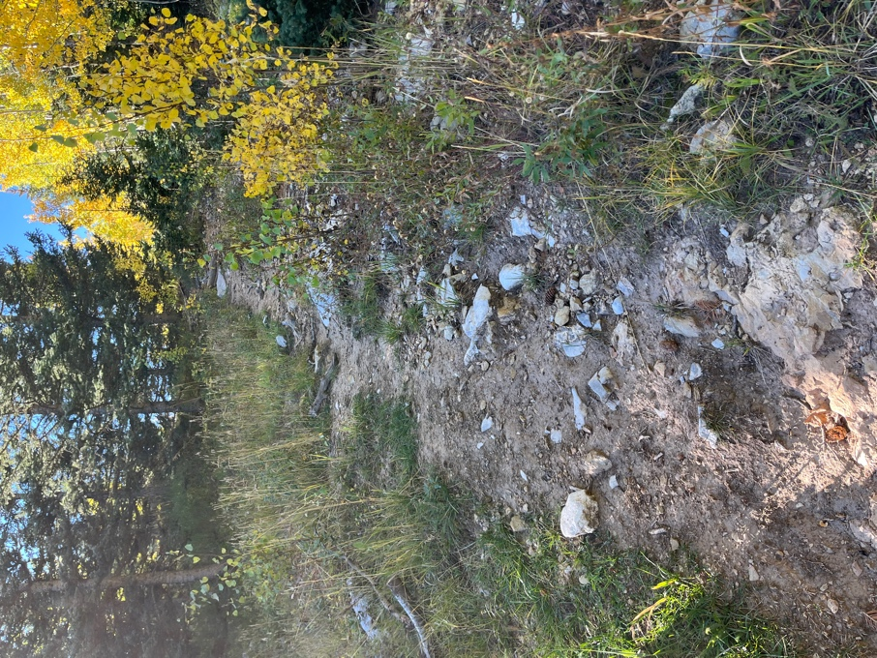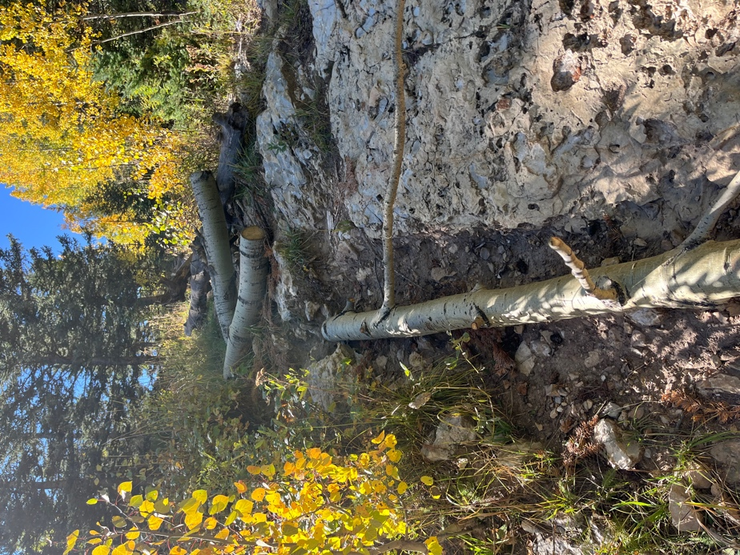

De-obliterated and re-obliterated again on reroute #6.

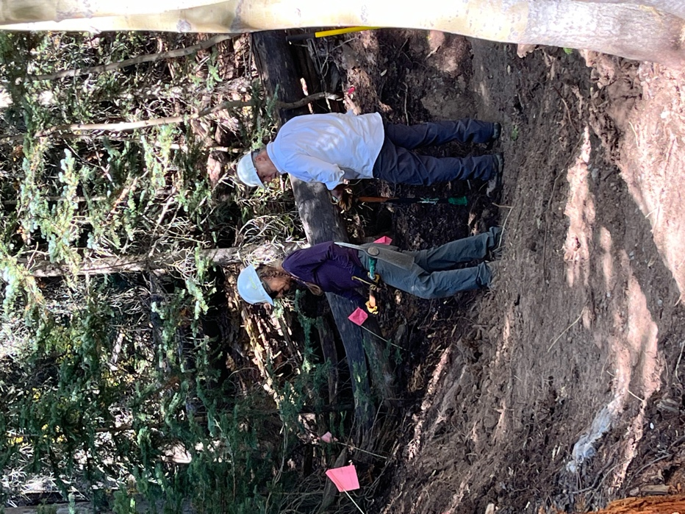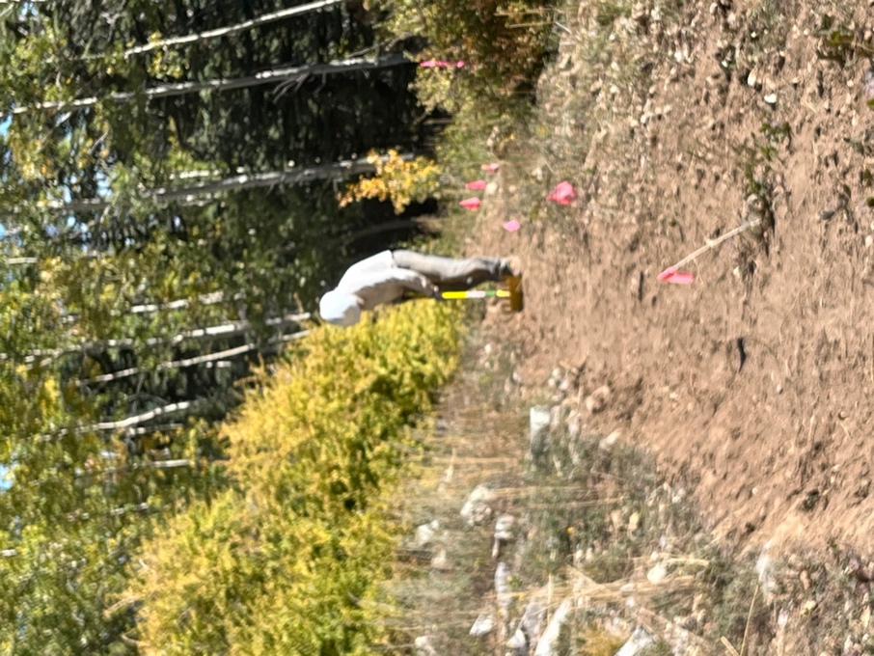

Claudia and Rich work their magic Bill always makes the trail look perfect.
on a curve at the end of #6.

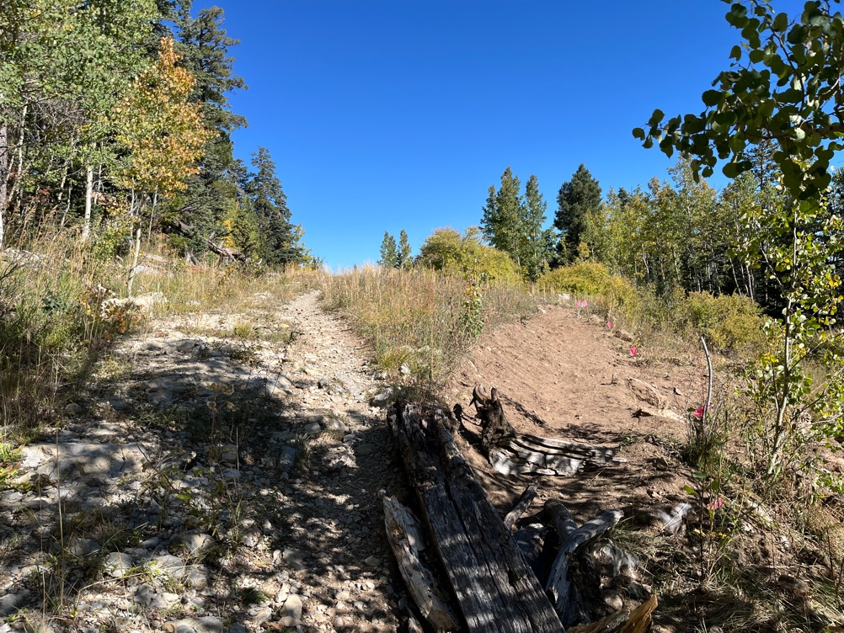 Old and new trail at #7.
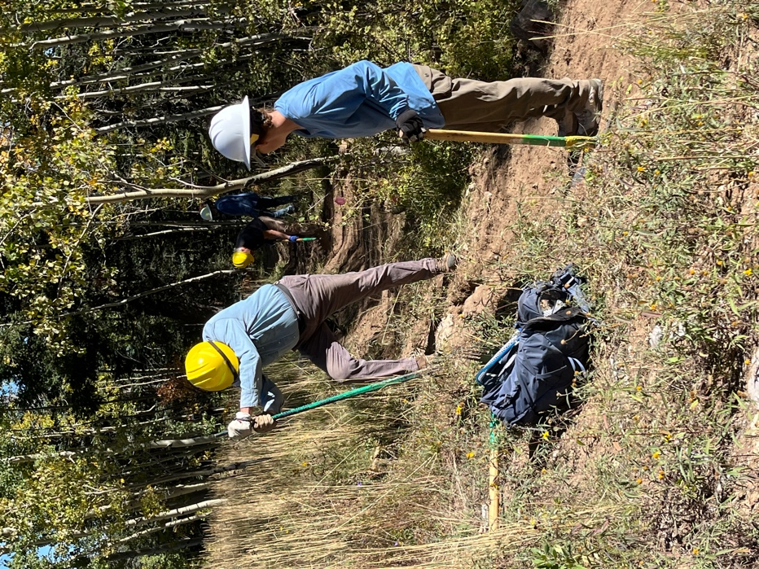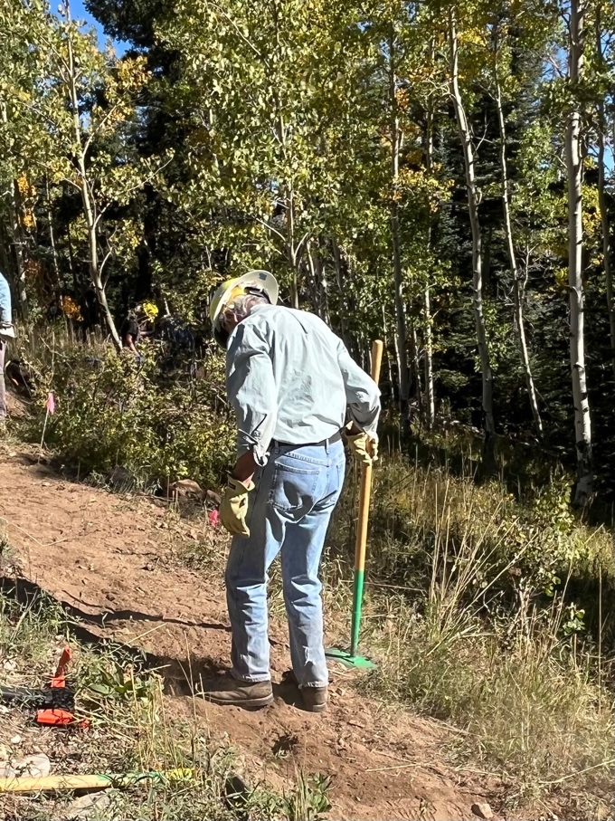

Becky and Eric moving out BIG rocks. Byron tamping down soil after
removing a rock.

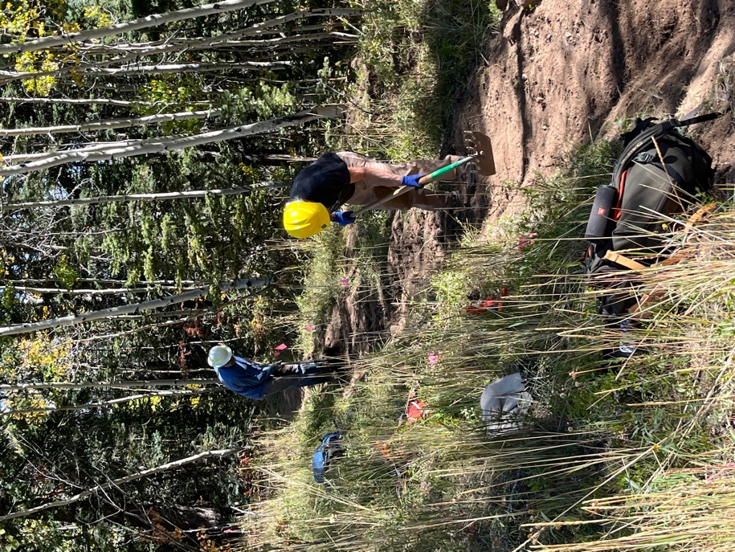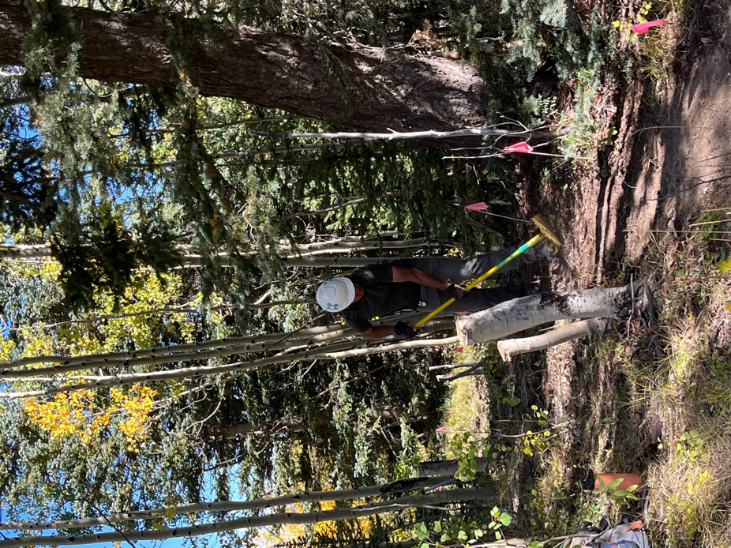

Mike, Jim and Luis taking care of business.

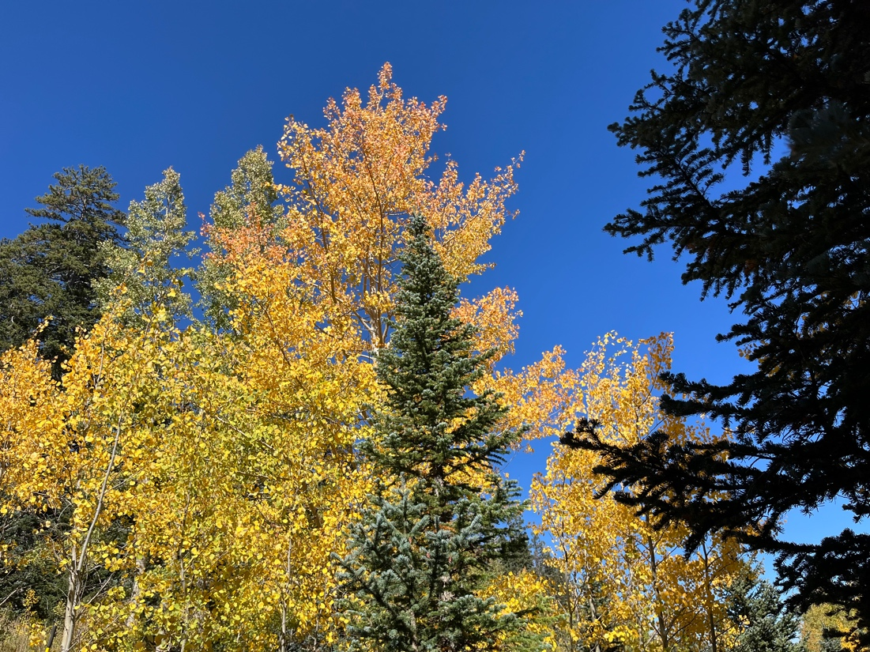

Fall colors are starting to show while wild flowers are starting to fade.

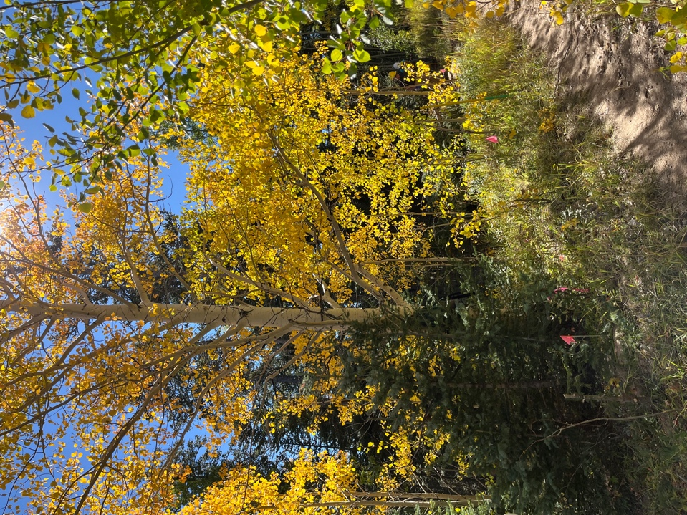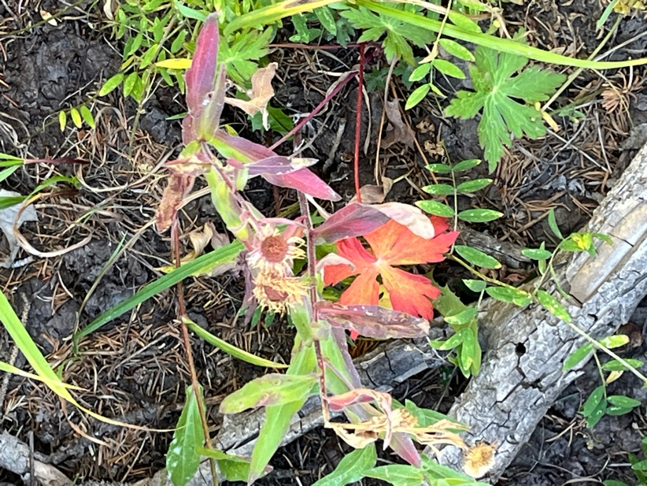

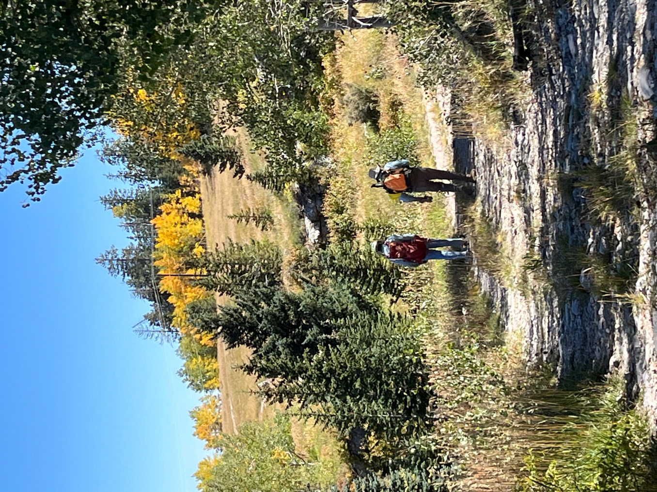

A long hike back to the parking area is always better with a friend.
Eric and Byron make their way.

