**Report of the FOSM Project to Cut Brush for Better Driver Sight Distance at the Intersection of Cienega Road and the Crest Highway on Wednesday, October 2, 2024**

Sam Beard

On Wednesday, October 2, eight FOSM volunteers cut brush at the intersection of Cienega Road and the Crest Highway to improve driver sight distance for safe passage through the intersection. The crew used the two FOSM power brush cutters and chain saws. They also cut brush around the large Cienega Canyon/Sulphur Canyon Picnic Areas sign and along the road to Sulphur PA. With the large number of equipment operators, the project was completed before lunch.

The volunteers were Dan Benton, Eric Russell, Cliff Giles, Jerry Carroll, Sim Cook, Steve Roholt, Mike Madden, and Sam Beard.

Project photos are presented below.

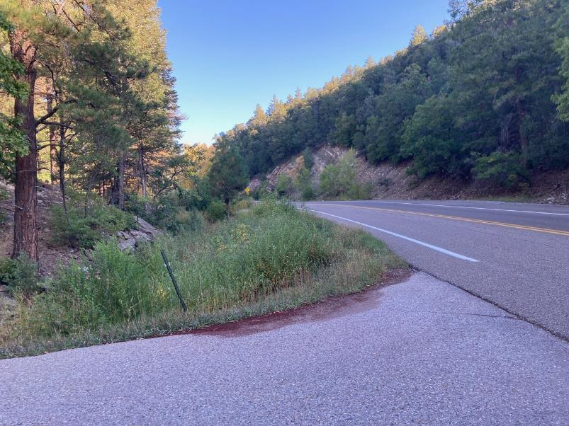

View up the Crest Highway showing the brush growing along the stream that reduces the driver sight distance.

All photos by Cliff Giles

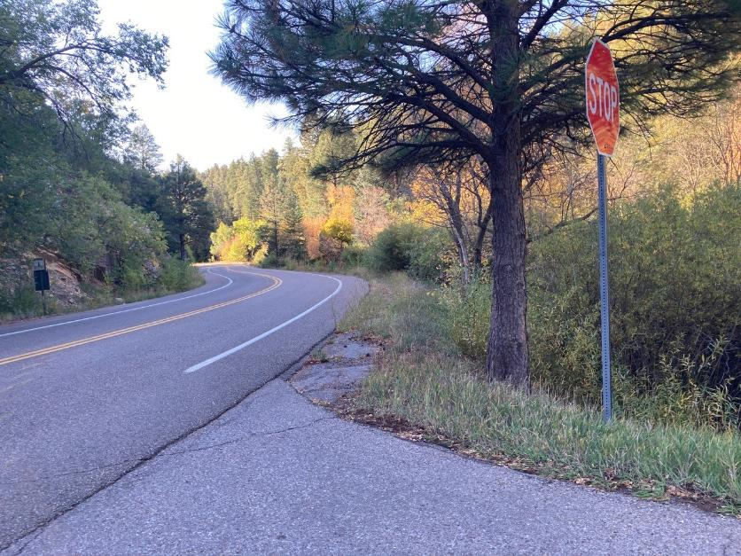

View down the Crest Highway showing the tall brush near the stop sign.

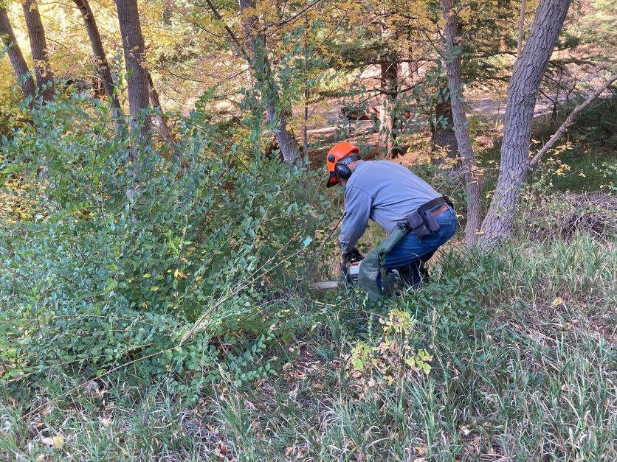

Jerry Carroll cutting brush with his chain saw in the upper part of the area.

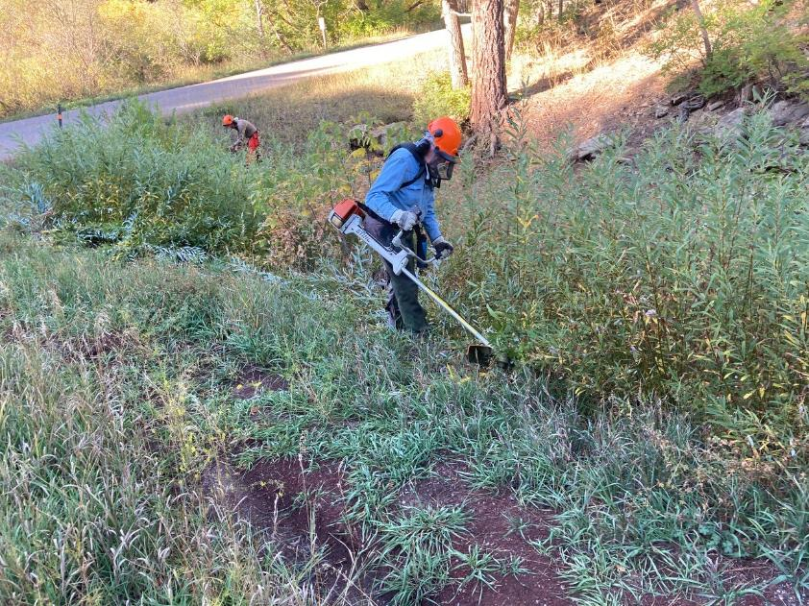

Eric Russell using the large Stihl brush cutter to cut brush along the stream that flows from a spring near Doc Long Picnic Area.

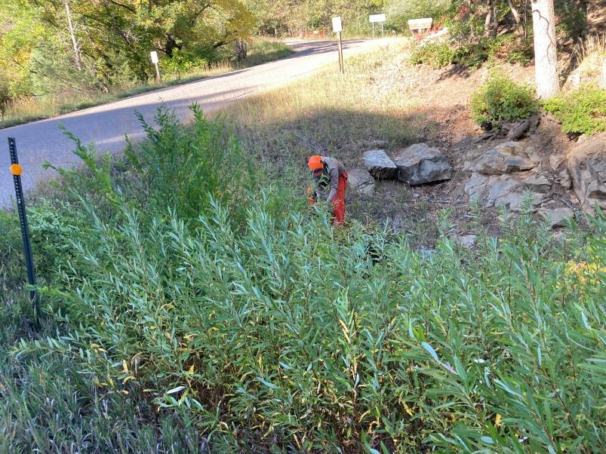

Mike Madden using a chain saw to cut brush near the large culvert under the road. Water was flowing in the stream, and just upstream

of the culvert was a large pool of water which made access to the brush difficult.

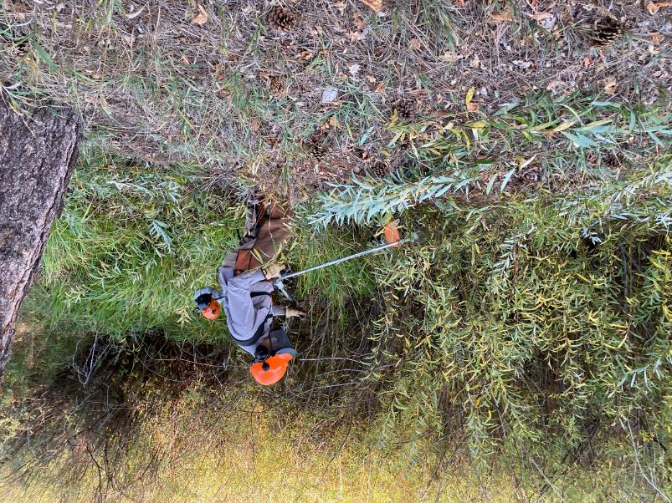

Dan Benton using the small brush cutter along the stream.

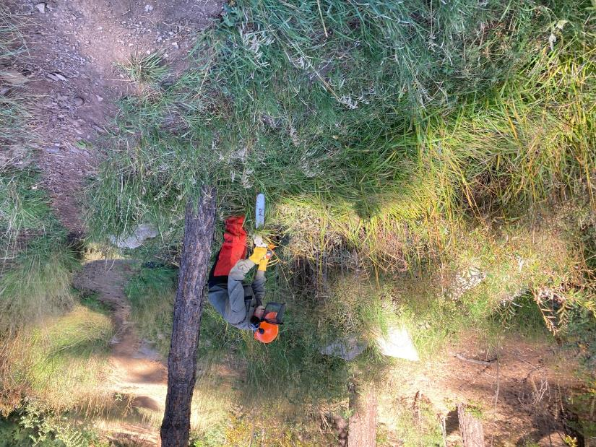

Sam Beard using a chain saw to cut brush near the one pine tree in the area.

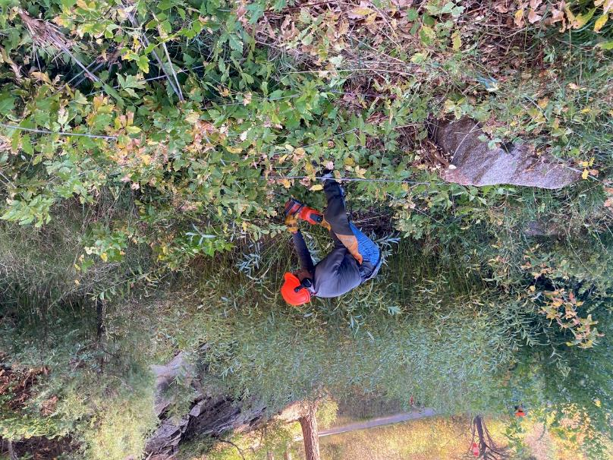

Steve Roholt using the Husqvarna battery-powered chain saw cutting brush along the stream.

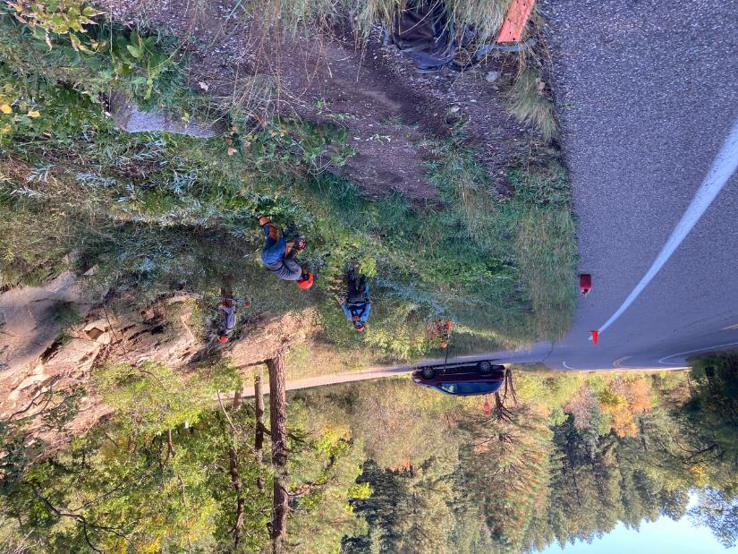

Two chain sawyers and two brush cutter operators removing brush in the lower part of the area

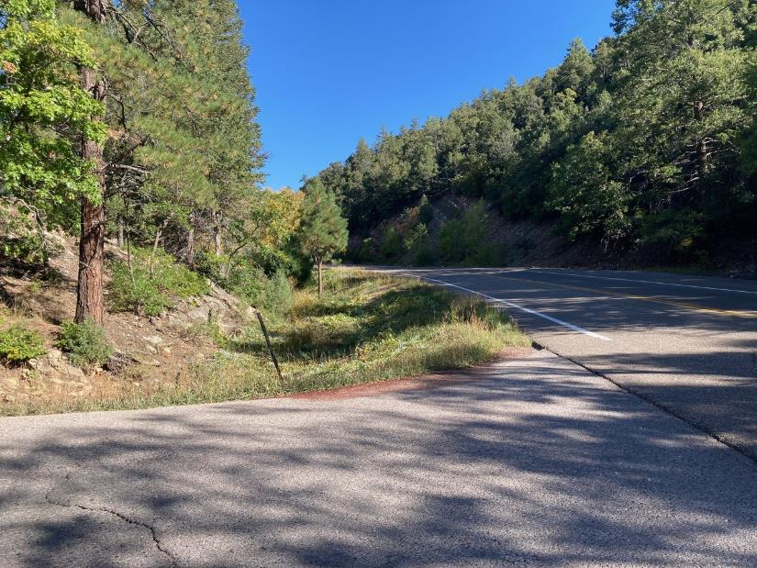

The sight distance up the Crest Highway is much better after the brush was cut.

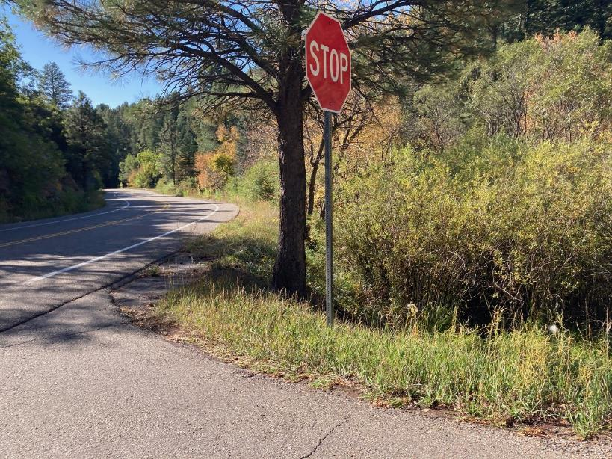

The sight distance down the Crest Highway was improved.