Thursday, 10/03/24: We did it! Ellis reroutes are finished! Twelve weeks of working on Ellis has been a treat. We’ve watched as the flowers bloomed, then the grasses and now, with the weather cooling, the aspens blazing. The most amazing crew ever gave it their all on Thursday and the 10 volunteers and the 3 SRD crew (Dorothy, Zay and Chris) pushed through a long day and a long hike out with tools. The last 2 reroutes, #8 and #9 were finished and the obliteration completed. We even managed a cranky hiker who “just doesn’t understand” why we were out there messing with the trail. Thanks to everyone who has participated over the last 12 weeks- you helped make this job a success!

Volunteers: Luis Cuadros, Laura Leon, Cleve Sharp, Bruce Hasche, Mike Madden, Eric Messerschmidt, Eric Russell, Jim Houle, Claudia Bergsohn, and Byron Garner.

Pictures: Luis Cuadros and Laura Leon

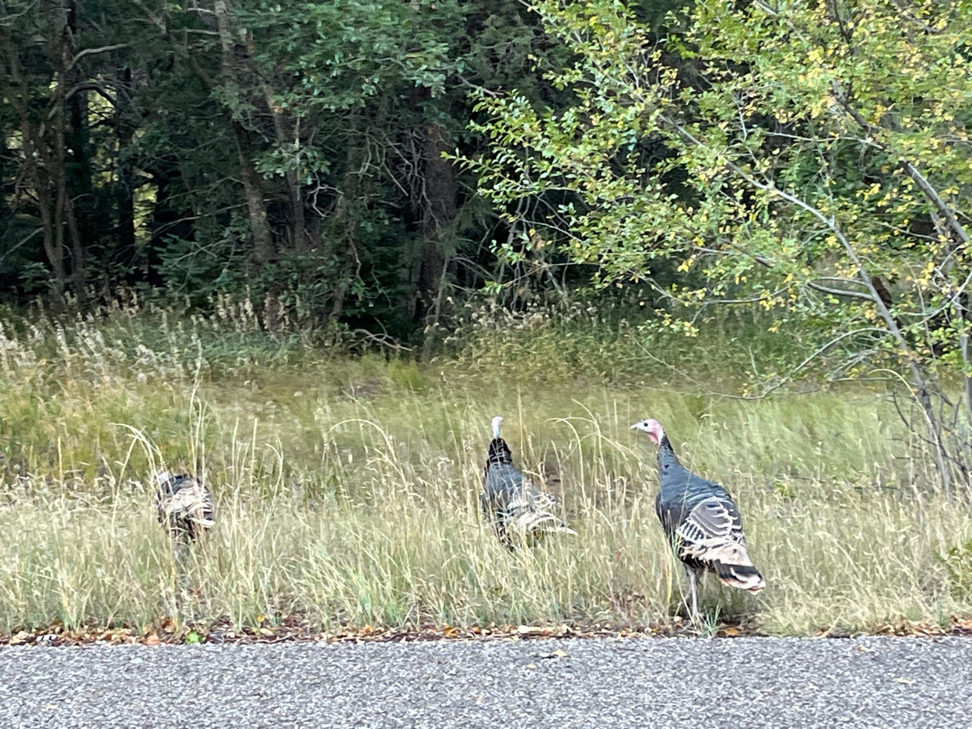

Turkeys are everywhere in the mornings!

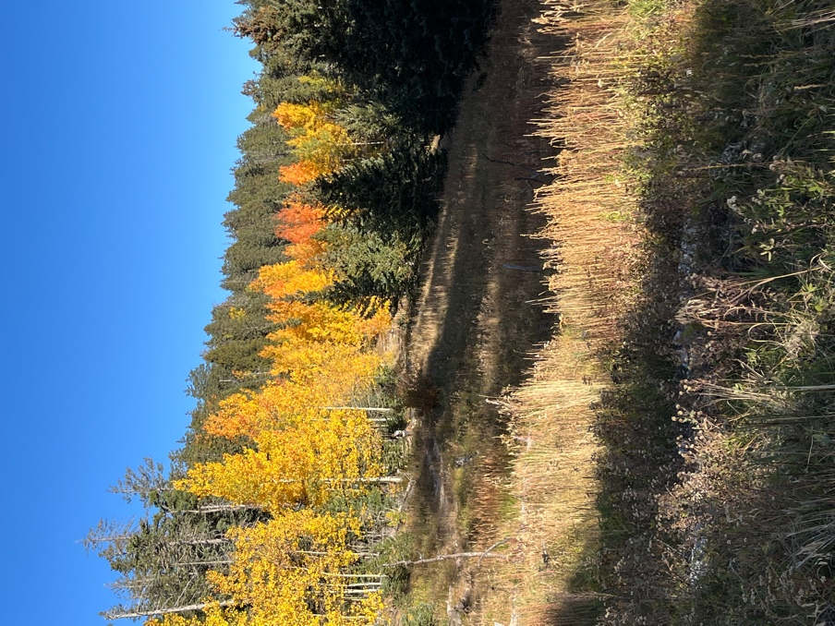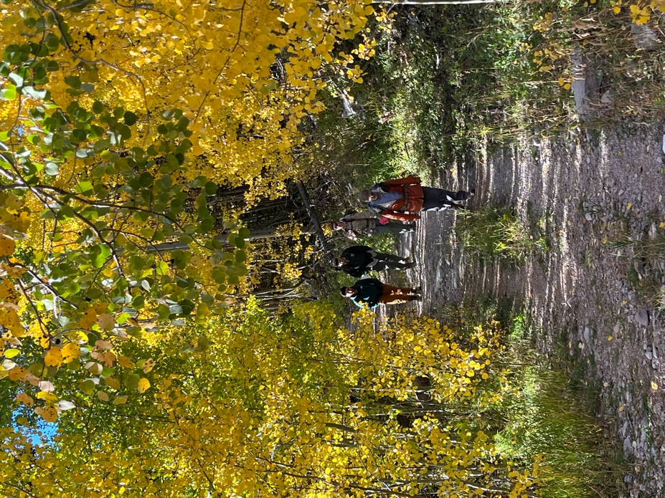

Hiking in.
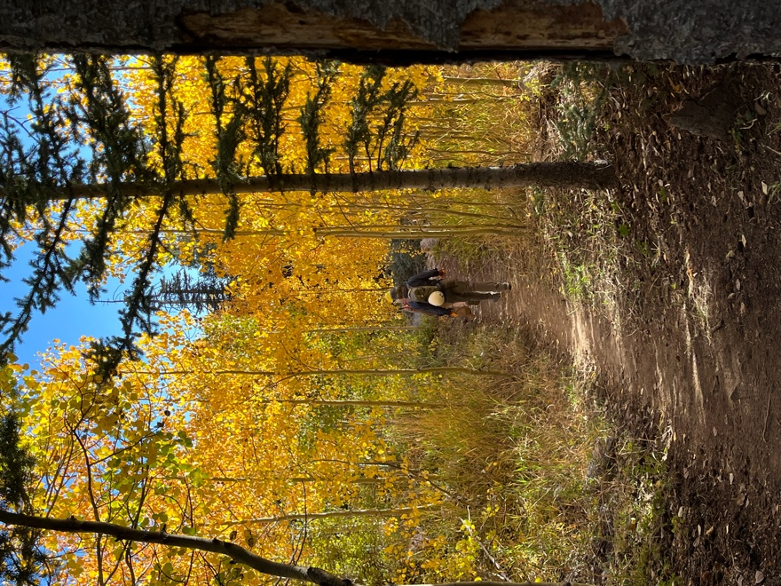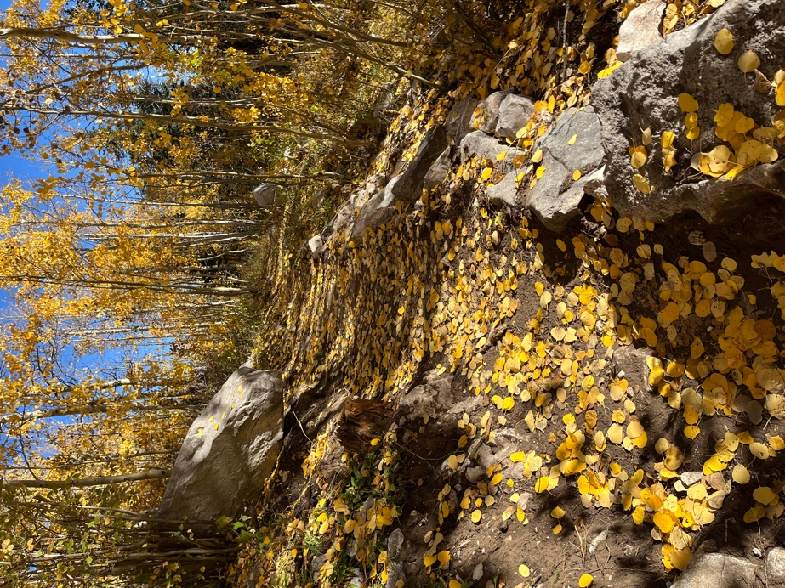
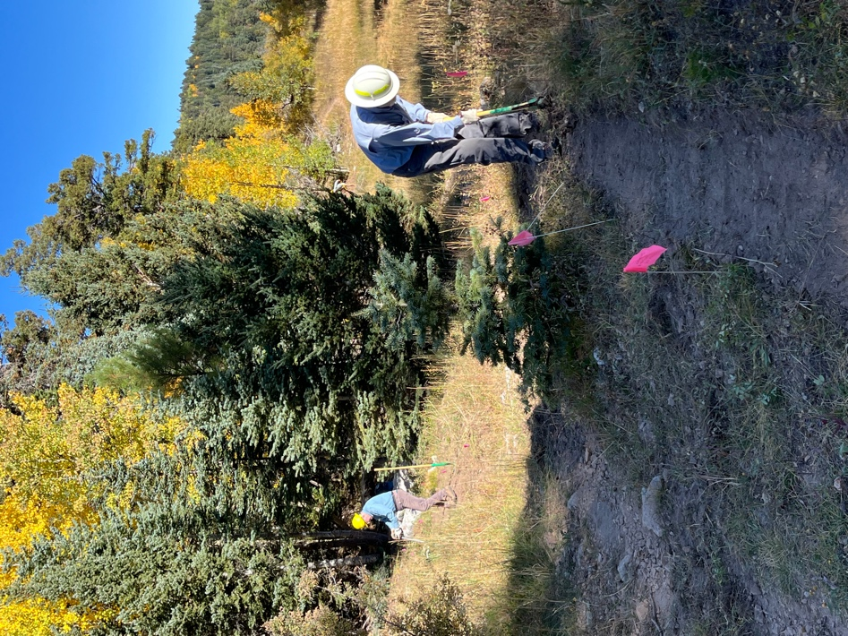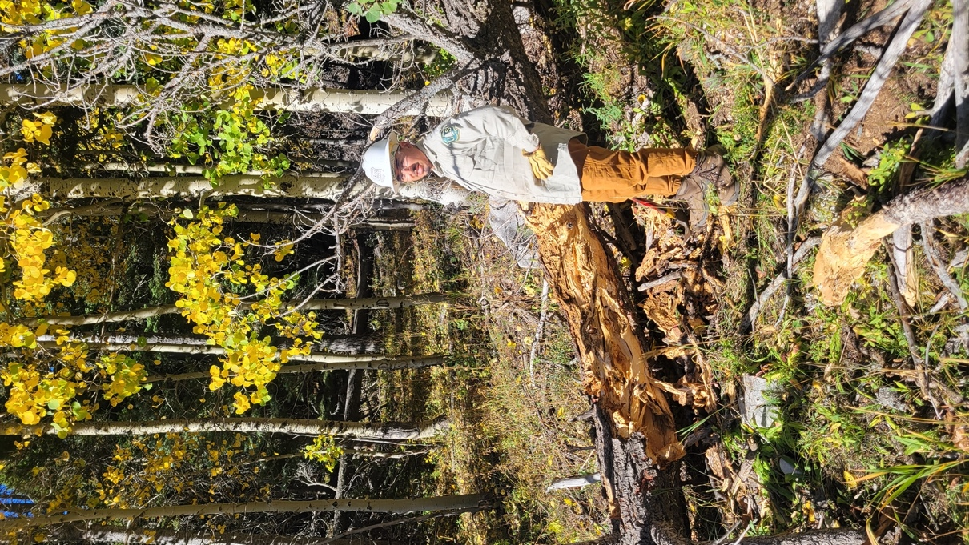

Eric R. and Cleve get started on #8. Zay takes on a log at the end of #8.

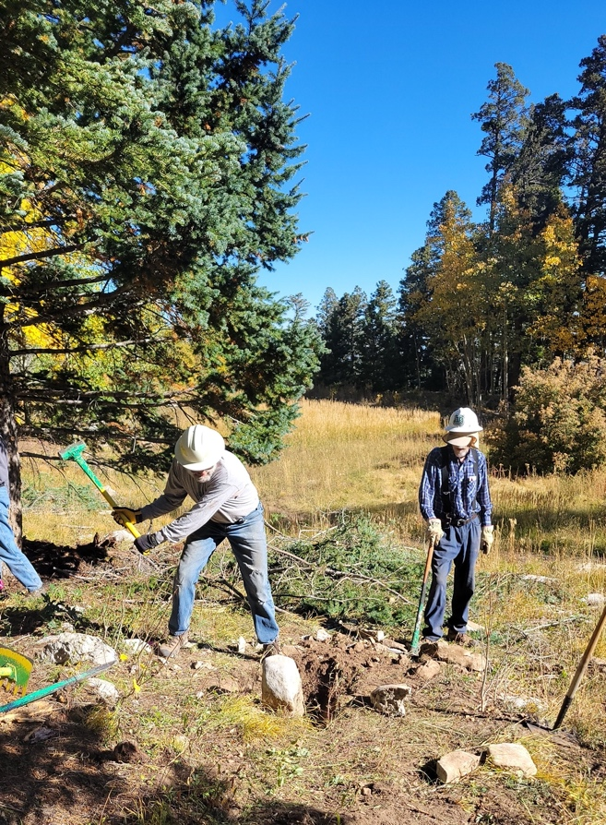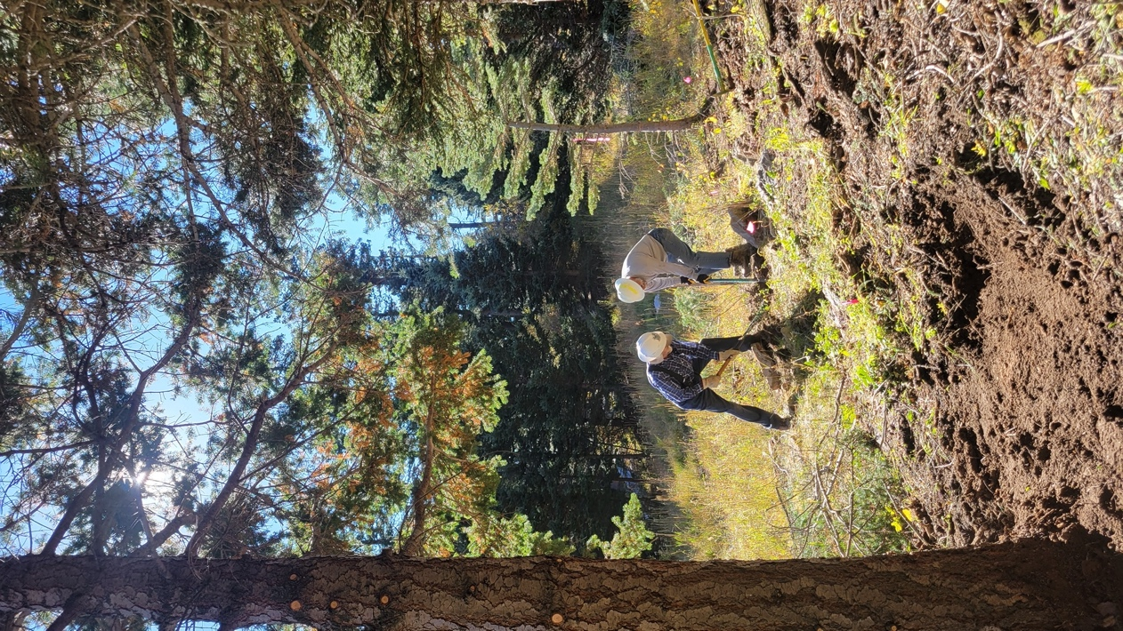

Jim and Bruce – the rock wrestlers!!

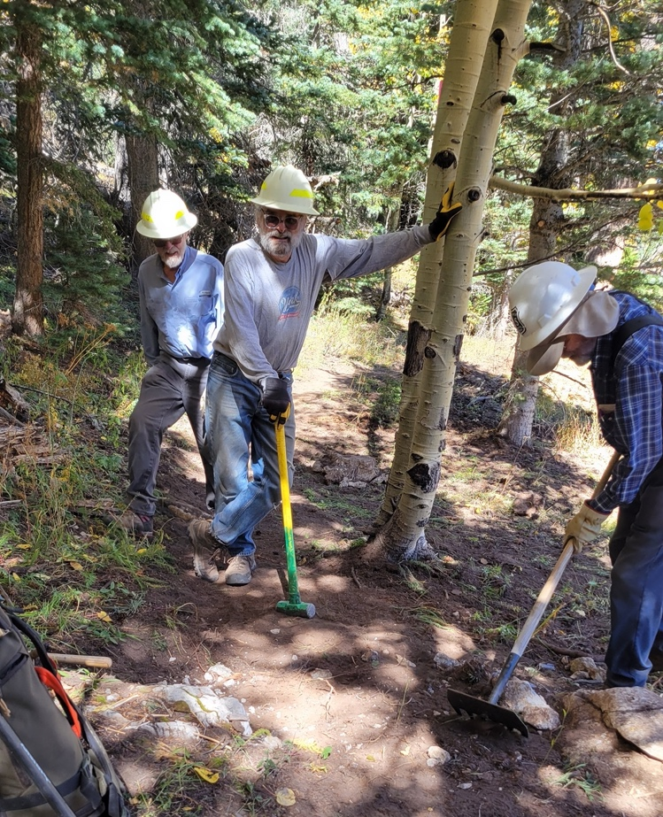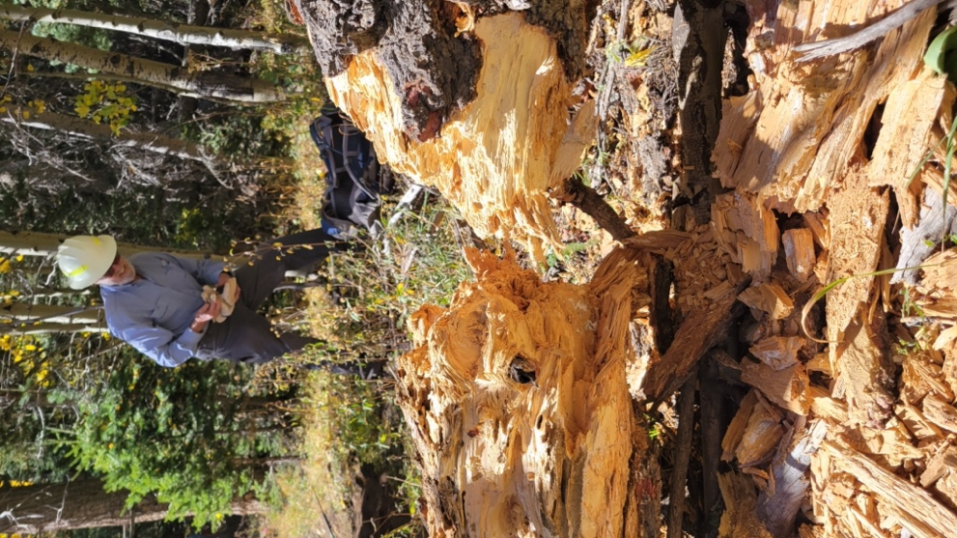

A job well done! Cleve checks out Zays work and gets ready
to move sections out of the way.

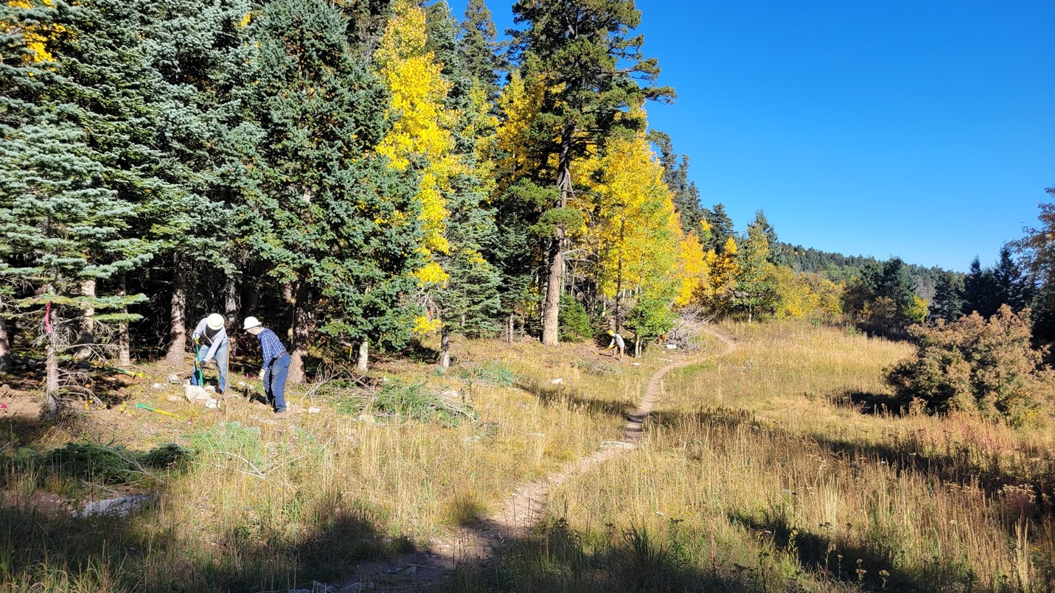

Jim and Bruce clear the rocks and Eric M. digs trail.

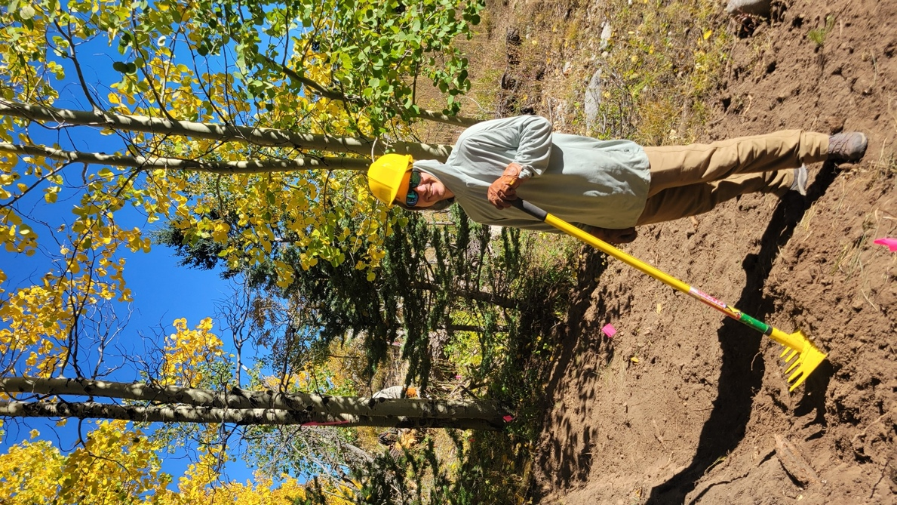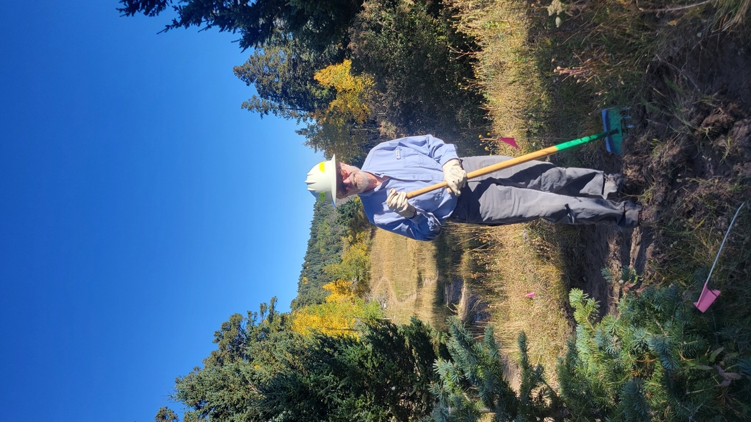

Eric M. and Cleve finish up #8 and then it’s off to #9 for lunch.
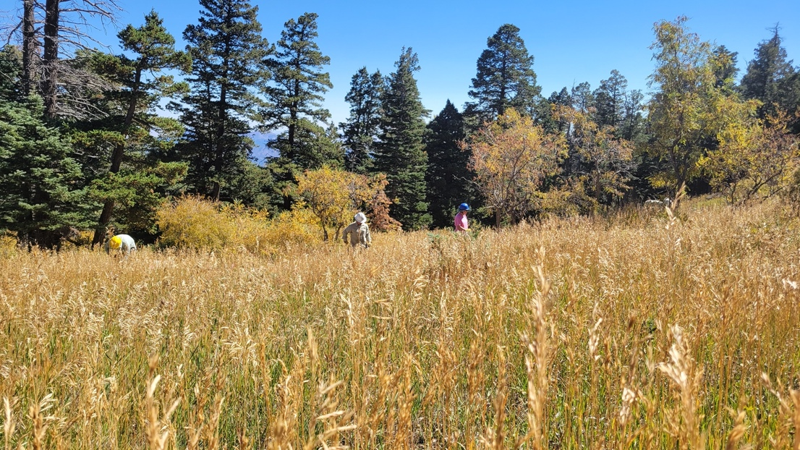 A bit grassy here.
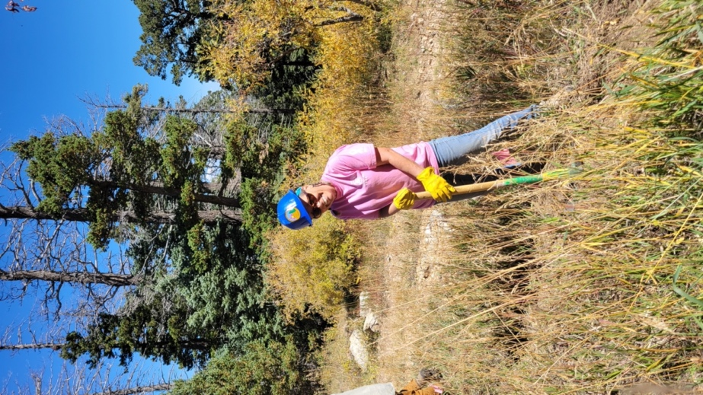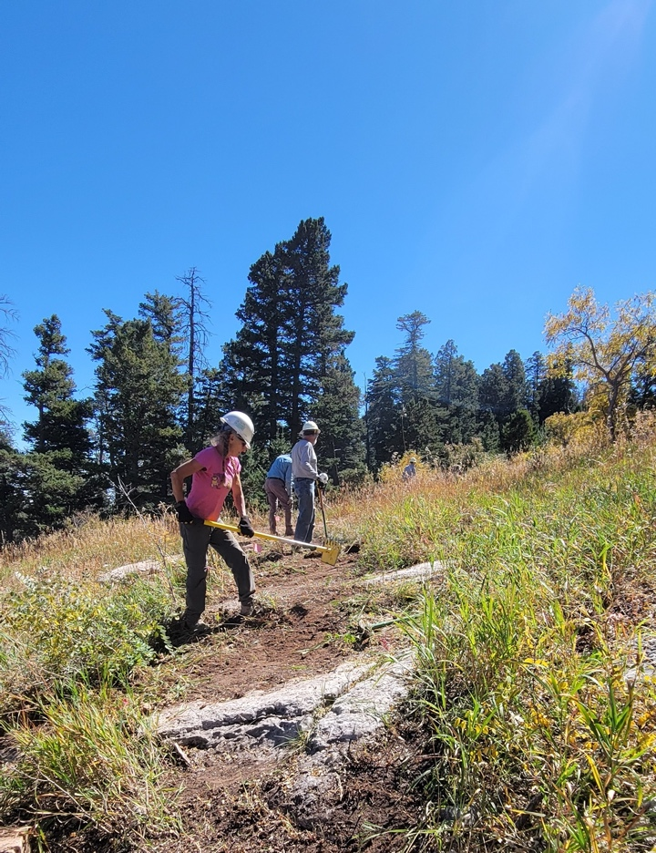

Laura, Claudia, Jim, Eric R., Eric M. and Bruce digging like crazy with the end in sight! Thank goodness the weather has been cooler.

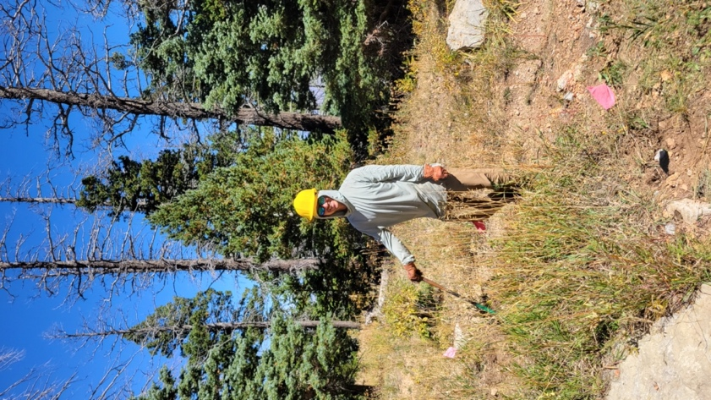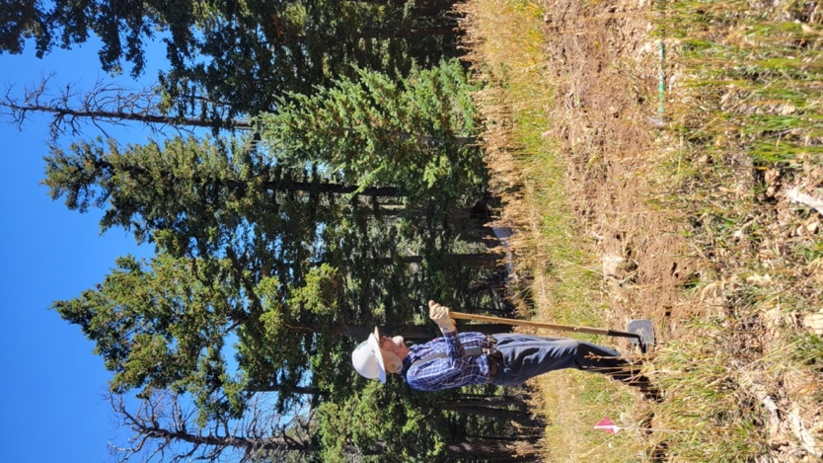
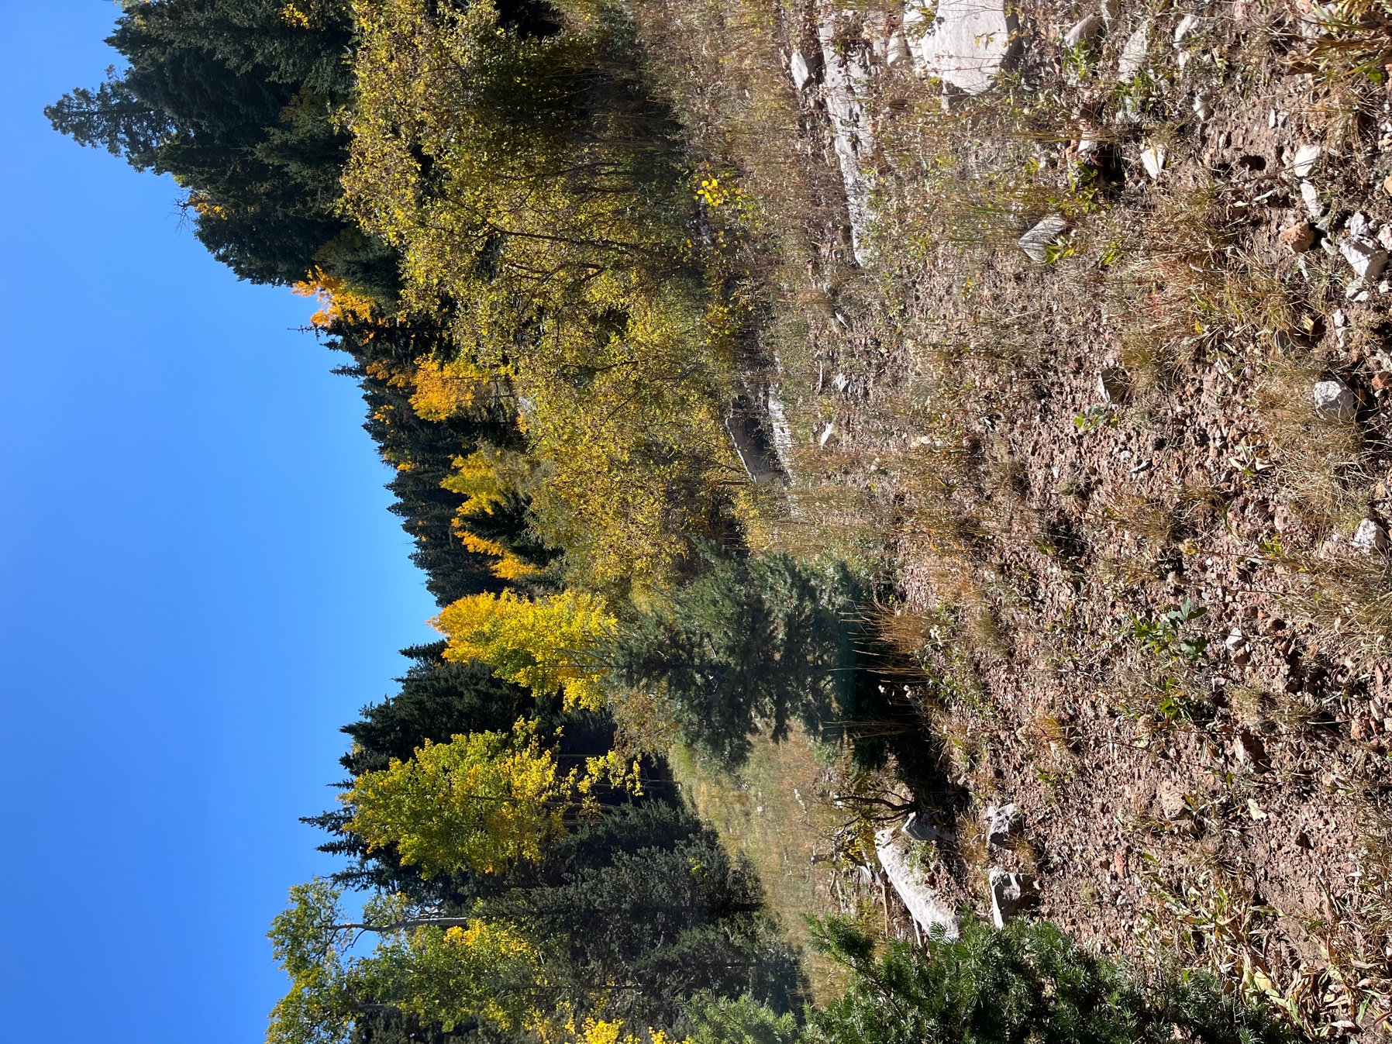

One last look before putting the heads down and making our way to the parking area.
