Thursday, Oct. 17, 2024: A crew of 13 scallywag volunteers and 4 SRD staff (Jen, Dorothy, Chris and Zay) met at the 10K parking area to finish the 3 reroutes on the Double Eagle Trail. It started out sunny and cold but conditions changed throughout the workday from sun to cloudy with grapple. The cold temps stayed. We picked up where we left off last week on reroute #2 and then moved onto reroute #1 to finish the day. Signage is going up. A farewell to Dorothy who is going to work at Bernco Open Spaces. We have really enjoyed crewing with her this season- Bernco has made a lucky find and we will miss her.

Volunteers: Steve Roholt, Luis Cuadros, Eric Messerschmidt, Tony Pachelli,
Laura Leon, Bruce Hansche, Byron Garner, Claudia Bergsohn, Cleve Sharp,
Eric Russell, Mike Madden, Rich Fagioli and Rich Feddersen

Pictures: Laura Leon

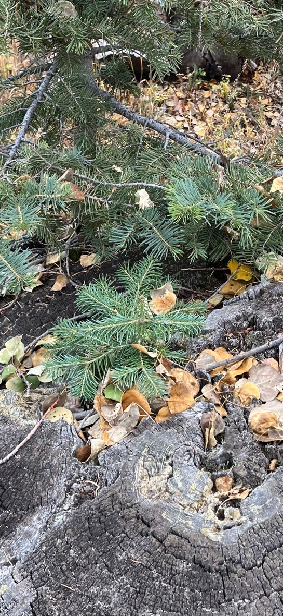 This little guy is trying to grow out of the rock!
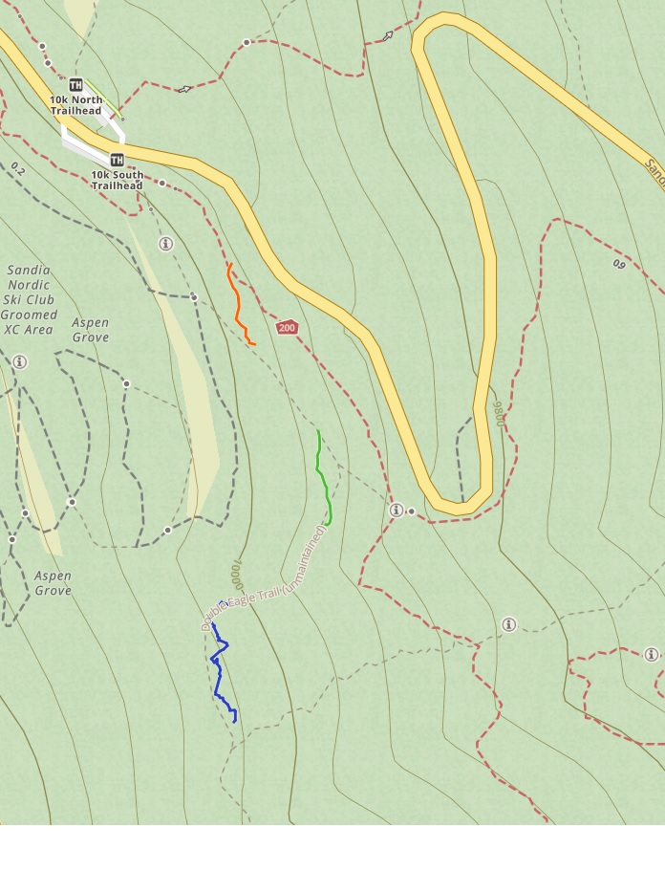

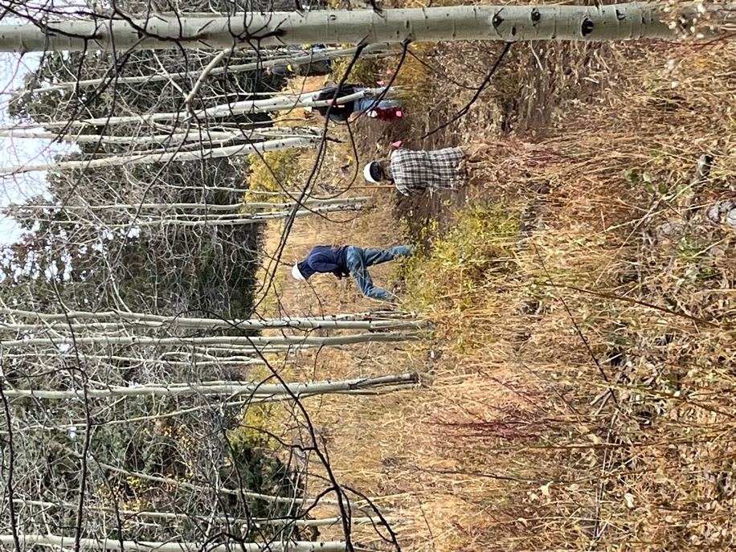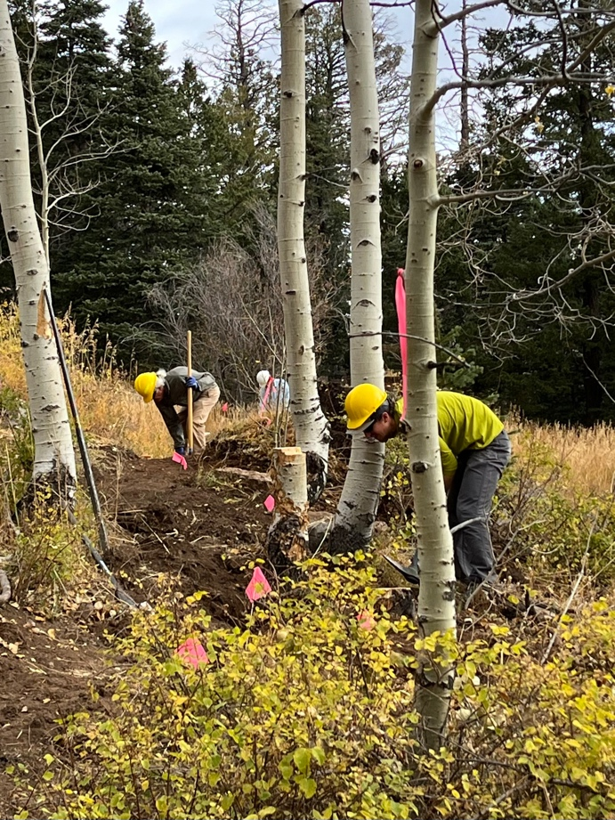

Claudia, Steve and Byron working the trail. Eric M. and Mike dig away.

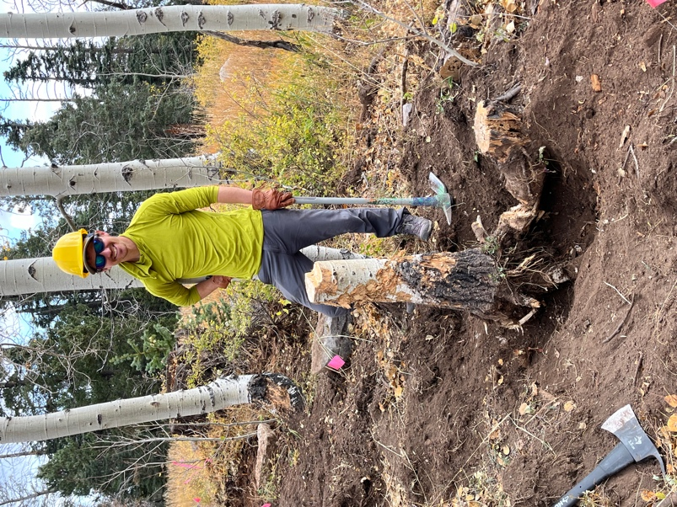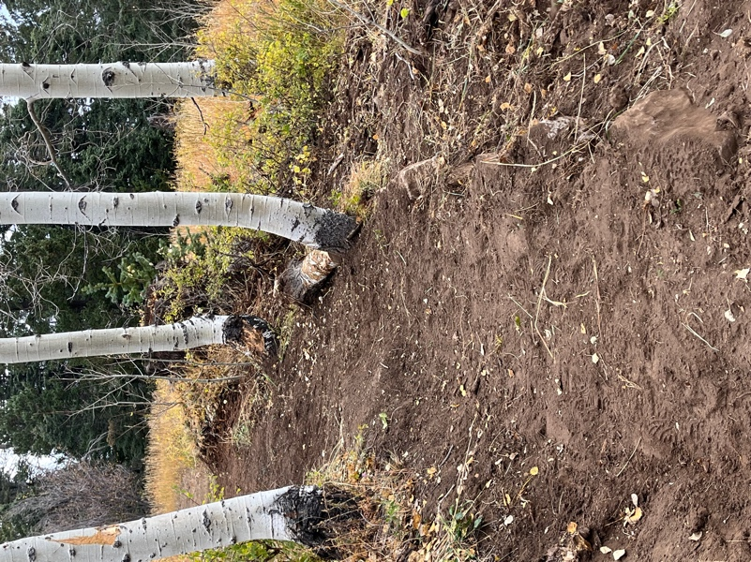

Eric M. show off his stump removal chops- before and after.
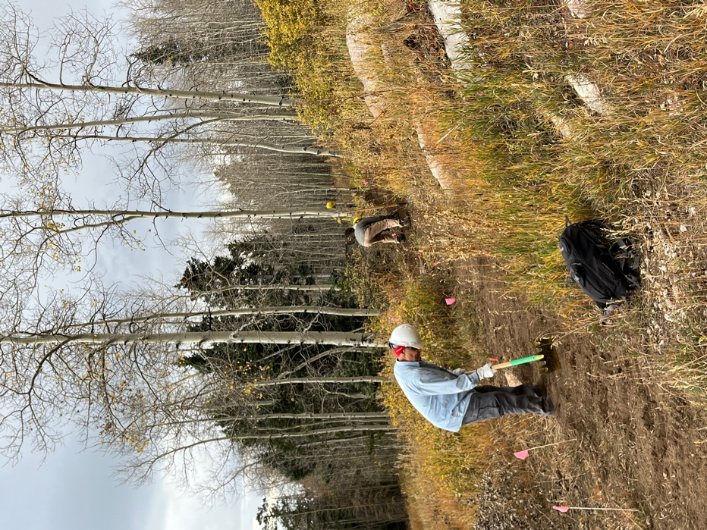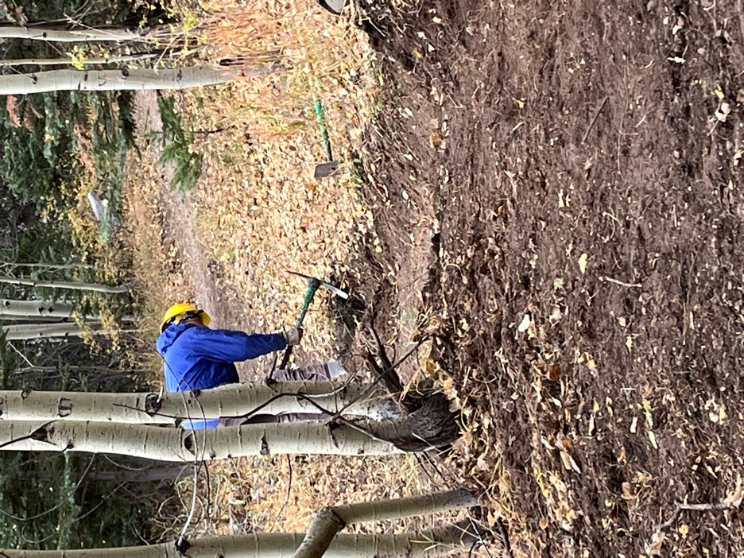

Tony finishes one end of reroute #2 and Eric R. finished the other.

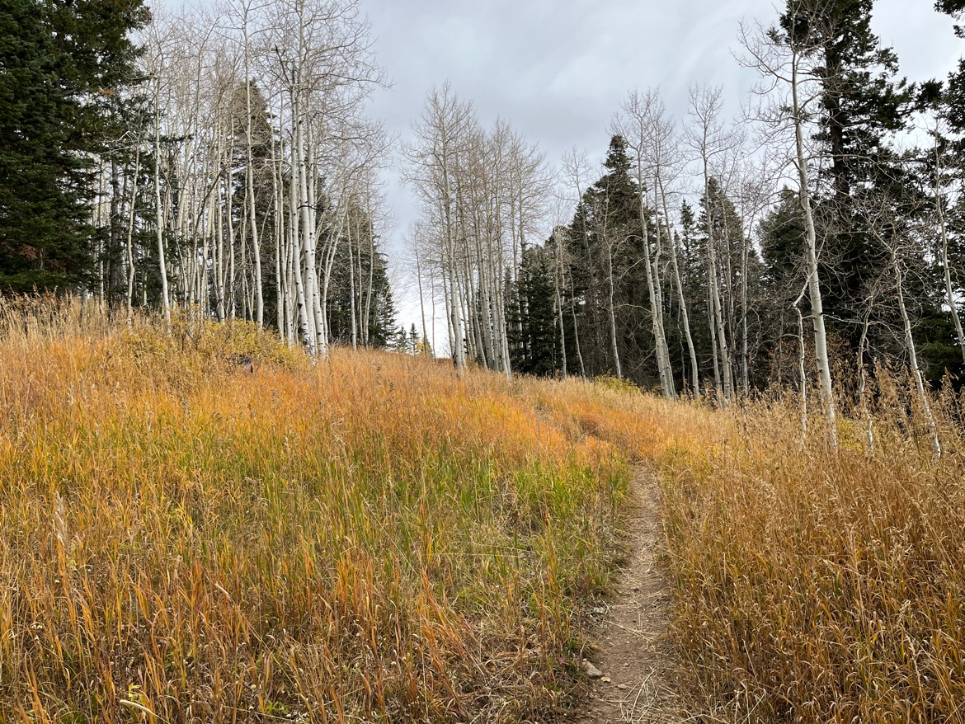
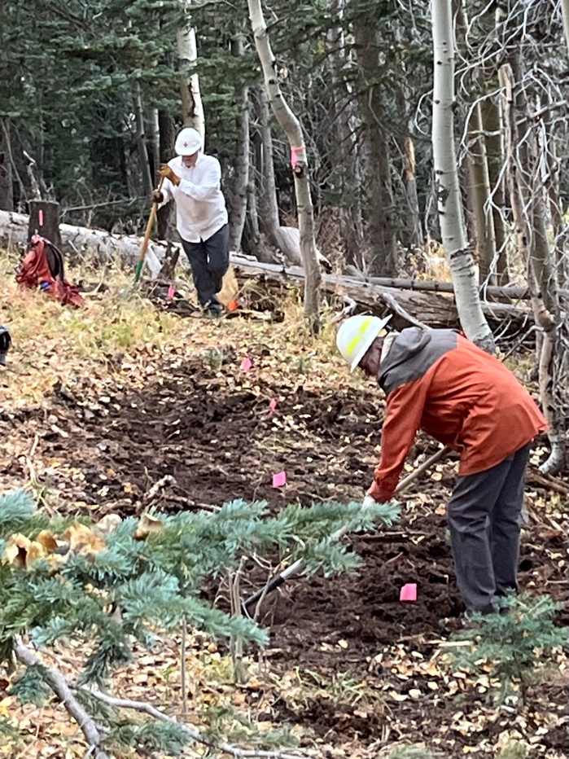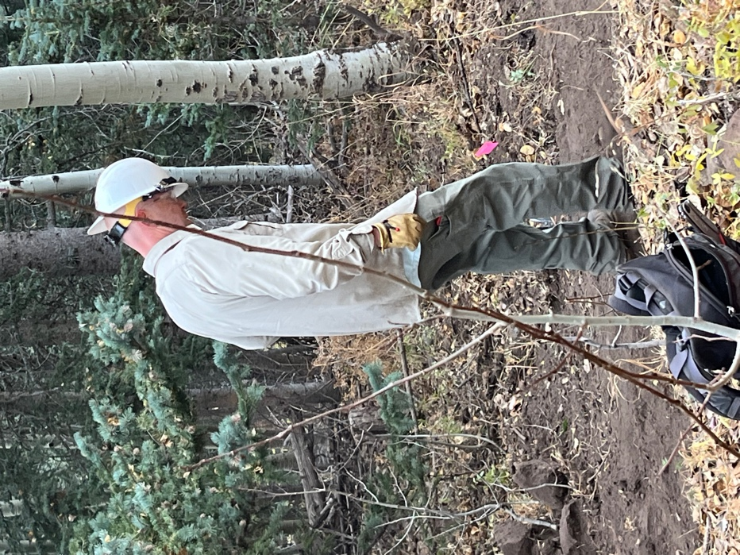

Rich Fagioli has found another stump Chris rechecks his work.
while Cleve digs away.

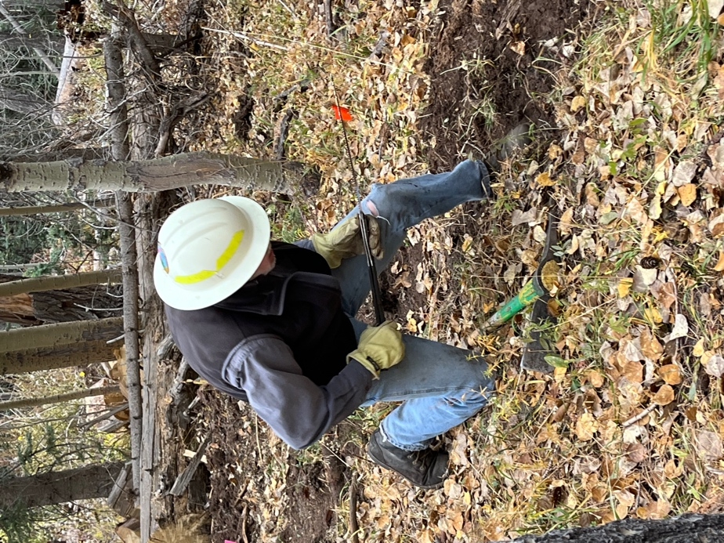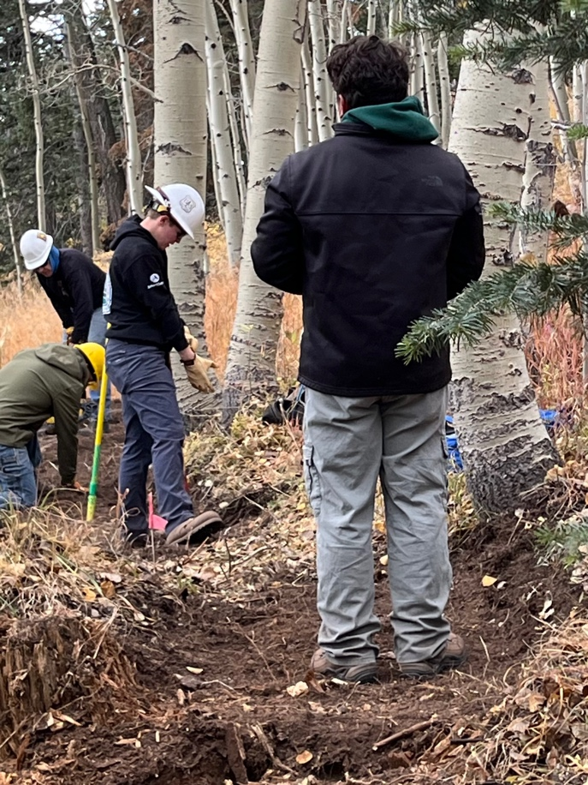

Byron gets after some roots. Dorothy and Zay spend some time on a large
root while Steve and Rich Feddersen dig.

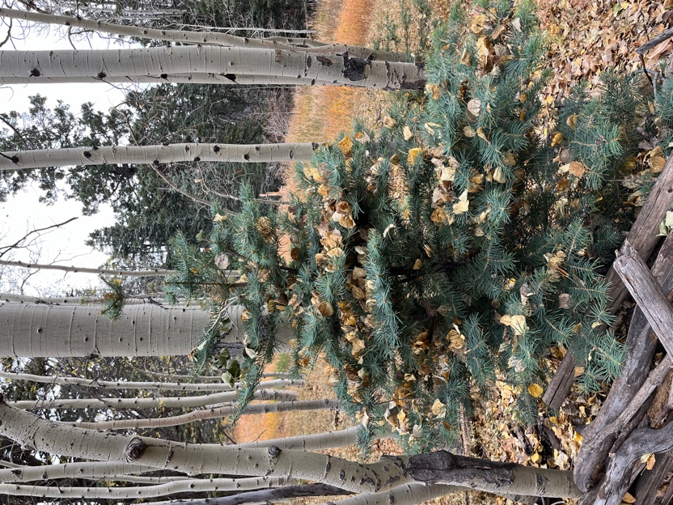 A tree decorated for fall.
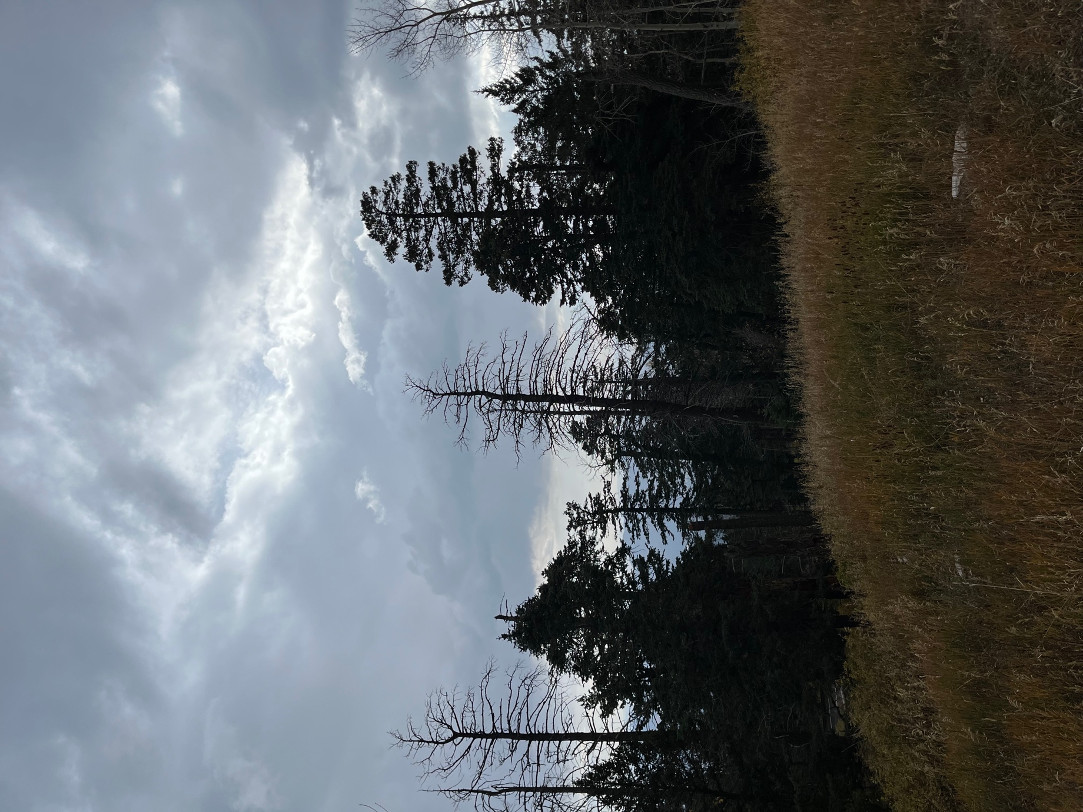

It was a dark and stormy day…..

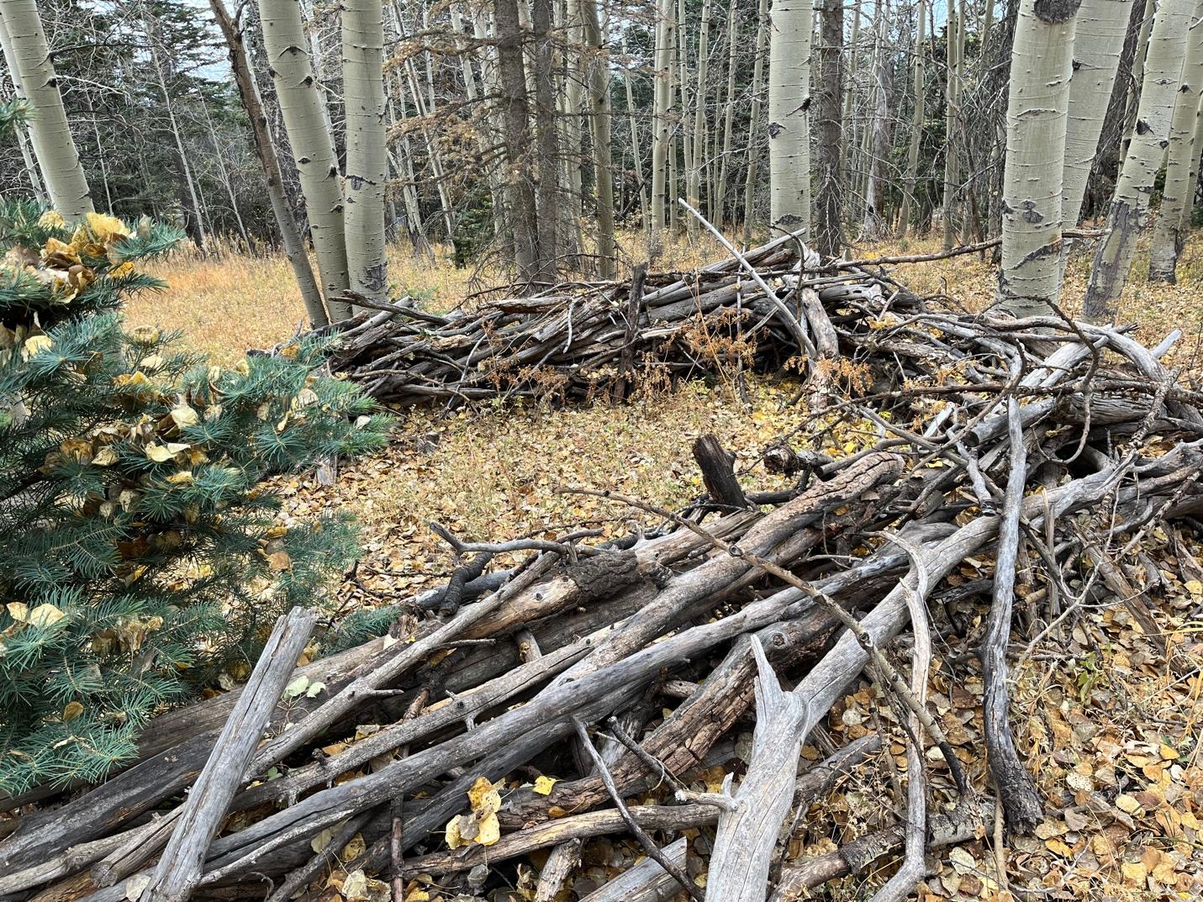

Someone’s fort- Laura and Rich Feddersen took it apart and dispersed the wood.

