**Report of Removing Graffiti Tag from Boulder at Otero Canyon Trailhead**

**on Tuesday, October 15**

Sam Beard

On Tuesday, October 15, Pete Rhyins and Sam Beard removed a black and silver graffiti tag from the south side a boulder at Otero Canyon Trailhead. We applied World’s Best Graffiti Removal System chemical for stone on the very rough surface of the boulder three time with a wait time of 3 minutes between applications. After rinsing the area with water, we saw that not all the tag had been removed. We repeated the treatment, rinsed the area, and saw that all the paint had been removed.

Before and after photos are presented below.

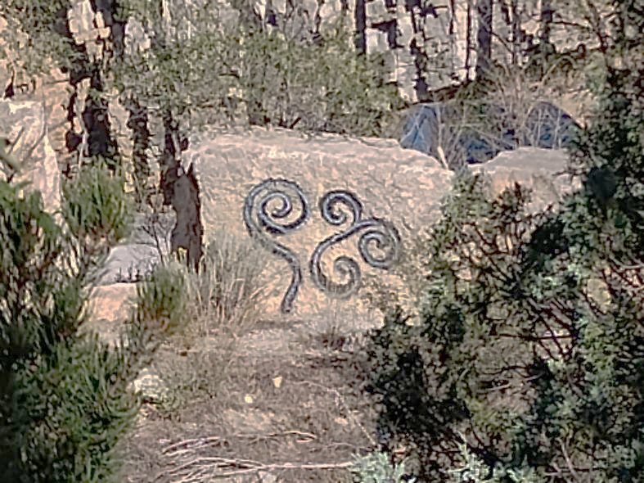

Black and silver graffiti tag on boulder at Otero Canyon Trailhead. Photo by Pete Rhyins

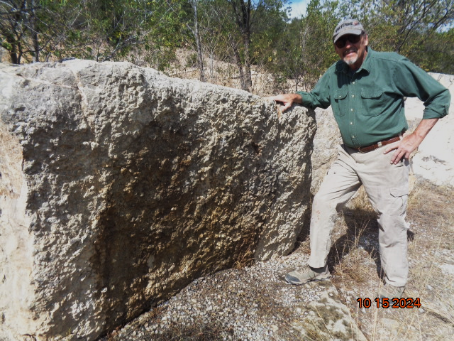

Pete Rhyins standing beside the boulder where the tag was removed. Photo by Sam Beard