**FOSM Report of Maintenance of Sandia Nordic Ski Club Trails on Wednesday, October 16, 2024**

Scott Dietrich and Sam Beard

On Wednesday, October 16, a FOSM chainsaw crew bucked several trees that were blocking portions of the Sandia Nordic Ski Club trail system on Sandia Mountain between Ellis Trailhead and 10K South Trailhead.  The trees that were bucked included a large (~24") spruce that had fallen across Klaus Trail near the Gravel Pit. The crew also bucked several trees ranging from 16 inches to 18 inches in diameter just above the 10K Meadow, which Scott had felled on Thursday, October 10, during a felling practice outing with Sandia Ranger District Trails and Wilderness Manager, Canyon Young.  The group felled several small trees that were impeding grooming equipment at the southern intersection of the Klaus and Rocky Point Trails as well as the southwest corner of 10K Meadow.  Today's outing provided Scott Dietrich and Sim Cook with additional opportunities to hone their felling and bucking skills under the tutelage of Sam Beard and Jerry Carroll.

The volunteers working on this project were Sam Beard, Jerry Carroll, Dan Benton, Eric Russell, Dennis Crowther, Sim Cook, Scott Dietrich and Chuck Logan.

Project photos are presented below.

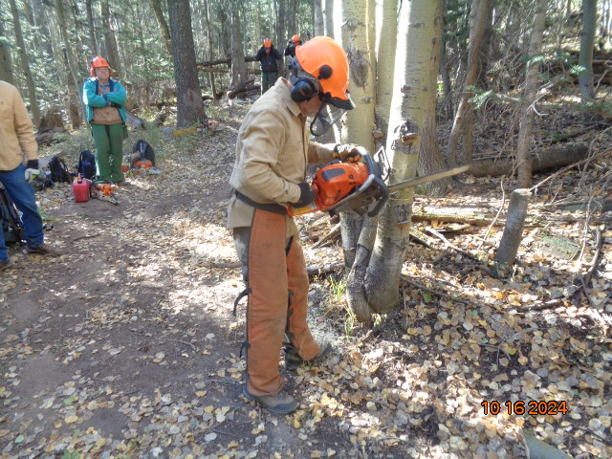

Scott Dietrich making the face cut in an 8-inch aspen he was felling. Photo by Sam Beard

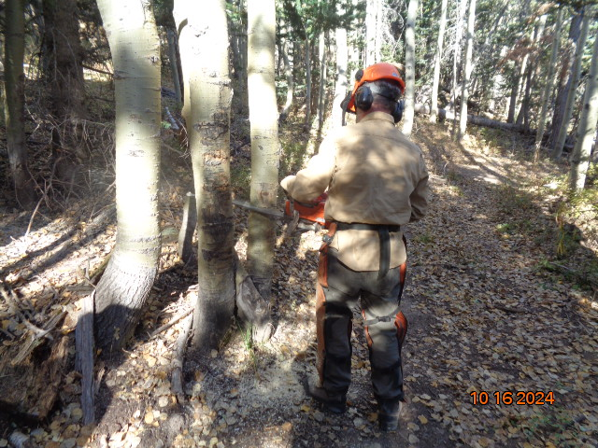

Scott making the back cut in the tree was felling. Photo by Sam Beard

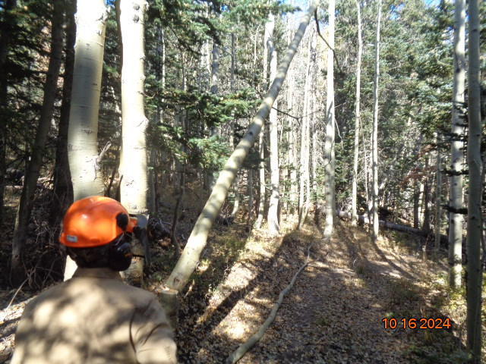

The aspen is falling. Photo by Sam Beard

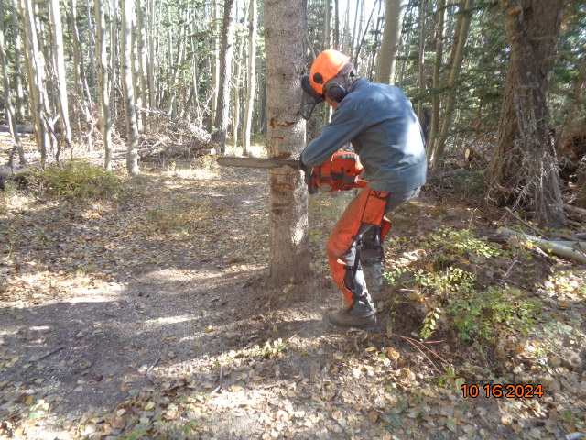

Sim Cooking making the face cut in the tree he was felling. Photo by Sam Beard

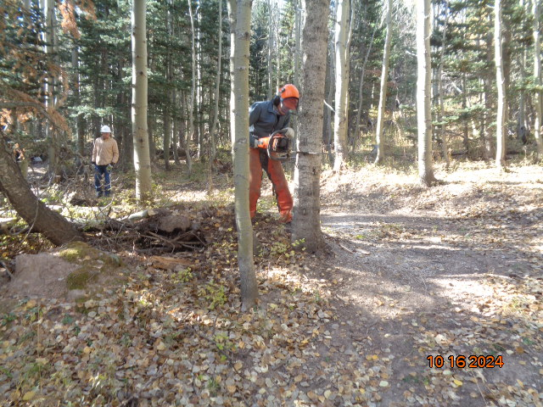

Sim making the back cut in the tree he was felling. Photo by Sam Beard

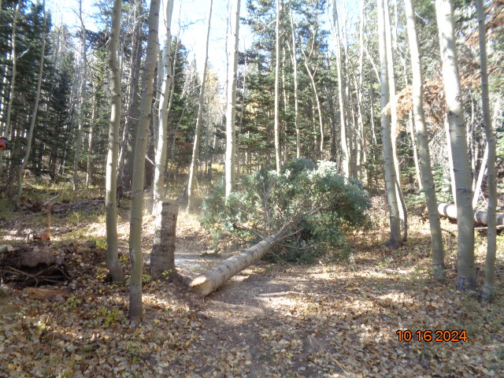

The tree is safely on the ground. Photo by Sam Beard

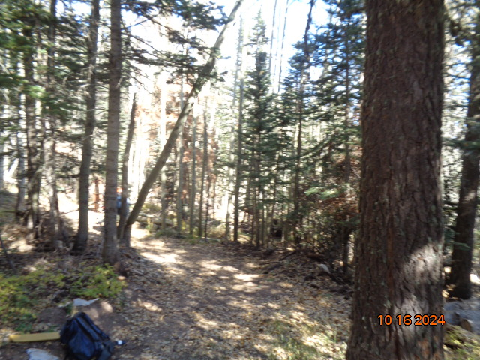

Another tree felled by Scott. Photo by Sam Beard

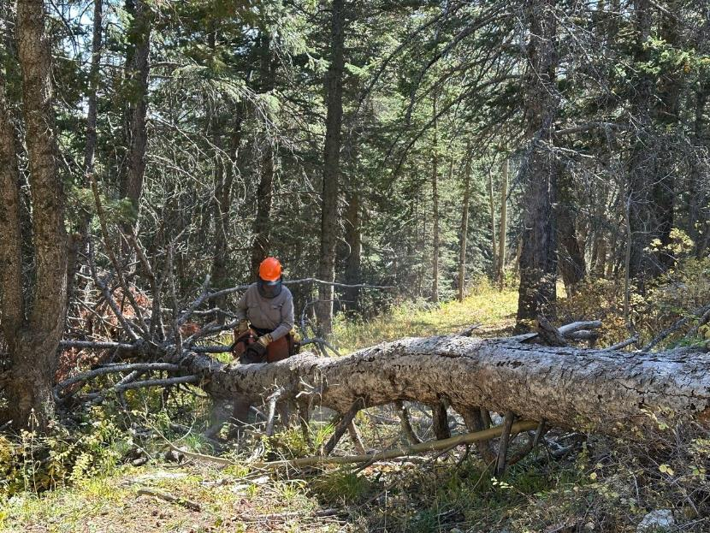

Dan Benton limbing a large spruce down on Klaus Trail. Photo by Scott Dietrich

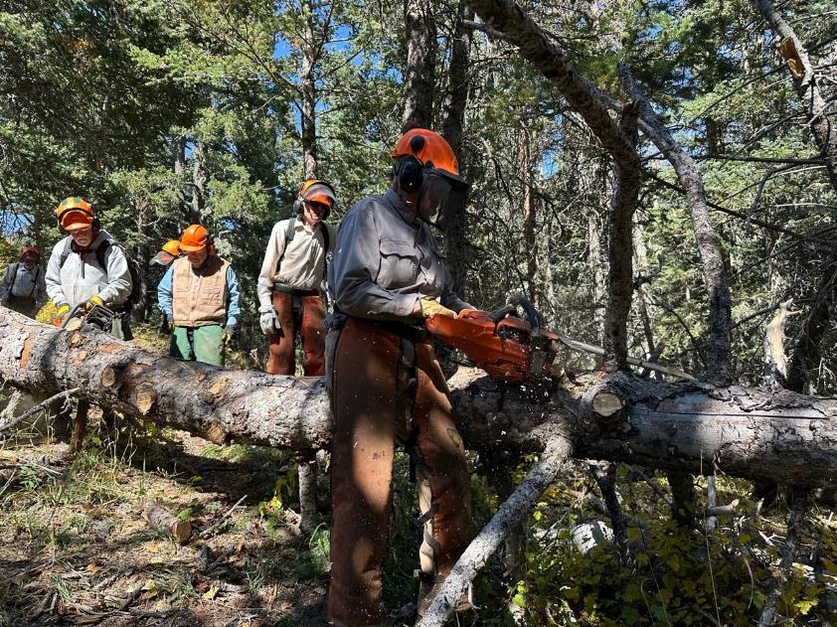

Jerry Carroll and Dan Benton continue to limb the large spruce.. L to R: Jerry Carroll, Dennis Crowther,

Sim Cook, and Dan Benton. Photo by Scott Dietrich

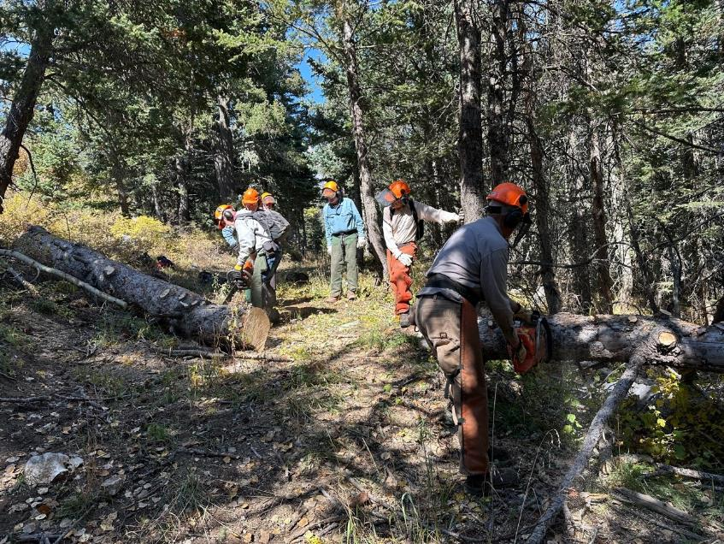

The trail is almost completely cleared.

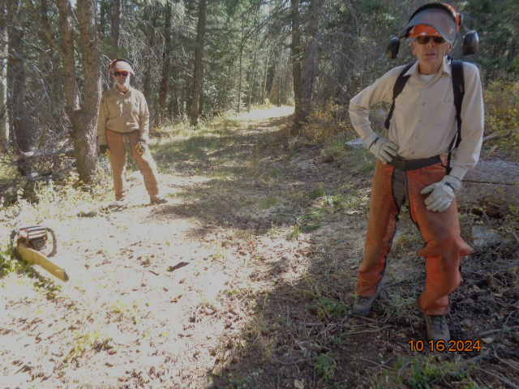

L to R: Scott Dietrich and Sim Cook. The trail is clear and ready to be groomed after snow has fallen.

Photo by Sam Beard

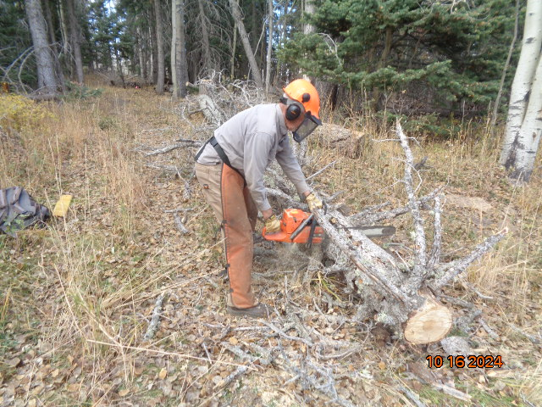

Dan Benton bucking a log on another trail. Photo by Sam Beard