**Report of Limbing and Bucking Logs on the Ground at the First Switchback**

**below Ellis Trailhead on Wednesday, October 23, 2024**

Sam Beard

On Wednesday, October 23, seven FOSM volunteers limbed and bucked numerous trees felled recently by sawyers being certified by USFS personnel near the first switchback in the Crest Highway below Ellis Trailhead. As the photographs below show, in some parts of this area the ground was literally covered with multiple limbs and tree trunks.

It was obvious that the crew could not “clean-up” the entire area; therefore, they focused on removing trees and limbs from three segments of trails groomed by the Sandia Nordic Ski Club for cross country skiing. Also, limbs and trunks were removed from the northwest side of the area where skiers enjoy telemarking. Approximately two dozen logs were bucked and moved to clear the trails for skiing. The largest log was about 24 inches in diameter.

The FOSM volunteers working on this project were Lou Romero, Scott Dietrich, Dan Benton, Sam Beard, Sim Cook, Cliff Giles, and Dennis Crowther.

Project photos are presented below.

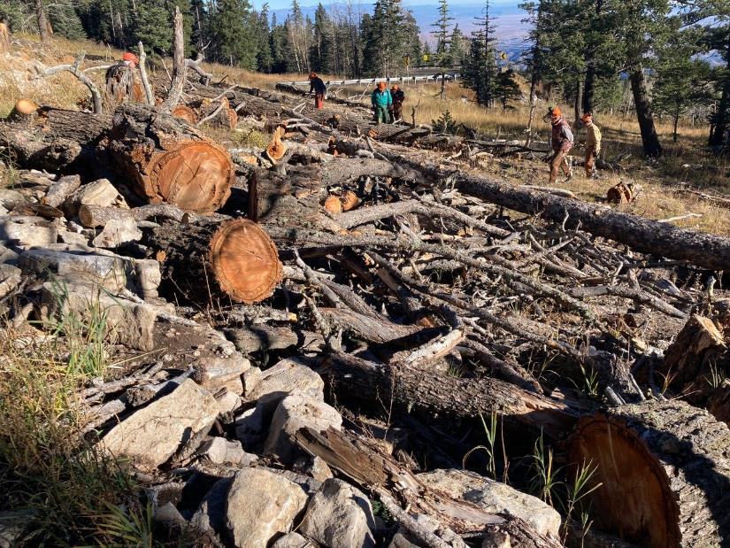

The many limbs and trunks in the area near the first Crest Highway switchback below Ellis Trailhead where trees were felled by chain sawyers

being certified earlier by USFS personnel. All photos by Cliff Giles unless noted otherwise

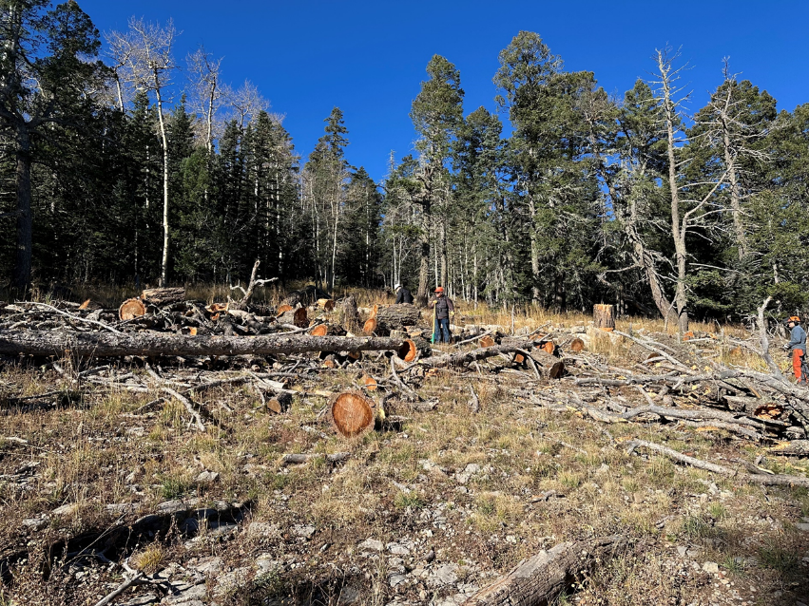

Looking up the hill at the fuel on the ground in this area.

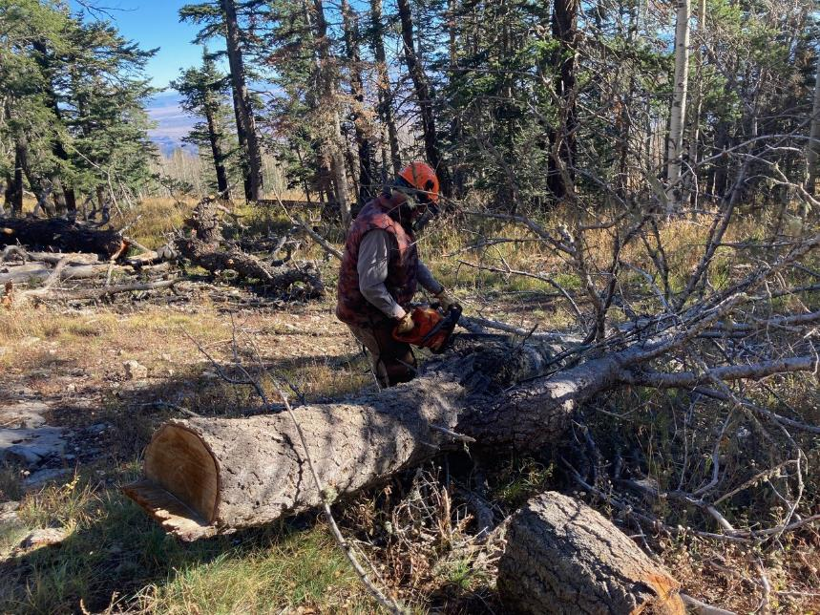

Dan Benton limbing one of the logs.

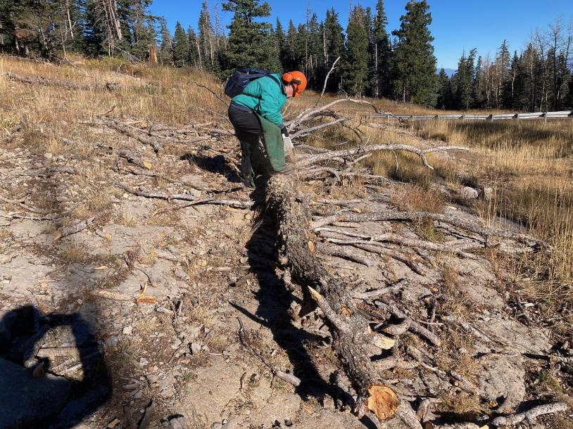

Dennis Crowther limbing one of the logs with his battery-powered chain saw

in the lower part of the area with the highway in the background.

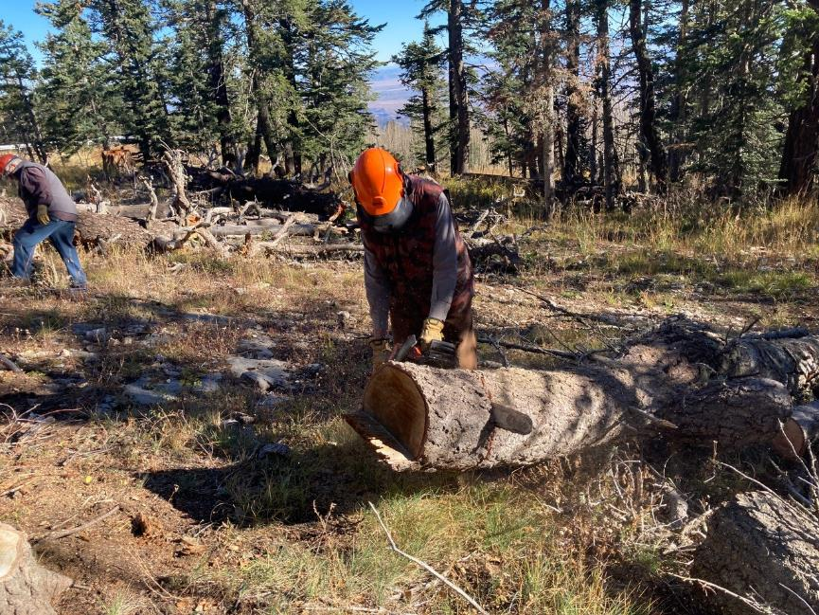

Dan Benton bucking one of the smaller logs.

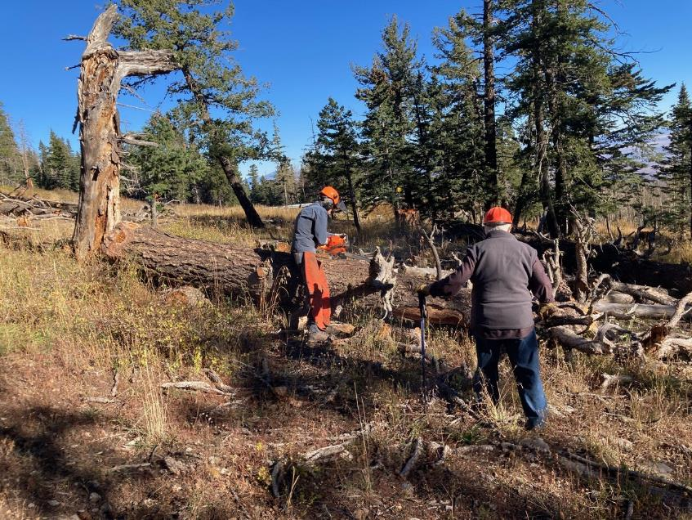

Sim Cook limbing one of the largest logs with Lou Romero observing.

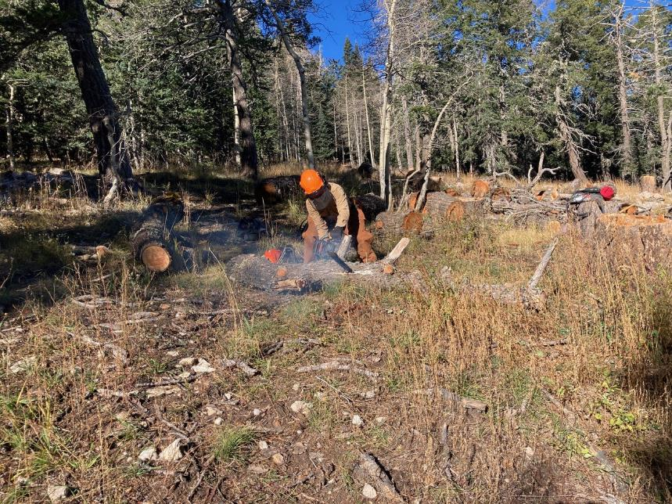

Scott Dietrich limbing a log on a Sandia Nordic Ski Club trail.

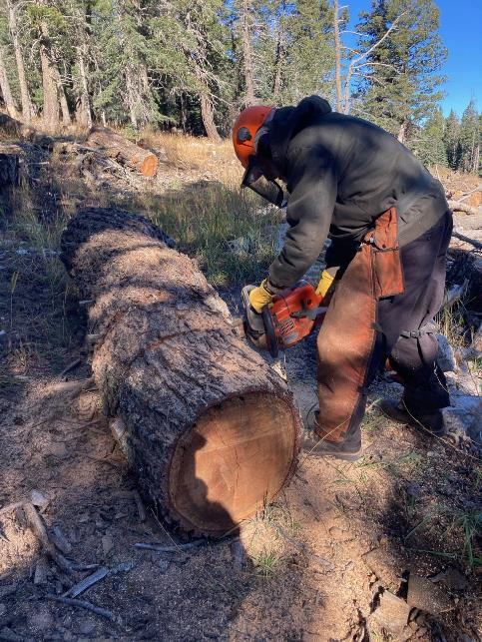

Sam Beard bucking a log near a ski trail.

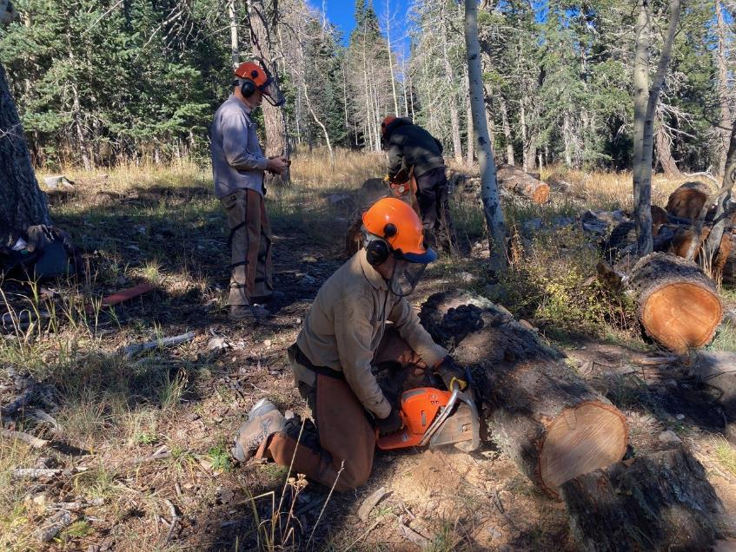

Scott Dietrich and Sam Beard bucking logs on a ski trail with Dan Benton observing.

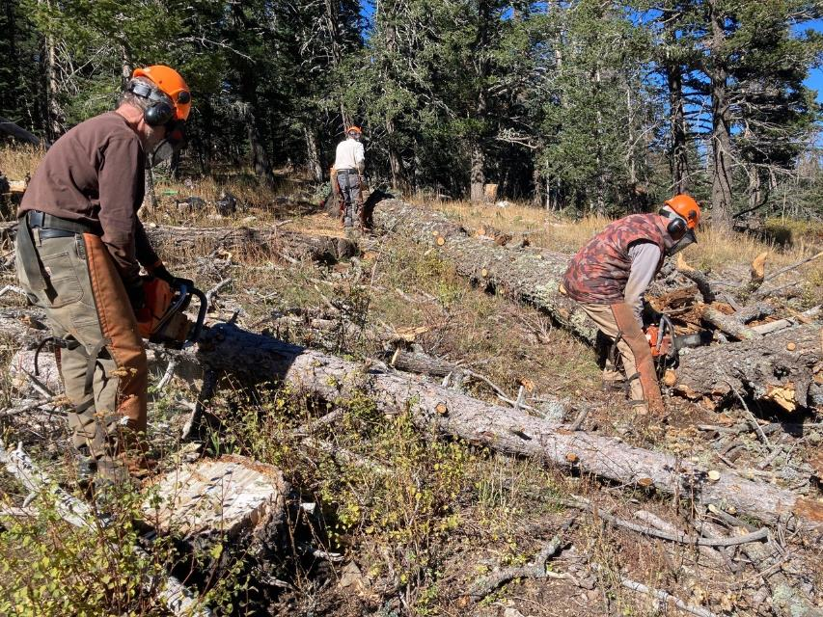

L to R: Scott, Sim, and Dan bucking logs.

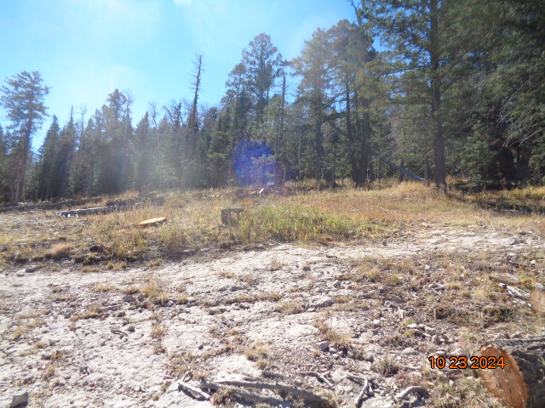

Looking uphill at the northwestern side of the area where the logs were removed so that the area could be used for telemarking.

Photo by Sam Beard