Thursday, 10/24/24- Tablezon: It was a cold start for the 10 volunteers and SRD staff (Jen, Chris and Zay) on Thursday. As the crew hiked the mile or so out from the Lower Pine Trailhead the sun started peeking into the canyon and the temps warmed up nicely by lunchtime. ROCKS was the work for the day- all sizes and shapes. The crew was able to work most of the reroute but ran out of time before actually reaching the end. All signs indicate that the burning crew will be in that area next week so the finishing work will have to be put off for at least a week.

Volunteers: Tony Pachelli, Bill Perkins, Rich Fagioli, Mike Madden, Eric Russell,

Sim Cook, Claudia Bersohn, Byron Garner, Bruce Hansche and Laura Leon

Pictures: Laura Leon

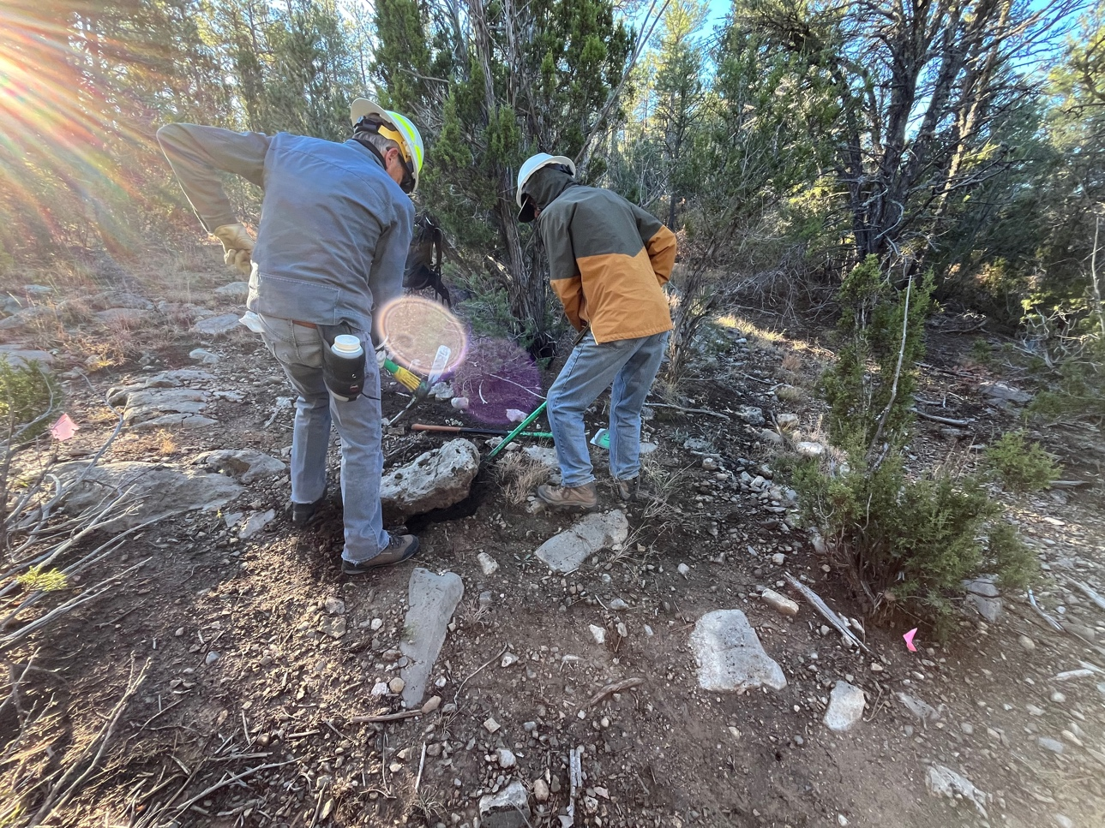

The sun sneaking onto the scene to create some weird effects. First big rock of the day but Sim and Bruce are on it.

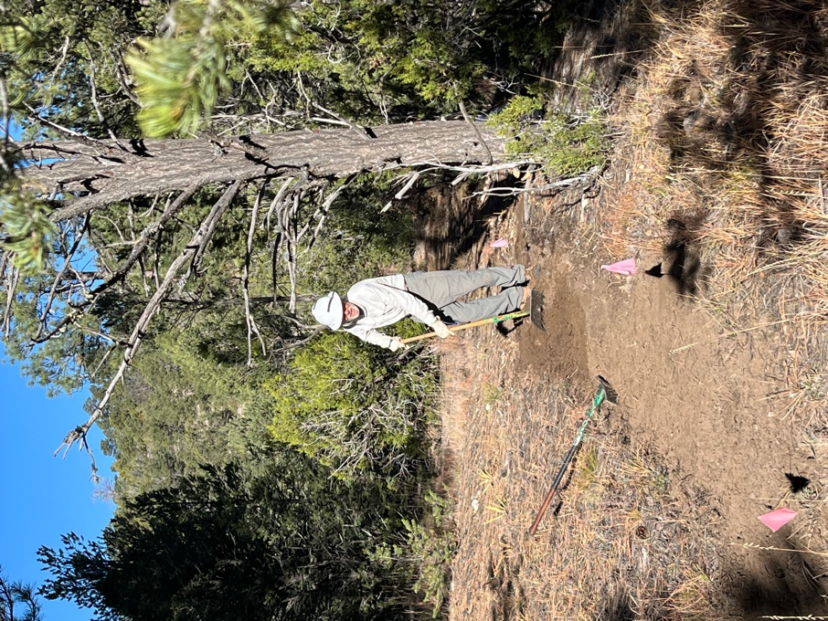 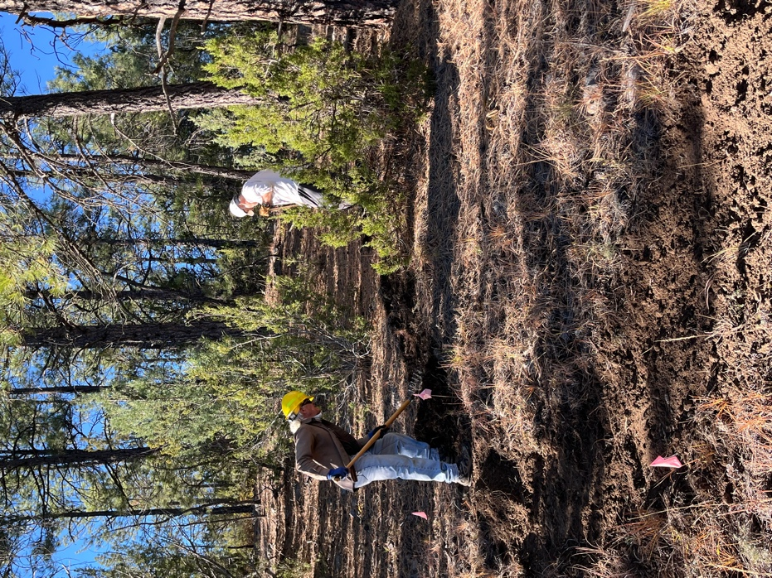

Bill, Mike and Rich work through piles of pine needles.

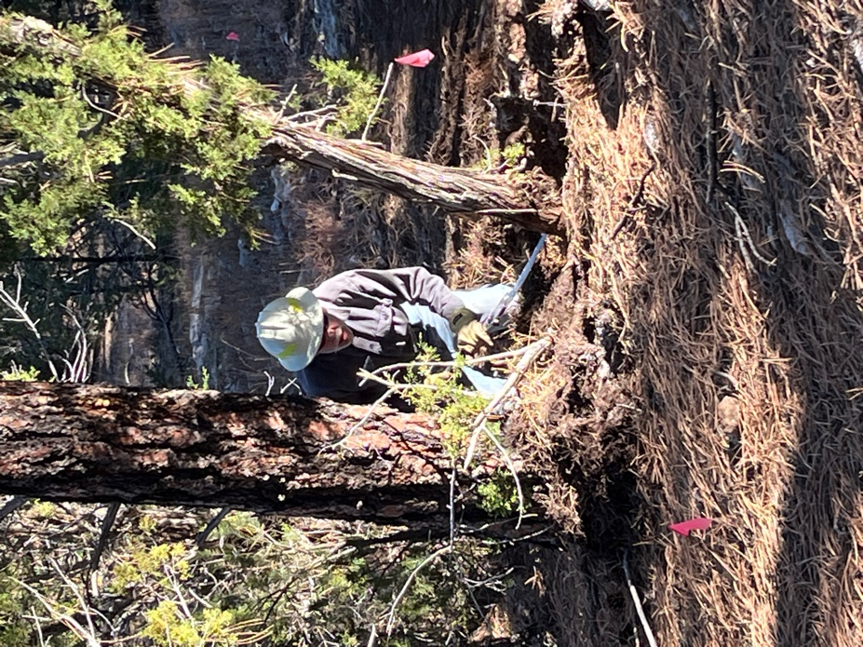 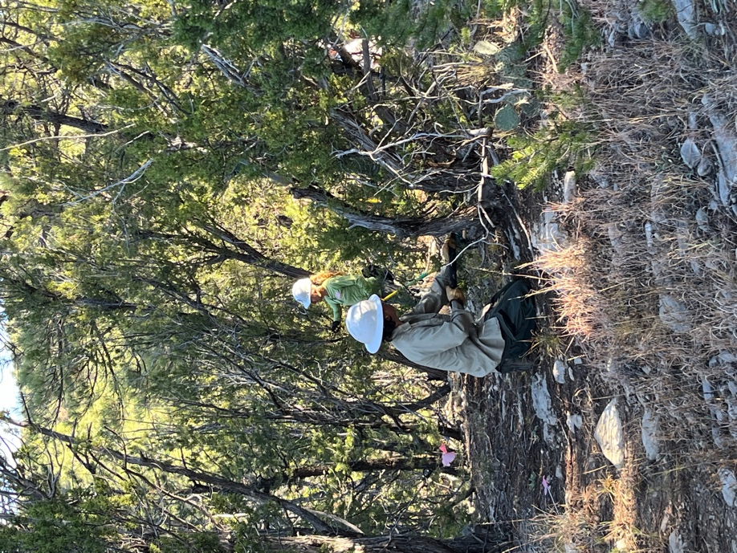

Byron, Jen and Claudia saw and clip their way through.

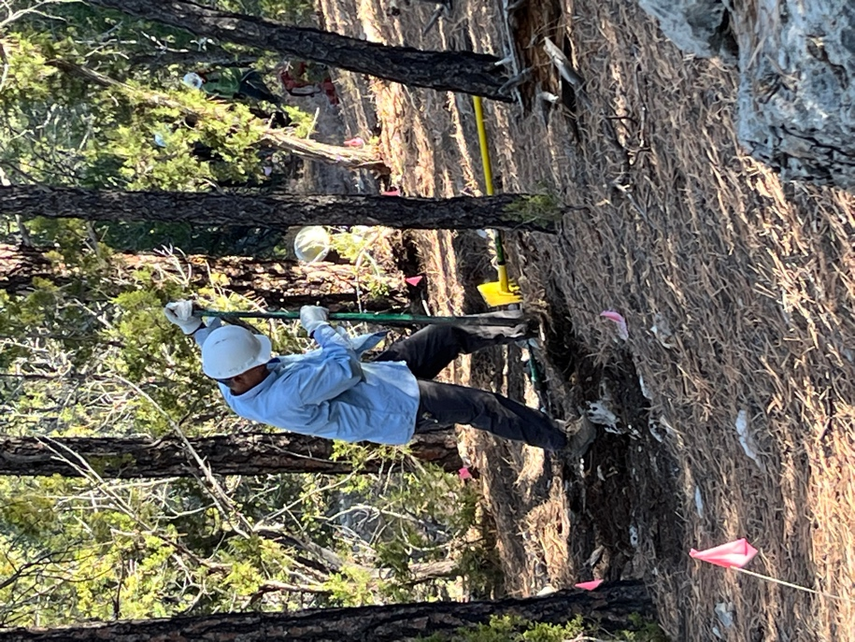 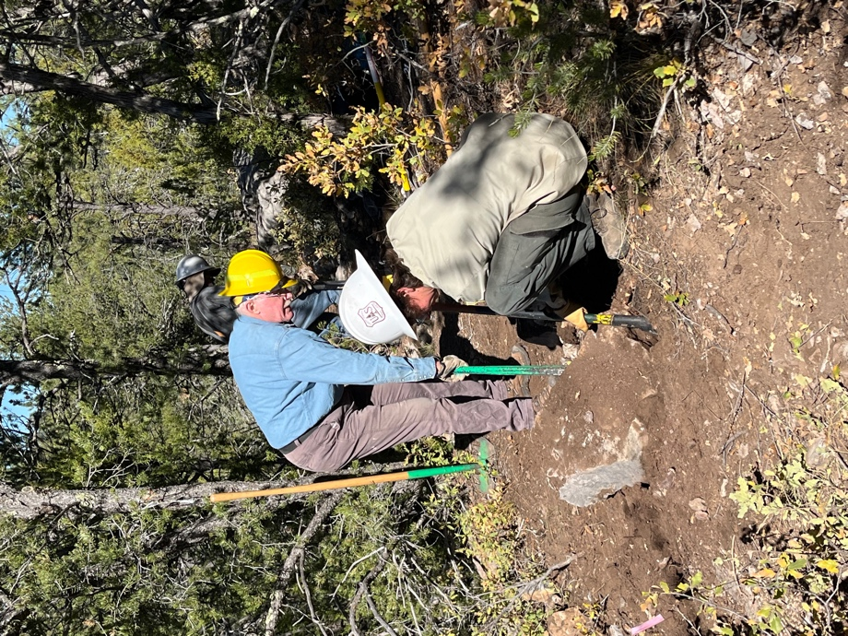

Tony, Eric and Jen getting after the rocks.

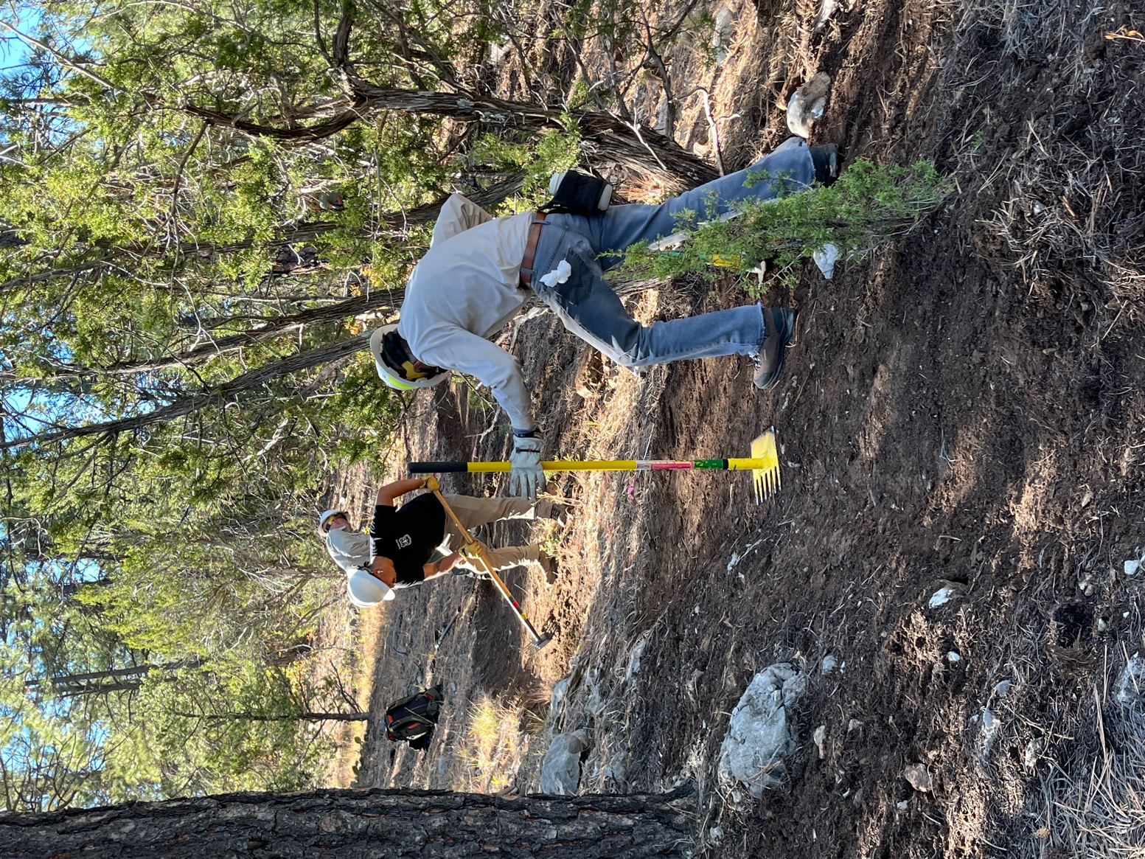

Sim, Zay and Chris create some beautiful trail.