Trail Maintenance Report: Monday, October 28, 2024

Byron Garner

Our trails project for October 28 as originally planned was to hike the newly extended Challenge trail starting at Capelin picnic area in search of unreported down trees, but a last a minute report of new downfall on 10K-S, 130 S and Tree Spring realigned our priorities to clear known trees rather than "maybe" trees. The crisp, cloudy and breezy beginning of a beautiful morning hike from 10K-S trail head soon led us to the work at hand which included a 4"aspen, a 16" fir and two pesky intrusions all on 10K. Continuing on and reaching the 130 junction, we turned our efforts to hiking up that trail to clear the top half of a large 12" aspen which was now standing vertical against a fir tree stabilized by little more than a few sprigs of fir needles. This unusual situation required careful rigging of rope and carabineer to position us well away from the direction of fall as the tree was pulled from it's base which required little more than tightening the rope. With the aspen now down and out of the way, a widow maker (compliments of the aspen when originally falling) was cleared from the supporting fir tree. The focus now was to head down to Tree Spring, clearing a 7" fir along the way, to address an 18" fir laying fully in a trench like portion of the trail. After a much needed lunch and rest, this heavily branched fir supported about three feet off the ground made for an interesting and lengthy collaboration which resulted in stabilizing with rope, removing all unsporting branches and making four sequential cuts. After considerable effort by a dedicated and determined crew, the trail was clear and the reroute closed. The crew included John Cooper, Ken Wilson, Dave McCreery and Byron Garner

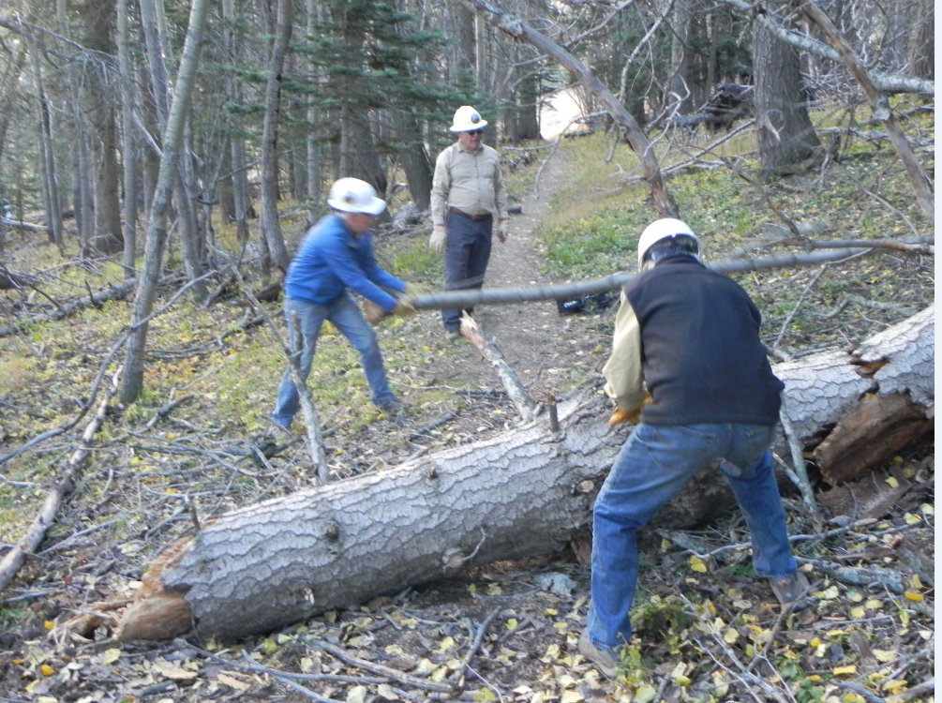

John makes quick work of an aspen while Ken limbs

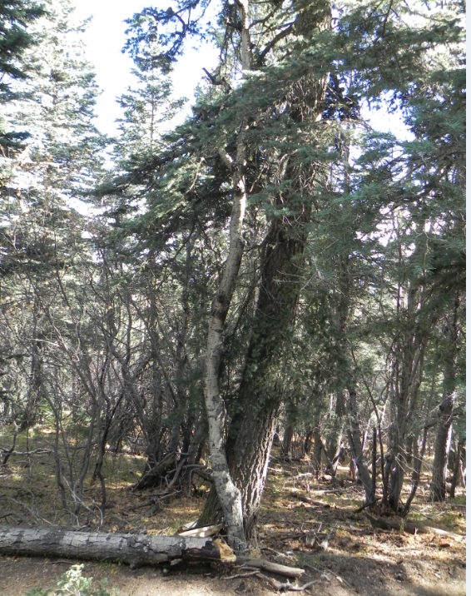

With the lower half of this aspen on the ground, the upper half stands barely supported

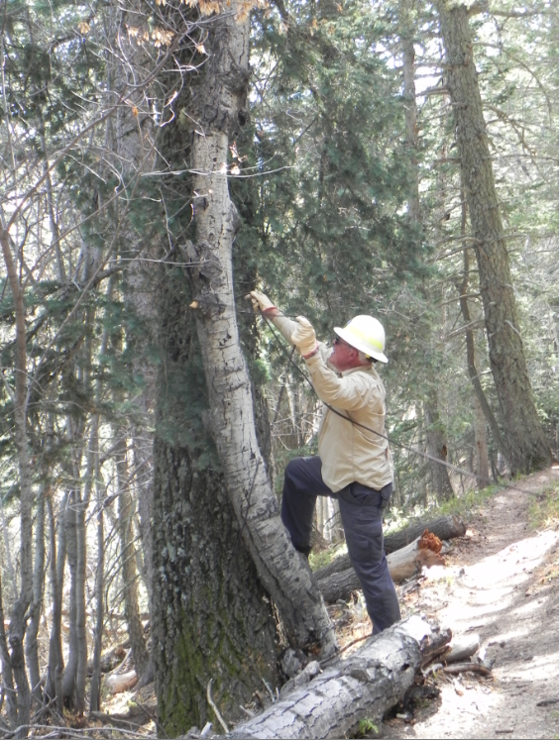

Dave rigs up for the pull

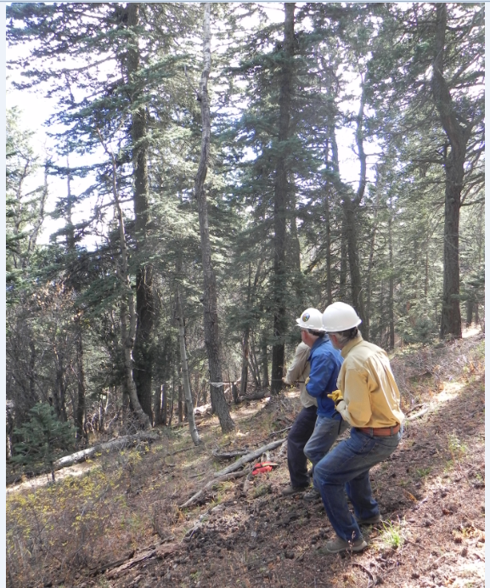

With a little tug at 90 deg. to the line of fall

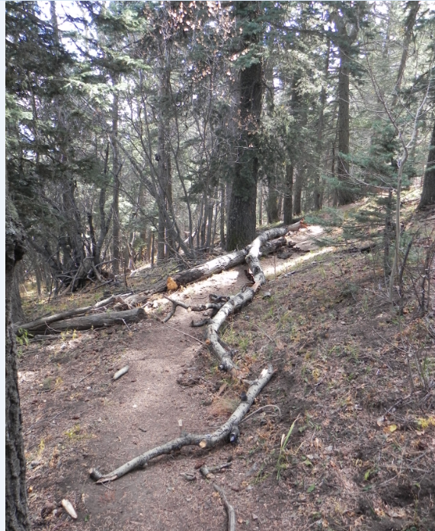

Down it falls

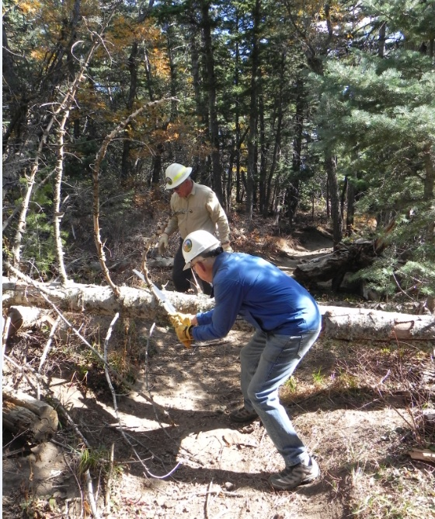

John goes for the next fir

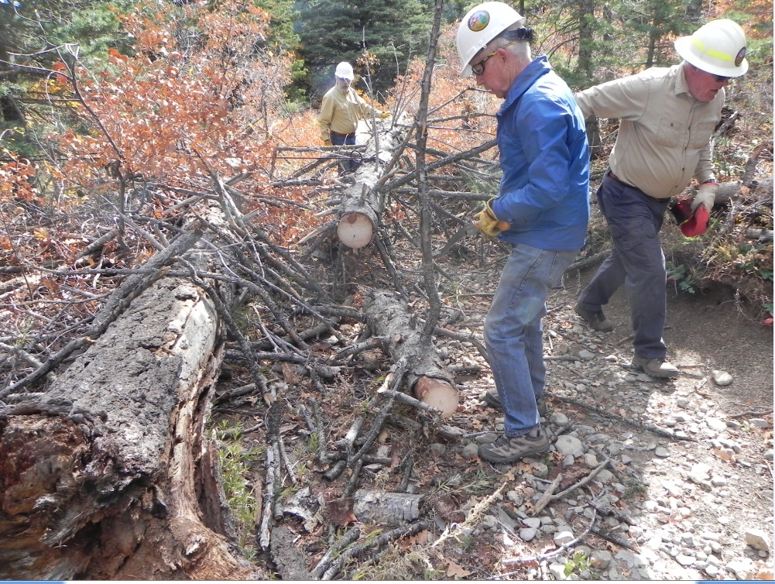

It's fir time - AGAIN - and our main effort

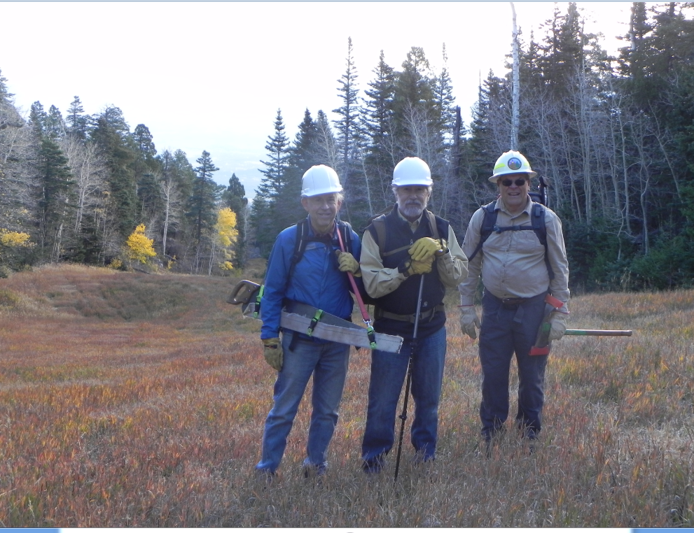

And a great day it was

John, Ken and Dave