Thursday 10/31/24, Challenge Trail: We put down our Pulaskis and Pick mattocks this week and grabbed a pole saw, hand saws and loppers to do some brushing. Ten volunteers met at the Sandia Ski parking area and we started by brushing both ends of the Challenge Trail on either side of the ski area. The brush was dense and hiding the trail signs. Once we got those brushed, we worked our way up the Challenge Trail towards the 9 Mile Picnic Area. We cleared a nice corridor, removed a lot debris near the trail and Byron and Luis cleared a tree that had fallen across the trail. The weather was cold but nice once the sun reached down into our work area. We made about 1.25 miles up the trail before quitting time so the last little bit leading into the picnic area did not get worked on. Driving down the mountain we could see the smoke from the prescribed burn around Tablazon.

Volunteers: Byron Garner, Eric Messerschmidt, Rich Fagioli, Mike Madden,
Bill Perkins, Bruce Hansche, Jim Houle, Cia Reil (He’s a new, live one!),
Luis Cuadros and Laura Leon

Pictures: Luis Cuadros and Laura Leon

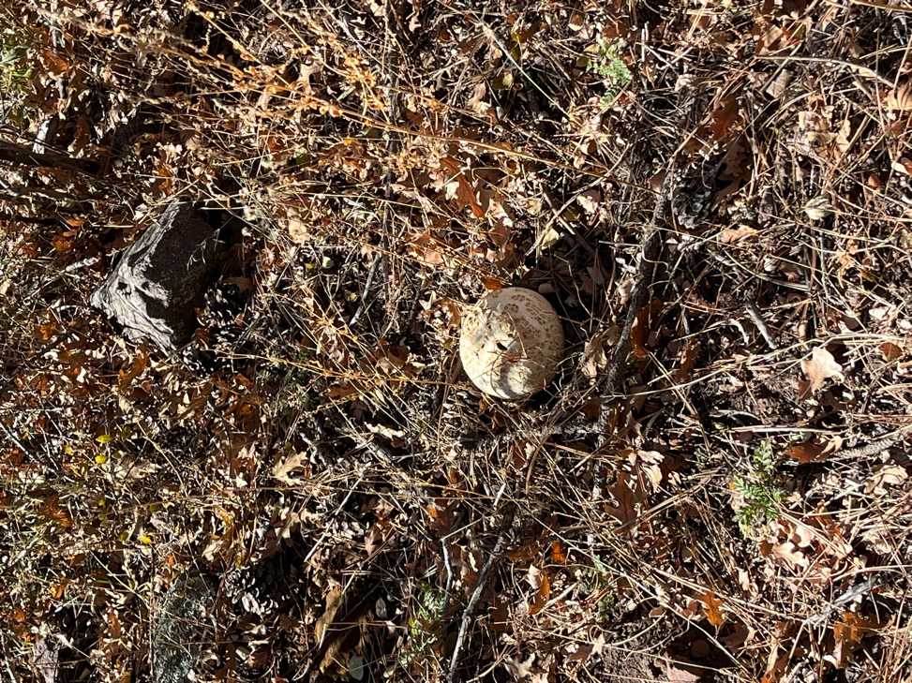 A nice big puffball mushroom.

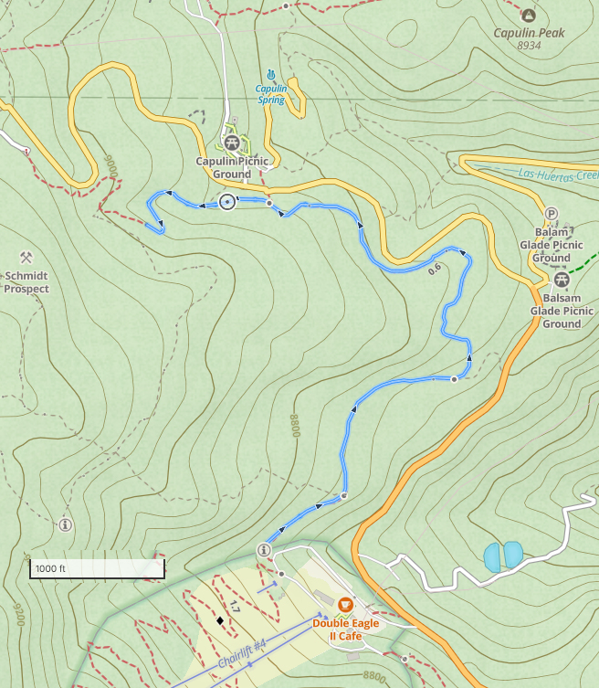

Mission almost accomplished! We also brushed the area just below the Double Eagle II Café on the map where the Challenge Trail starts up again.
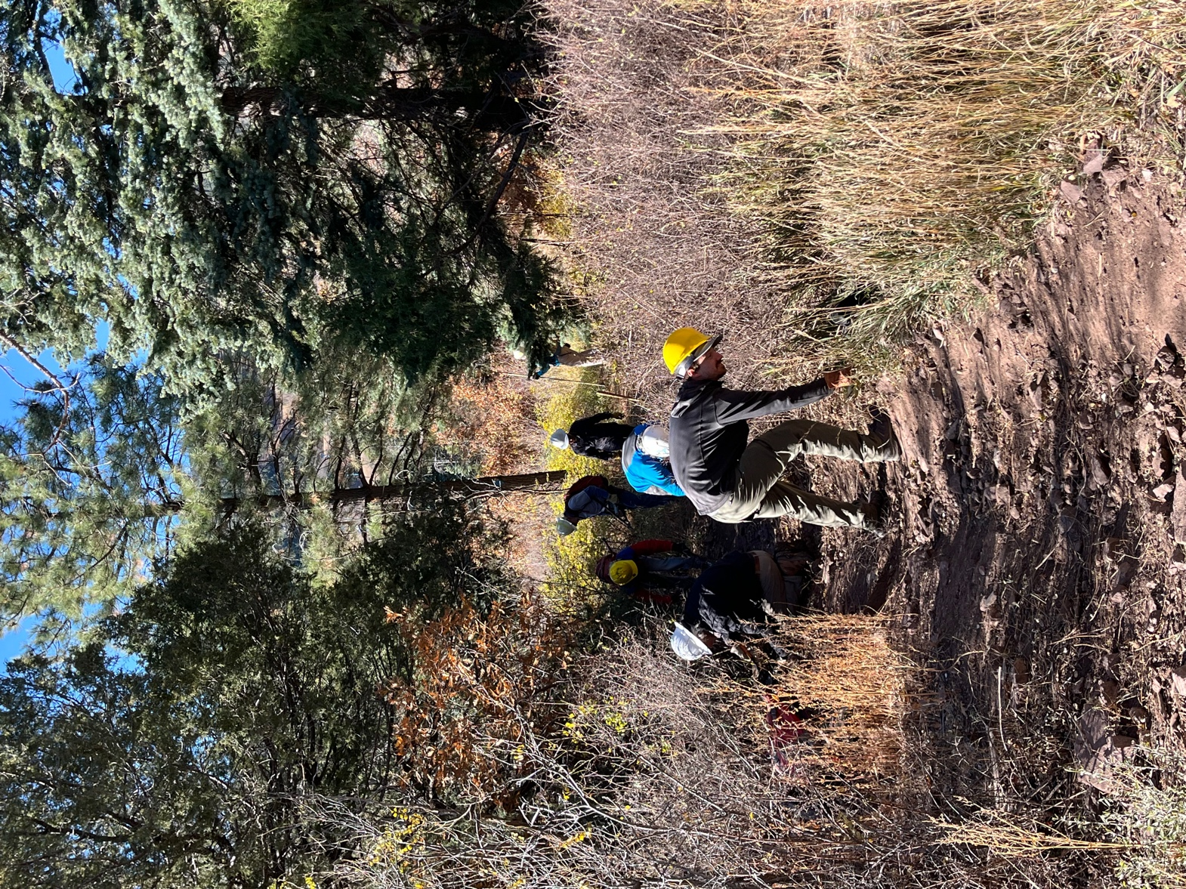

Lots of hands and lots of stooping. Jim was all about the pole saw.
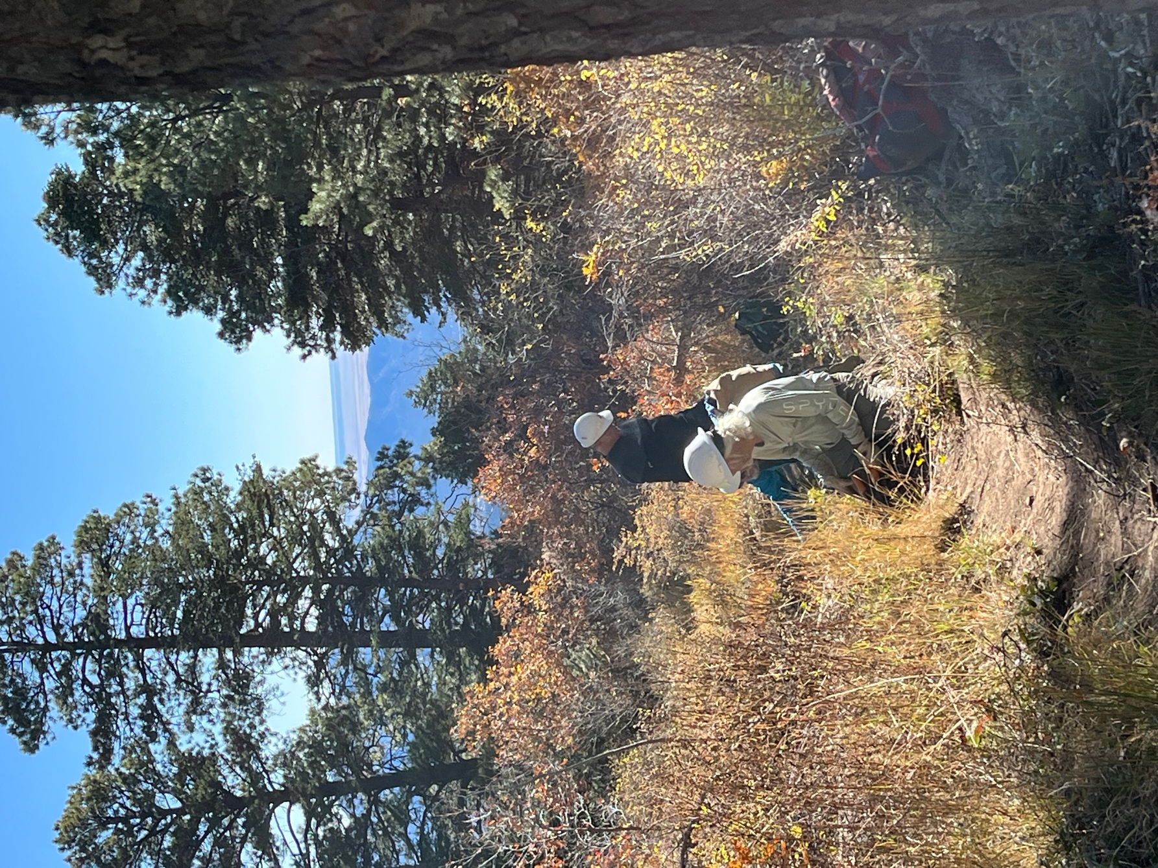

Some areas had dense oak and other areas had locust. Yuck.

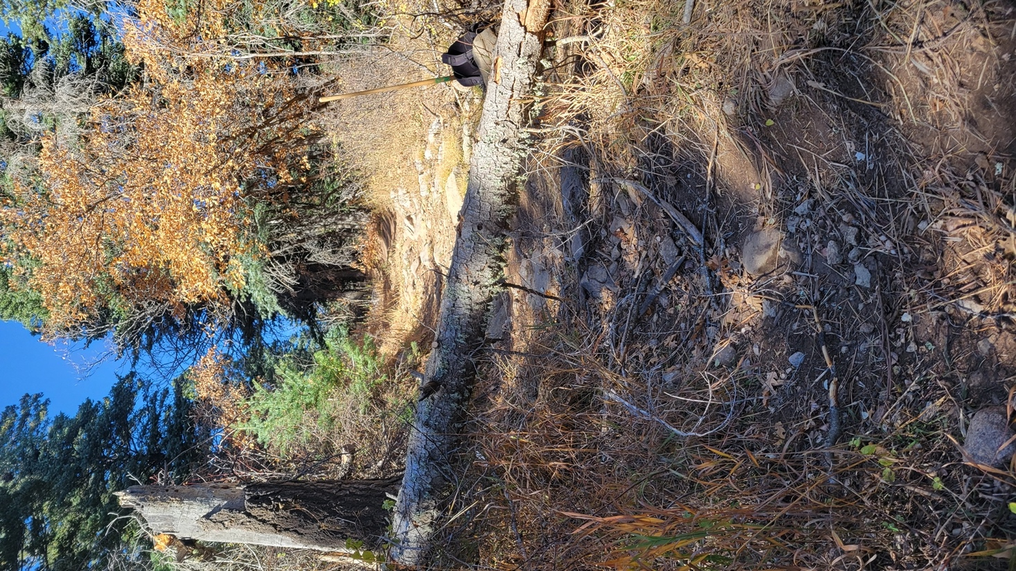

Luis’ downed tree waiting to be cut.

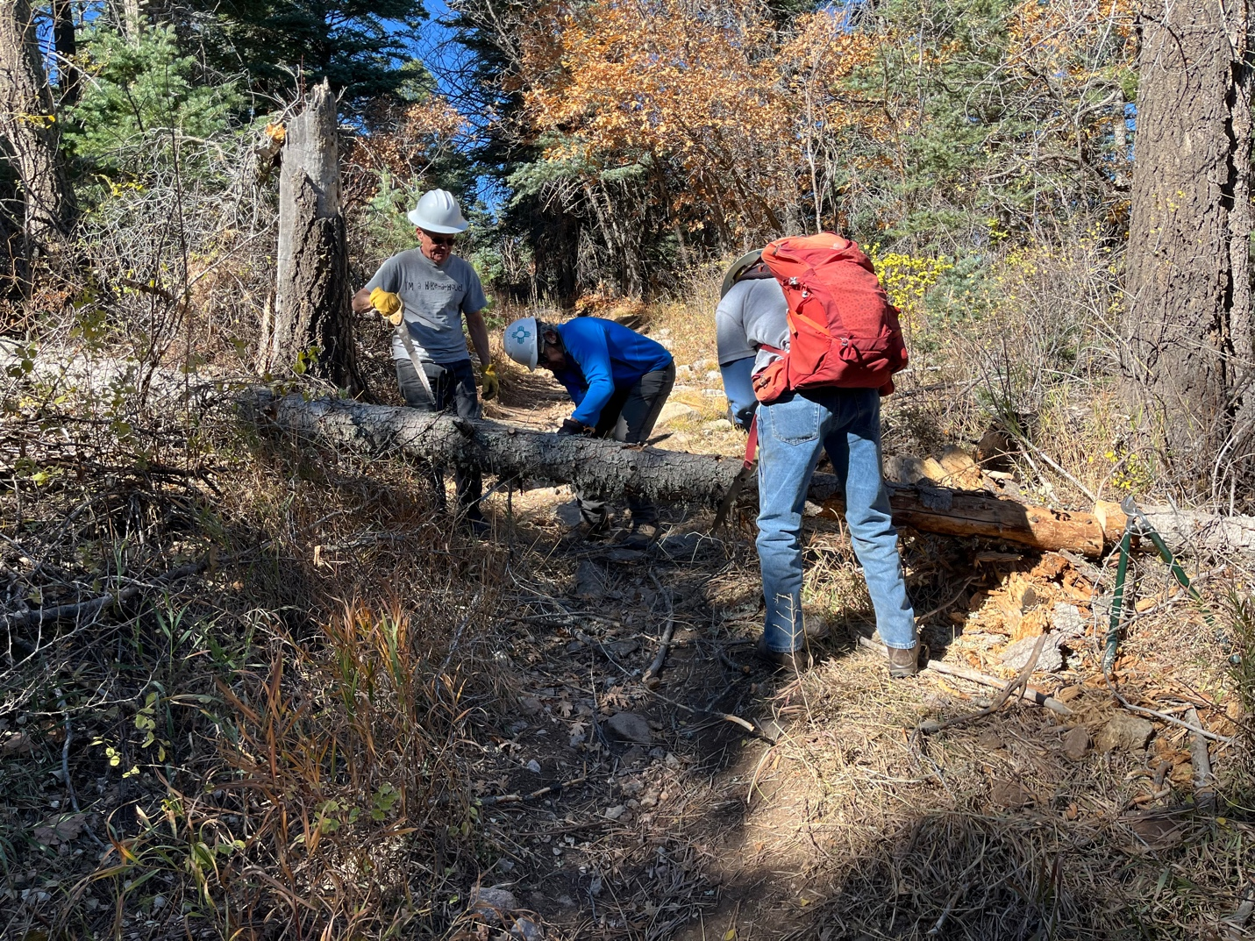

Byron coaches Luis and Cia on removal.

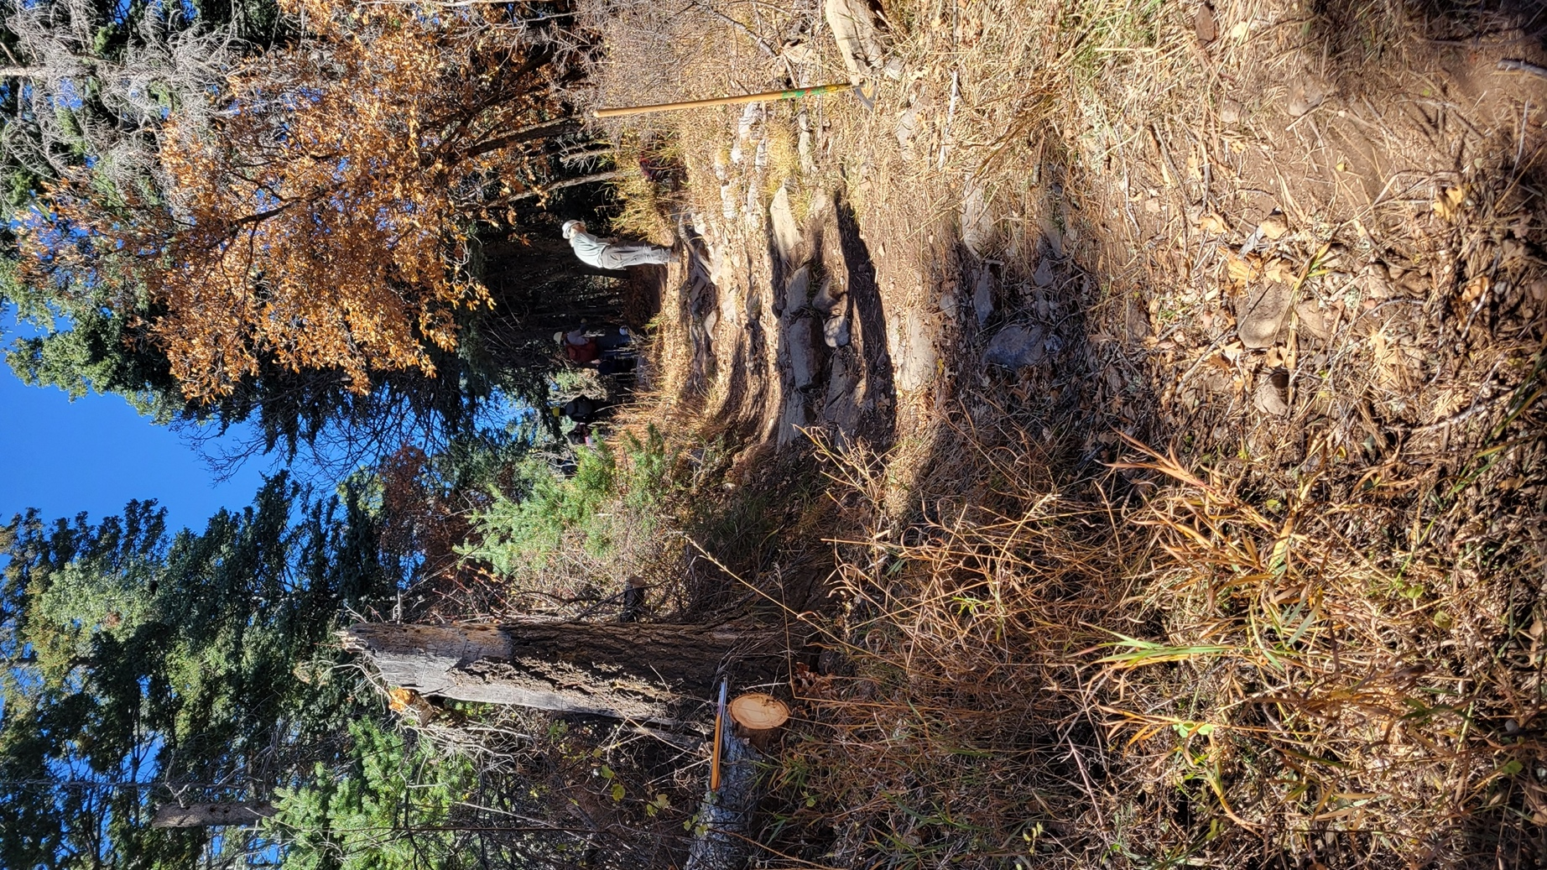

All clear and moving on up the trail.

