**Report of FOSM Project to Fell Hazard Trees in the Capulin Snow Play Area on Wednesday, October 30, 2024**

SamBeard

On Wednesday, October 30, eleven FOSM volunteers felled approximately a dozen hazard trees in the Capulin Snow Play Area. The dead trees or trees with dead tops were located beside the road leading to the CSPA, at the parking lot, along the trail to the gazebo or at the gazebo and in the forested area surrounded by the parking lot, the trail, and the old and new sledding areas. The tree with a diameter of 23-inches was the largest tree felled.

Volunteers working on this project were Dennis Crowther, Dan Benton, Lou Romero, Byron Garner, Eric Russell, Sim Cook, Jamey Browning, Steve Roholt, Don Carnicom, Jerry Carroll, and Sam Beard.

Project photos are presented below.

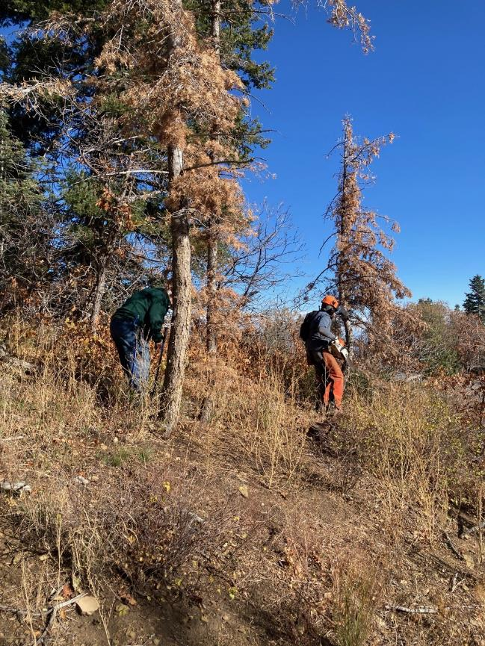

Lou Romero and Sim Cook on the hillside above the Snow Play Area parking lot looking for a tree for

Sim to fell. All photos by Cliff Giles unless noted otherwise

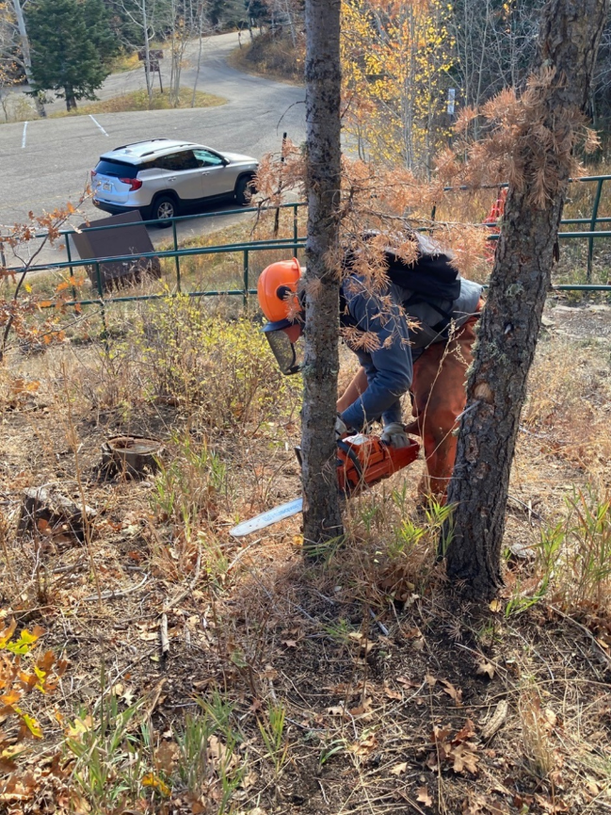

Sim felling a small dead tree beside the trail going to the gazebo.

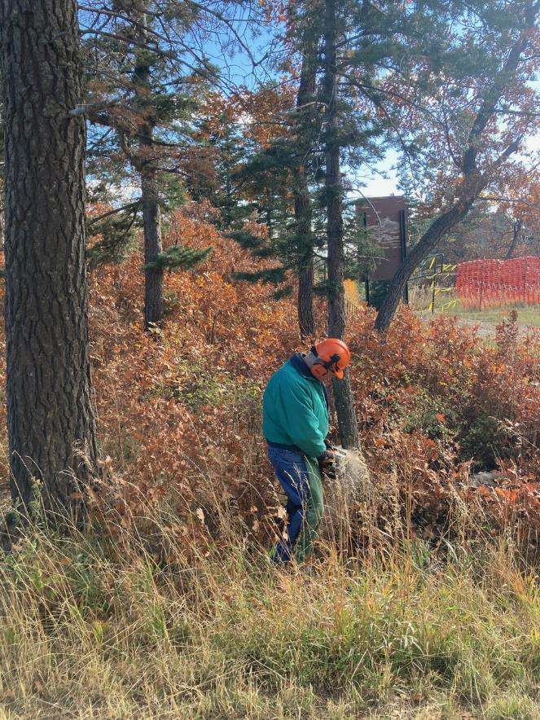

Dennis Crowther felling a small tree in the lay of the large tree behind him.

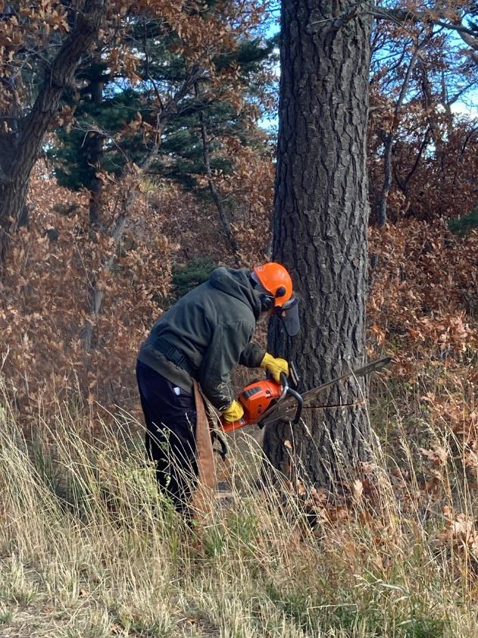

Sam Beard making the face cut in a 23-inch diameter fir near the gazebo.

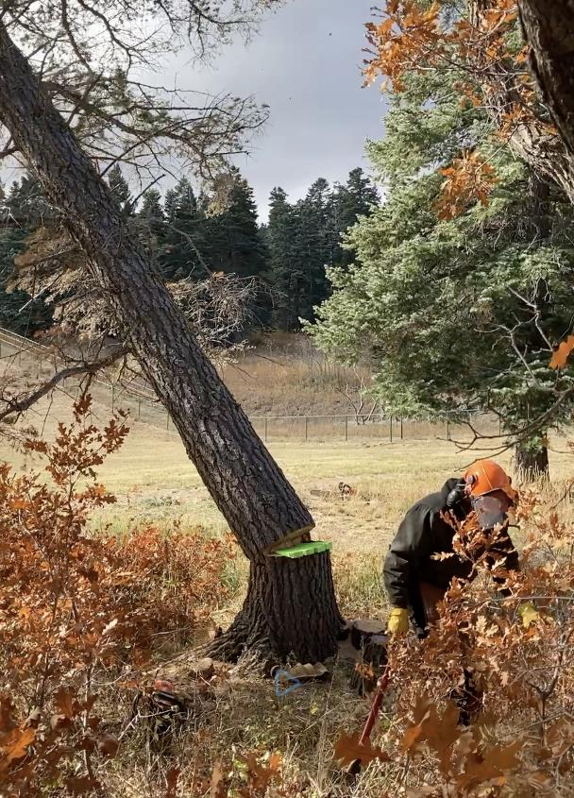

Sam running away from the falling tree that was felled with four wedges.

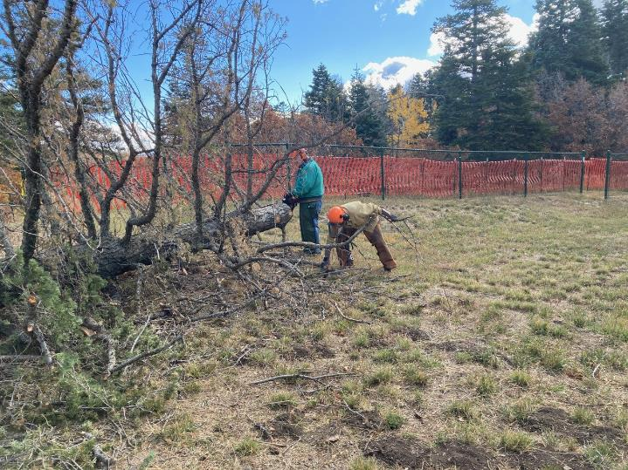

Dennis bucking the large log and Don Carnicom picking up branches.

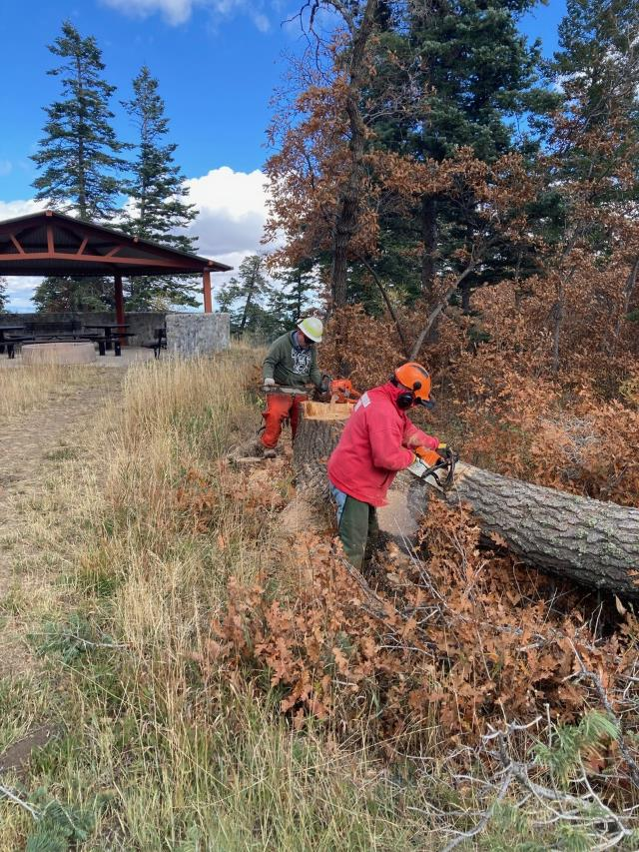

Jerry Carroll bucking the fir and Tim Kirkpatrick changing the chain on a saw.

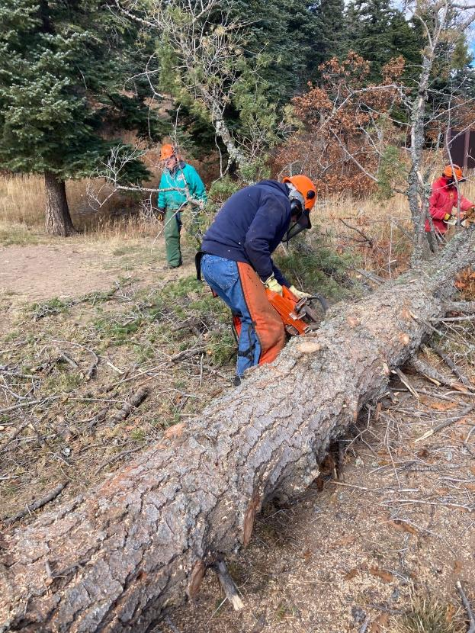

Byron Garner limbing the large fir.

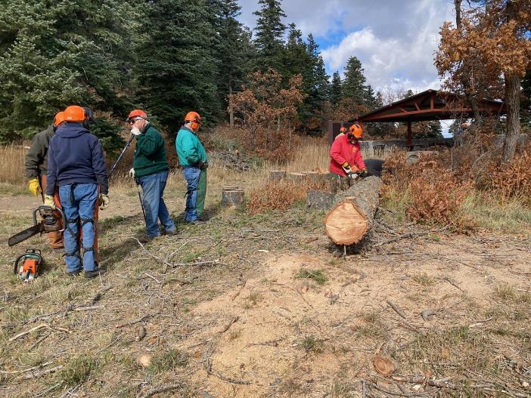

Jerry continuing to buck the fir while Sam, Byron, Lou, and Dennis observe near the gazebo.

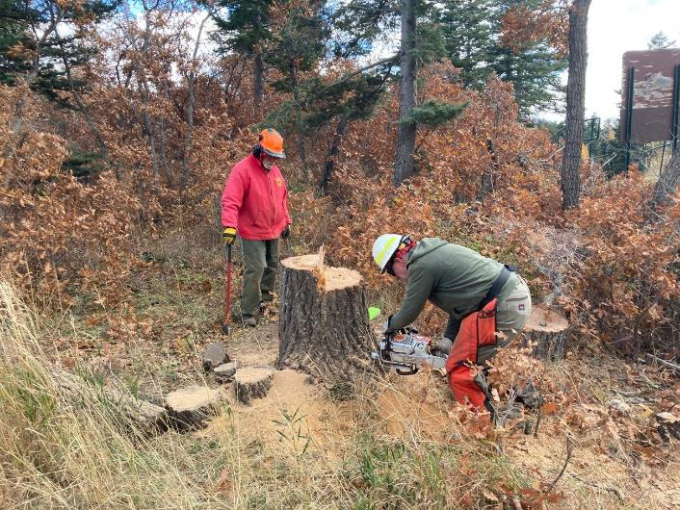

Tim low stumping the large fir.

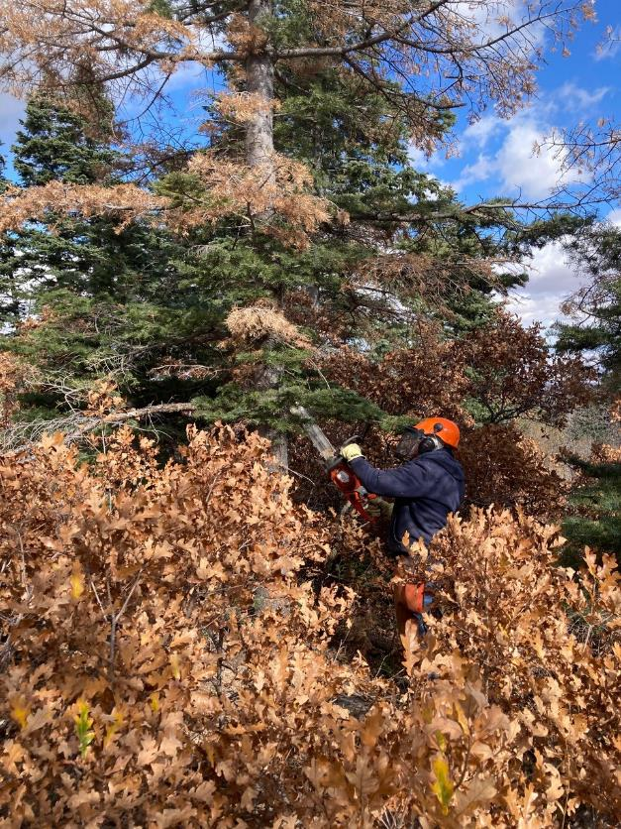

Jerry limbing a dead fir before felling it.

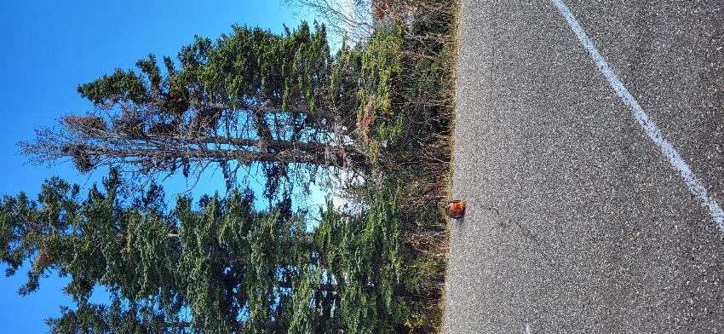

Dead tree at the parking lot. Note the three trunks coming from the single lower trunk.

Photo by Eric Russell

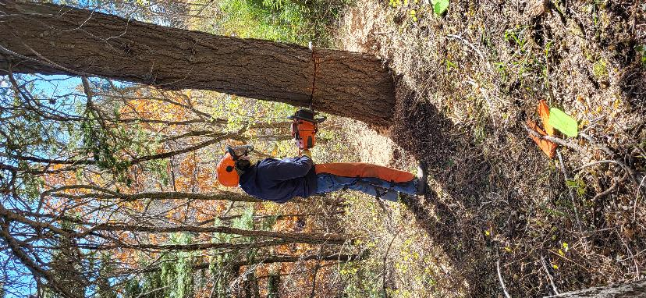

Byron Garner felling this tree. Photo by Eric Russell

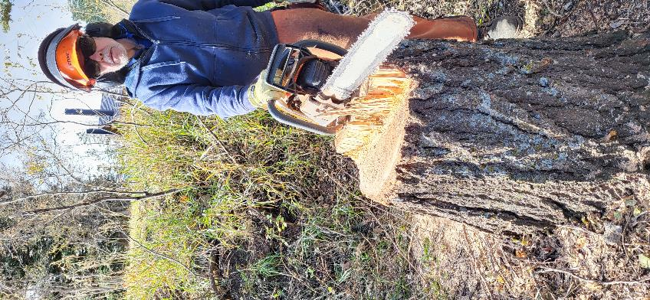

Byron at the stump of the tree he felled. Photo by Eric Russell