Thursday, 11/14/24- Strip Mine Trail: Eight volunteers joined SRD staff (Jen, Chris and Zay) in Placitas on Thursday for some brushing and trail work. We had really nice weather and mostly dry trail to work with. The crew covered Strip Mine Trail and Chalk Dust Trail, brushing and dealing with erosion issues. We stopped for lunch and worked on a section of Strip Mine where the trail had become very narrow along a steep drop off. A huge thank you to Chris and Zay, who’s season has ended. They have been a huge part of our successful season and we will miss their good humor and energy as we try to finish up work before the ground freezes.

Volunteers: Eric Messerschmidt, Rich Fagioli, Claudia Bergsohn, Bill Perkins,

Jim Houle, Byron Garner, Luis Cuadros and Laura Leon

Pictures: Laura Leon and Luis Cuadros

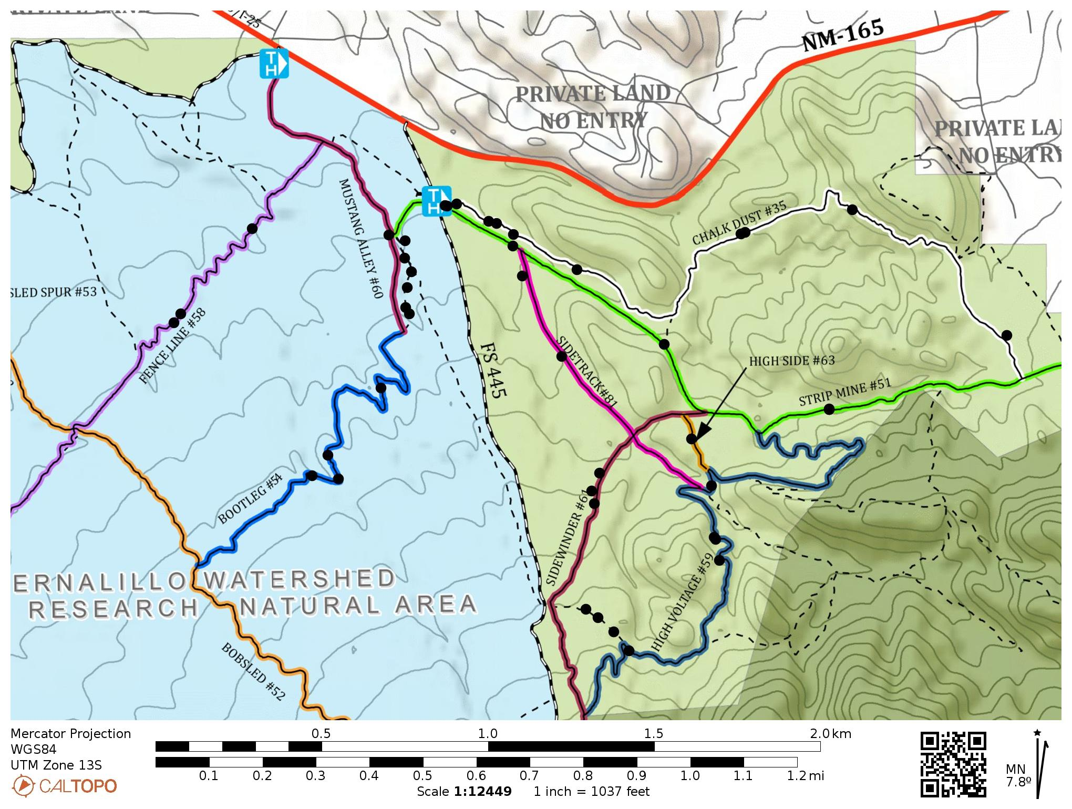

We worked the Strip Mine and Chalk Dust loop.

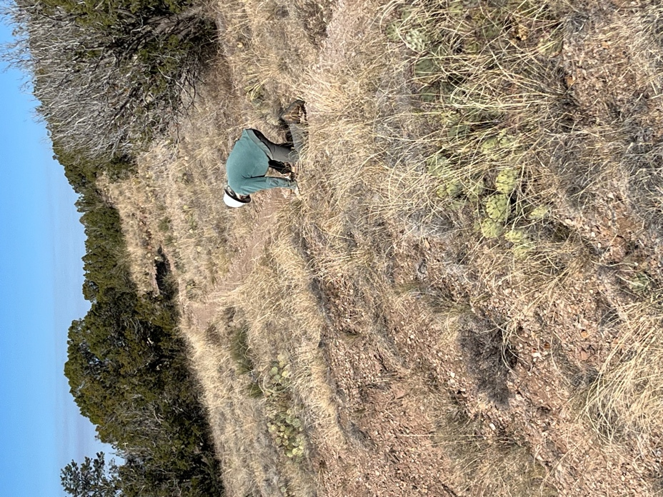 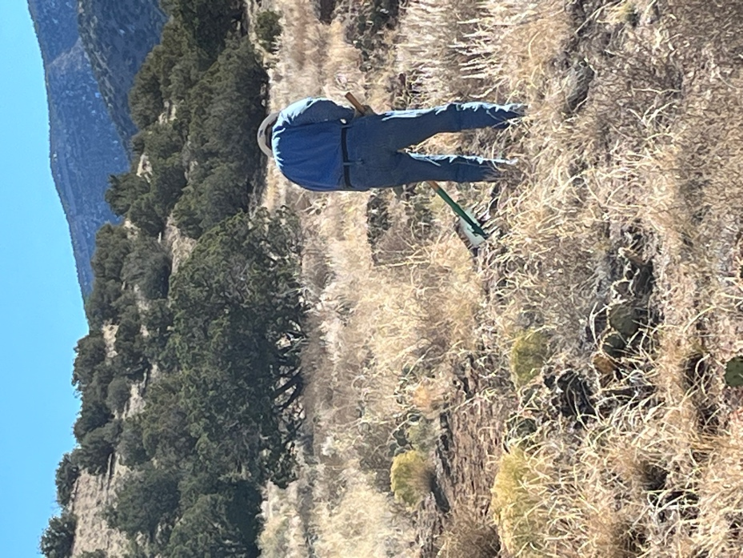

Bill fits rocks into a drainage area to slow erosion and Byron creates and area of water runoff.

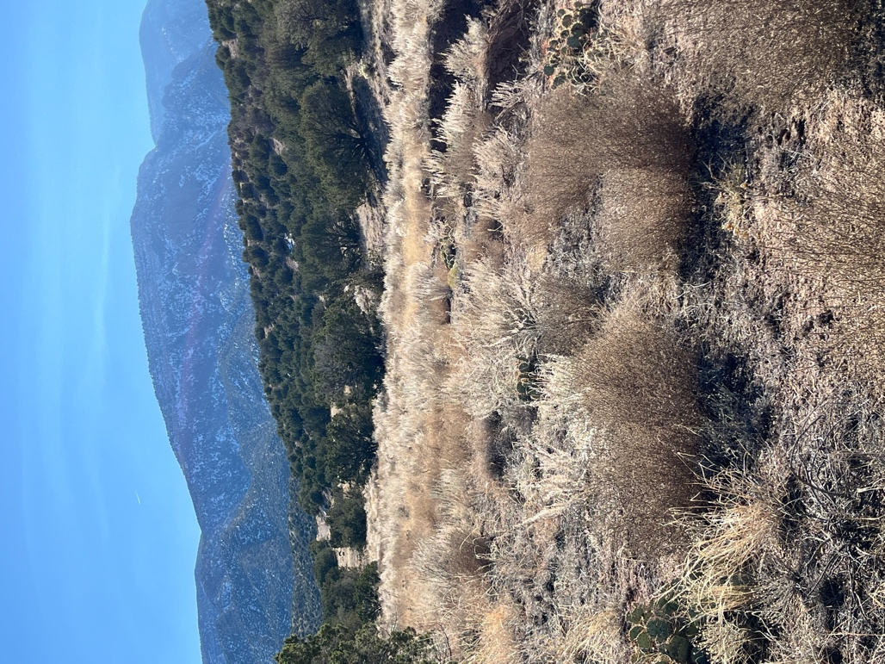 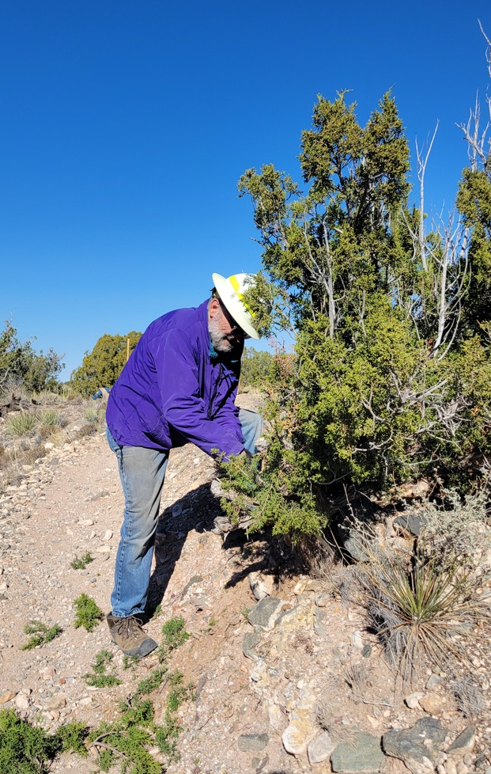

Quite a different view of the Sandias! Jim cuts back juniper.

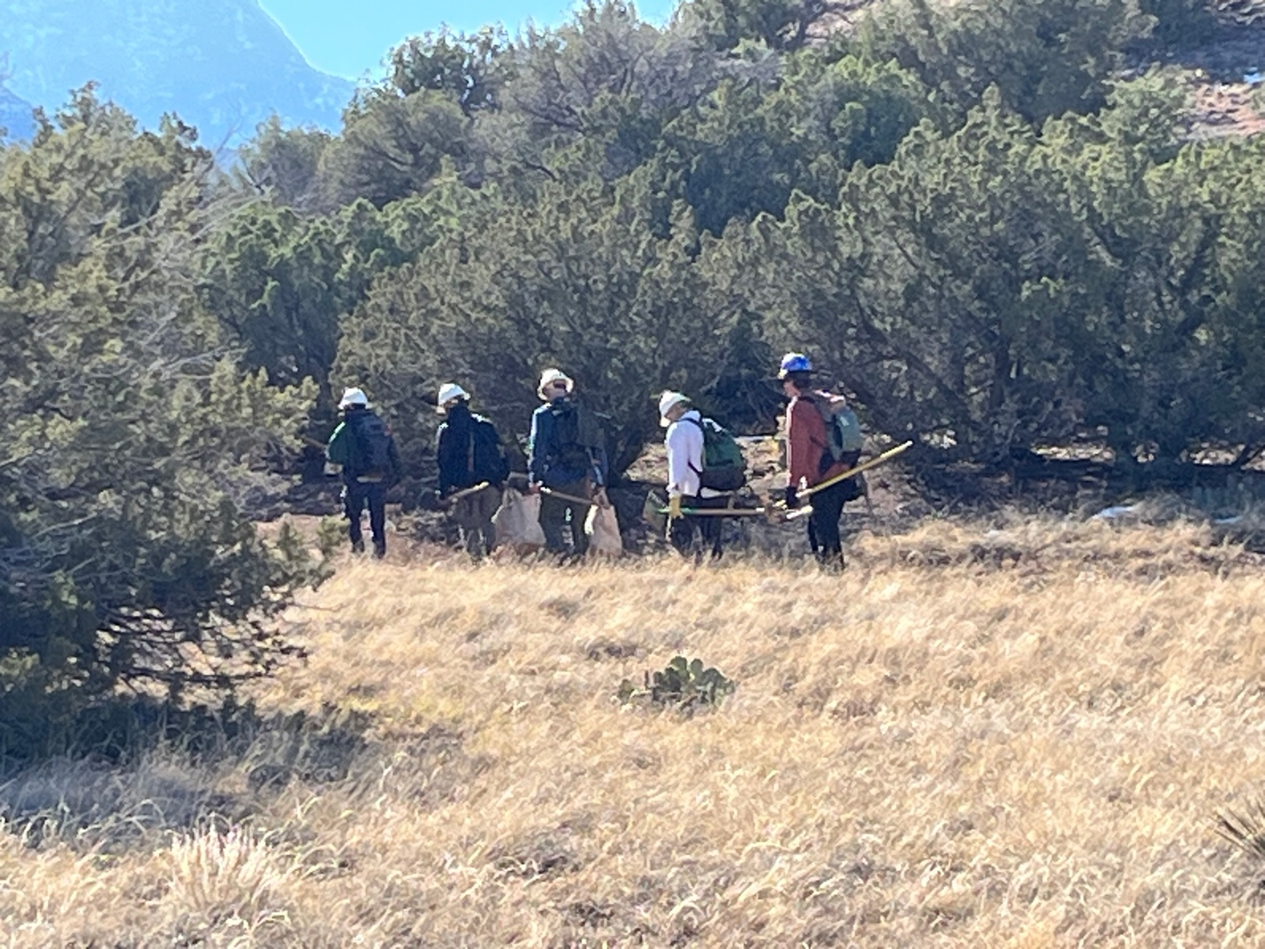

Hiking along, bumping up to the next spot.

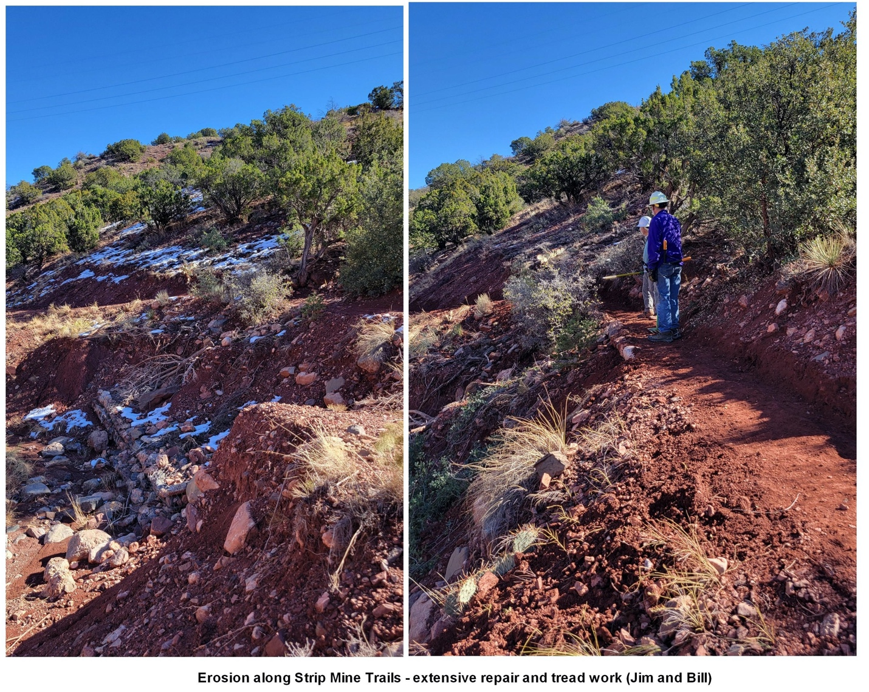

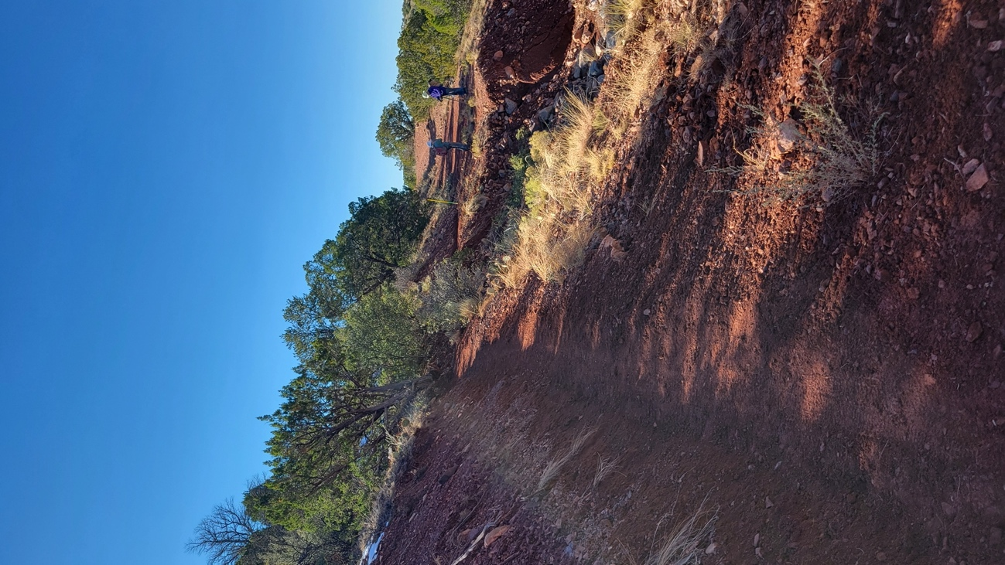 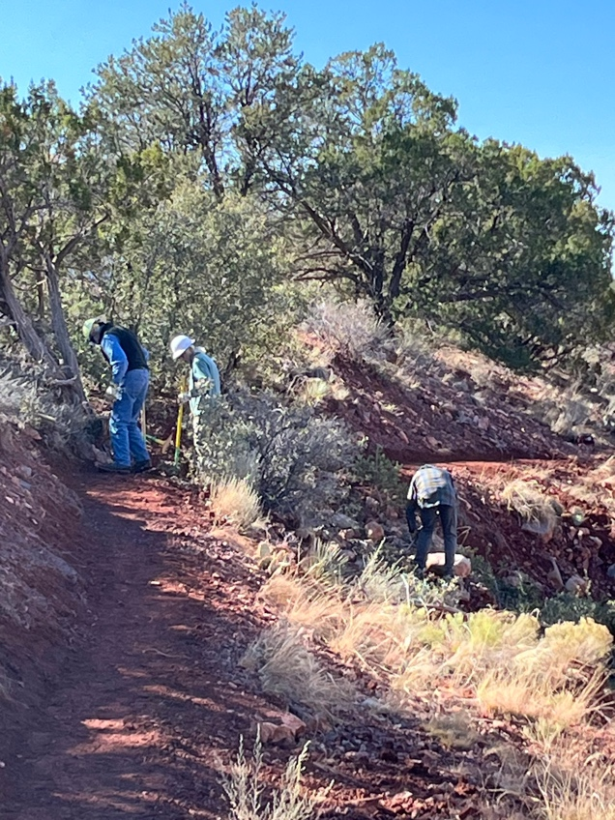

The team worked this section from an overgrown, 8 inch wide track to a stable foot wide path.

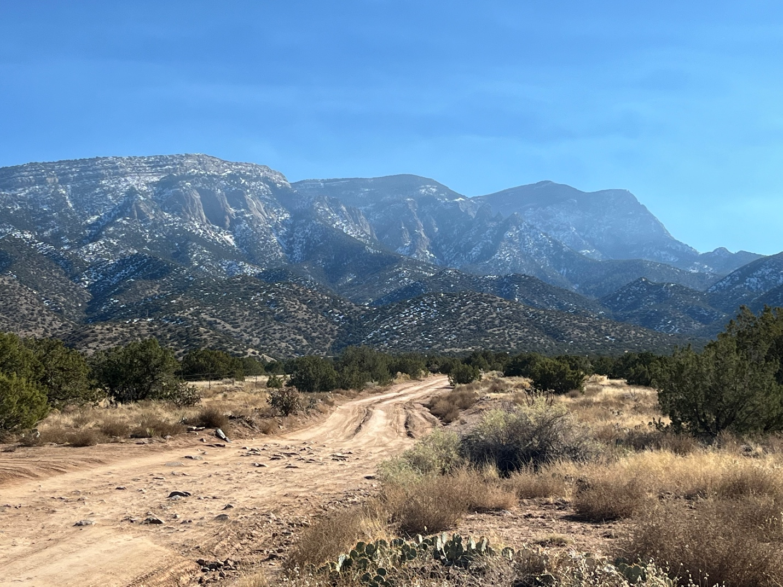

We thought we were seeing water vapor but it turns out Isleta Pueblo was doing some burning so the haze is probably smoke. Still a very nice view.