**Report of FOSM Project to Fell, Limb, and Buck Three Dead Pinon Trees**

**across the Street from the SRD Storage Yard, Wed., Nov. 13**

Sam Beard

On Wednesday, November 13, nine FOSM volunteers felled, bucked, and limbed three dead pinon trees at the request of Canyon Young, SRD Trails and Wilderness Program Manager. The trees were located across the street from the SRD storage yard, and the parking area size here was increased by felling the trees. The bucked wood was piled behind the hazmat building and will be moved to the Mountain Christian Church wood ministry lot when Mike Oliver’s truck and trailer are available.

The volunteers working on this project were Dennis Crowther, Sam Beard, Cliff Giles, Jerry Carroll, Chuck Logan, Eric Russell, Sim Cook, Dan Benton, and Tim Kirkpatrick.

Project photos are presented below.

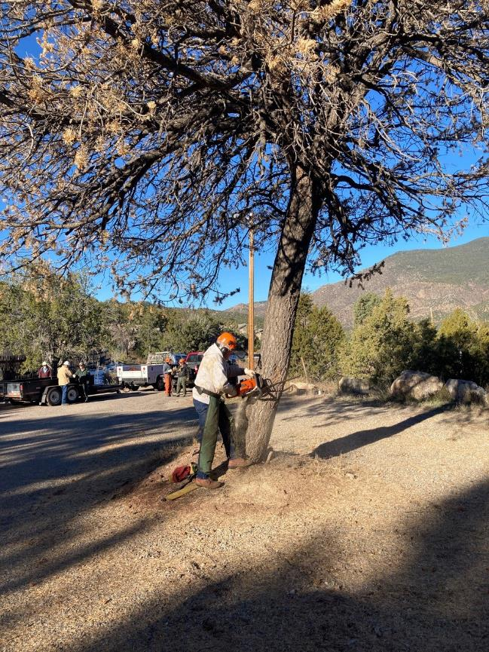

Eric Russell making a face cut in the largest pinon tree. All Photos by Cliff Giles

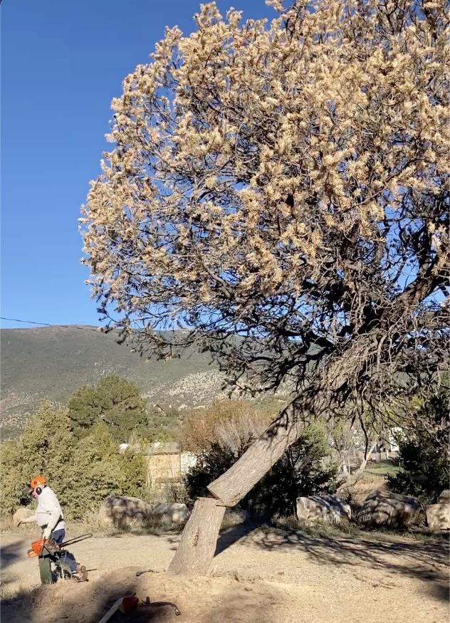

Eric’s tree is falling and he is running away.

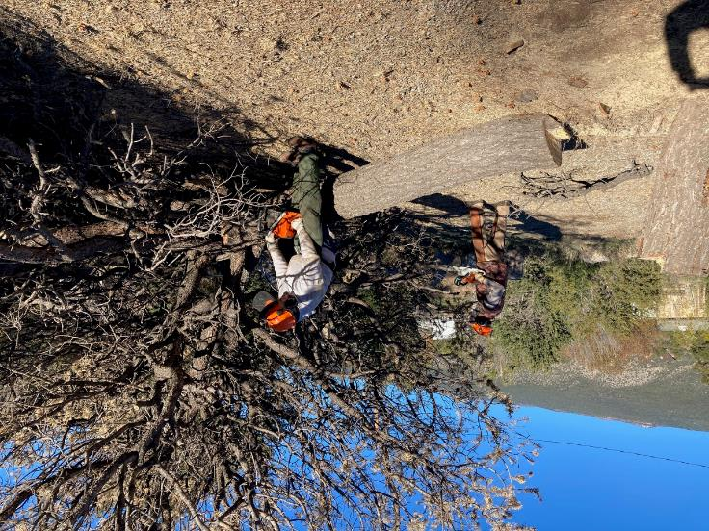

Dan Benton and Eric Russell begin limbing this large pinon tree.

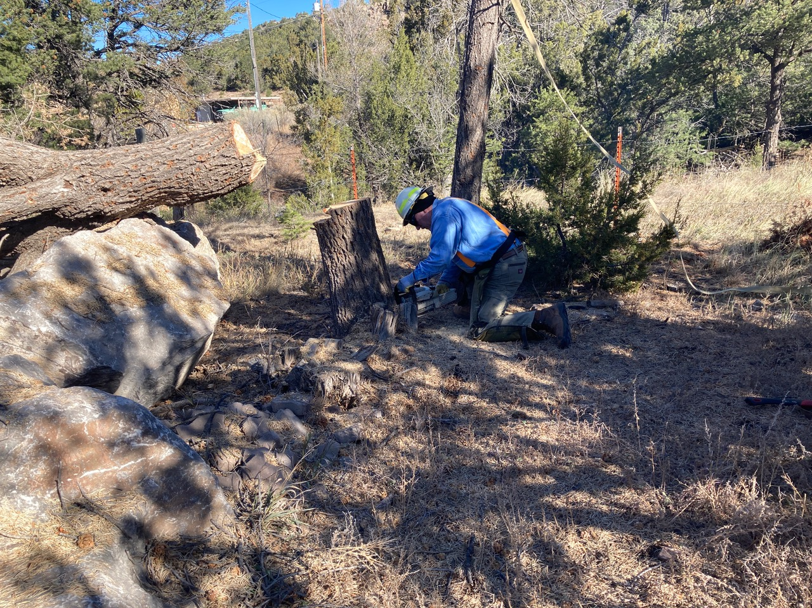

Tim Kirkpatric is low cutting this stump.

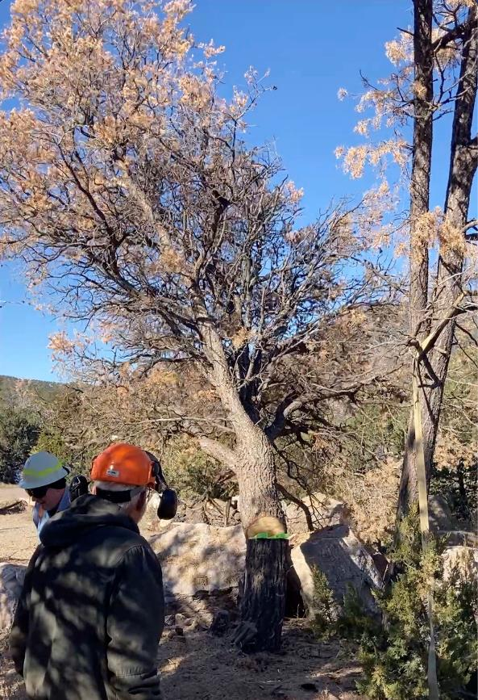

Tim Kirkpatric is running away from the tree he has just felled.

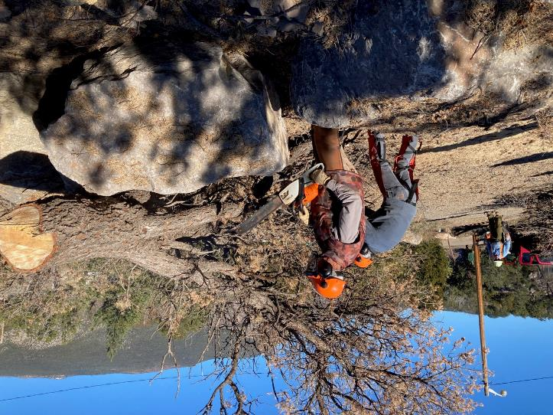

Dan and Sim Cook begin to limb this tree.

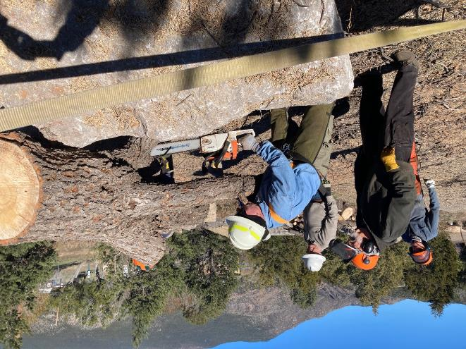

Tim is limbing the tree, and Sam Beard is observing.

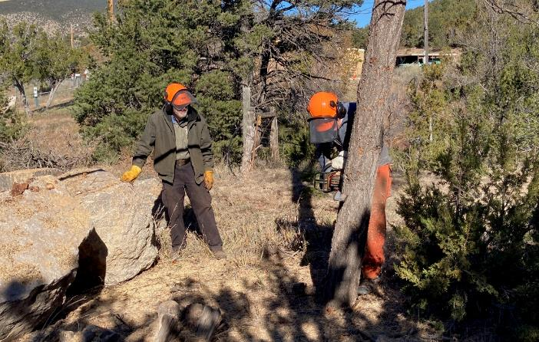

Sim is beginning to fell this dead tree.

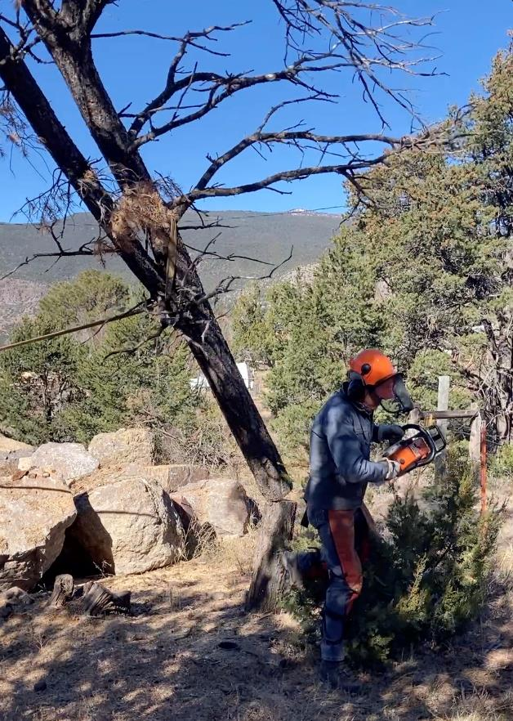

Sim is running away as the tree falls.

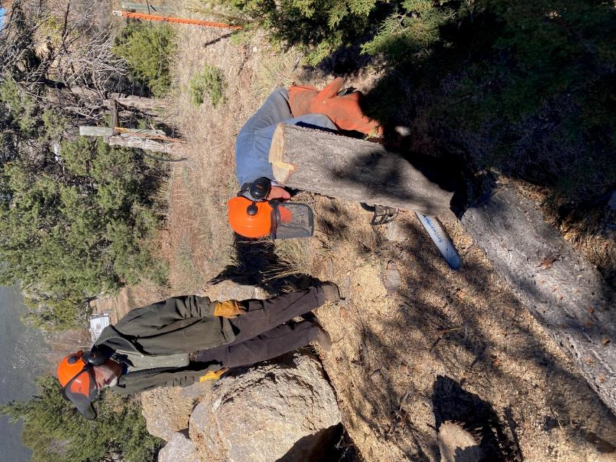

Sim is cutting the stump lower.

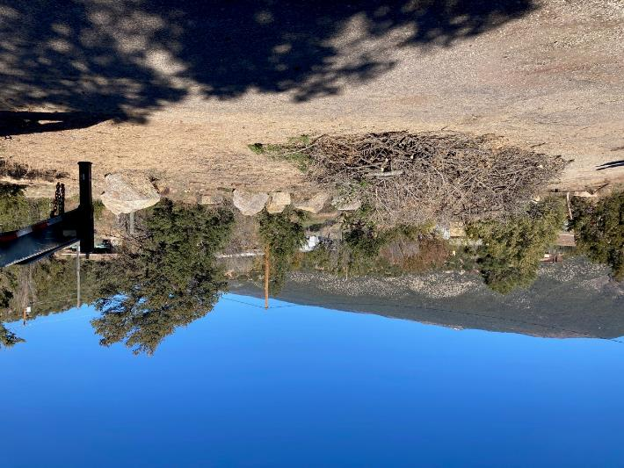

The fire wood has been moved to the north side of the hazmat building, and SRD personnel

are moving the slash to the Tijeras Transfer Station. The firewood will be moved to the church

woodlot at Mike Oliver’s house.