Trail Maintenance Report: Monday, November 18, 2024

Byron Garner

The Monday trail maintenance crew headed out November 18 from Cienega on Armijo to remove two reported down trees, located before the Un Poquito junction, only to discover our efforts were no longer needed. Dave, however, spotted a very poorly supported 9in. leaner at the Un Poquito junction, that was likely to fall on the trail and was easily resolved with a quick application of the rope. Being the beautiful day that it was, we continued on the Un Poquito loop, Valle and Pine Drop trails to find a 13 in. "spiky" protrusion and another down 9in. Ponderosa. In spite of the gloomy forecast, we had blue skies, mostly clear trail with a few short stretches of ice and a great fall day. Our crew included Silke Bletzer, Phil Cromer, Dave McCreery and Byron Garner with Silke providing photos and trail notes.

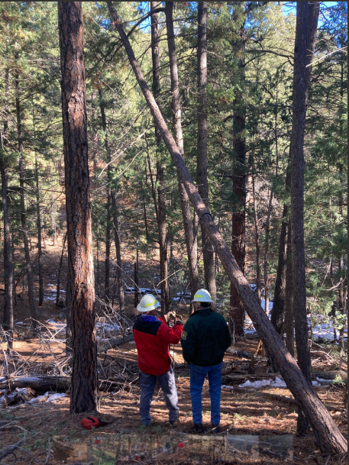

Dave rigs the pulling rope for the leaner

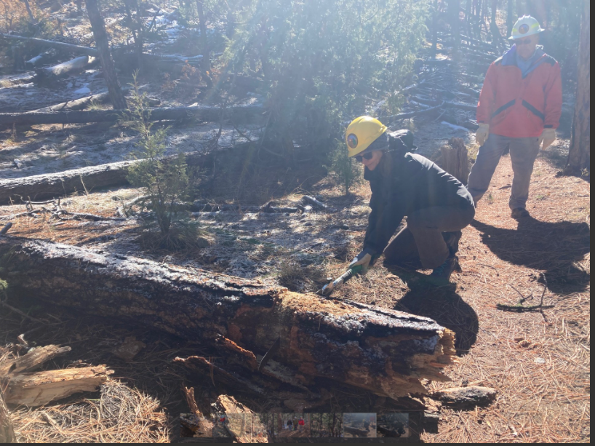

Silke goes full throttle on this 13" protrusion

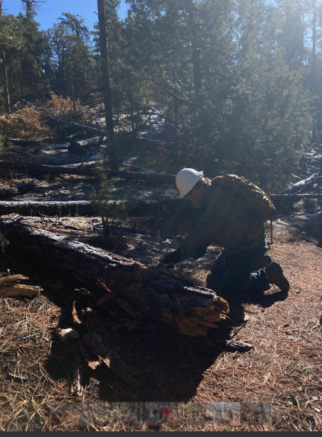

Phil takes the next shift

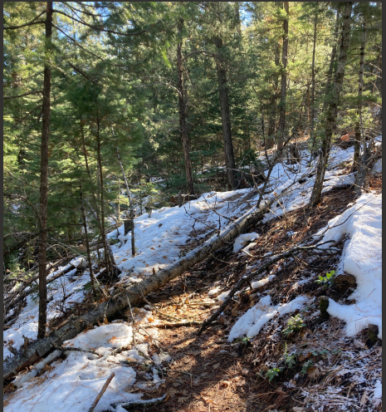

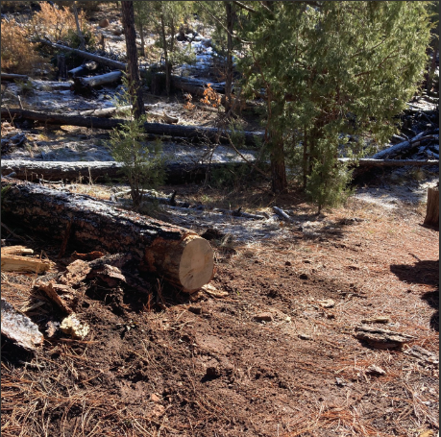

Clear and good to go

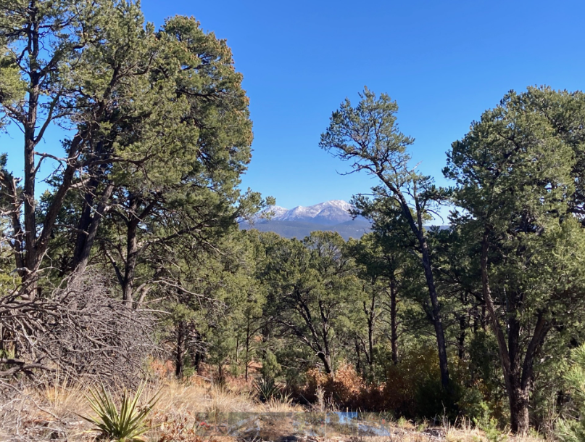

And a beautiful day it was