Thursday, 11/21/24- Tablazon: Ten volunteers joined Jen (SRD) at the Lower Pine parking area on Thursday. We had a cold start but were able to get some more work done on the Tablazon reroute. The weather warmed to a comfortable temperature but areas on the reroute were still snow covered or frozen so the crew hopped over these areas as they moved forward. About half way through the morning the sun had warmed areas of the reroute to a muddy mess so conditions were tricky and the hike out was a slippery mess. The crew can probably finish up most of the reroute in one more work day but some places will probably not be workable until the spring thaw.

Volunteers: Jim Houle, Mike Madden, Rich Fagioli, Claudia Bergsohn, Bill Perkins, Bruce Hansche, Cia Reil, Tony Pachelli, Luis Cuadros and Laura Leon.

Photos: Laura Leon

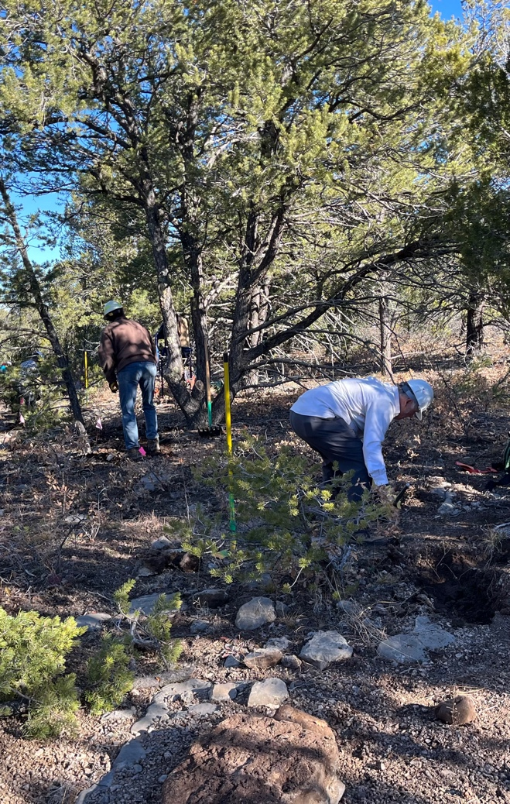 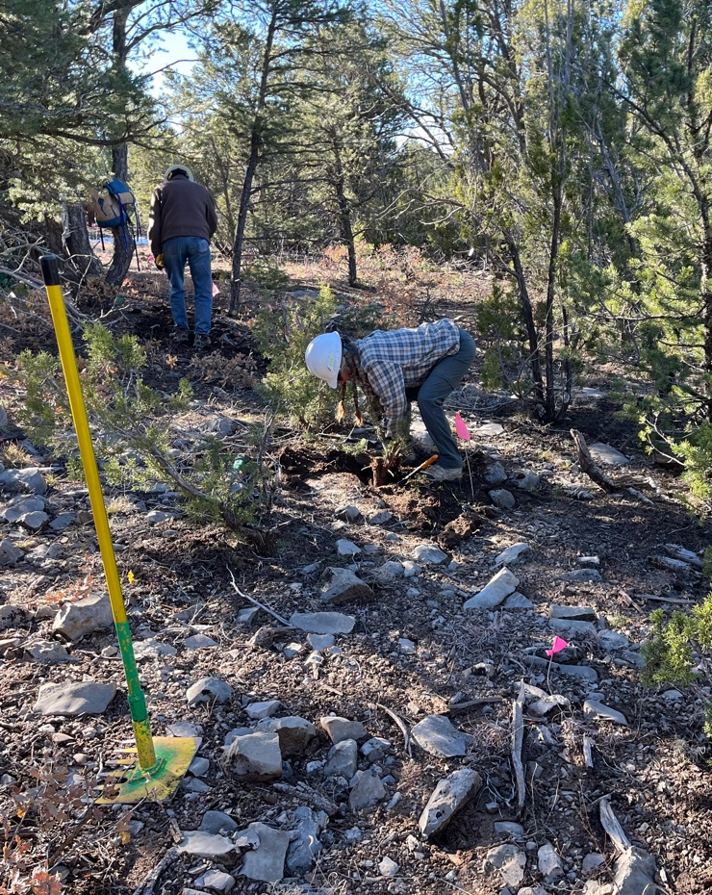

Rich, Jim and Claudia work a rocky, dry section of the reroute.

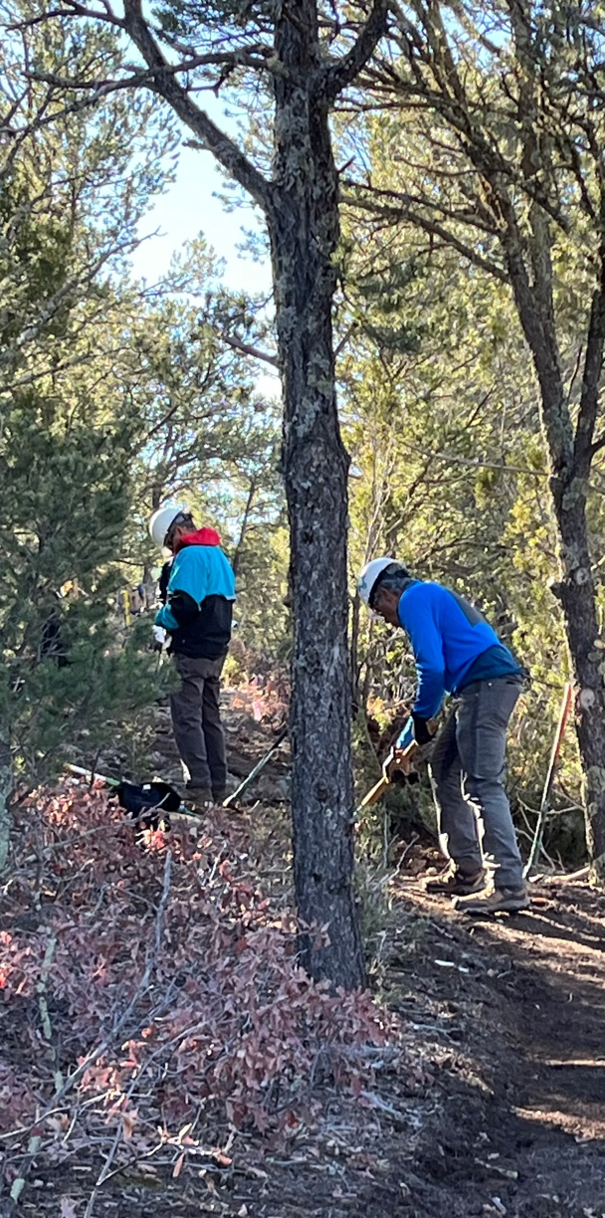 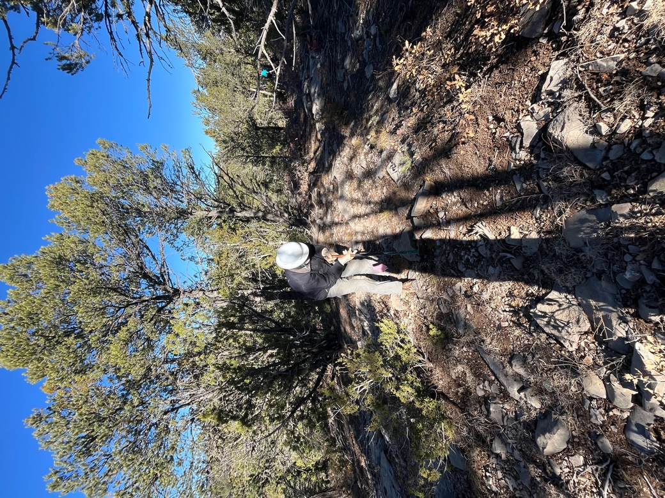

Tony, Luis and Bill work through the trees.

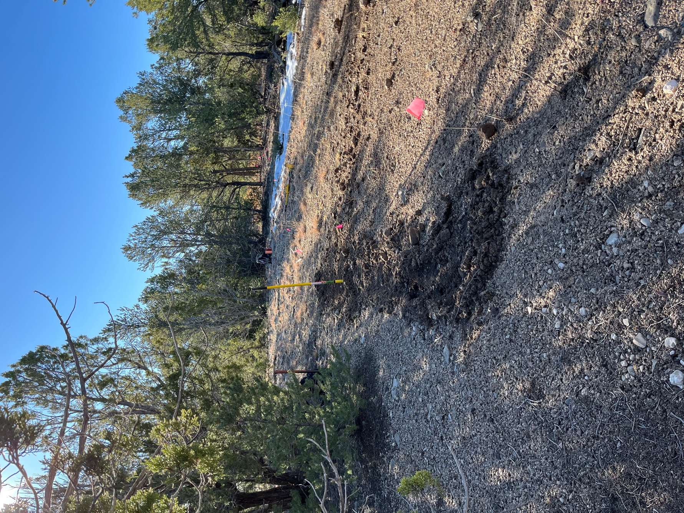

A work in progress.

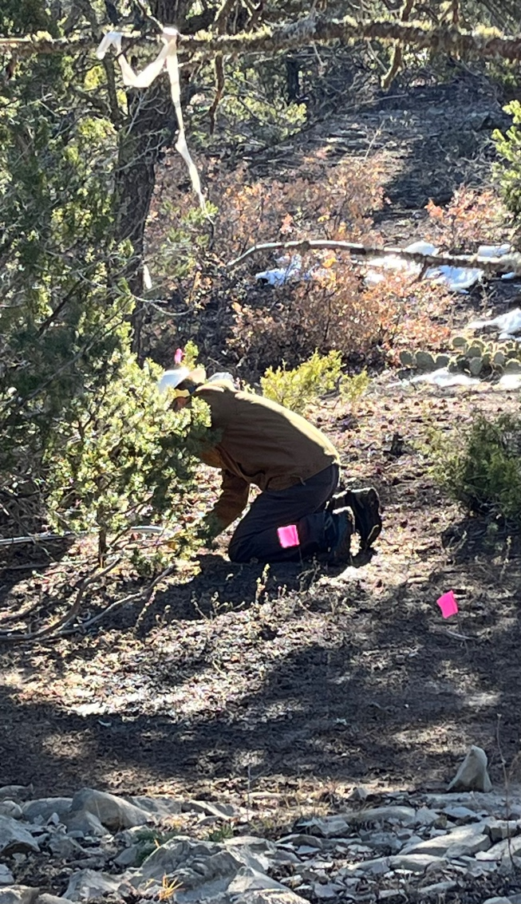 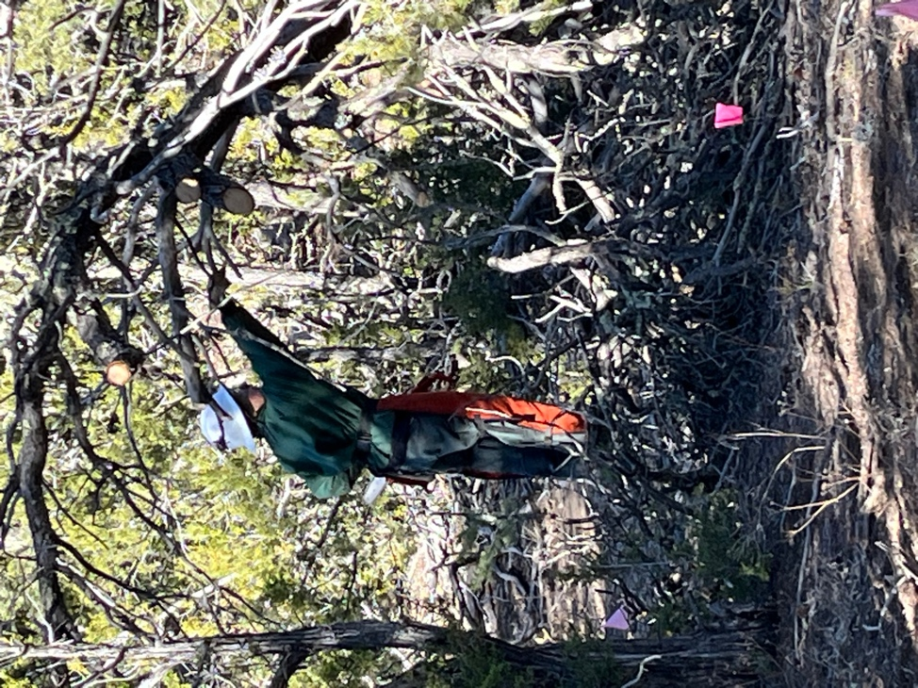

Cia, Laura and Jen cleared the corridor.