**Report of FOSM Project to Remove Graffiti Tags from Juan Tabo Picnic Area Boulders and CCC Shelter on Wednesday, November 20, 2024**

Sam Beard

On Wednesday, November 20, five FOSM volunteers removed seven large tags (2 ft by 3 ft) and nine smaller tags (1 ft by 1 ft or smaller) from a Juan Tabo Picnic Area table and the CCC stone shelter. They used the World’s Best Graffiti Removal System chemical for stone to dissolve the tag paint and the FOSM battery-powered low-pressure washer to rinse the water and chemical mixture from the surfaces. The gates to this picnic area are now locked for the winter season, and maybe there will be fewer graffiti tags to remove.

The volunteers were Sim Cook, Cliff Giles, Scott Christenson, Katrina Ziegweid, and Sam Beard.

Project photos are presented below.

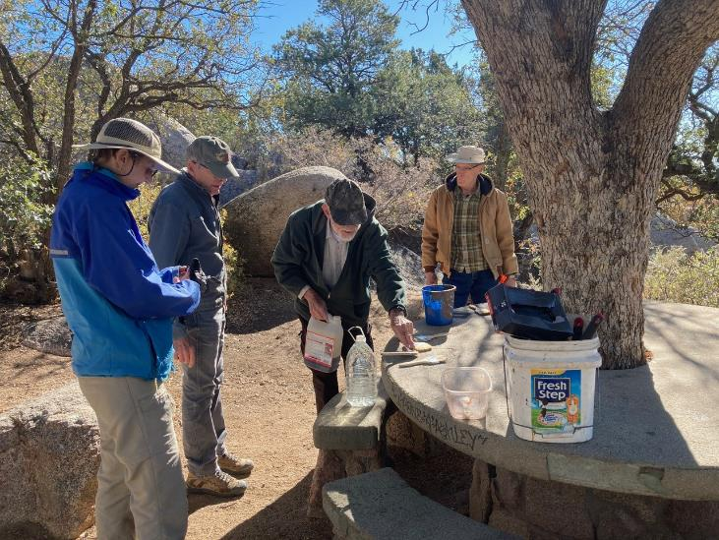

L to R: Katrina Ziegweid, Sim Cook, Sam Beard, and Scott Christenson preparing to remove the tags

from this round picnic table in Juan Tabo Picnic Area. All photos by Cliff Giles unless noted otherwise

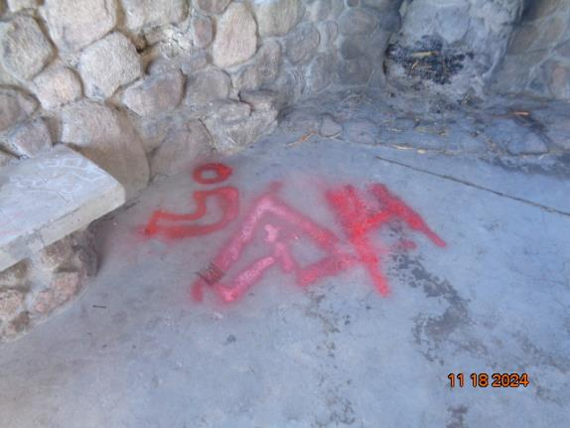

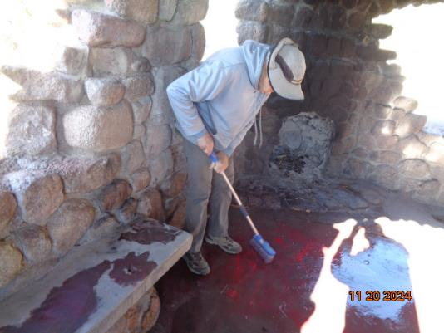

Cliff Giles pushing the gray water off the tag on the floor of the Juan Tabo CCC Picnic shelter.

Photos by Sam Beard

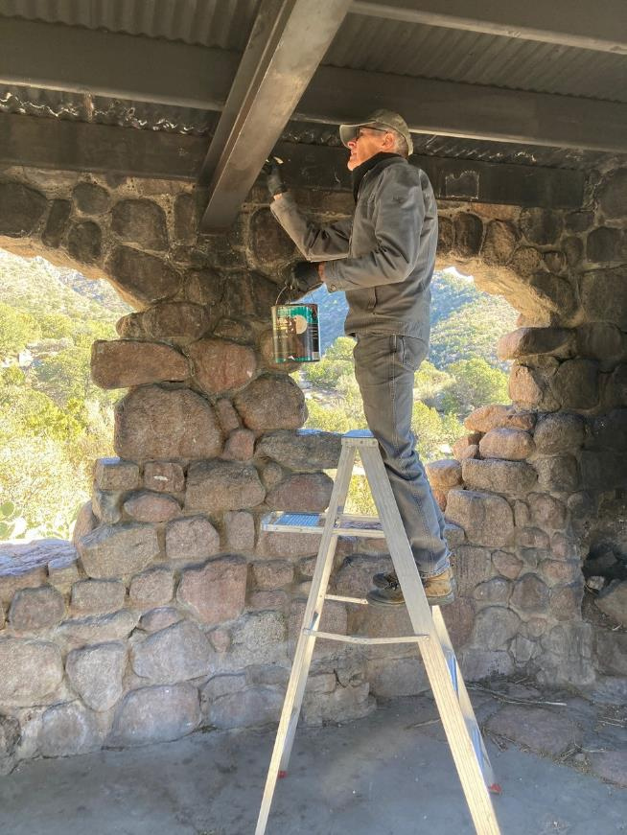

Sim painting over graffiti on a roof beam with USFS brown paint.

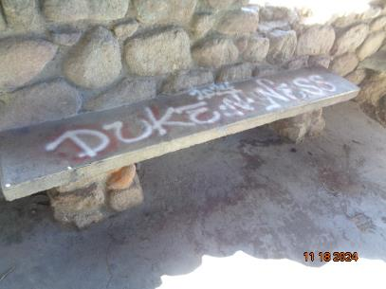

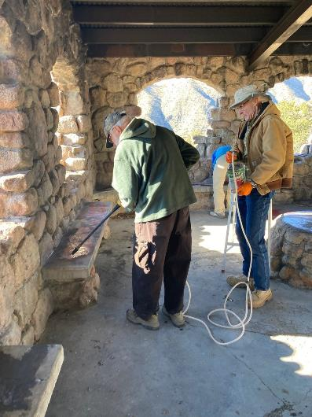

Sam and Scott rinsing water off tags on a concrete bench with the FOSM

battery-powered low-pressure washer. Photos by Sam Beard and Cliff Giles

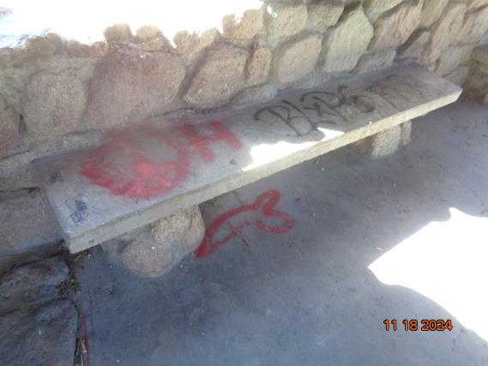

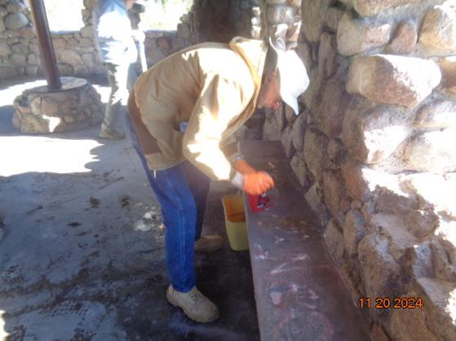

Scott applying chemical on tags on a concrete bench. Photos by Sam Beard

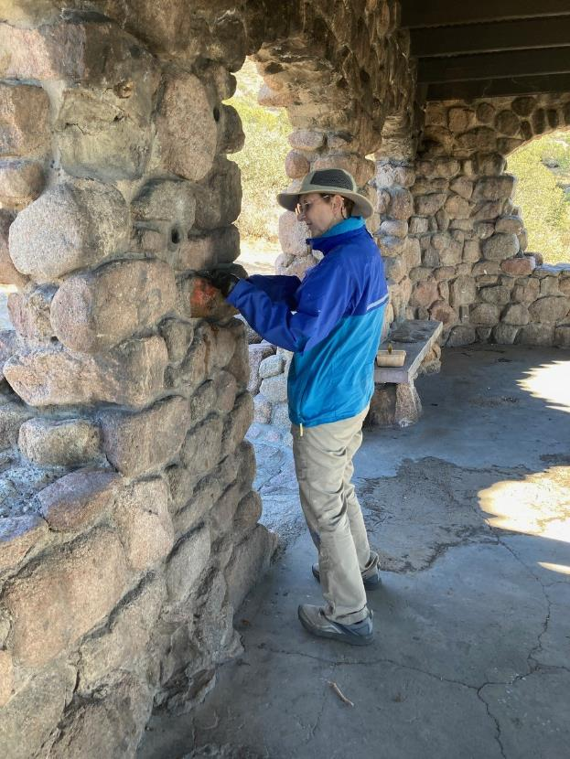

Katrina removing a tag from the west wall of the shelter.

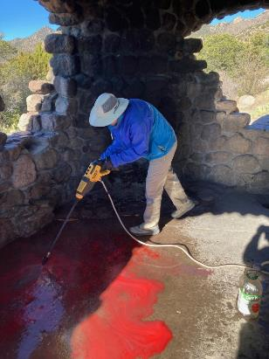

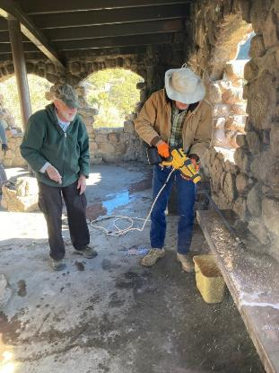

Katrina and Scott spraying water on the floor and a bench after tags were treated

with the chemical.

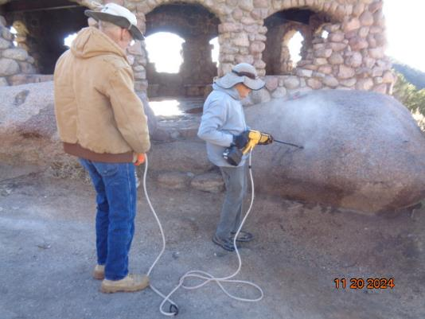

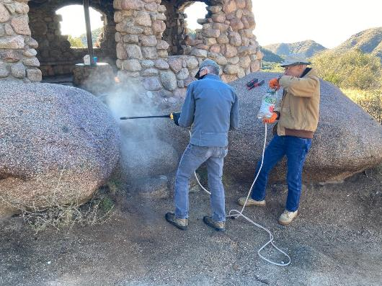

Cliff and Sim spraying water on boulders to complete the removal of tags.

Photos by Sam Beard and Cliff Giles

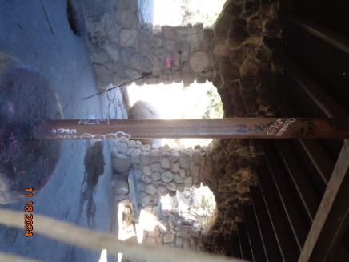

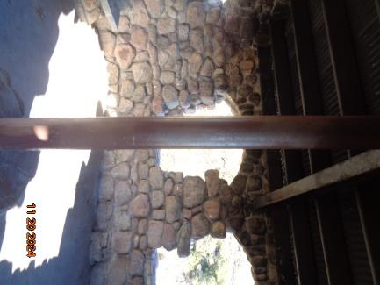

Sim painted over white tags on this post. Photos by Sam Beard

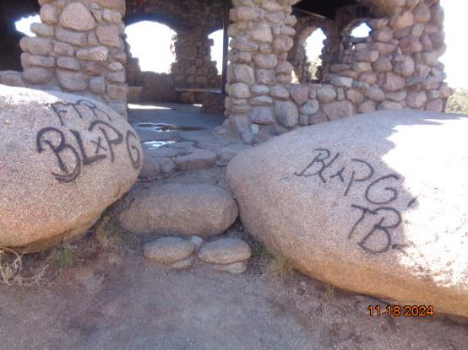

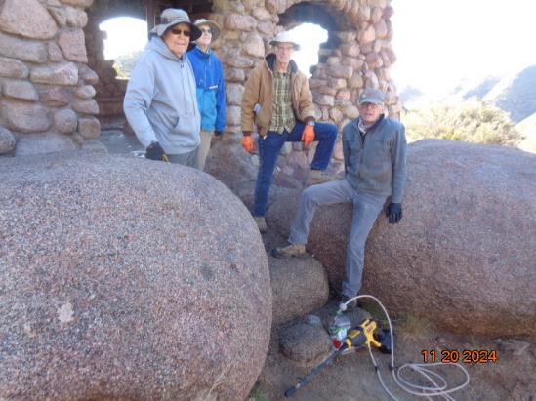

Tags on boulders and the crew that removed them. L to R: Cliff, Katrina, Scott, and Sim.

Photos by Sam Beard

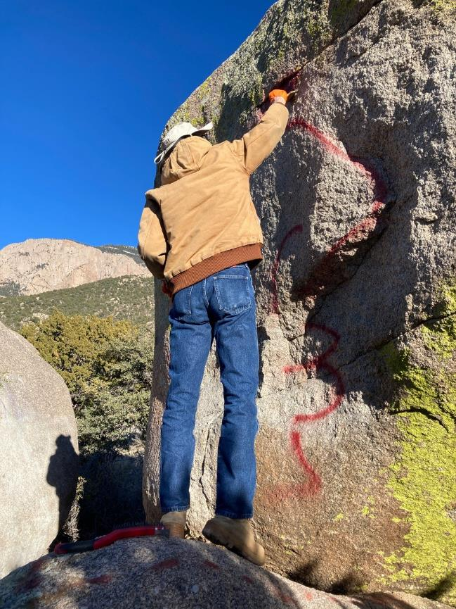

Scott applying chemical to a red tag on the west side of a very large boulder near the restroom.

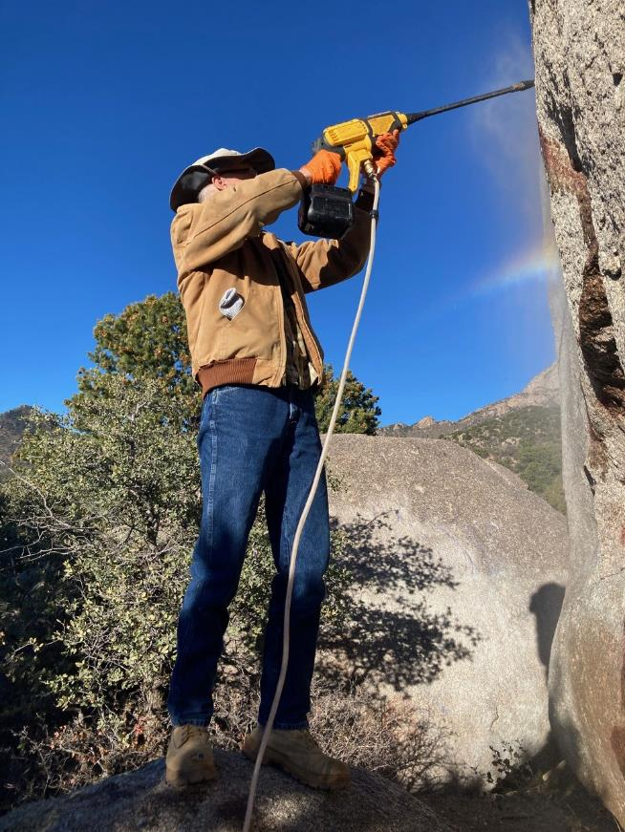

Scott spraying water on the treated tag. Tags were removed for the boulder in the background a few months ago.