Trail Maintenance Report: Monday, December 9, 2024
Byron Garner

On December 9 the Monday trail crew hiked Mystery Trail to clear a number of reported trees beginning at mile .9 with an eight inch fir requiring a bit of coordinated limbing and two cuts. Moving on, a seven inch dead fir, at the one mile point, was cleared with one cut. Having warmed up and become energized enough to face a real challenge, at mile 1.7 we found just that - a twenty-four inch ponderosa ( root ball and all ) with a trunk bifurcating into two sixteen inch+ trunks. With a bit of planning (more than a bit) and debate we proceeded with four cuts using the crosscut ( no Katanas here) reducing this once stately sentinel to manageable segments requiring , even then, some strategizing to clear them from the trail. With fatigue creeping upon us, we took our lunch "hour" between the third and fourth cut to take advantage of this fortuitously dry and warm location. With the completion of the fourth cut, we even found the root ball to be surprisingly cooperative and managed to move it. The top laying upper residual trunk segment had to be repositioned for more stability. Trail clear.
With our strutting feathers up and all feeling a bit victorious, we marched on down the trail in search of another adventure which presented as a small dead overhanging oak which was cleared. We also encountered a heavily branched fir suspended five feet above the trail and stable. Further down two more fallen trees were spotted which will be addressed next Monday.
The progressively warming conditions throughout the day made for a very enjoyable hike and ideal working conditions discounting for some soft ground and ice. The whole crew made an exceptional team effort to safely coordinate and complete a complicated but really fun project with our trophy ponderosa. The crew included Susan Gregory, Chuck Logan, Rav Nicholson, Phil Cromer, Ken Wilson, John Cooper, Silke Bletzer who provided trail notes and photos and Byron Garner also providing photos.
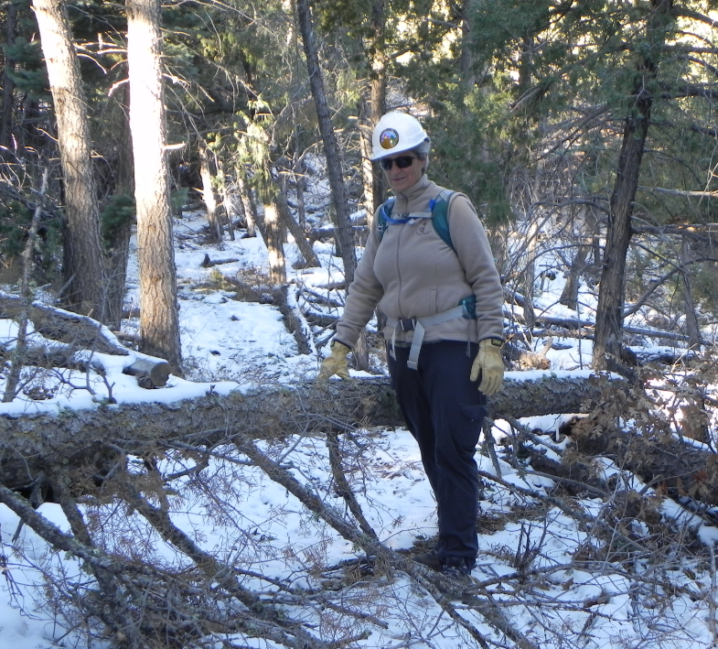
Susan sizes up our first tree

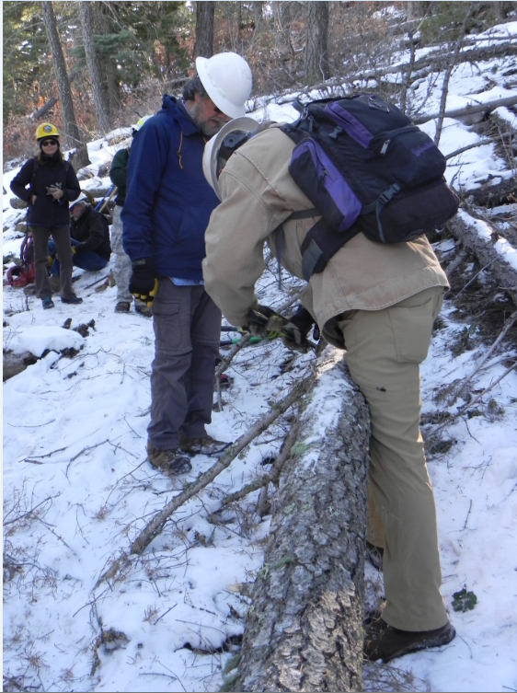
Phil and Chuck finish limbing
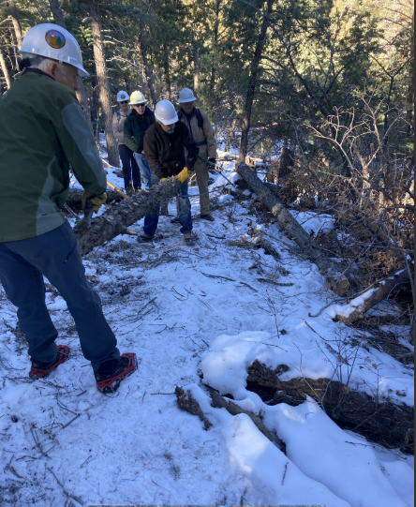
John and Ken hoist away

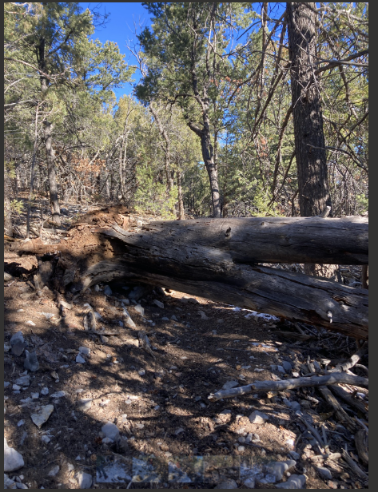

Meet Mr. Ponderosa

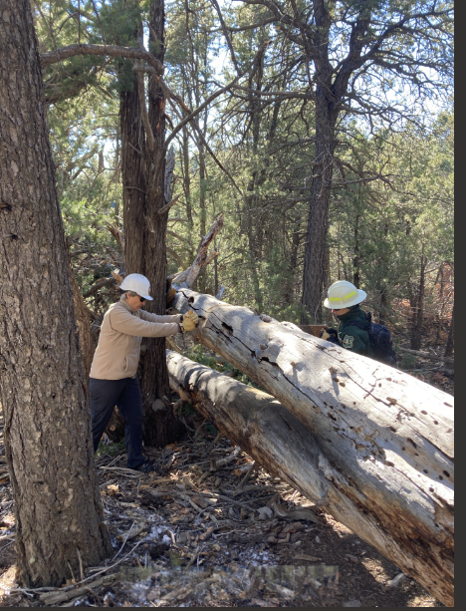

Susan and Rav kick things off

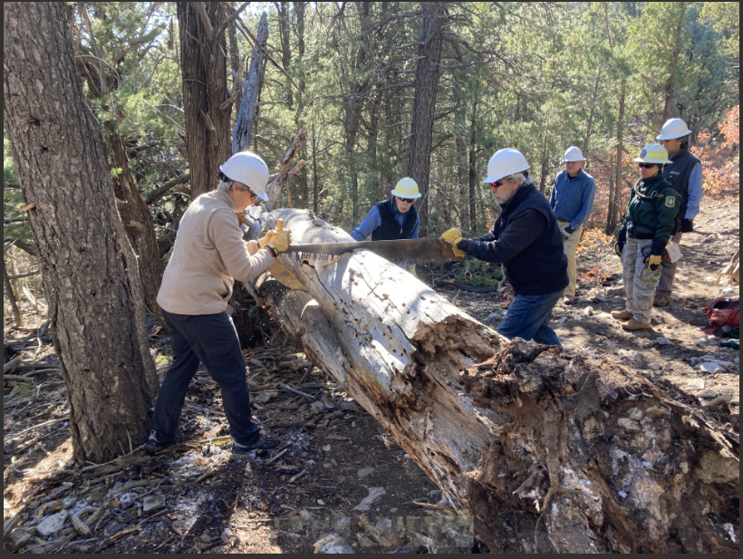

Susan and Ken on cut #2

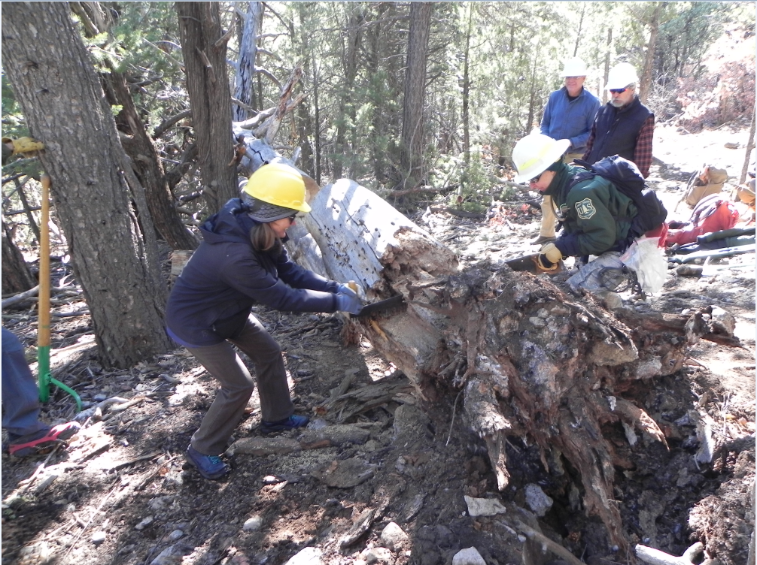
Silke and Rav show how it's done the FOSM way

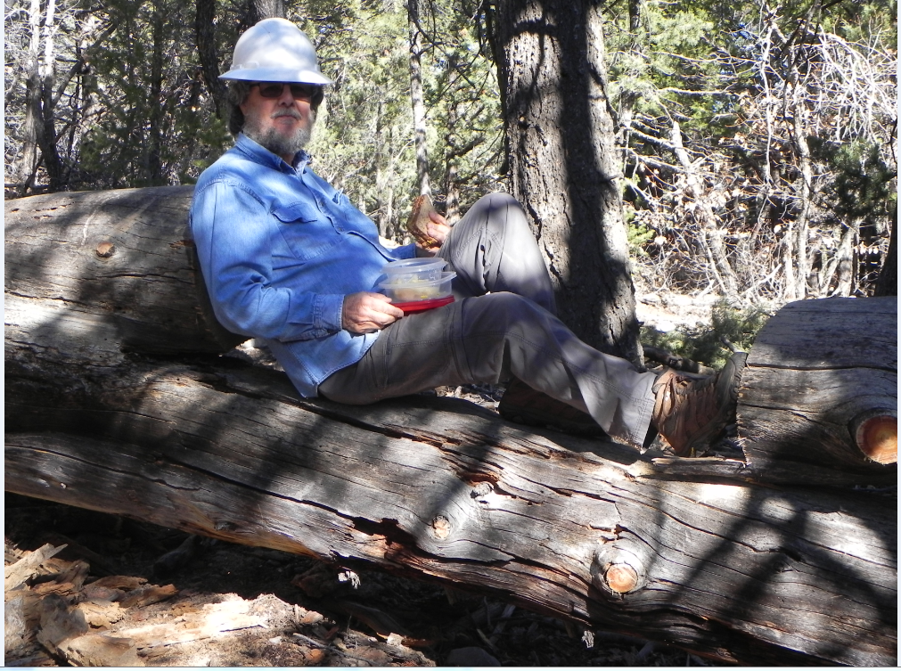

Phil declares "Miller Time"

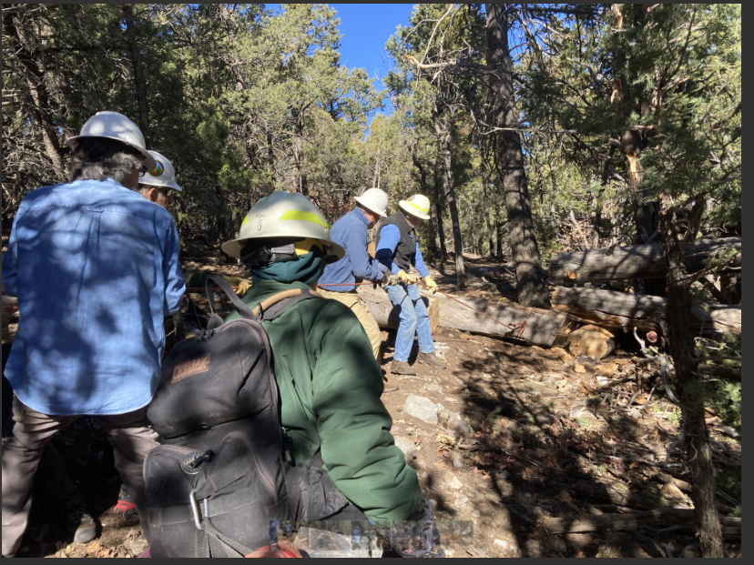

Pulling this segment off trail takes most of the crew

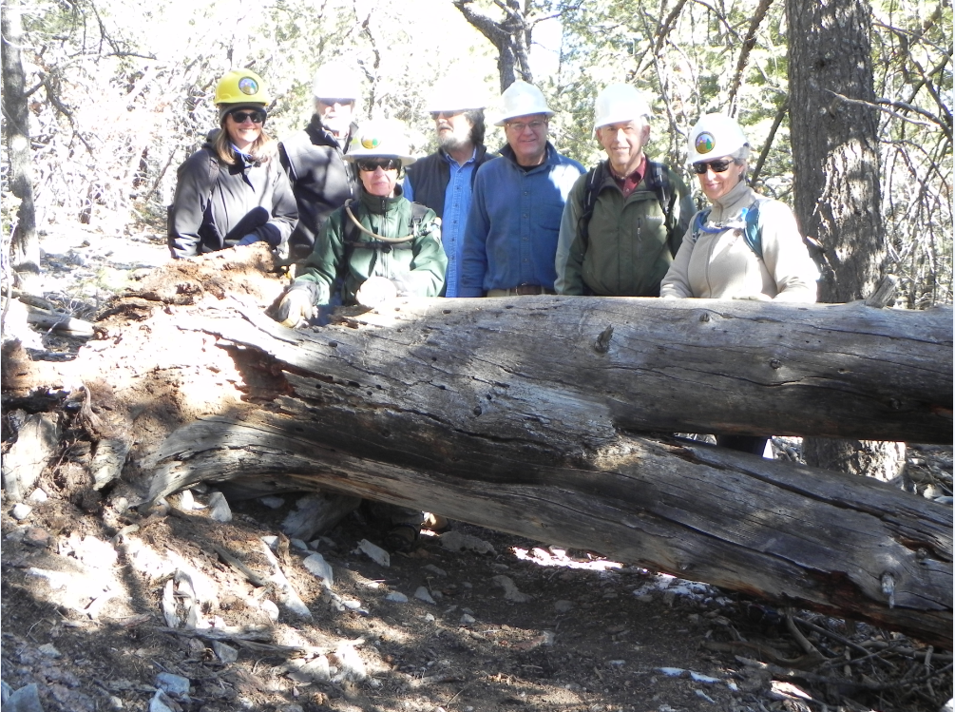
Silke, Ken, Rav, Phil, Chuck, John and Susan

Before

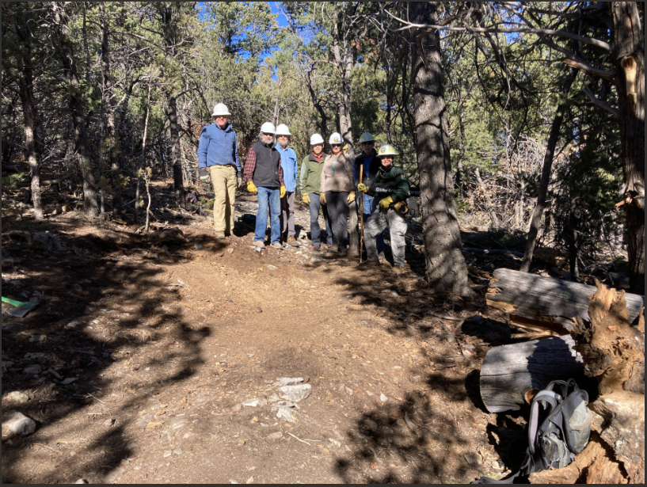
After

