**FOSM Report of Removal of Graffiti Tags in Large Culvert at Curve**

**in Challenge Trail between Barro Canyon and Tree Spring Trailhead,**

**Tuesday, November 26, and Sunday, December 1, 2024**

Sam Beard

On Tuesday, November 26, Sim Cook and Sam Beard painted over six graffiti tags in the 15-foot diameter culvert at a curve in Challenge Trail between Doc Long PA and Tree Spring TH. Sam had selected the only gray color of Rust-Oleum paint on the shelf in Lowe’s Home Center (when not at the culvert with a fan deck of paint colors), and the color was much lighter than the gray surface of the galvanized corrugated steel culvert.

On Sunday, December 1, Sim and Sam painted over the light gray with two darker gray colors. The Federal Standard Color 36300 was not a good match with the culver wall color. The Behr Slate Gray color was a much better match with the culver wall color.

After completing the work at the culvert on Tuesday, they painted over a small tag on the guard rail at first switchback in the Crest Highway with light gray paint, and it was a good match with the galvanized rail.

After completing the culvert work on Sunday, they drove up the highway to Capulin PA looking for tags. When driving down, they painted over a tag on the rusty guard rail below Tree Spring Trailhead at the 8000-foot sign.

Project photos are presented below.

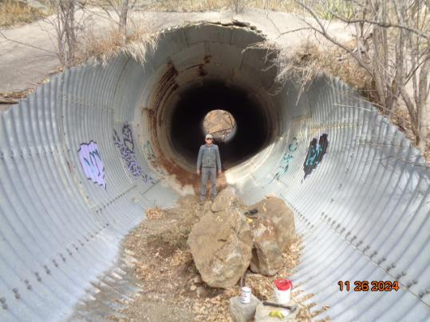

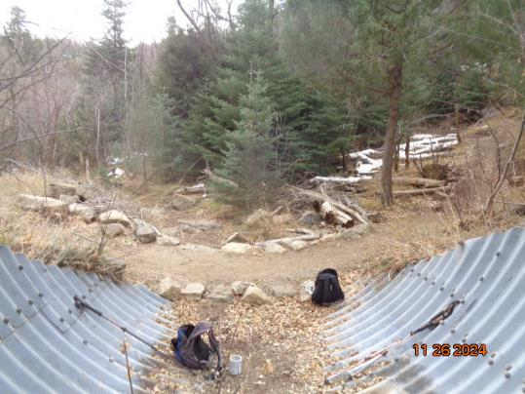

Top – Sim Cook in the lower end of the 15-foot culvert in Tejano Canyon where five

tags were located. Bottom – Curve in Challenge Trail that is still in good condition.

All photos by Sam Beard

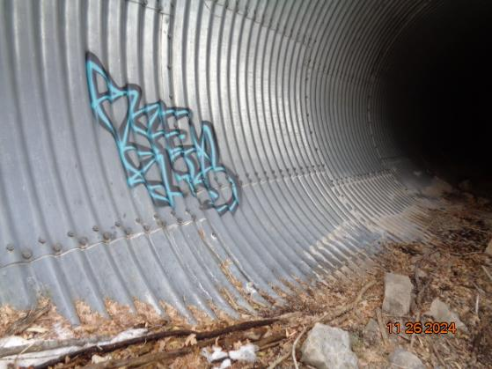

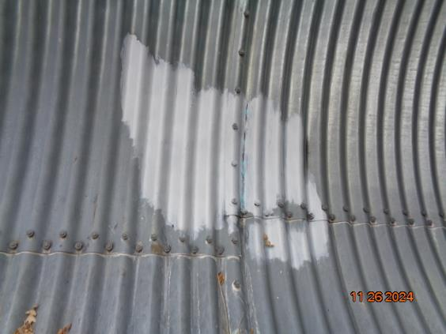

Before and after views of graffiti tag at the upstream end of the culvert.

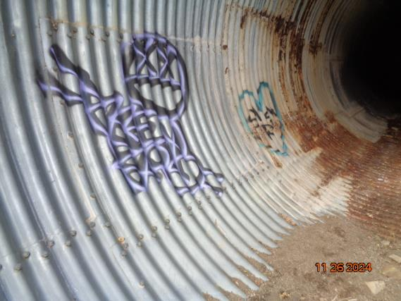

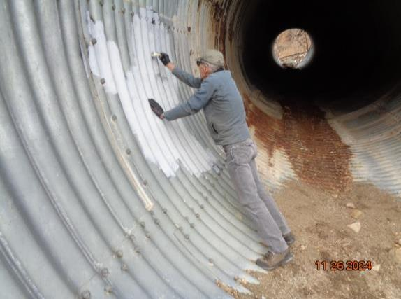

Two tags on the left side of culvert looking upstream.

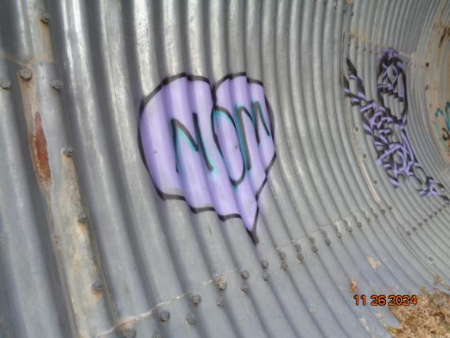

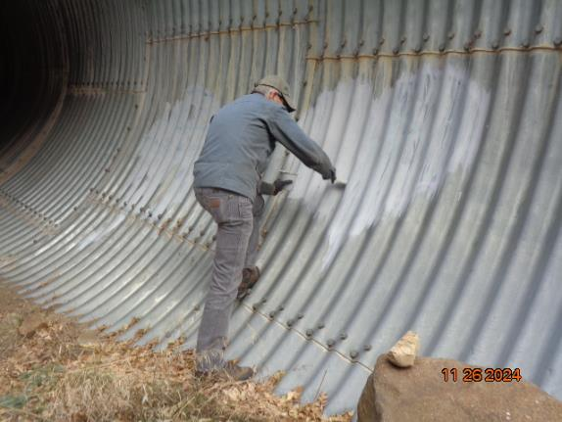

Two tags on the right side of the culvert looking upstream.

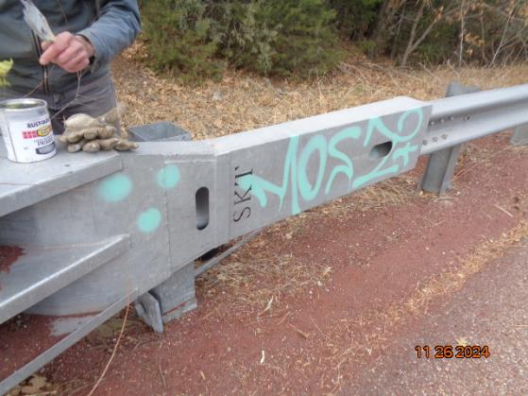

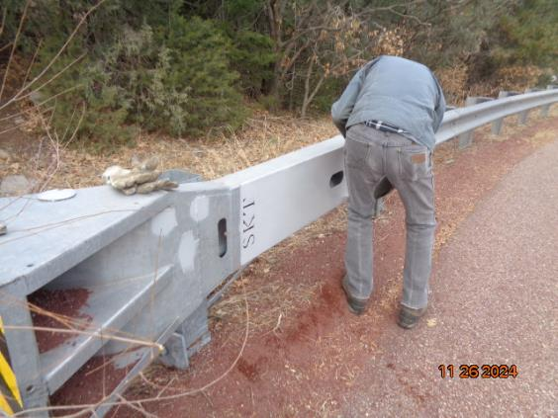

Sim painted over tags on guard rail with the light gray color paint at first switchback

in the Crest Highway above Doc Long Picnic Area.

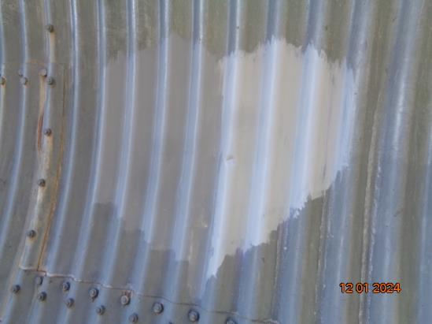

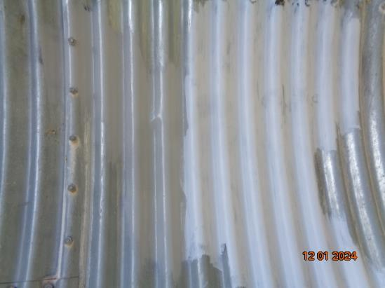

Top: Light gray painted over with Federal Standard Color 36300. Bottom: Light gray painted over

with Slate Gray color. The Slate Gray is a better match with the galvanized culvert wall.

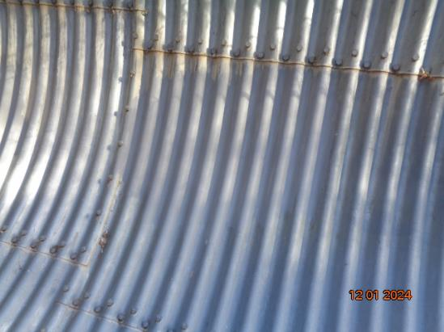

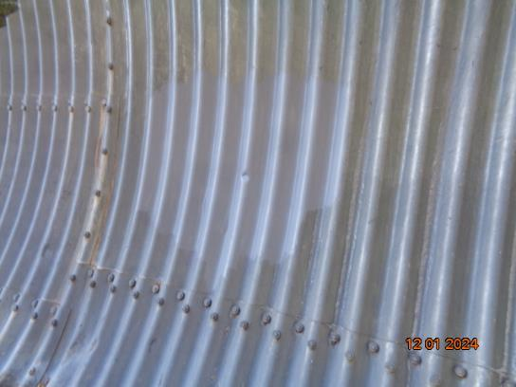

Two light gray spots painted over Slate Gray color. The matches with the galvanized

culvert wall is so good that it is difficult to see the painted spot.

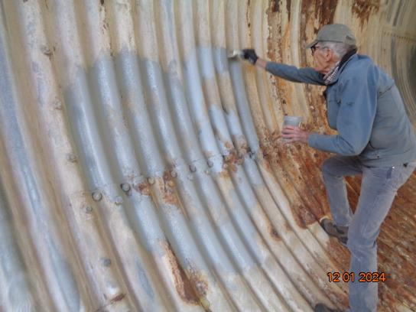

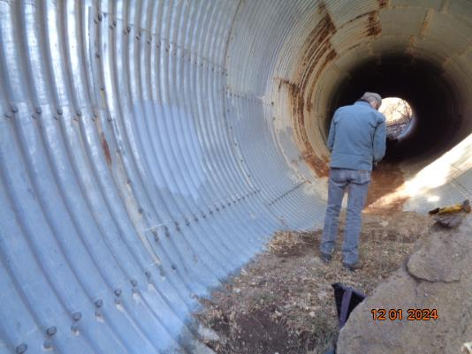

Top: Sim painting over light gray color on wall coated with white deposit. Bottom: Left side

of culvert where light gray color has been covered with darker gray colors.

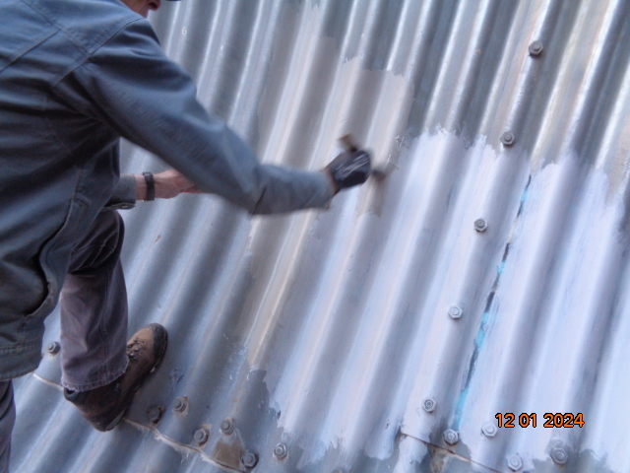

Sim painting over light gray color with Slate Gray color at upper end of culvert. The darker gray

is on the left side of the painted area where his arm and hand are.