**FOSM Report of Manually Splitting Rounds and Bucking Branches from Three Pinon Trees**

**Felled near the SRD Storage Yard, Wednesday, December 4, 2024**

Sam Beard

On Wednesday, December 4, seven FOSM volunteers manually split several rounds and bucked numerous branches from three dead pinon trees felled near the Sandia Ranger District storage yard a few weeks ago. Later this month, Mike Oliver, a Mountain Christian Church wood ministry member, will haul this wood to the church wood lot in the East Mountains Area.

The volunteers were Dennis Crowther, Sim Cook, Eric Russell, Jerry Carroll, Jamey Browning, Dan Benton, and Sam Beard.

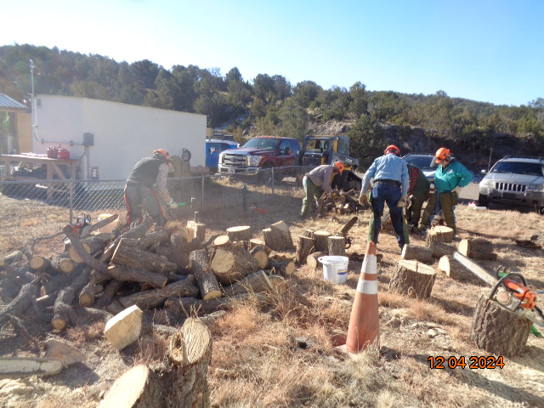

At the beginning of the project, all of the rounds and most of the branches were in the pile shown here. Chain saws were

used to cut two scores about 2 inches deep in the rounds to make starting the splitting easier. All photos by Sam Beard

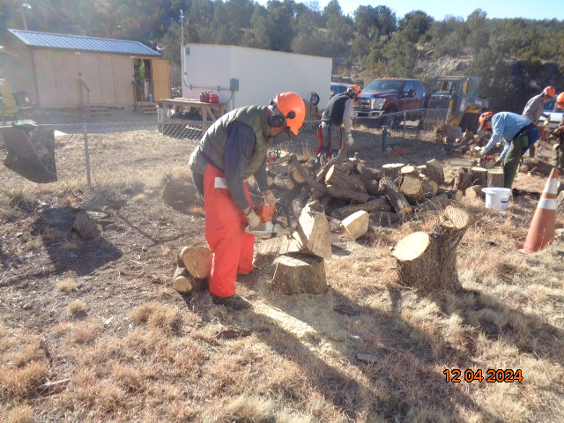

Dan Benton is using the large FOSM Stihl Model 460 chain saw with a 28-inch bar to cut the very large piece of wood

where the most of the branches grew from the tree trunk into small pieces. The grain here was very complex,

and manually splitting this piece would have been very difficult.

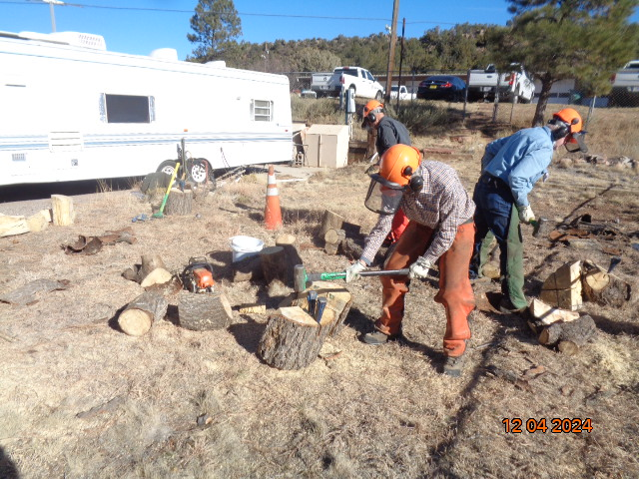

Sim Cook is using two steel wedges to split one-half of a round from the trunk.

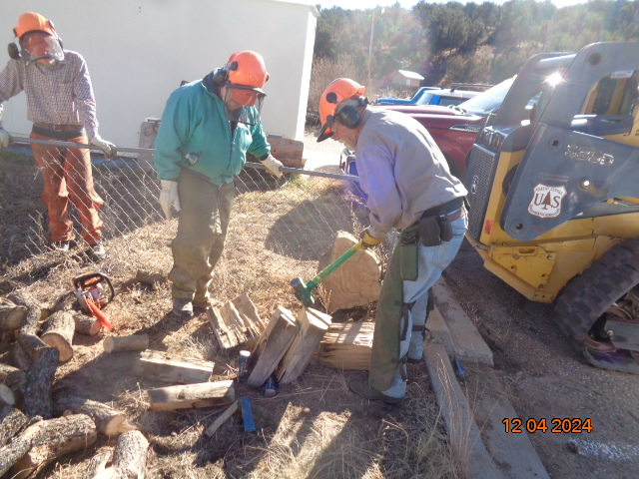

Jerry Carroll is splitting the last round from the stump of a tree that had been growing beside the parking lot.

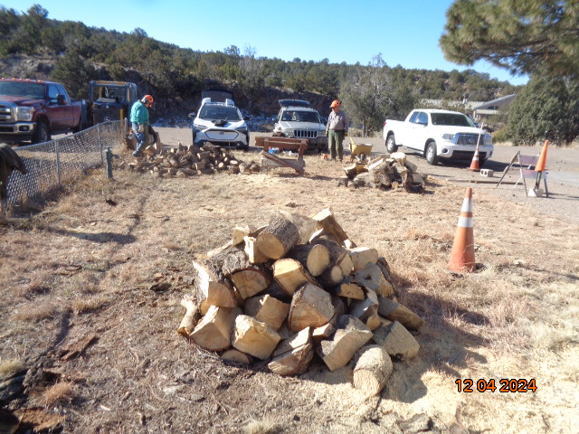

L to R: Dennis Crowther and Jerry Carroll looking at the split and bucked wood that the crew had processed earlier.

Approximately a cord of donation wood will be hauled to the church wood lot by Mike Oliver in a few weeks.