Thursday, 12/05/24- Tablazon: What a nice day! We hit the sweet spot with nice warm sun, light winds and a mostly dry surface to work on. Eleven volunteers joined up with Jen (SRD) to work on the Tablazon reroute. We were close to finishing but the last bit has a lot of scree/rubble and it was difficult to get it all finished. Hopefully the weather will give us one more week to work there. We have had to skip over some spots where the ground was just too hard, we have the last 100 yards or so to finish and then of course we’ll need to obliterate the old trail so there is still some work to do. Close, but no dice!

Volunteers: Byron Garner, Roland Stumpf, Eric Russell, Jim Houle,

Claudia Bergsohn, Bill Perkins, Bruce Hansche, John Braly, Tony Pachelli,

Luis Cuadros and Laura Leon

Pictures- Laura Leon

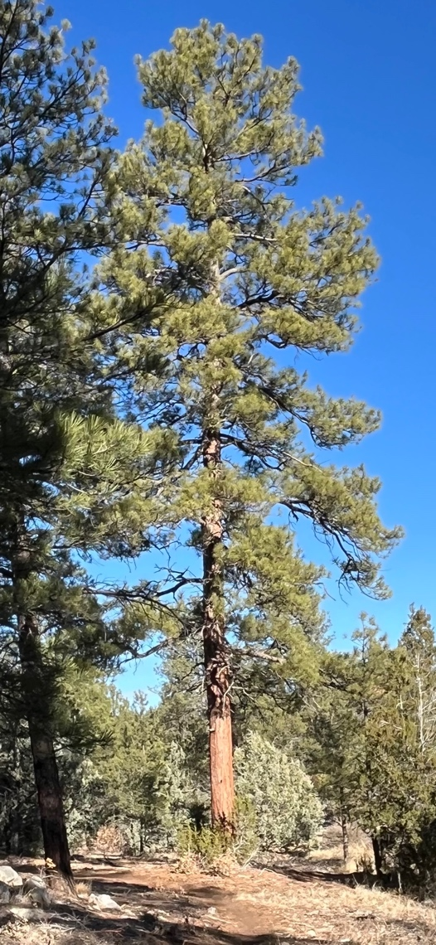 I love Ponderosa Pines! Their color, their smell, their sound, their…. Well, you know what I mean.

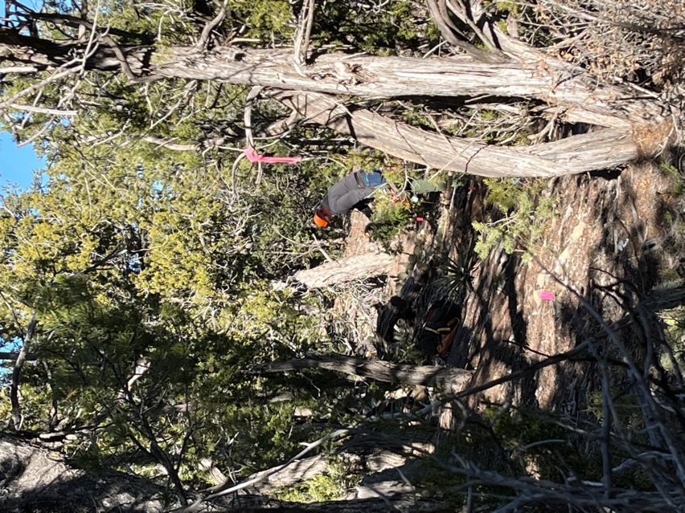 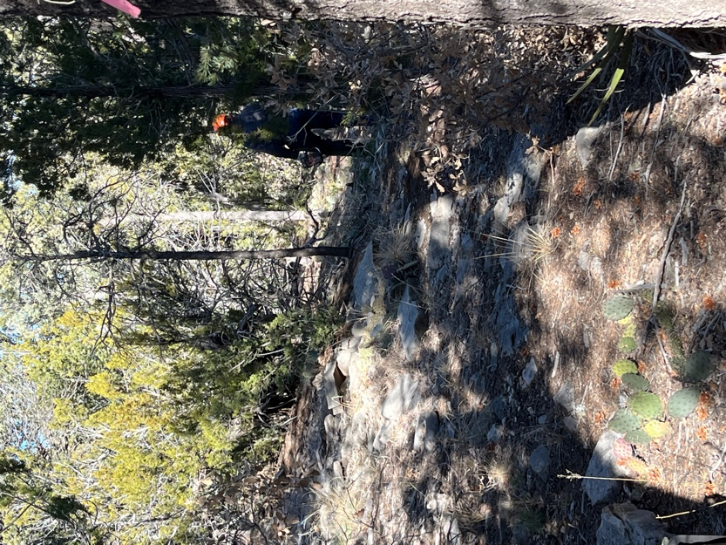

Eric was our trusty sawyer, clearing the big stuff. Jen laid out flags and Laura cleared debris off the corridor.

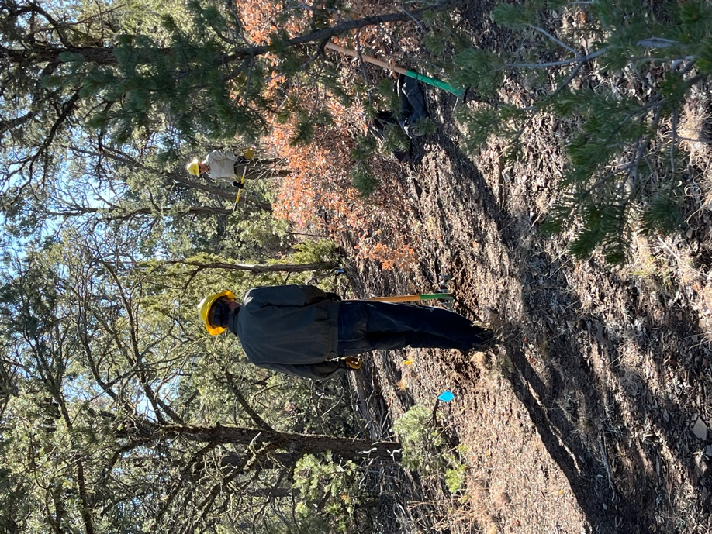 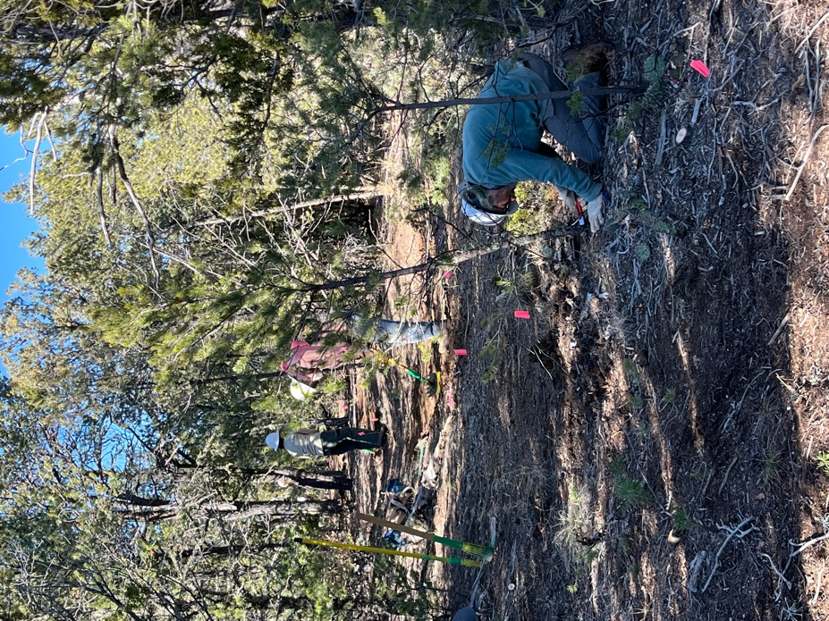

Roland and Jim work through Bill, Jim and Jen work the line- Bill

some oak. gets the neatness award.

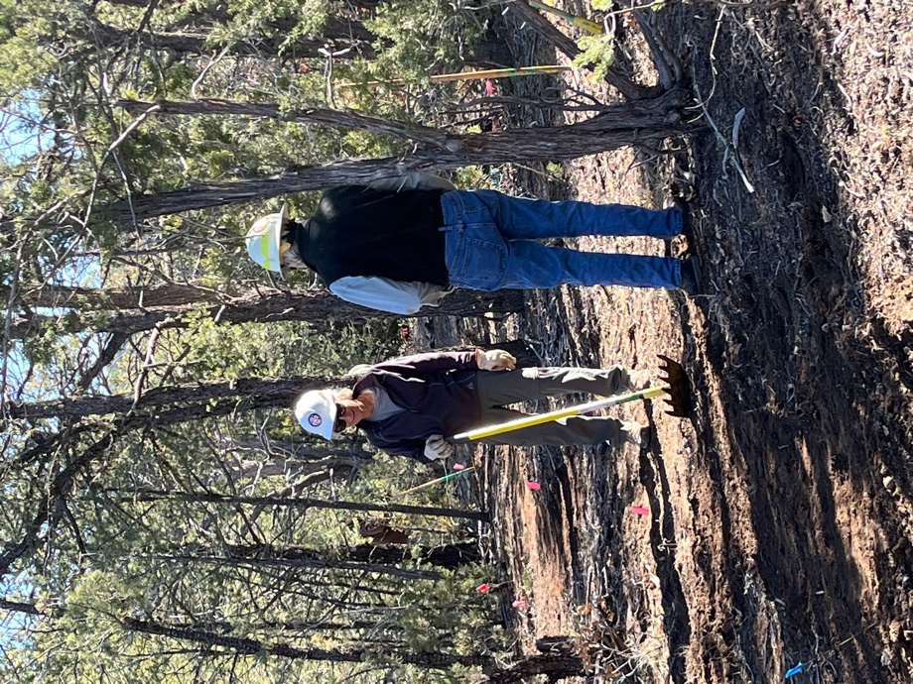 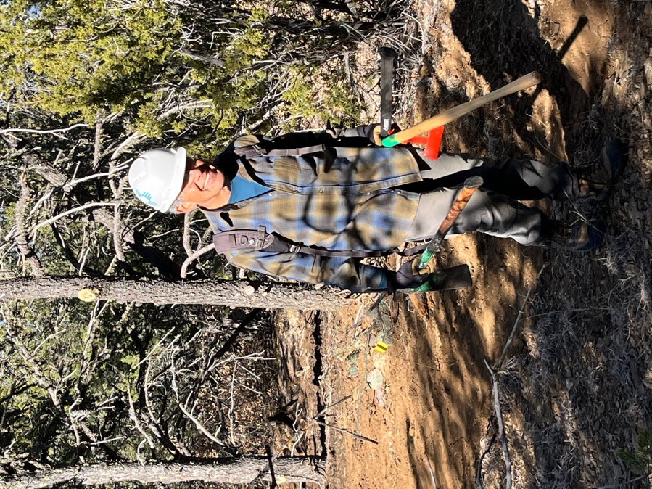

Byron and Claudia discuss…… Luis can’t wait to jump ahead to the

There’s always something to talk about! next space.

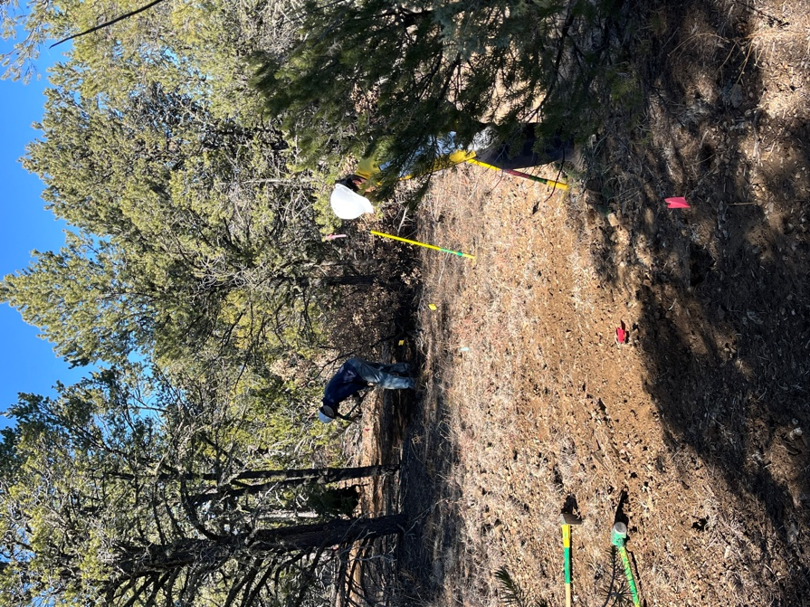 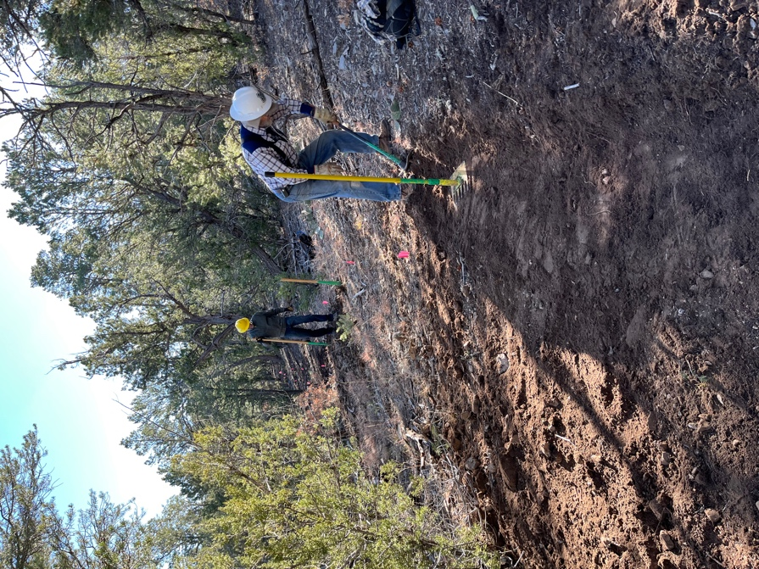

Tony and Bruce work through a Bruce and Roland work on a slope.

flat area. Tony found a rock that

he formed a special bond with.

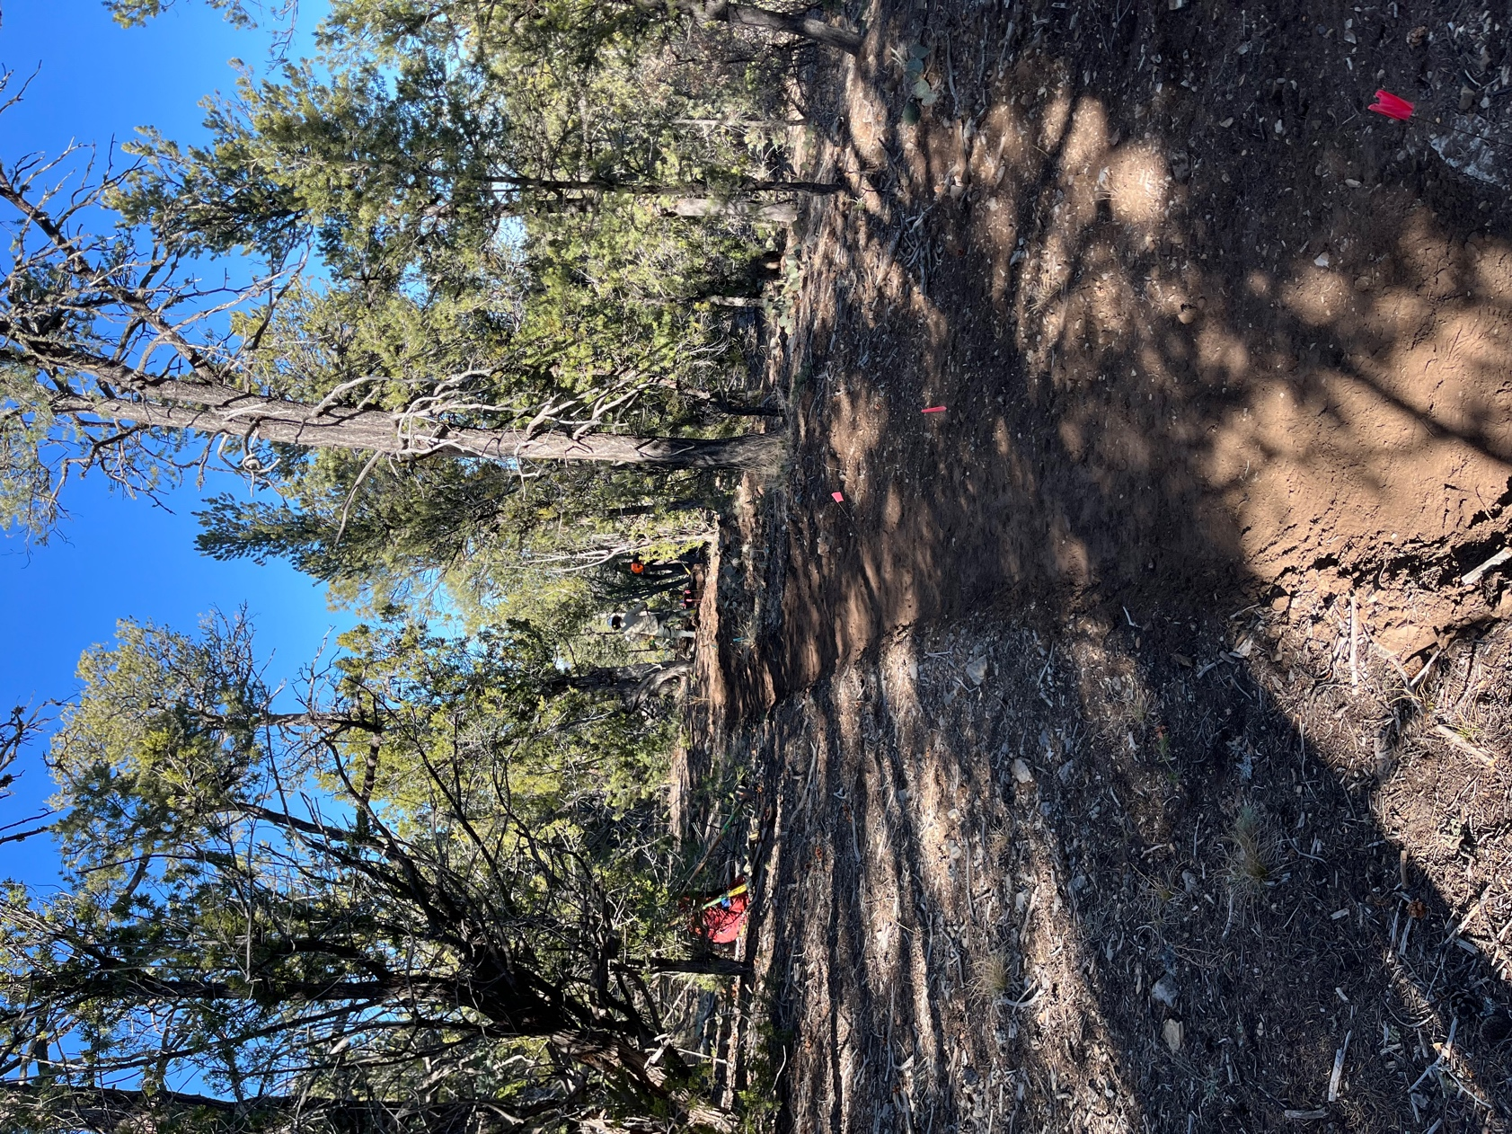

New trail runs through the Pinon.