**Report of FOSM Project to Restore Informational Sign**

**on Old Embudito Trail, Dec. 5 and 6, 2024**

Sam Beard

Recently Dan Benton found an old informational sign on the abandoned Embudito Trail that directed hikers to the north side of the canyon where the current official trail is on the south-facing slope. Dan reported that the official trail was built by Phyllis Martinez over 20 years ago. This informational sign was very weathered but still in good condition, and he suggested that FOSM refurbish it before it is relocated to the intersection of the official trail and the user trail in the canyon bottom.

Following Dan’s directions, I located the weathered sign and restored it on Thursday and Friday, Dec. 5 and 6. The photos below show the condition of the weathered sign and the process I used to restore the redwood sign and the plywood backing. Assuming that FOSM relocates the sign, it will continue to provide useful information to hikers.

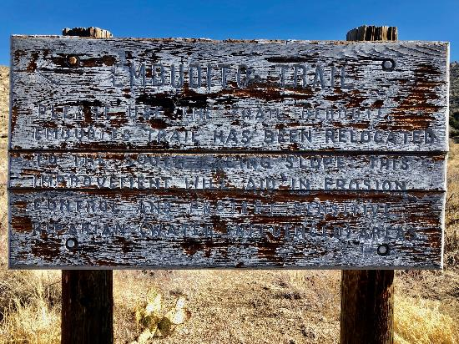

Weathered sign on abandoned Embudito Trail found recently by Dan Benton. Photo by Dan Benton

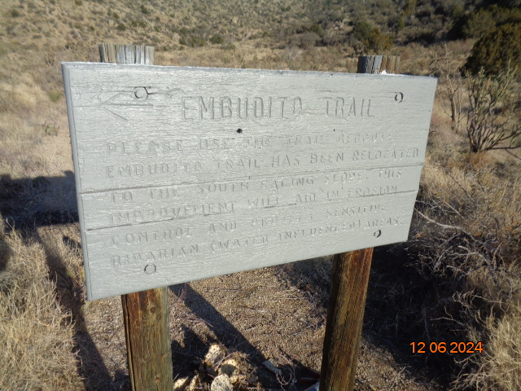

Restored front side of informational sign on abandoned Embudito Trail. The sign reads “Embudito Trail - Please use the trail reroute. Embudito Trail has been relocated to the south facing slope. This improvement

will aid in erosion control and protect sensitive riparian (water influenced) areas.” Photo by Sam Beard

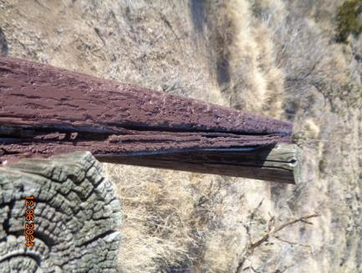

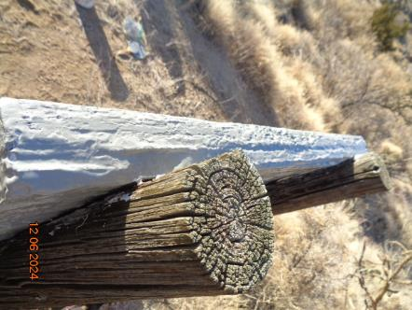

Top – The weathered top edge of the redwood sign and plywood backing before restoration.

Bottom – Top edge of the sign and plywood after sealing and restoration with caulk and paint.

(Note – I applied brown paint on the sign before I remembered that the sign

was in the wilderness where signs are painted gray.) Photos by Sam Beard

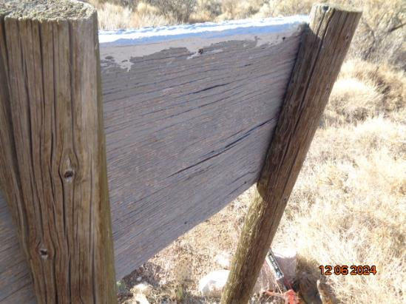

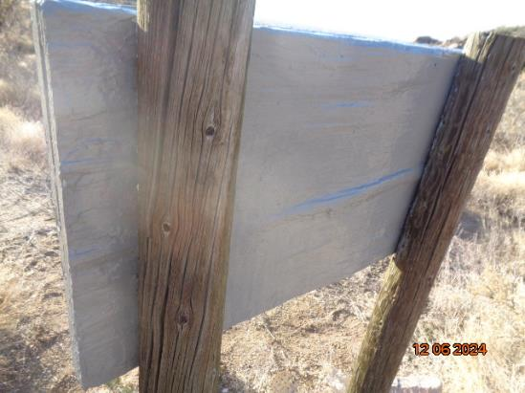

Top – Severely cracked plywood backing before restoration.

Bottom – Plywood backing after being sealed and restored with a thin layer of caulk

and paint. Photos by Sam Beard