Trail Maintenance Report: Monday, December 9, 2024

Byron Garner

On December 9, the Monday trail maintenance crew continued the work on Mystery Trail to remove the two fir trees located last week further down trail, but without enough remaining time, were left to clear at later time. These two firs, 12" and 4" on a snow packed trail, were cleared with three cuts. A short excursion down trail presented no new work so we began our return hike to address two remaining issues on this segment of trail. The first was the large fir suspended approximately five feet above the trail that was reported last week. All unsporting limbs affecting the trail were removed from this well supported tree which will be reassessed at a later date. The second issue on our return was to clear a previously felled 13" fir that blocked the trail and had a significant amount of slash to be removed. The earlier snows of the season, until receding, had obscured the problem this tree presented. With a full team effort, the limbing and slash removal was finished. The Katanas were drawn and one cut later, the trail was clear. Though our early morning start was a bit cold, there was a gradual welcomed warming though intermittent ice and snow remain on the trail. The crew included Susan Gregory, Chuck Logan, Dave McCreery, John Cooper, Rene Archer, Ken Wilson and Jamey Browning. Photos: Jamey Browning and Byron Garner

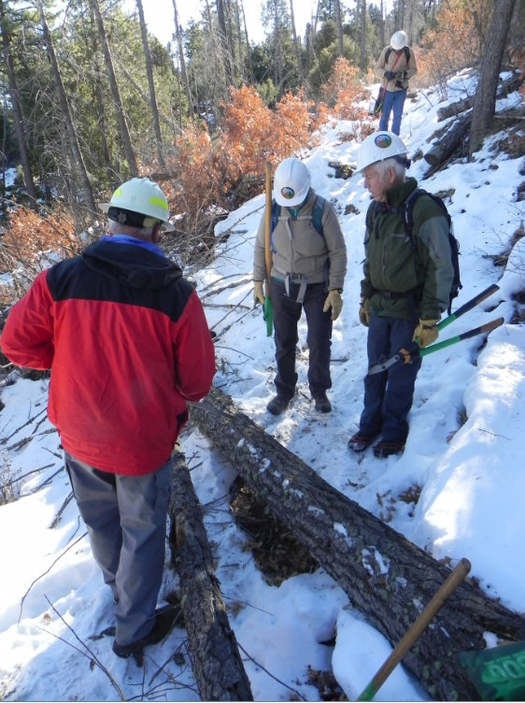

Dave, Susan and John weigh the options

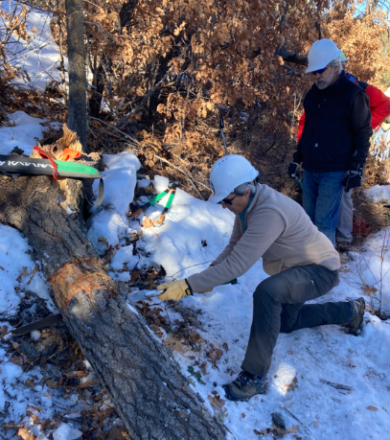

And Susan and Ken take the lead

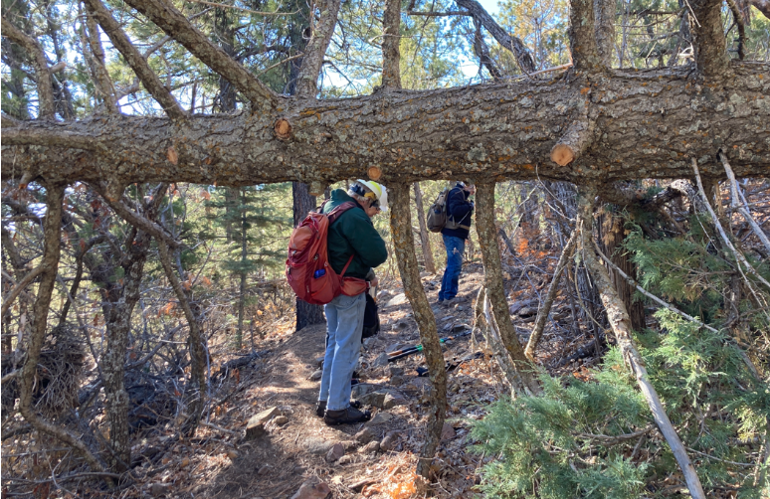

An interesting challenge

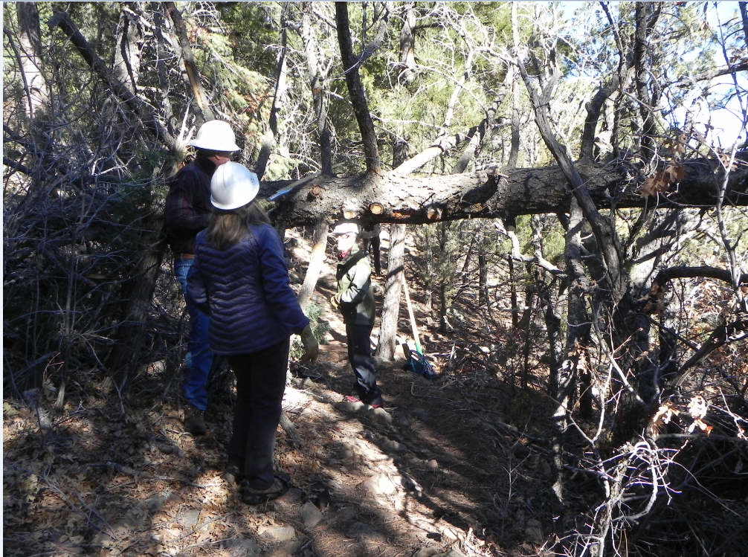

Chuck and Rene team up for limbing

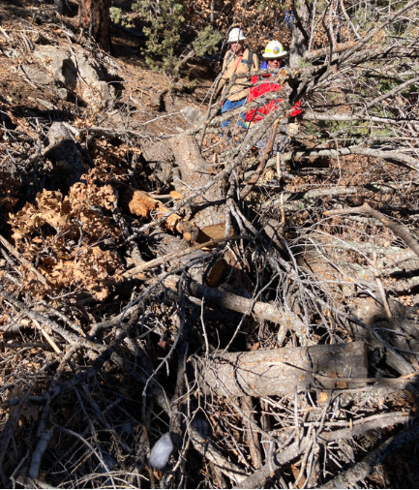

Yes, there really is a trail here

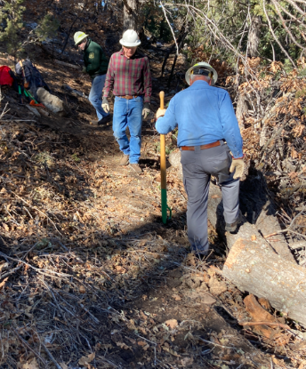

And there it is

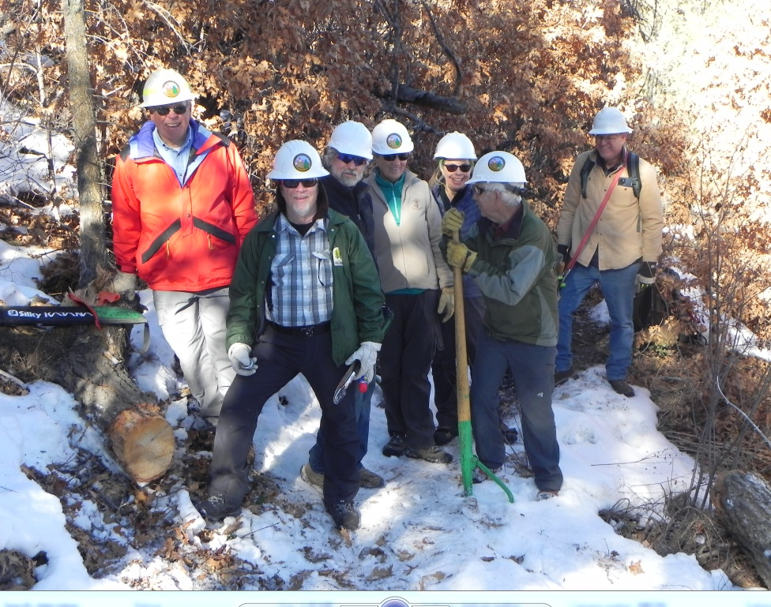

Dave, Jamey, Ken, Susan, Rene, John and Chuck