Thursday, 12/12/24- Tablezon: A cold morning pushed our start time back to 9AM on Thursday. Twelve volunteers joined Jen (SRD) back at the Tablezon reroute to push out the last of the work. The ground was actually receptive to work-not as hard as we thought it might be. The work involved benching both ends of the reroute, doing some touch up work on the reroute where the soil had been too difficult to work earlier, obliterating and adding some check dams for erosion to the old trail and posting 2 new signs at the intersection of Gear Grinder and Tablezon. An amazing group of workers did it all and finished up 30 minutes earlier than planned- Go Team!! Another completed project!!

Volunteers: Rich Fagioli, Eric Messerschmidt, Byron Garner, Eric Russell, Jim Houle, Claudia Bergsohn, Bill Perkins, Bruce Hansche, John Braly, Tony Pachelli,

Luis Cuadros and Laura Leon

Pictures: Luis Cuadros and Laura Leon

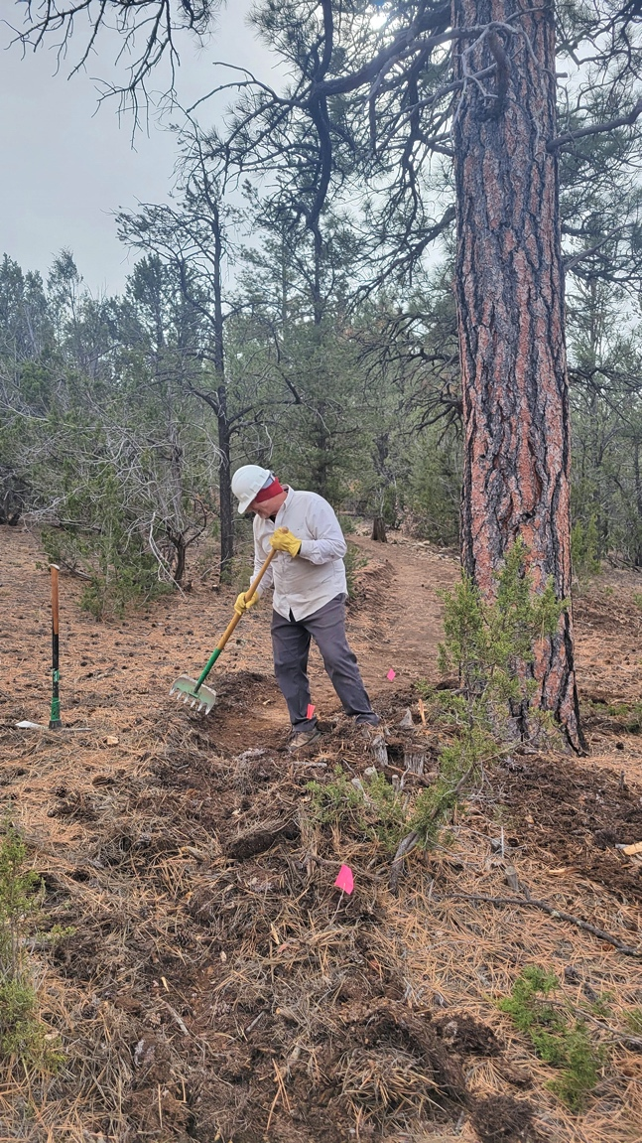 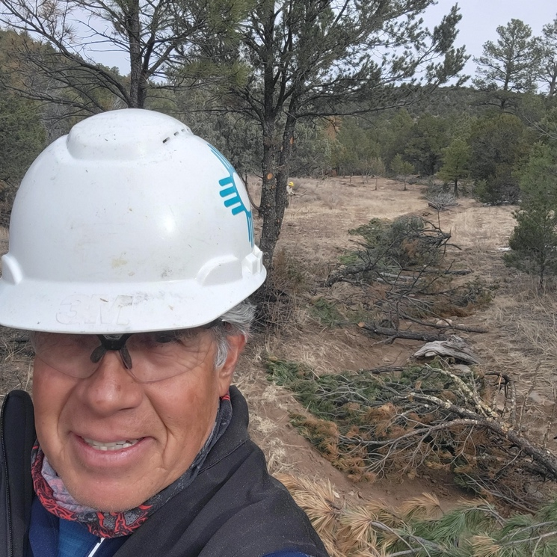

Rich benches trail on the trail end near Lower Pine. Luis looks dashing.

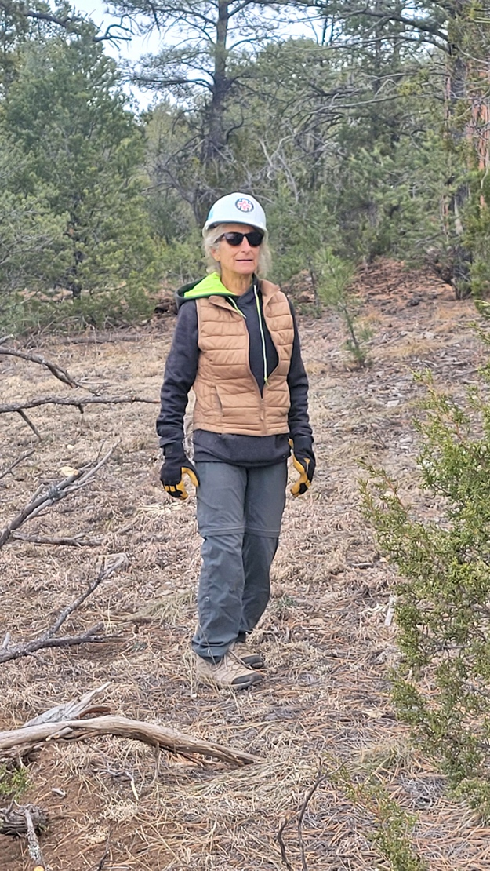 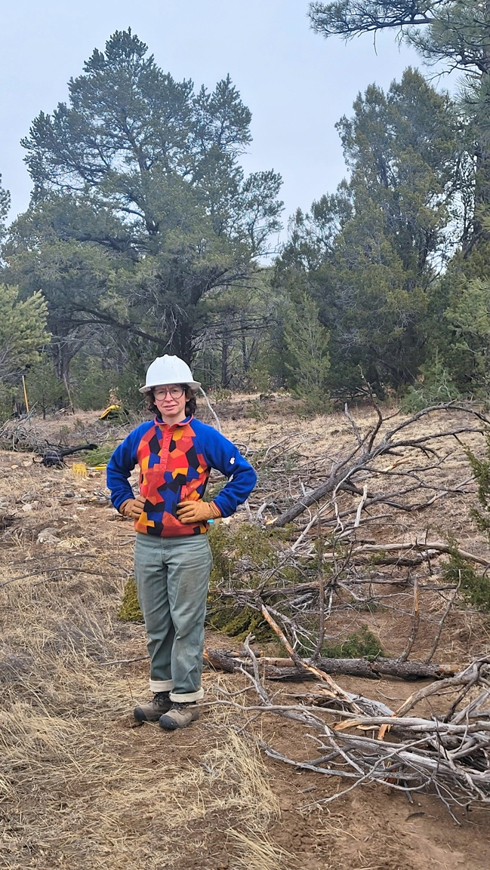

Claudia works on obliterating. Jen leads in a very festive sweater.

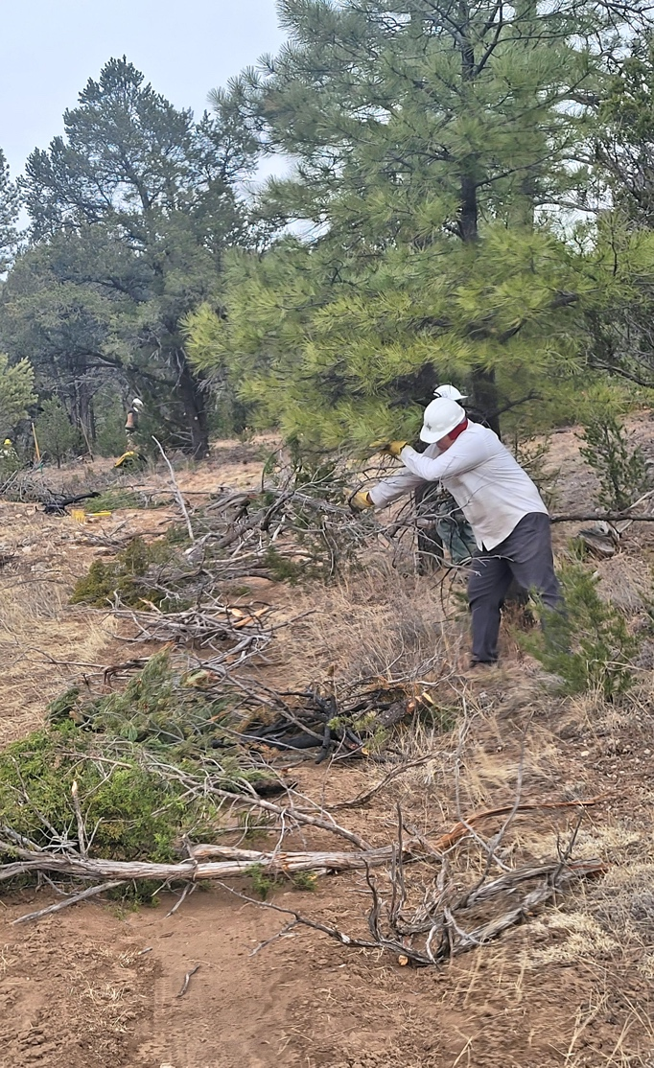 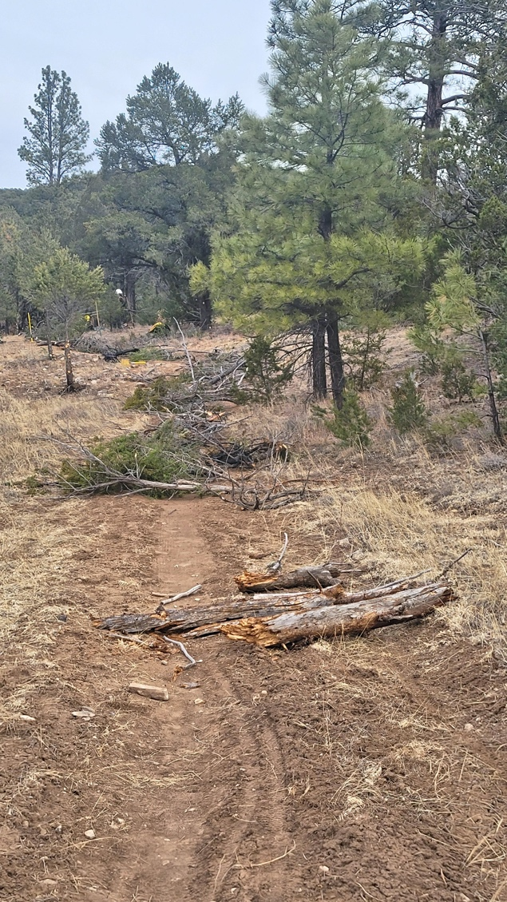

Rich works on obliteration.

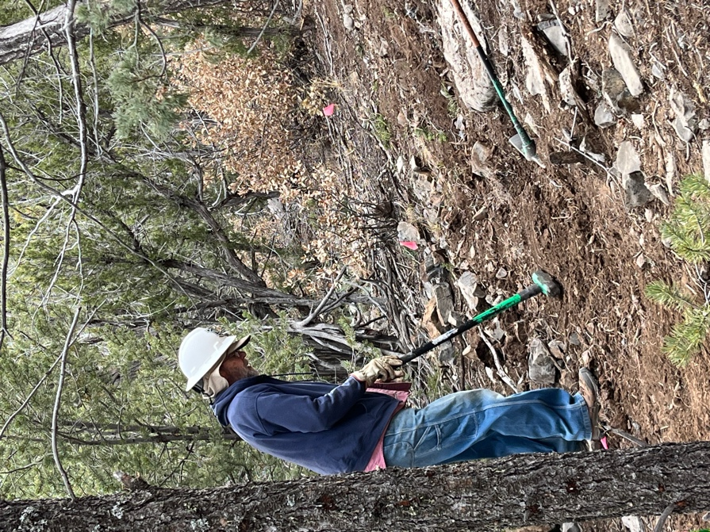 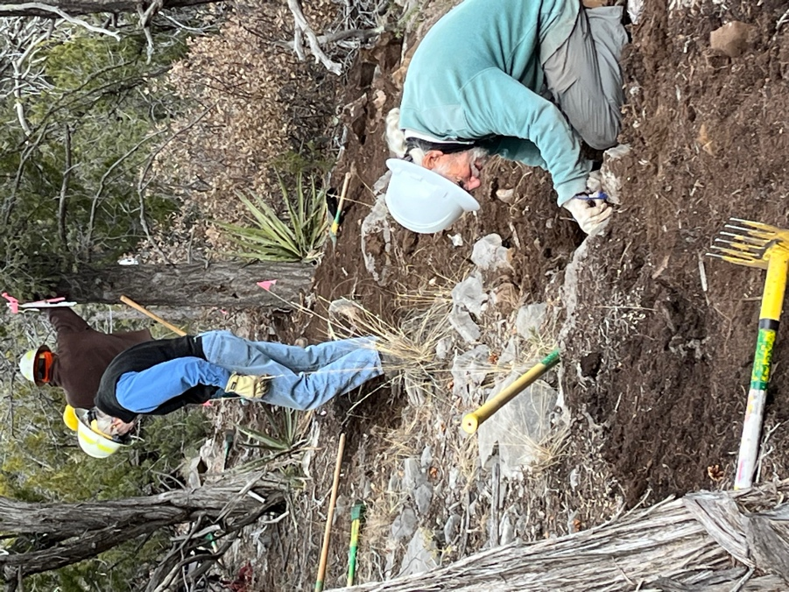

Meanwhile, up on the high end near Gear Grinder, Bruce gets after some rocks and Byron and Bill work at deciding which rocks must go and which can stay. Some cribbing was necessary around the tree seen on the left in Bill’s picture.

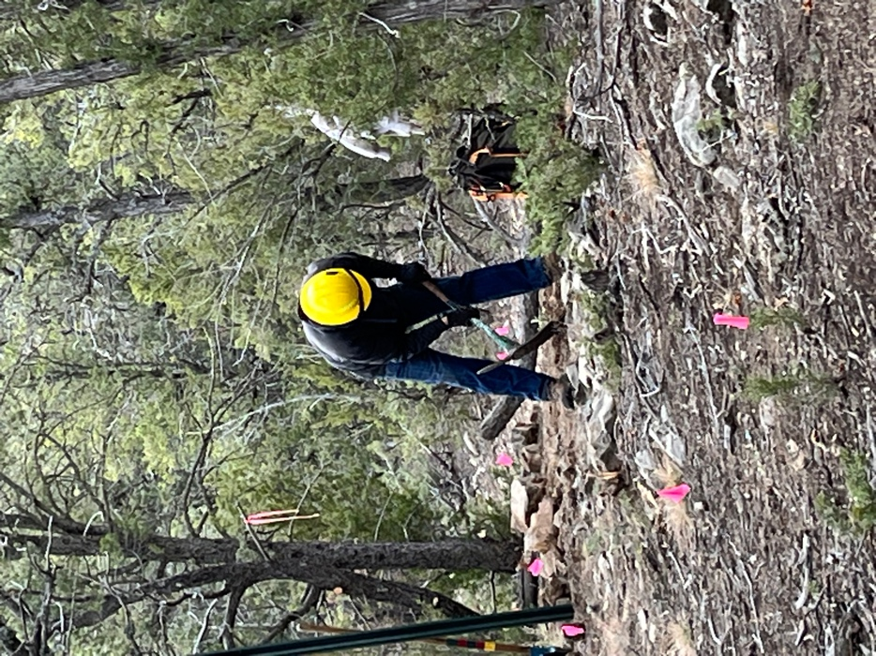 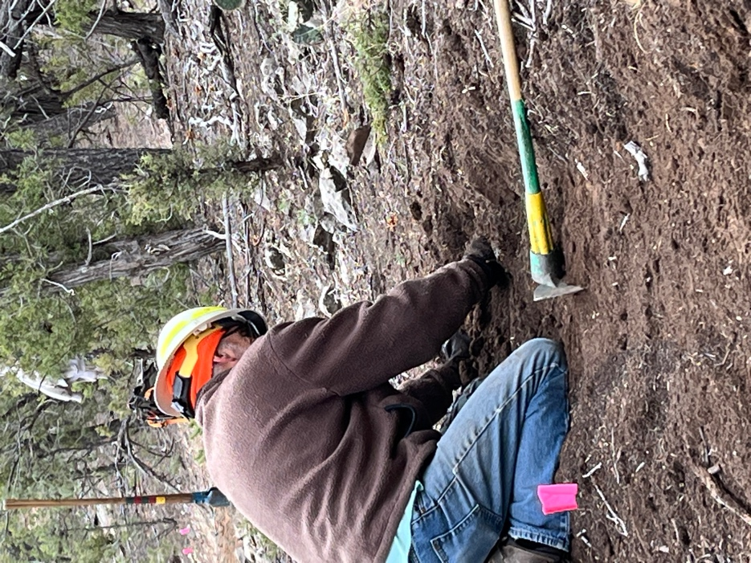

Eric R. picks to his music. Jim clears out all those little stone buggers.

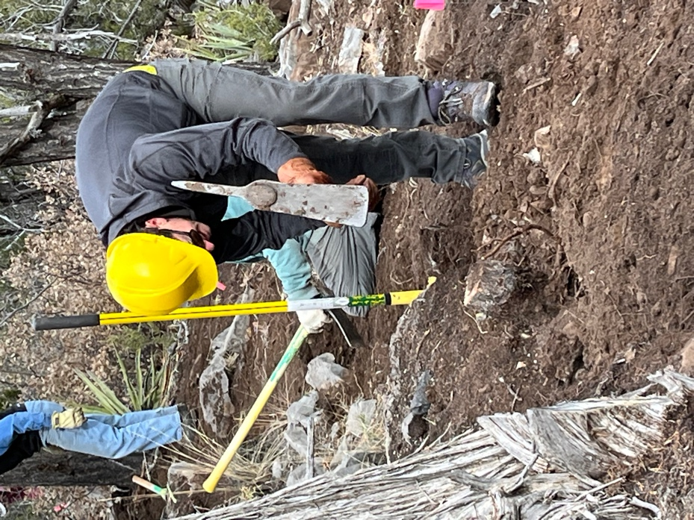 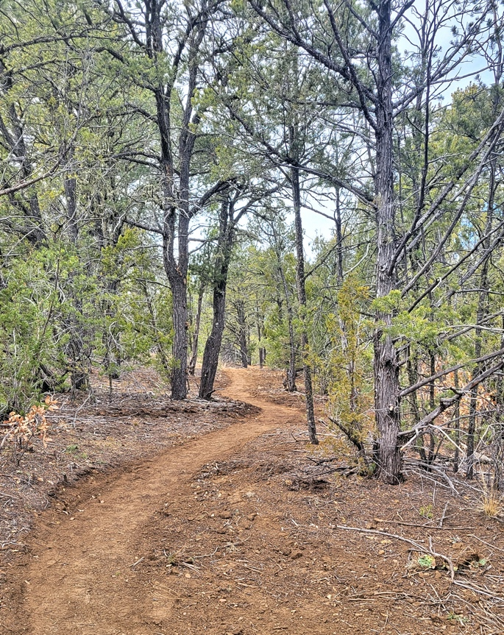

Eric M. loves removing stumps. A beautiful new trail to use!

And the final touch – new signage! Installed with Eric R.’s excellent touch and a bit of pounding and digging.

