**Report of Two Recent FOSM Projects and One Large Purchase, Monday, December 16, 2024**

Sam Beard

The two recent projects and the equipment purchased are described below.

1. **Installation of Three Work Lights in the SRD Wood Shop** – On Friday, Dec. 13, Joelle Hertel, Sim Cook, and Sam Beard installed three 4-foot LED work lights in the SRD wood shop where the overhead lights have not been operative for many months. Each light was hung with two 12-inch chains from the ceiling so that the lights are about 8 feet from the floor. The lights are turned on and off with a pull chain. The lights provide excellent lighting throughout the shop and will make it safer to work there and find items in the cabinets.
2. **Painting the Large Sign at the Highway in Front of the Ranger Station** – During the past week, Sim Cook and Sam Beard completed painting the sign at the highway in front of the Ranger Station where information is posted for the public to see. The paint on the sign had faded, and rust was showing in many places.
3. **Second Battery-powered Chain Saw Purchased by FOSM** – At the recent meeting of the FOSM Board of Directors, the purchase of a second battery-powered chain saw was approved. The following equipment was purchased through the national Husqvarna Web site: Husqvarna 540i XP chain saw kit including a 16-inch bar, Bli300 9-Ah battery, 16-inch SP21G chain, battery charger, and tool bag. A second chain and battery were also purchased. This equipment is identical to that already owned by FOSM.

Project photos are presented below.

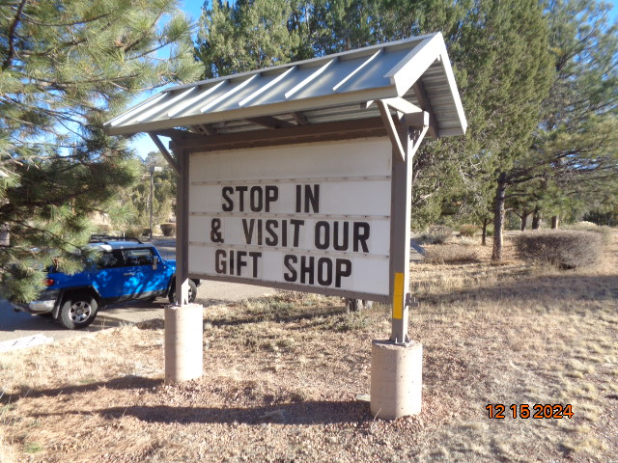

SRD sign at the highway painted recently by FOSM volunteers. All photos by Sam Beard

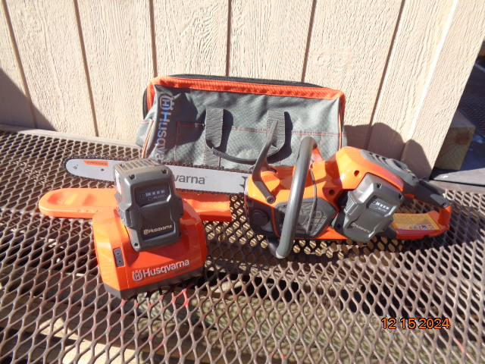

Husqvarna battery-powered chain saw and other equipment purchased by FOSM.