Thursday 12/19/24- Piedra Lisa fixes: Seven volunteers met Jen (SRD) at the south end of Piedra Lisa Thursday. After about a half mile hike we came across several spots where up slope and trail needed repair and also several places where some rock work was needed to stabilize the trail. We were spread out over about half mile working on several of these spots in groups of 2 and 3. There were lots of hikers out enjoying the day and the nice working conditions made the day go by really quickly. Repairs were made up until the junction with the old Piedra Lisa trail where the group obliterated the old trail a little more substantially to keep visitors out.
Volunteers: Eric Russell, Jim Houle, Claudia Bersohn, John Braly, Roland Stumpf,
Rich Fagioli and Laura Leon

Pictures Laura Leon and John Braly

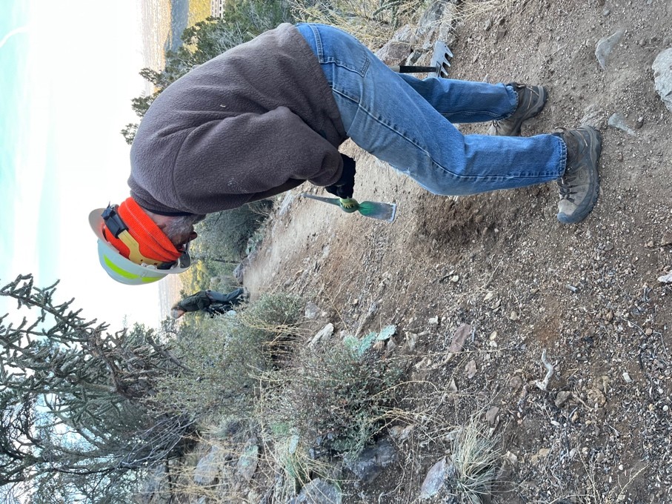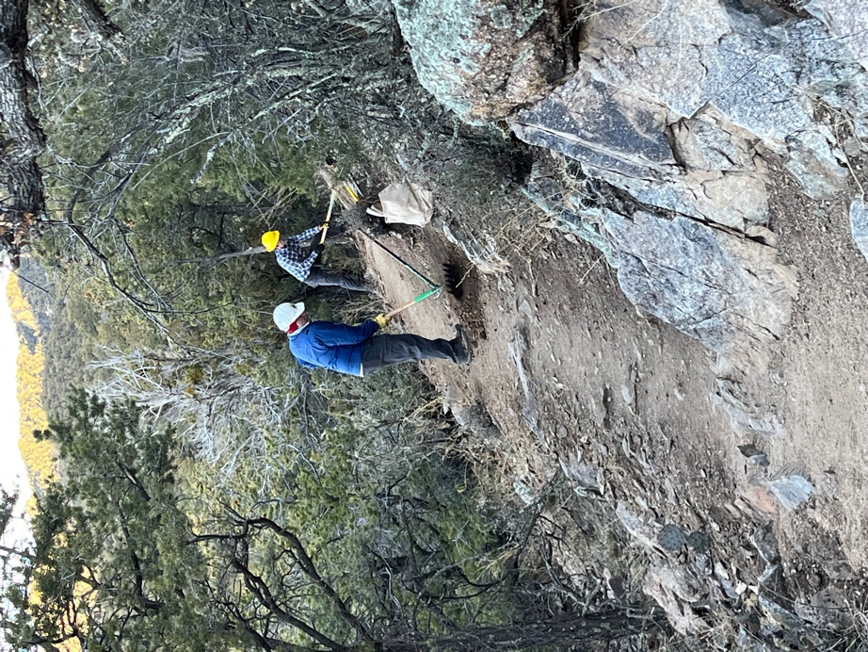

Claudia and Jim… Roland and Rich get started on work.
It was cold until the sun came over the mountain.

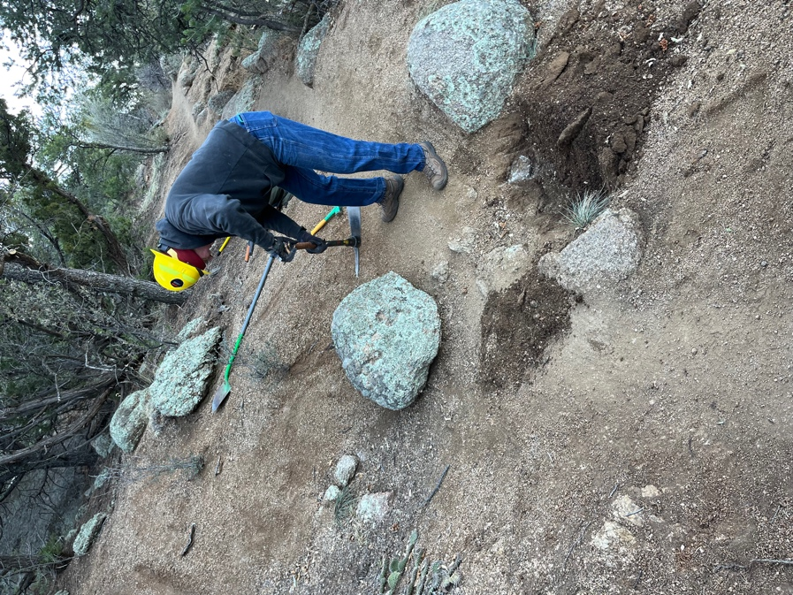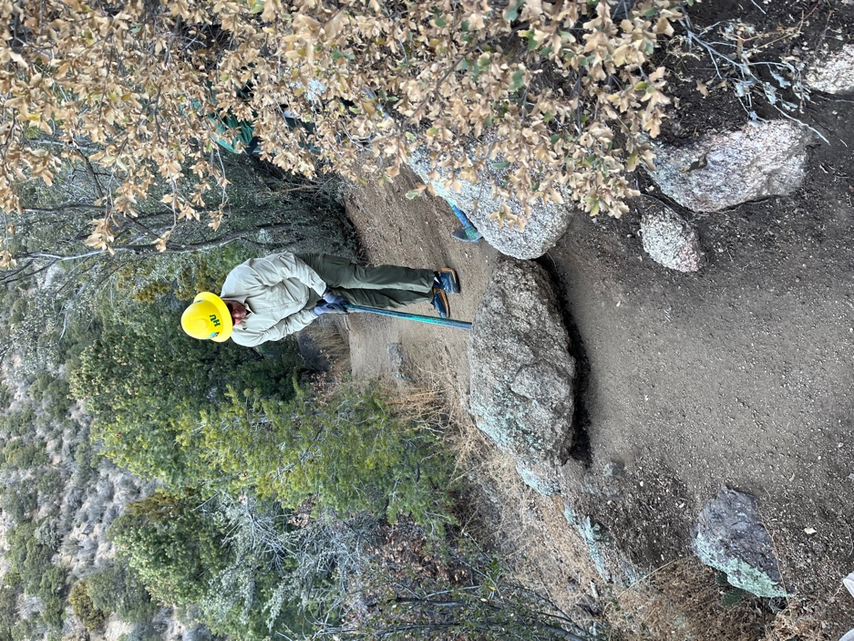

Eric and John start moving big rocks.

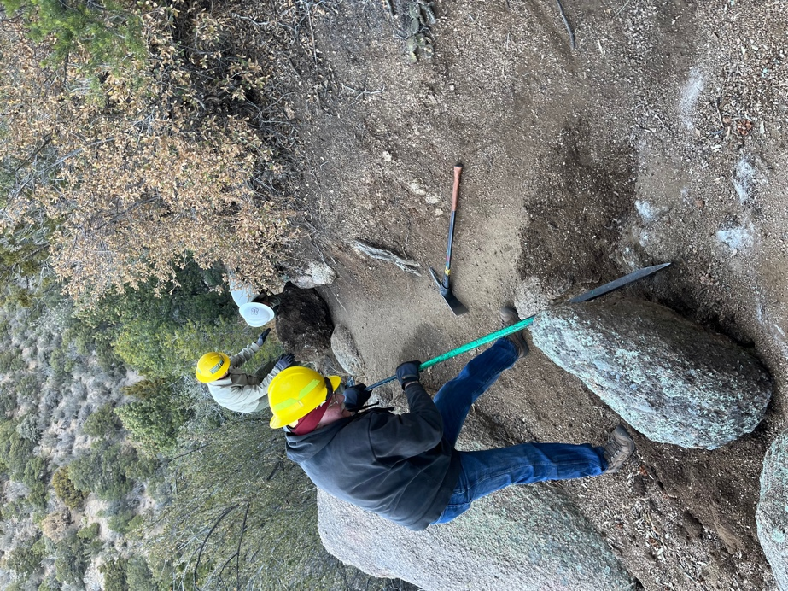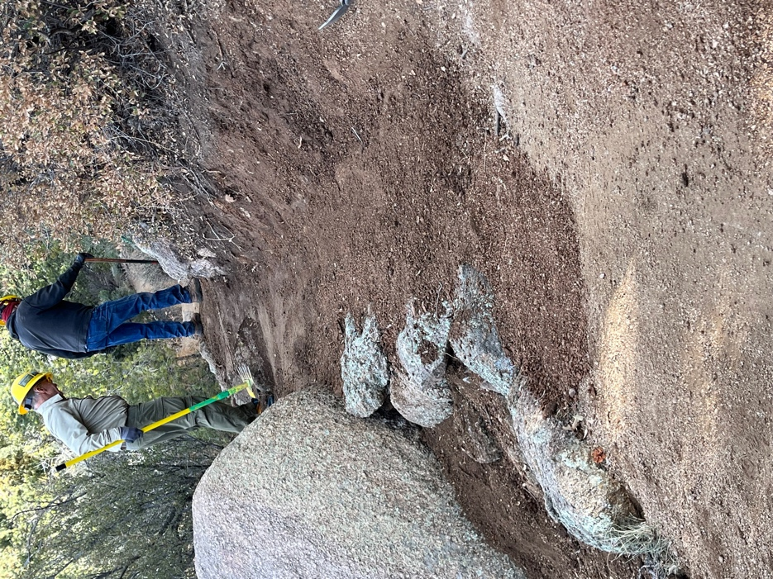

Eric maneuvers the big rock into a spot along the trail downslope while Jen and John manhandle the other big one out of the middle of the trail.

A nice new reinforces trail edge so on to the next trouble spot. Add a little back sloping and tahdah(!) a beautiful trail. About 4 or 5 areas needed some rock work.

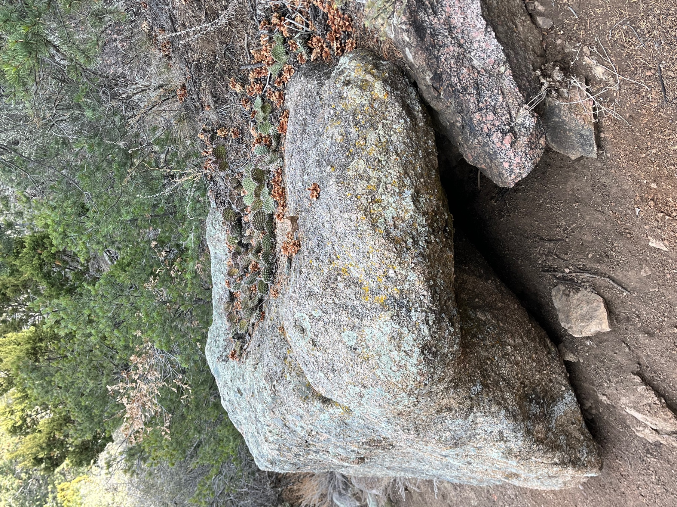

Prickly Pear sunbathing on a rock.

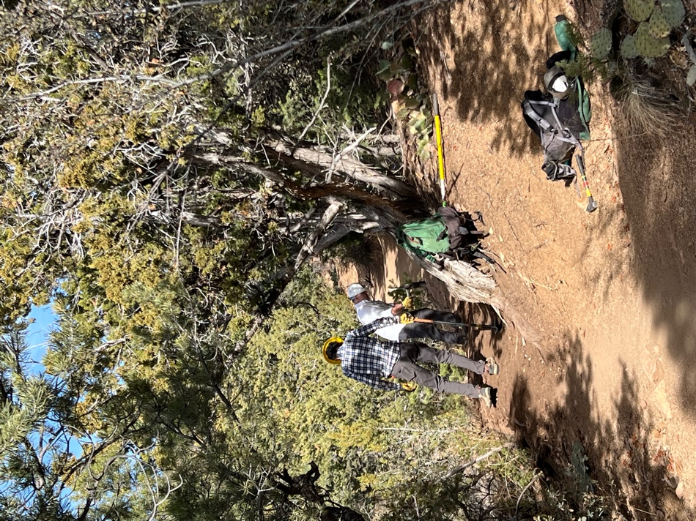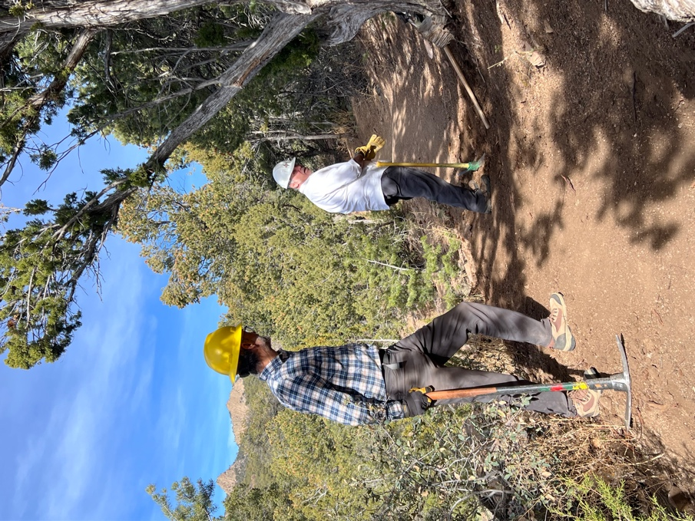

The dynamic duo of Rich and Roland repair tread.

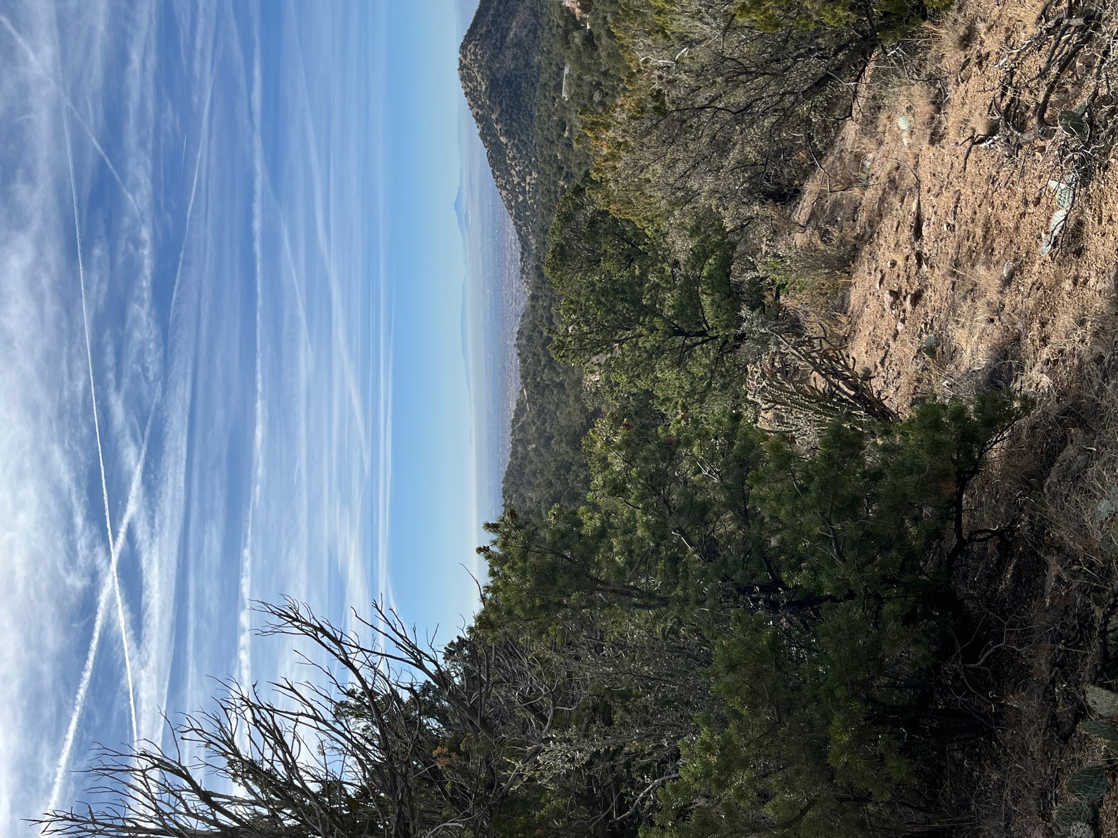

A beautiful vista.

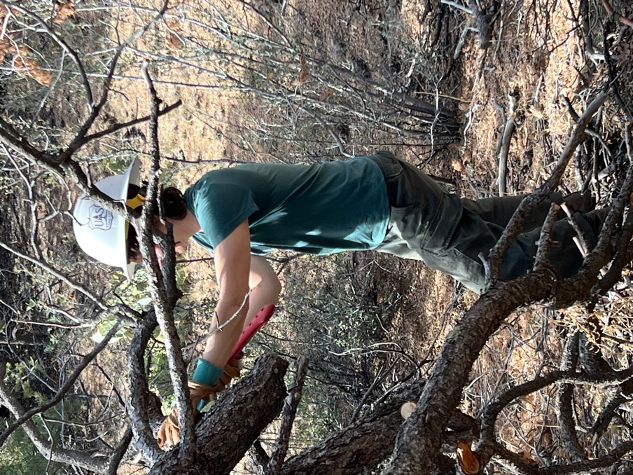
Jen cuts some branches to use for obliterating.

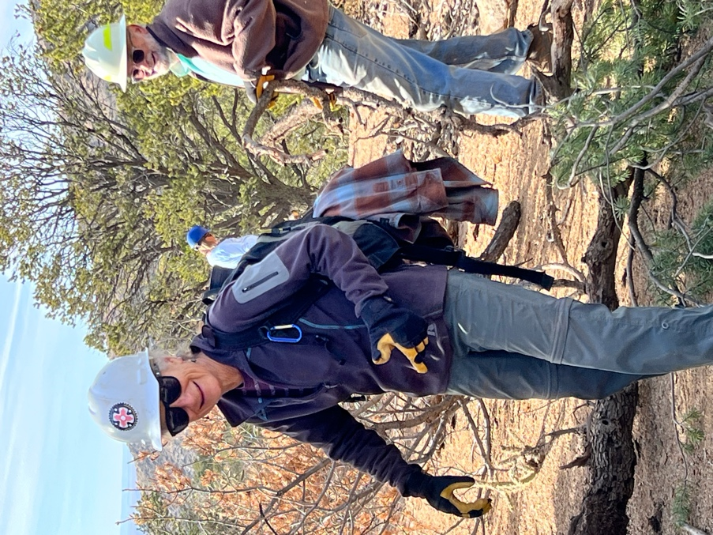 Just a few more obstacles….

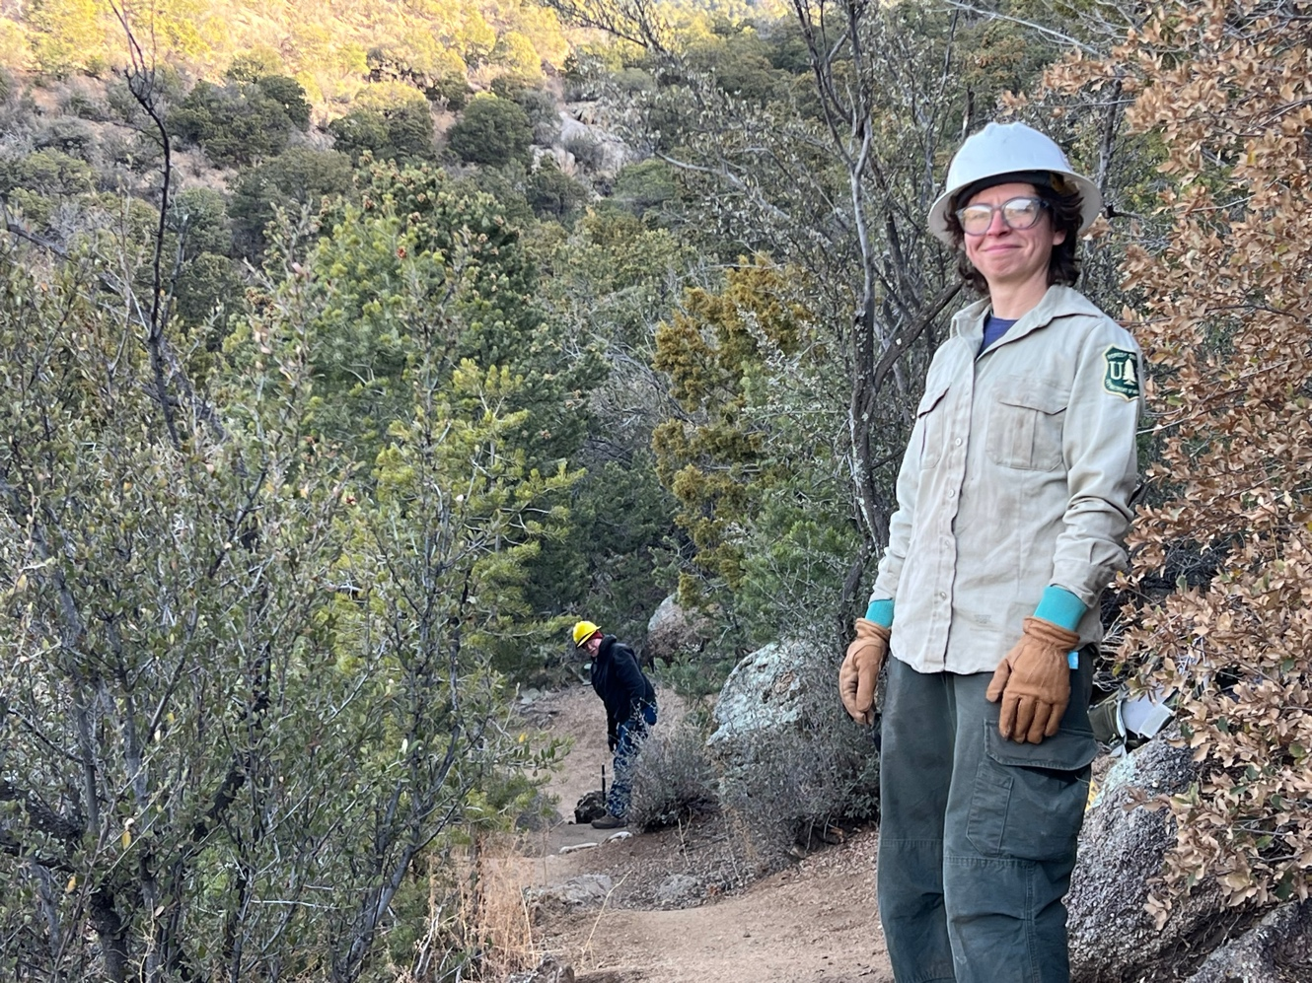

The boss is satisfied with the work so it’s time to pack up!

