Trail Maintenance Report: Monday, December 16, 2024

Byron Garner

On Monday December 16, the Monday trail crew returned once again to North Faulty Trail (Mystery Trail) to clear trail corridor on reroute segments 3 and 4. With the able guidance and assistance of Jen Medina-Gray to lead the way , our crew of nine made the 2+ mile trek with tools to the work site and dove into the work of clearing dead fall, thick stands of scrub oak and a few small trees. This was the first such effort for some of the crew, but all worked together for a job well done to help make this very pleasant trail even better. In spite of the cold early morning start and lingering icy stretches of trail, it turned out to be ideal working conditions and a pleasant day. The crew included Scott Christenson, Rene Archer, John Cooper, Steve Roholt, Susan Gregory, Paul Keras, Phil Cromer and Jennifer Medina -Gray USFS. Photo Credits: Jennifer Medina-Gray and Rene Archer

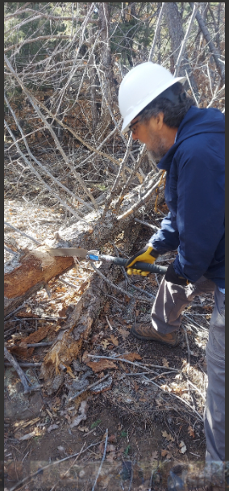

Phil works on this surprise trail blocker found on the way up

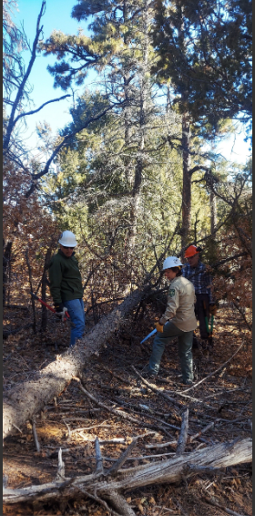

Phil, Jen and Scott contemplate the next move

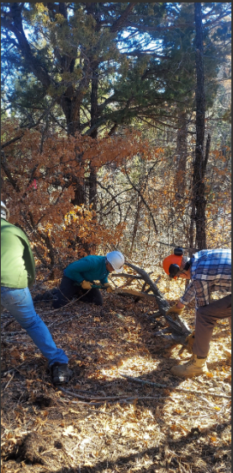

The corridor emerges as Steve, Phil and Scott do some final clearing

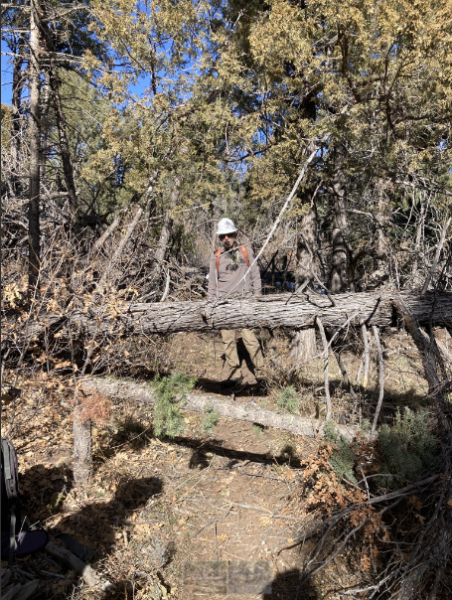

They weren't all small as Paul discovers

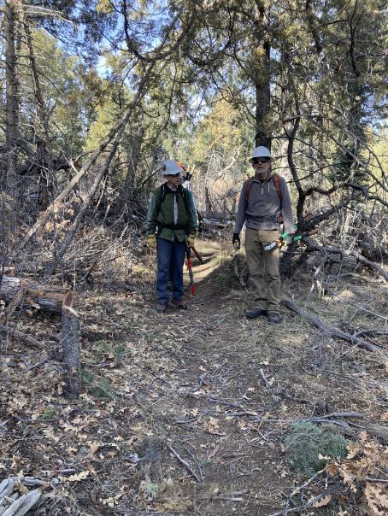

John and Paul declare this corridor open for business