**Report of FOSM Project to Fell Hazard Trees on Sandia Mountain Natural History Center on Wed., Dec. 18, 2024**

Sam Beard

On Wednesday, December 18, eight FOSM volunteers removed approximately 16 hazard trees from trails in the Sandia Mountain Natural History Center on the east side of the mountain a short distance west of NM-14. At the request of the SMNHC management, Susan Gregory, a Center volunteer and a FOSM volunteer, made arrangements for FOSM volunteers fell these hazard trees.

The volunteers were Sim Cook, Sam Beard, Dennis Crowther, Cliff Giles, Susan Gregory, Steve Roholt, Jerry Carroll, and Eric Russell.

Project photos are presented below.

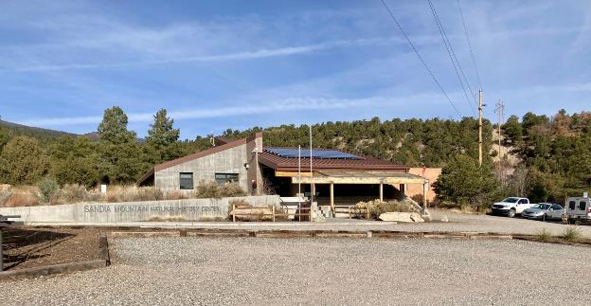

Office building at the Sandia Mountain Natural History Center.

All photos by Cliff Giles

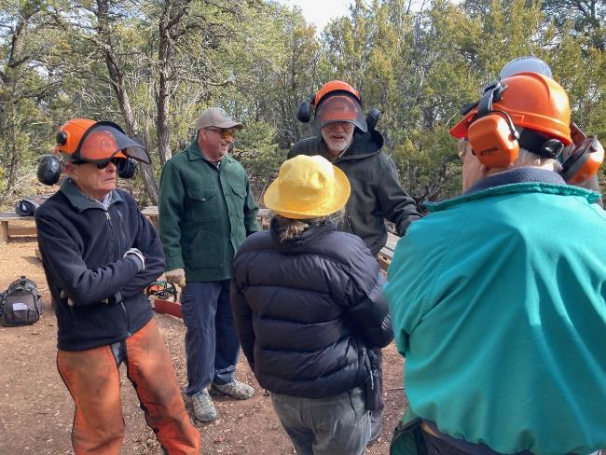

Planning the project to fell hazard trees along trails

in the Sandia Mountain Natural History Center (SMNHC).

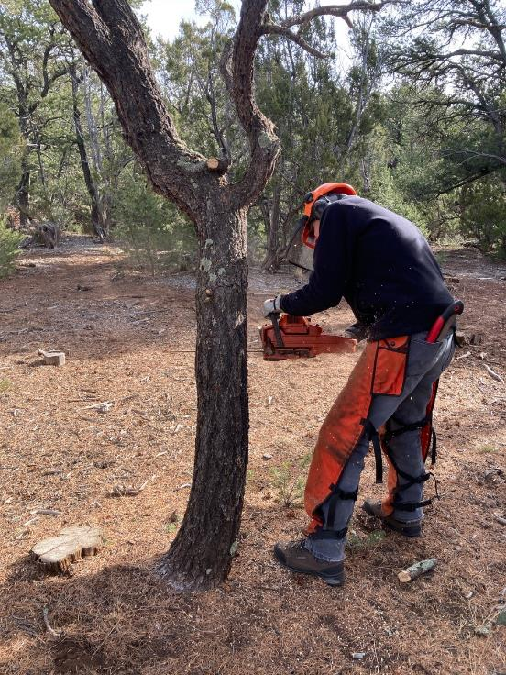

Sim Cook making the face cut in a small pinon tree that he is felling.

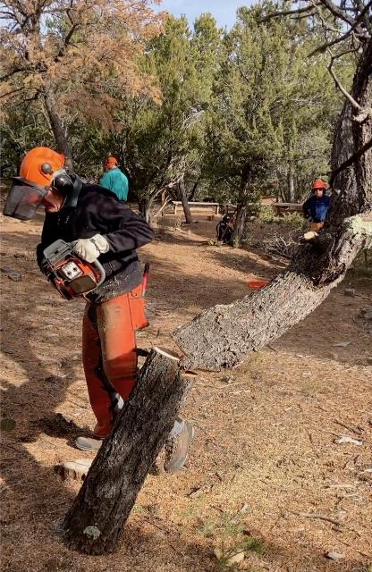

Sim running away from the falling tree.

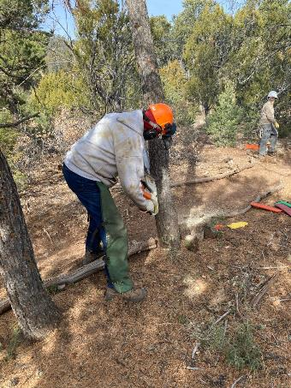

Eric Russell felling a small tree.

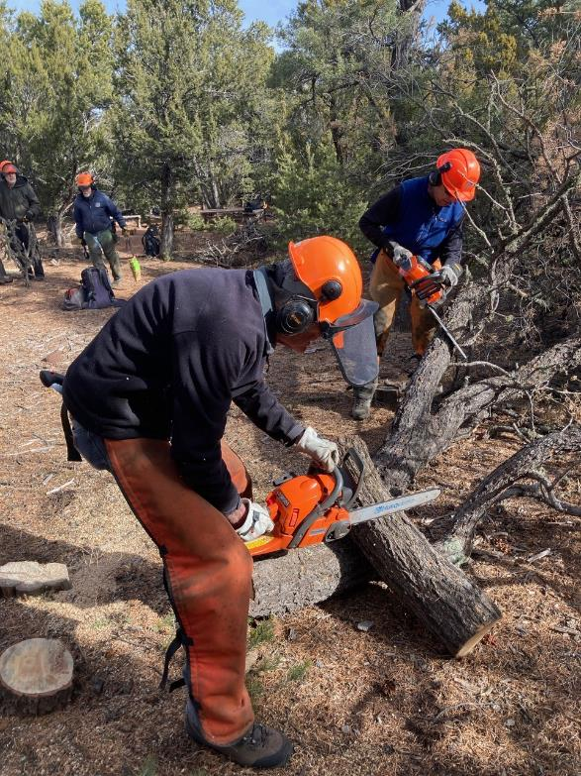

Sim bucking a piece of tree trunk and Steve Roholt limbing the felled tree.

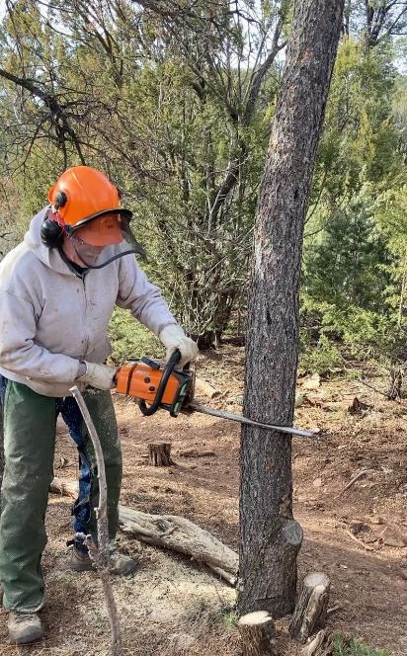

Eric making the back cut in a tree he is felling.

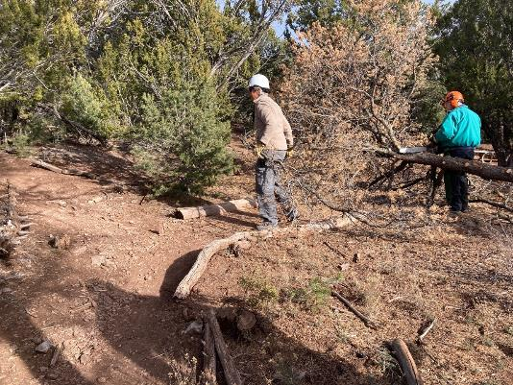

Susan Gregory scattering slash, and Dennis Crowther limbing a tree he has felled.

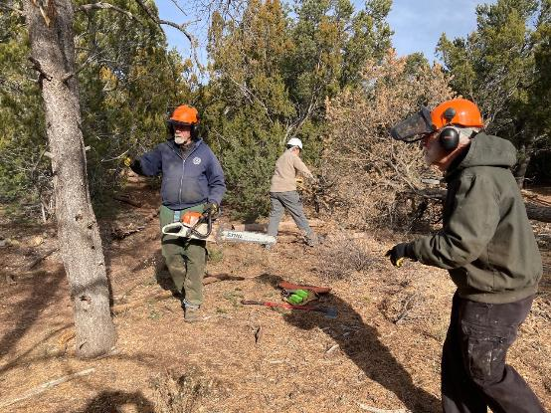

Jerry Carroll planning to fell a hazard tree.

L to R: Jerry Carroll, Susan Gregory, and Sam Beard

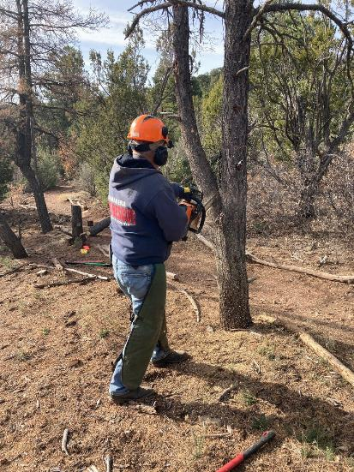

Jerry cutting off a limb on the tree he will fell.

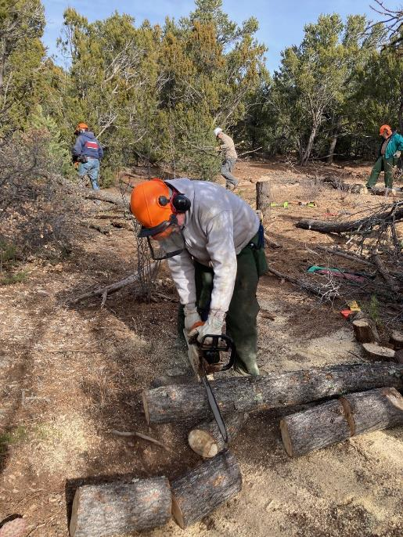

Eric bucking a tree trunk.

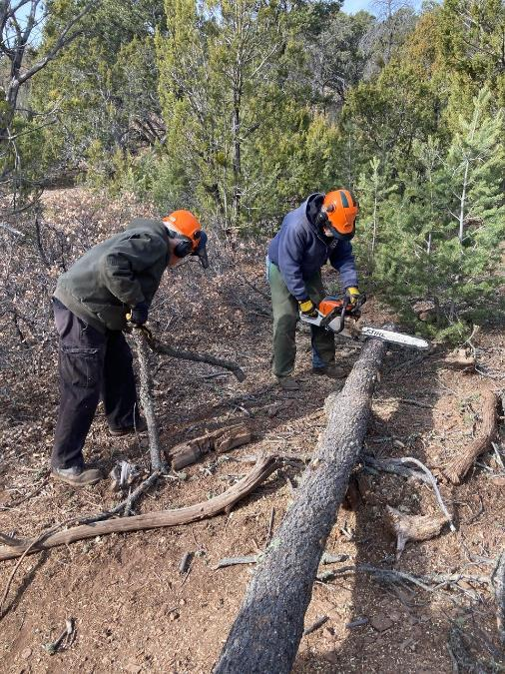

L to R: Sam scattering slash and Jerry bucking a tree trunk.

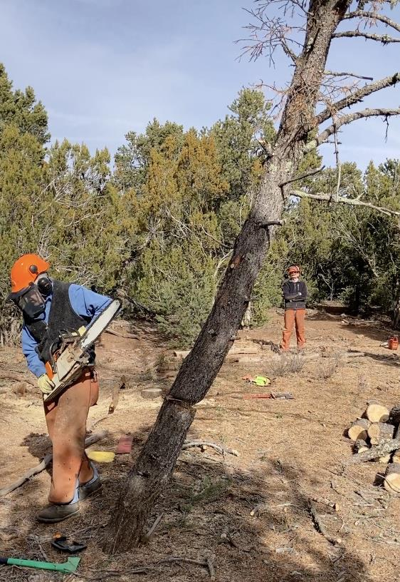

Byron Garner running away from a tree he is felling.

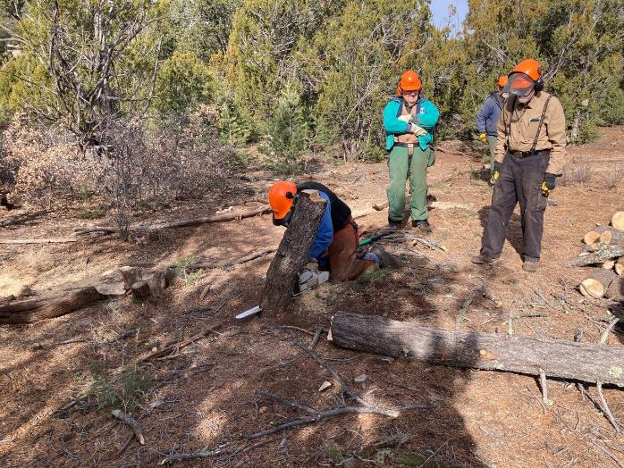

Byron low stumping the tree he has just felled.

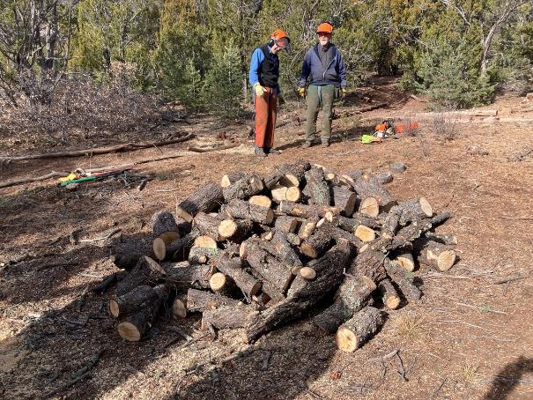

Pile of fire wood resulting from the felling of several hazard trees.

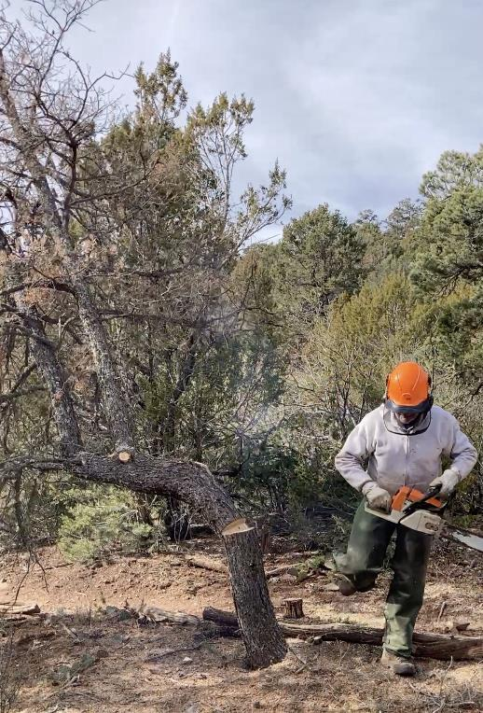

Eric running away from the tree he has just felled.

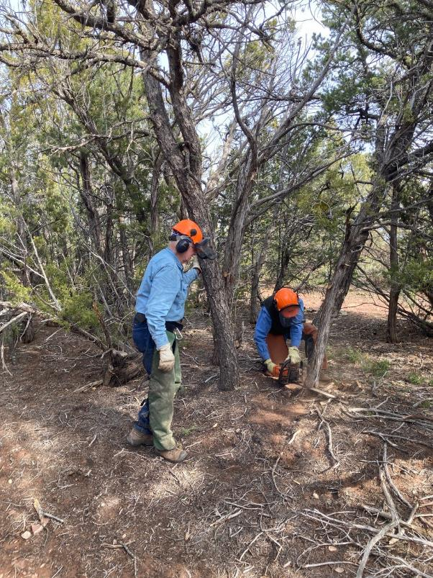

Eric observing Byron felling a very small juniper to make room

to safely fell a dead pinon tree.

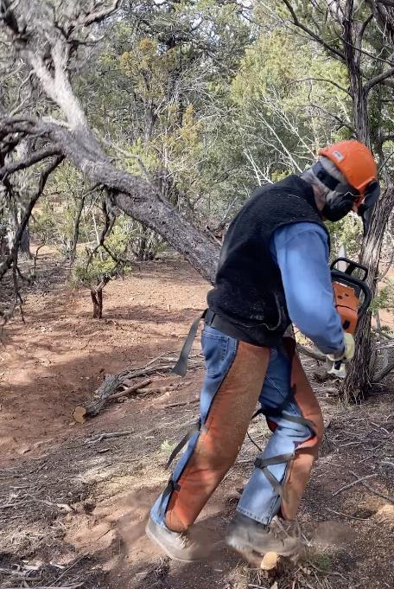

Byron running away from the falling tree.

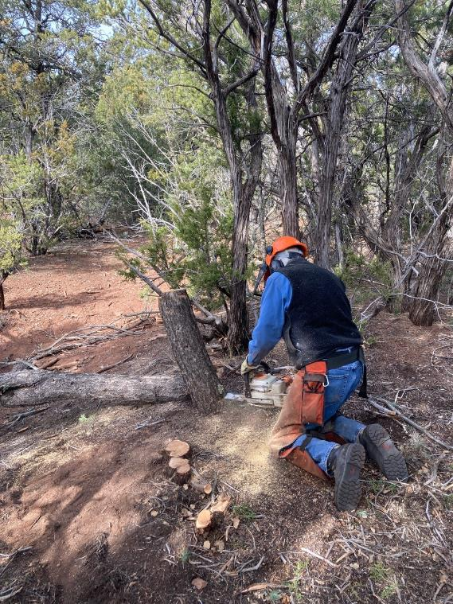

Byron low stumping the tree he has just felled.

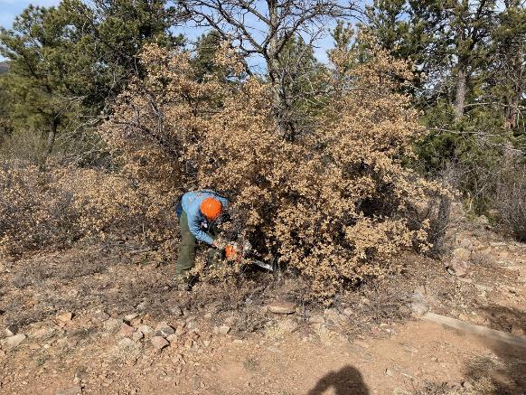

Eric cutting oak brush around a dead pinon so he will have room

to safely fell it.

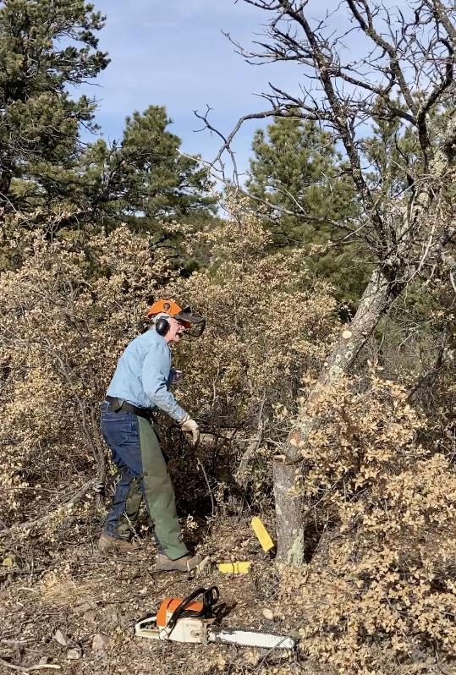

Eric has just pushed over the small dead pinon he was felling.

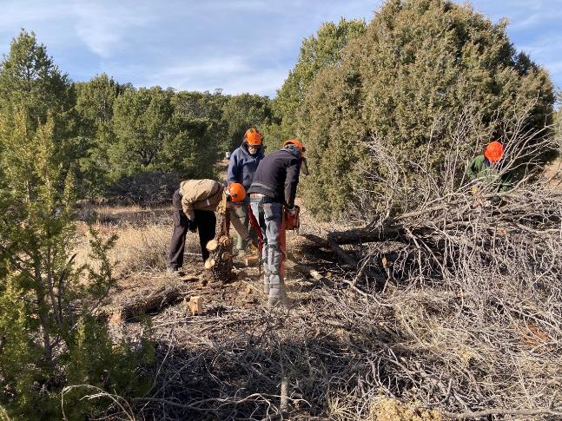

Byron bucking the pinon he has just felled.

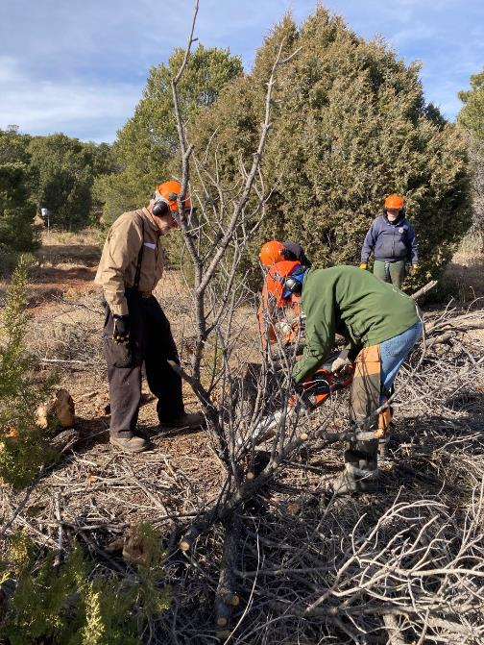

Steve Roholt bucking a felled tree with the FOSM battery-powered chain saw.