**Report of Removal of Graffiti Tags at Otero Canyon Trailhead**

**on Wednesday, January 1, 2025**

Sam Beard

On December 30, Pauline Ho and Rick Buss removed graffiti tags on the back of a large aluminum sign at Otero Canyon Trailhead, but they were not successful when they tried to remove the graffiti on adjacent plastic kiosk surfaces. On January 1, they worked with Sam Beard and were successful in removing tags from the kiosk panels with chemicals from the World’s Best Graffiti Removal System Company.

Project photos are presented below.

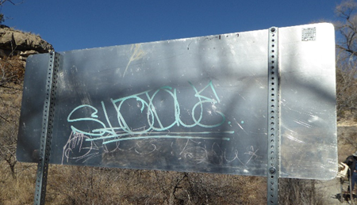

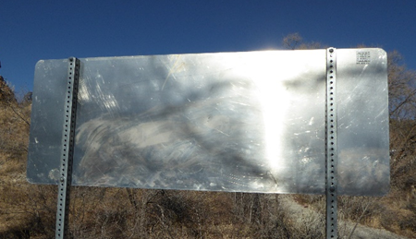

Pauline Ho wrote that on Dec. 30 “our solvents worked well on the smooth metal sign, but didn’t work

too well on the textured plastic signboard.” All photos by Pauline Ho

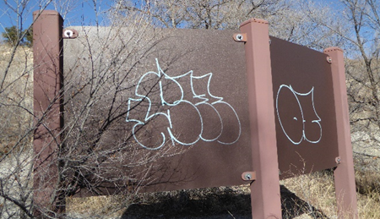

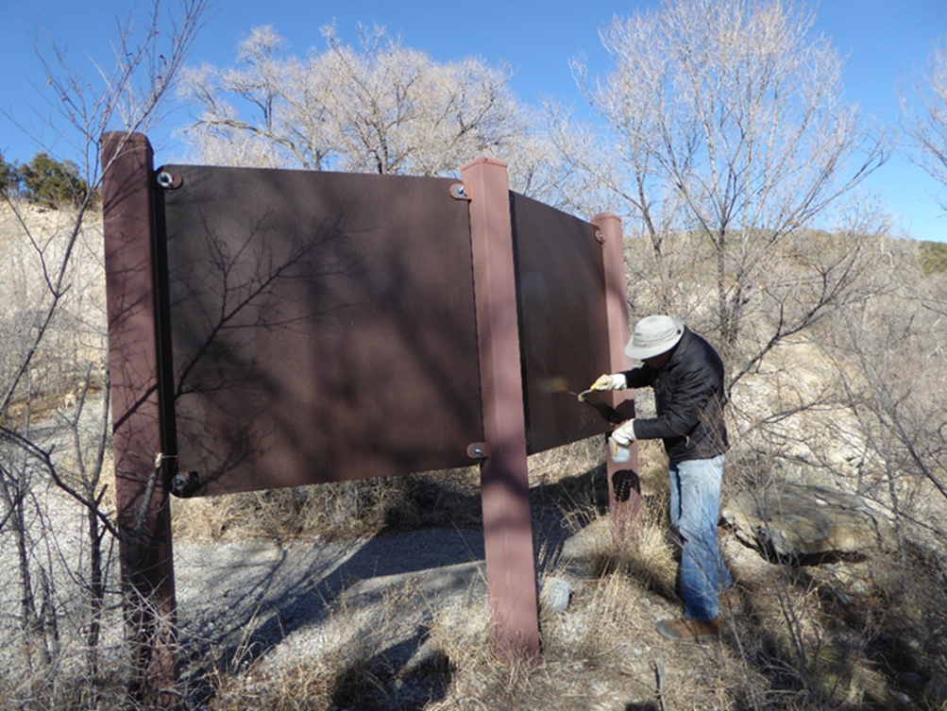

On January 1, Pauline Ho, Rick Buss, and Sam Beard used World’s Best Graffiti Removal System chemicals

for sensitive surfaces and the felt tip fadeout chemical. With these chemicals, all the tags

on the kiosk textured plastic back surfaces were removed.