Trail Maintenance Report For: Monday, January 6, 2025
Byron Garner

On January 6, the Monday trail crew headed south into the Mazanitas to the Mars Court trail head area to clear three Podarosas on Three Bottles Advanced trail that were reported by Canyon Young USFS. Beginning on FR 530, we hiked to the Cajun Pine junction and continued on that trail to the Three Bottles Advanced junction. This area has a complex network of bike trails branching off the main trail and not all of which are mapped or named but are signed with difficulty ratings of which our target area was a black diamond rated branch trail off Three Bottle Advanced. With the GPS coordinates Jen provided and the formidable GPS skills of John, Chuck and Jamey, we located the first two trees on a very challenging (for bikers) segment of this trail. These two Pondarosas ( 16" and 12") lay across the trail forming an elongated "X" diagonal to the trail. The size of these trees and the complexity of their position required a bit of thought, site preparation and strategy, but after a couple initial Katatna cuts we fired up the crosscut and finished the job with six cuts.
After continuing with a short hike up Three Bottles Advance and arriving at the next tree, it was time for lunch and rest which quickly alerted us to the cooling temps. With a couple of well placed cuts to this 14" Pondarosa using the crosscut, the trail was clear and open for business again. A large and poorly supported "widow maker" at this site was also cleared.

A few minor encroachments and a poorly supported leaner found along the way were also cleared. The crew included Ken Wilson, Rav Nicholson, Steve Roholt, Phil Cromer, Dave McCreery, John Copper, Chuck Logan, Jamey Browning and Byron Garner.

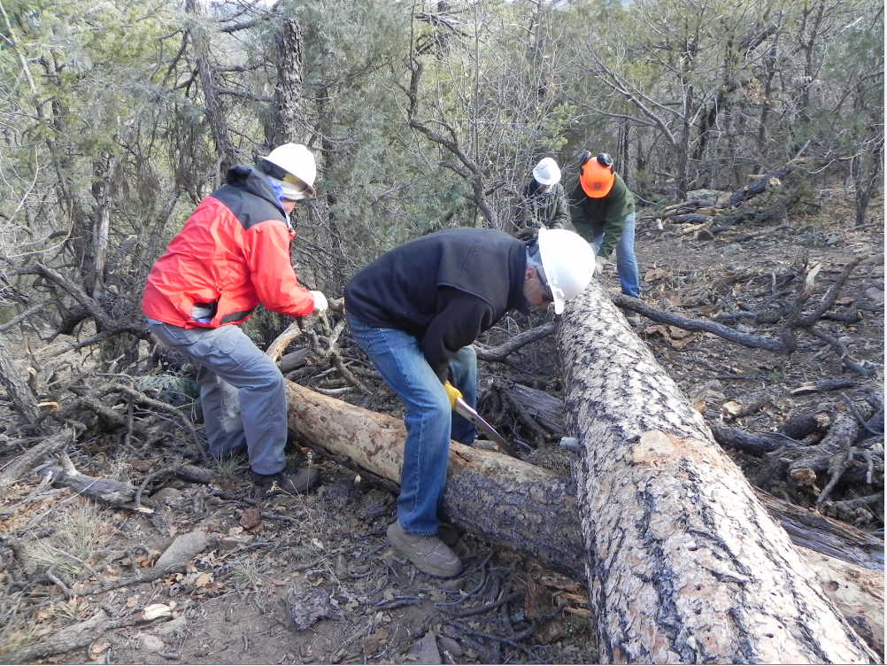
Dave and Ken start the limbing while Phil and Steve size up the first cut on this long trunk

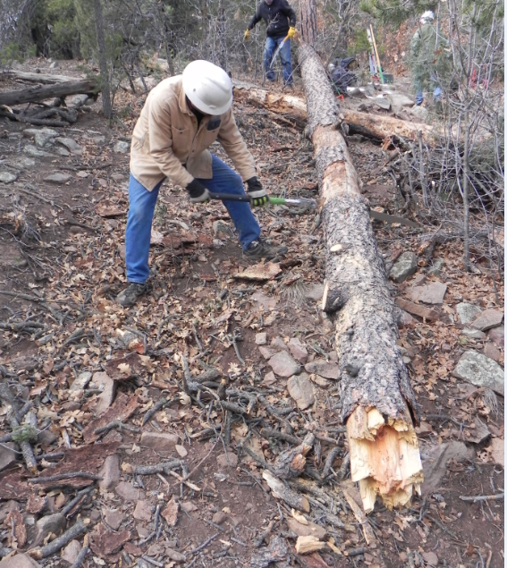
Chuck works the first cut

It takes teamwork

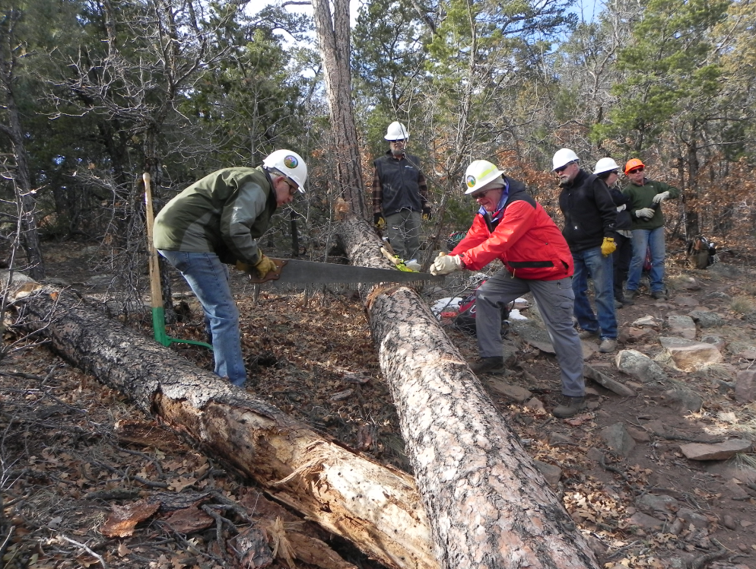

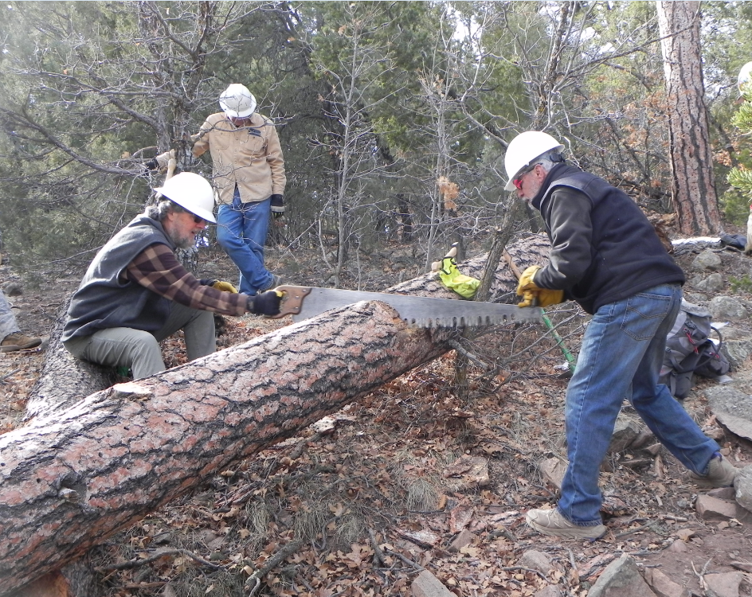

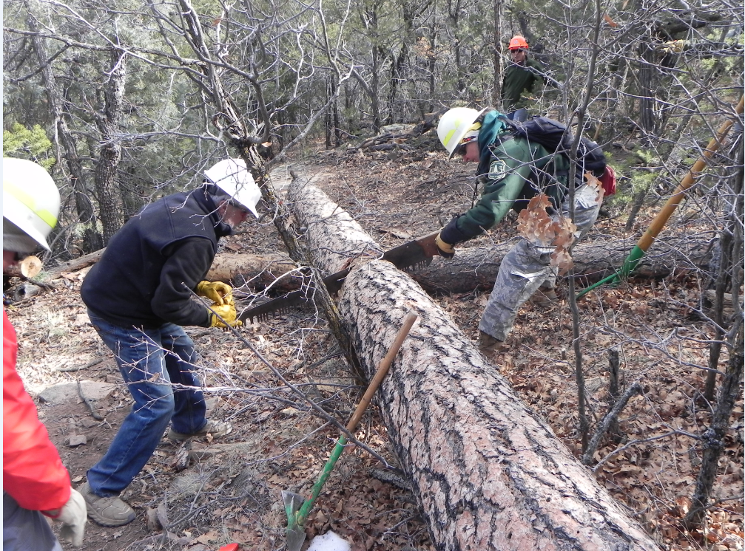

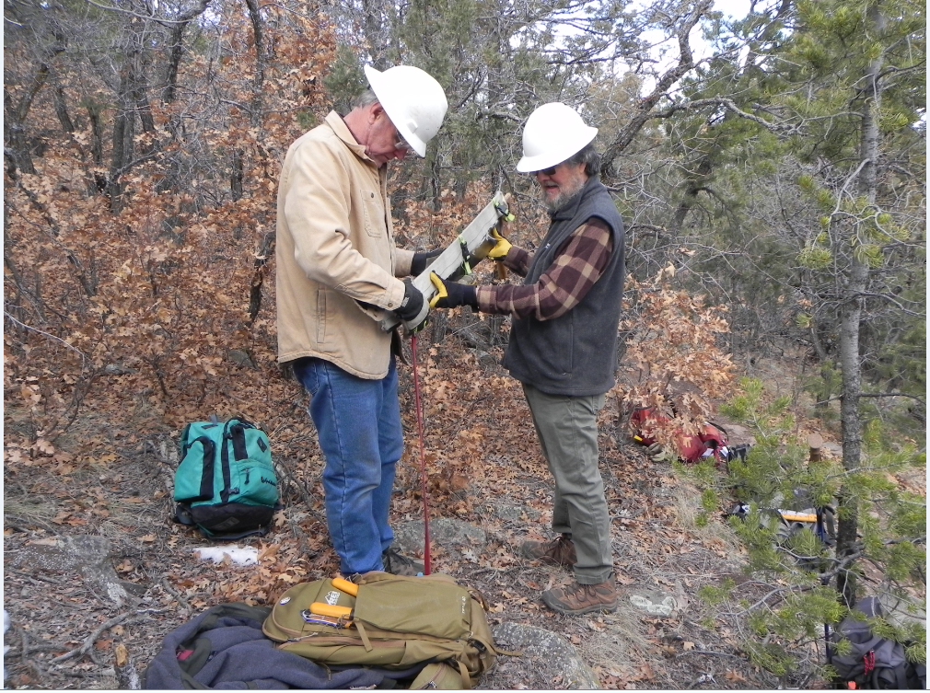

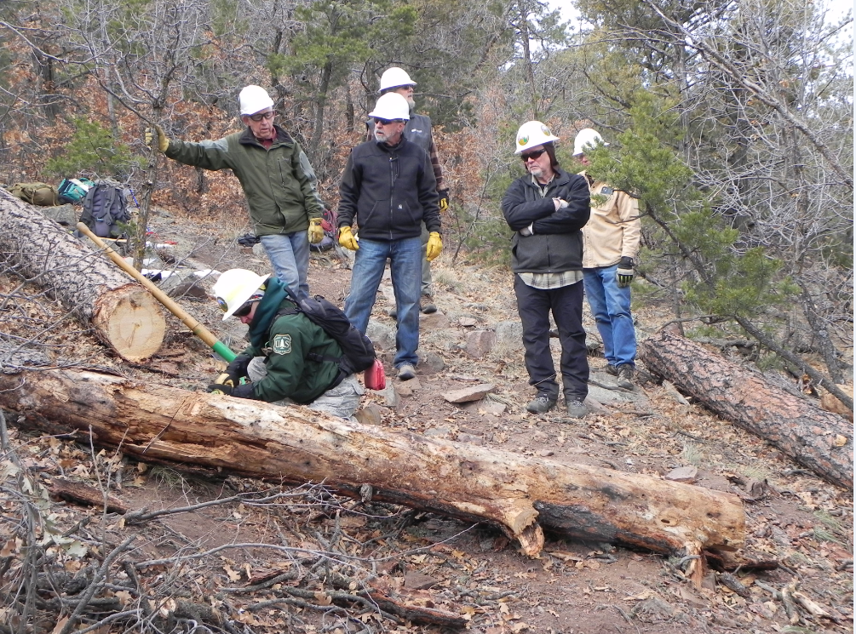
Bucking - the latest spectator sport

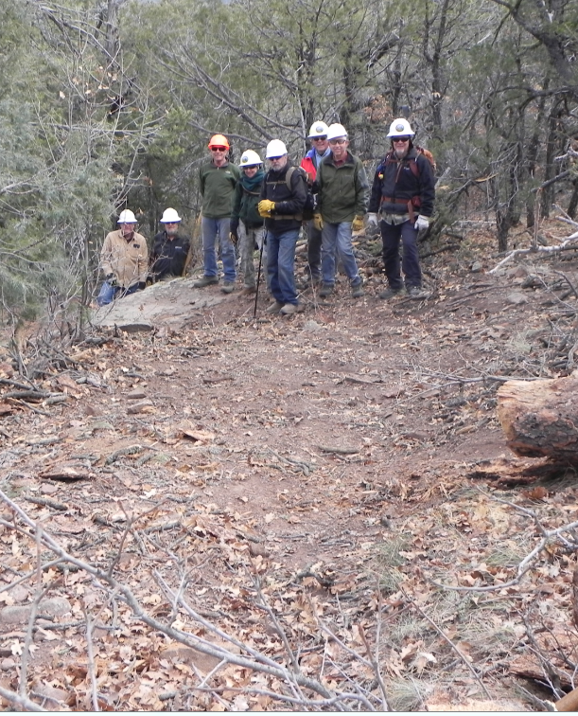
All clear and good to go as Chuck and Phil stand below this large boulder where the bike jumpers land
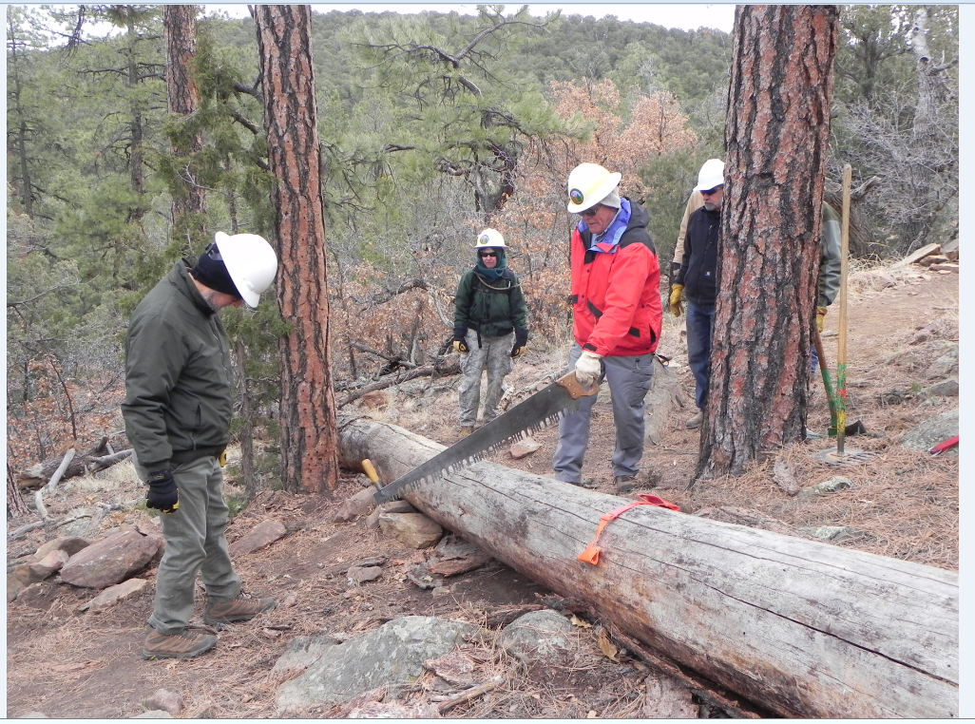

Jamey and Dave finalized the strategy for our third tree

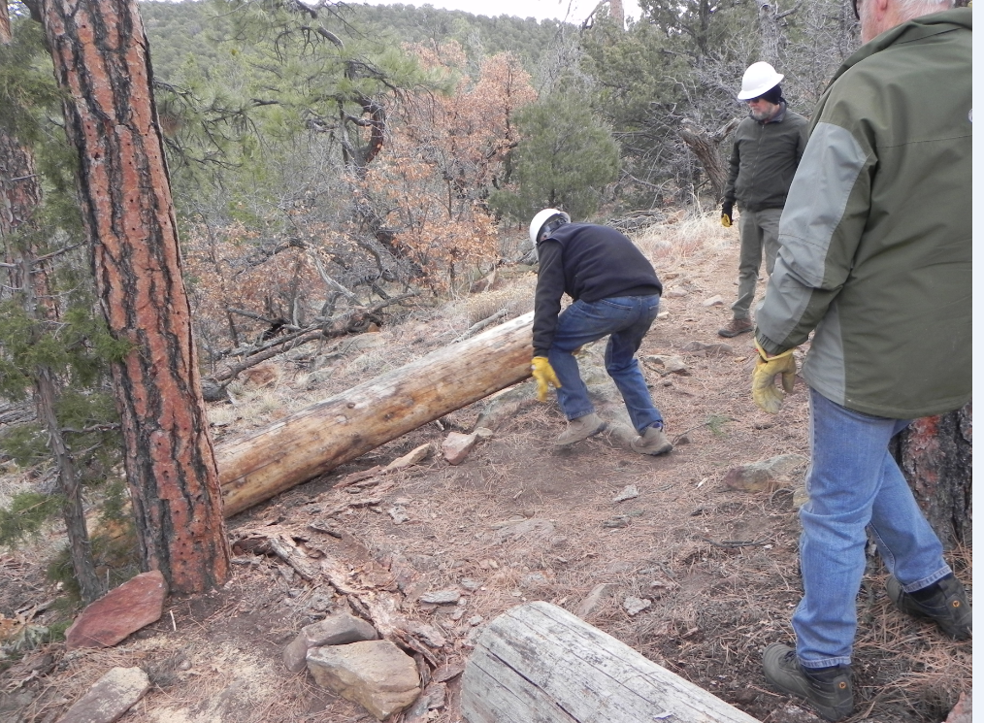
One more heave and the job is done

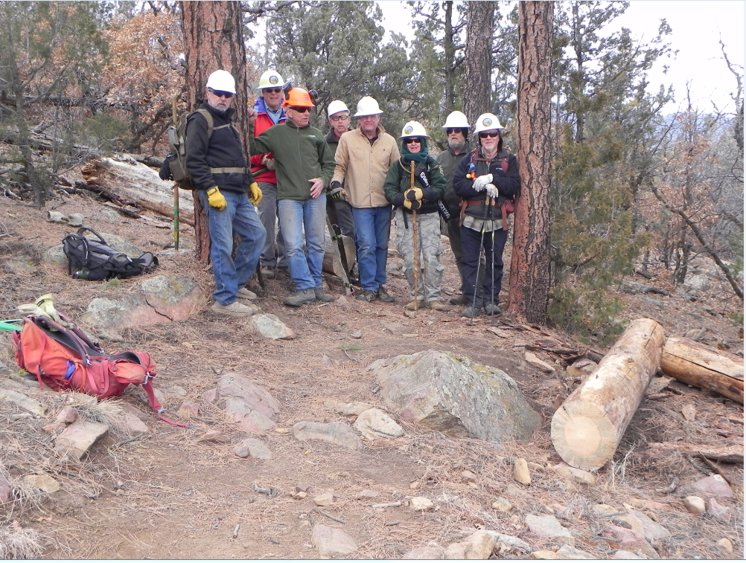
Ken, Dave, Steve, John, Chuck, Rav, Phil and Jamey

