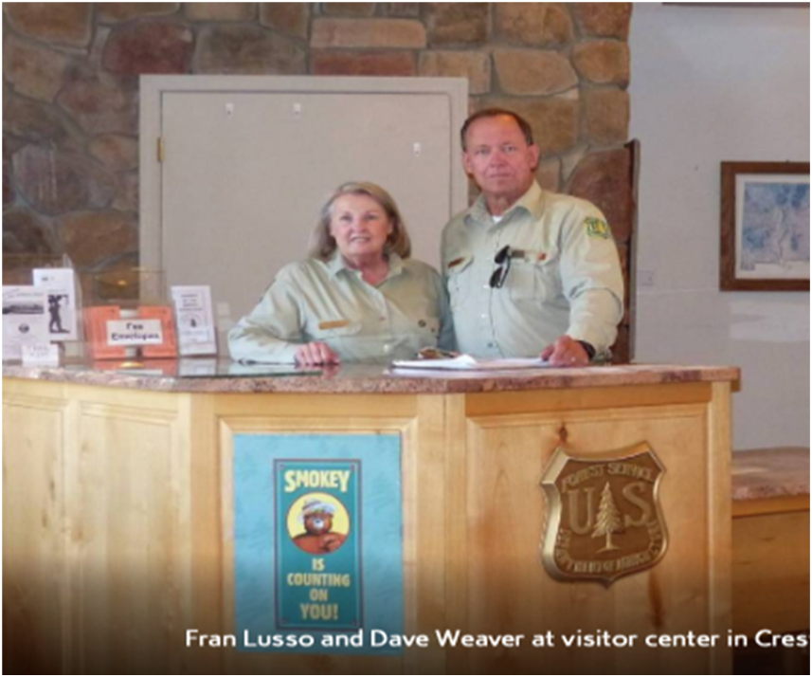

Photograph of Dave Weaver and Fran Lusso in the Visitor Center of the Crest House from the current PowerPoint presentation about Friends of the Sandia Mountains.